



***July 15th, 22nd, 2021***

***‘New Leadership Month’***

**IN THE LANCE**

**Business Meeting**

**Bits & Pieces**

**Speaker Dr. Paul Geneau**

**Visitor Charlotte**

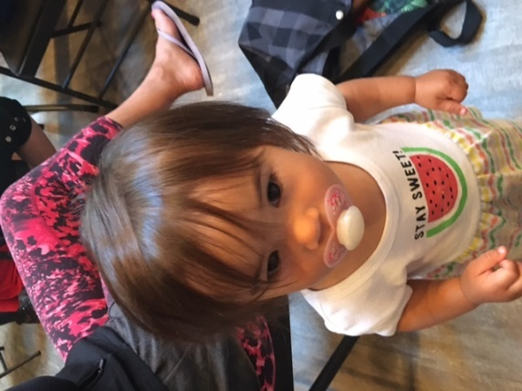

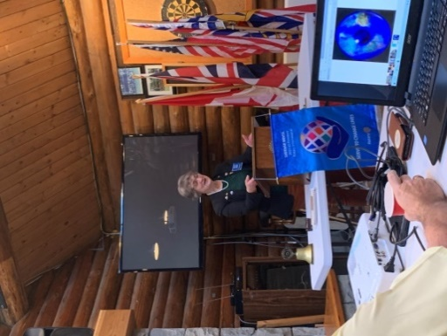

**President Jodie – Business Meeting**

Lots of activity within our club and within Rotary.

Jody gave an update on changes to District Grants. Club eligibility will be based on prior year, per member contributions. District is encouraging members to use Rotary Direct for Foundation donations.

To build fellowship and increase our visibility, incoming RI President Shekhar Mehta is encourages same community clubs to hold joint hands-on-projects.

Stephen reports planning is underway for 2022-2023 Rotary Youth Exchange.Outgoing student applicants must include 3 confirmed host families for inbound students with their application. RYLA Fall 2021 will be hybrid zoom with smaller in-person events at 3 VI locations.

For the July Nanaimo News Bulletin Rotary page, Greg wrote about our Fairwinds Golf event, focusing on our sponsors.

President Jodie circulated 2021-2022 committee and duty rosters.

*‘Great things are not done by impulse, but by a series of small things brought together.’*

**INSPIRATION**

*‘The most beautiful people we have known are those who have known defeat, known suffering, known struggle, known loss, and have found their way out of the depths. These persons have an appreciation, sensitivity, and an understanding of life that fills them with compassion, gentleness, and a deep loving concern. Beautiful peop0le do not just happen.’* ~~~ Elisabeth Kubler-Ross

**SERGEANT AT ARMS –BITS & PIECES**

In an early morning zoom call, Doug and Heather were pleasantly surprised, happy to learn their son had eloped.

Randy was delighted to find the missing Rotary tents safely in storage in Bev’s garage.

Don T. was very pleased with his many birthday wishes.

Long awaited visits from family and friends were highlights for Greg &Susan, Brian & June. Michael enjoyed taking his nephew to the BC Museum in Victoria.

James ‘new’ Mercedes was upstage by his daughter’s brand new Audi.

A fun afternoon, Sandi & Bryan greatly enjoyed the Garden Party at Joy & George’s.

**DUTY ROSTER – JULY 29TH, 2021**

Greeter: Lee Cash: Mark

Sgt-Arms: Doug Inspiration: Jan

Introductions: David Foundation: Jodie

Rotary Minute: Joy

**SPEAKER**

Nick Scott, President

Nanaimo Rugby Club

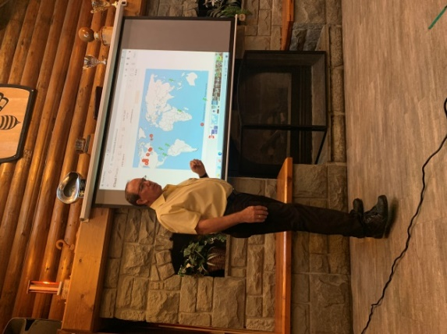

**Dr. Paul Geneau**

Canadian Vision Care (CVC), an Alberta based registered charity, began in 1981. CVC volunteers have and continue to provide primary eye care and surgical care to hundreds of thousands of people around the world.

The initial project began as a mission project in Jamaica for 4 University of Waterloo School of Optometry students. Those same doctors have returned to Jamaica twice a year, every year since. Today CVC volunteers also provide services in Africa, the Philippines, Costa Rica, Guyana and rural locations within Canada.

Dr. Geneau shared pictures and memories from he and Kathy’s many trips. They helped build the optometry school in Malawi. Every graduating optometry student receives a certificate and a ‘tool’ kit. In the Philippines, the CVC team built a clinic in an old train car. In Costa Rica, local labs are sponsored in making glasses. It is known that 75% of vision loss can be prevented or treated if diagnosed early.

Dr. Geneau has traveled on over 35 eye care missions. He has been an active Rotarian since 1981 and is deeply involved in the Rotary Youth Exchange program.

**DISTRICT GOVERNOR – 2021-2022**

**LORNA CURTIS**

Lorna has been a Rotarian since 1997. She has been a club president, secretary, membership chair and the event chair for many fundraisers. She has been district, secretary, youth policy coordinator, Rotary Foundation Fundraiser and an AG. She brought 10 Rotary Clubs together in Victoria to raise a half a million dollars to support the Food Rescue Project (getting perishable food items from grocery stores gleaned and cleaned, then distributed to vulnerable populations in the community).

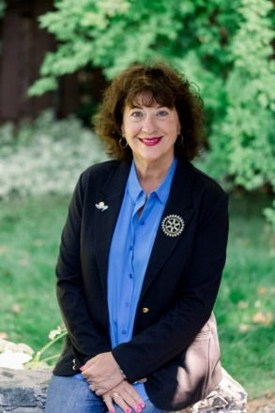

Lorna’s education background is in Public Administration. She spent 37 years working in municipal government, 31 of these years was in Parks and Recreation, finishing her career as the Director of Oak Bay Parks and Recreation Department in Victoria, British Columbia.

Lorna was a single mom, solely raising her sons from the age of 7 and 10. She is most proud of the men her sons have become, one is a Professor at Standford University and the other is an Electrician. Lorna loves to spend time with her two granddaughters 6 and 9 years of age who live in San Francisco.

Since retirement Lorna has travelled extensively around the world embracing many adventures through her travels. She enjoys old movies, loves to cook, garden and entertain.

***ROTARY’S VISION STATEMENT***

*"Together, we see a world where people unite and take action to create lasting change — across the globe, in our communities, and in ourselves."*



**OLD FARMER’S OBSERVATIONS**

* The best sermons are lived not preached.
* You cannot unsay a cruel word.
* Every path has a few puddles.
* When you wallow with pigs expect to get dirty.
* Being wise means having more questions than answers.
* Live simply, love generously, care deeply, speak kindly.