“Rotary Opens Opportunities”

July 23rd^{h}, 2020

IN THE LANCE THIS WEEK

CLUB BUSINESS

GREG DEVENISH
ROTARY MINUTE

VISITORS AND GUESTS

Visiting us were Cor Buys, Cheryl Prince Buys & baby Charlotte.

BIRTHDAYS & ANNIVERSARIES

Congratulations to Jan & Tom on their 25!

HEALTH OF THE CLUB

We had 20 smiling faces (including Jamal) at the Park. It was great to see everyone!

ROTARY CLUB OF LANTZVILLE
MISSION STATEMENT
Joining in fellowship to support growth and development in education and health for those less fortunate in our local and international communities.

MEETING NOTES

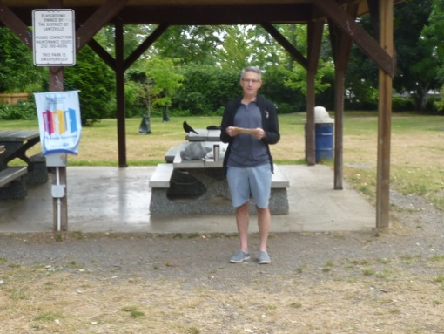
President Mark started the meeting by acknowledging that we are grateful to be gathering together on the unceded traditional territory of Snaw-Naw-as First Nation.

Lee – Foundation; Troy – membership & Michael – social media gave updates on club goals for 2020-2021.

Rachel offered to do a ‘Fitness in the Park’ by donation fund raiser in August. Details to follow.

Summer social, on the patio, Nanaimo Golf Club on August 16, 2020 is a go. As to weekly club meetings, consensus was to continue with zoom, alternating with meetings at Huddlestone Park.

A lovely note from Ian Savage: “Mark, re your 100th anniversary, post, I have had multiple great experiences with the Rotary Club over the years, like with the kids for Santa’s breakfasts, and the Easter Egg hunt. Not long ago, I asked the Rotary for help on a volunteer project in Lantzville. I was welcomed with love and kindness at the far too early breakfast meeting. What a fine group of people. The Rotary helped get my project completed. Multiply this experience by many times over 100 years in many communities and that’s the Rotary legacy. A beautiful group with such fine people. Please pass on my gratitude to the members.”
“It is not only what we do, but also what we do not do, for which we are accountable.”
- Jean-Baptiste Poquelin -
ROTARY MINUTE

Greg shared with us the story of Charles Plumb.

Plumb was a US Navy jet pilot in Vietnam. After 75 combat missions, his plane was destroyed by a surface-to-air missile. Plumb ejected and parachuted into enemy hands. He was captured and spent 6 years in a communist Vietnamese prison. He survived the ordeal and now lectures on lessons learned from that experience!

“Who Packs Your Parachute,” is a strong and interesting true story that has been shared with many people over the years during lectures and leadership courses. The message is that everyone has many people who provide what they need to make it through the day. And we need to recognize and remember to say thank-you to everyone around us more often. Thank-you Greg!

THE HISTORY OF ROTARY’S MOTTOES

Rotary’s official mottoes, Service Above Self and One Profits Most Who Serves Best, trace back to early days. At the Portland Convention in 1911, ‘He Profits Most Who Serves Best’ was approved as the Rotary motto. It was adapted from a speech made at the first National convention in Chicago. Arthur Sheldon declared that “only the science of right conduct toward others pays. Business is the science of human services. He profits most who serves his fellows best.” At this same convention, Ben Collins speech about his club’s motto ‘Service, not Self’ was met with great enthusiasm.

At the 1950 RI Convention, slightly modified versions of the two slogans were formally approved as the official mottoes of Rotary: He Profits Most Who Serves Best and Service above Self.

In 1989, Service Above Self was established as the principal motto because it best conveys the philosophy of unselfish volunteer service. In 2010 the second slogan was modified to its current wording: One Profits Most Who Serves Best.

