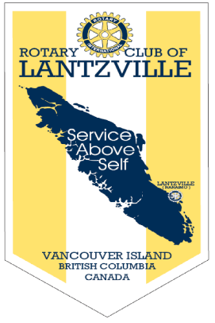

“Rotary Opens Opportunities”

July 30th, 2020

IN THE LANCE THIS WEEK

CLUB BUSINESS
LANTZVILLE HISTORICAL SOCIETY
LYNN REEV
ROTARY MINUTE

VISITORS AND GUESTS

Visitors, Rotarian - ADG Wayne Anderson, baby Charlotte, our forever friend Barry Sparkes.

BIRTHDAYS & ANNIVERSARIES

Wishing Mike Walker a very happy, happy BD!

HEALTH OF THE CLUB

Good member participation on zoom, lots of small talk, chit-chat about who is doing – not doing what.

ROTARY CLUB OF LANTZVILLE
MISSION STATEMENT
Joining in fellowship to support growth and development in education and health for those less fortunate in our local and international communities.

MEETING NOTES

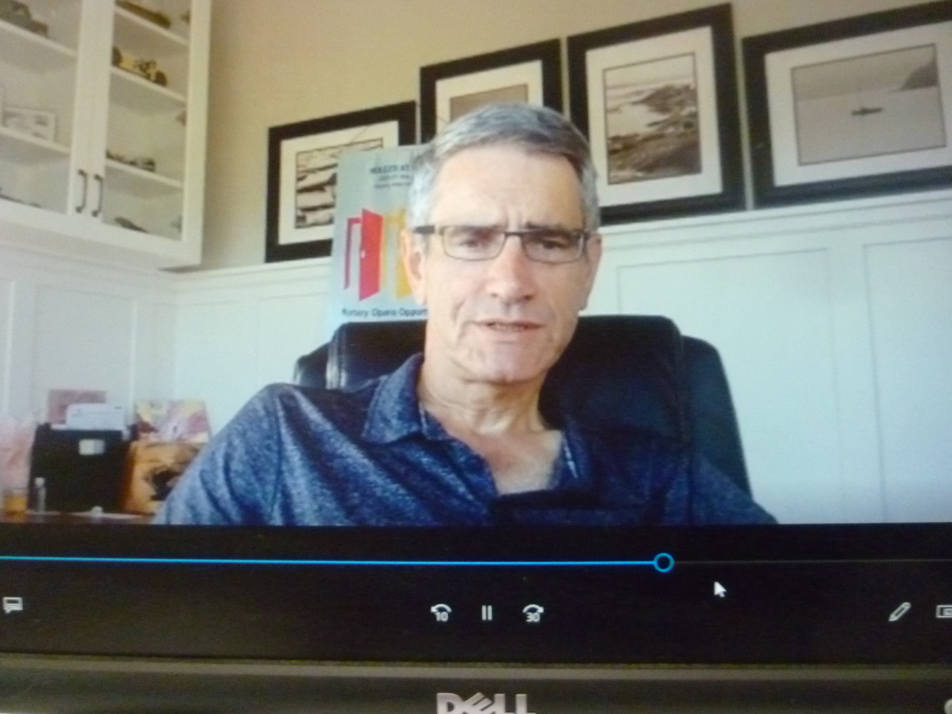

Following opening remarks, President Mark shared a zoom oral and picture presentation of Canada. All of us are exploring and learning new skills.

Mark wants club members to look at creative fund raising opportunities.

Troy gave an update on the recent 7-10 hot sandwich breakfast which was served to 40 very appreciative guests. We have upped our commitment to the 2nd and 4th Saturday of the month.

Rachel gave an update on ‘Fitness in the Park. We should have the August date confirmed next week.

What’s Up

- Barry, very happy to have a conditional offer.
- Wayne, PETS 2021 will be virtual.
- James, happy to be home from NRGH
- Tessa, busy helping daughter move.
-Doug, completed a new wood working project.

“When the power of love overcomes the love of power then the world will know peace.”
-----Jimi Hendrix

ROTARY MINUTE – JOY CAMERON

In June, ‘The Honourable Janet Austin, Lieutenant Governor of British Columbia asked us to join her,
“alongside leaders in government, business and social services, in pledging to uphold the Canadian values of diversity and inclusion and to oppose racism and hate in all its forms. We are stronger when we are #Different Together.”
#Different Together Pledge
Our B.C is inclusive and respects people of all ethnicities, cultures and faiths and their contributions of our collective well-being.
Our B.C. holds diversity as a fundamental value at the heart of the success, strength and resilience of our communities, workplaces, schools, public and private institutions.
I pledge to uphold and promote these values and I commit to speaking up to oppose racism and hate in all its forms.

District of Lantzville – Incorp. June 25th, 2003
Once known only as part of Nanoose, when coal was originally found. Lantzville was known as Grant’s Mine. In 1920, an American company bought the mine and property from Mr. Grant. Mr. Lantz was one of the company directors and the area became known as Lantzville.
Lantzville is known for its community charm. It is a place where neighbours care about neighbours and a place where if you pass someone on the street, you are greeted with a friendly ‘hello’. Currently home to 3,900+/- people, residents of Lantzville have always maintained a significant amount of community pride.

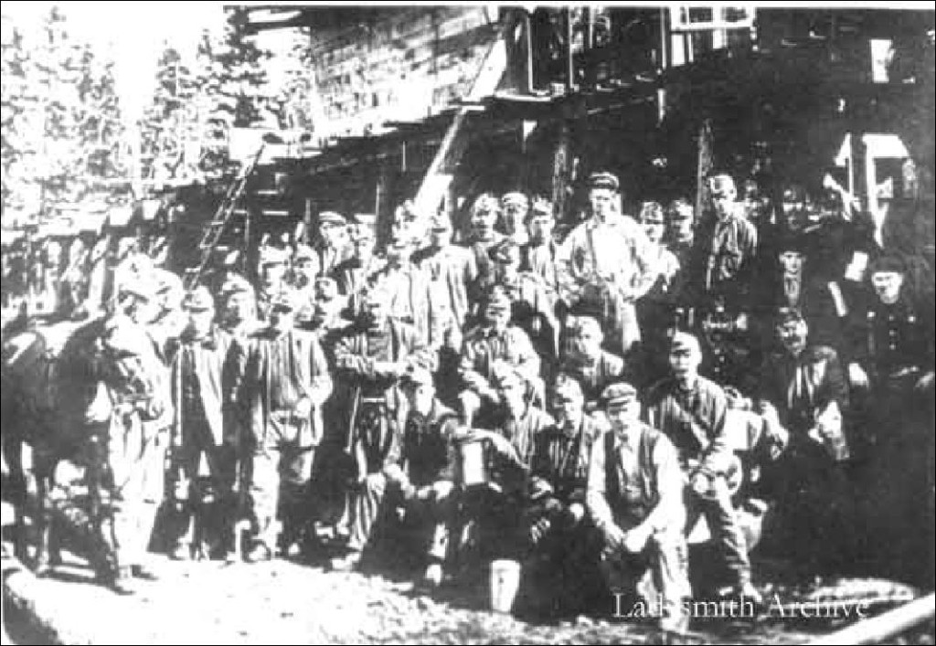
Picture is from the Ladysmith Archives. It was a group of miners at the Lantzville Mine, a.k.a. the ‘Gordon’ Mine on Jack’s Road in 1913.

LYNN REEVE – PRESIDENT
LANTZILLE HISTORICAL SOCIETY

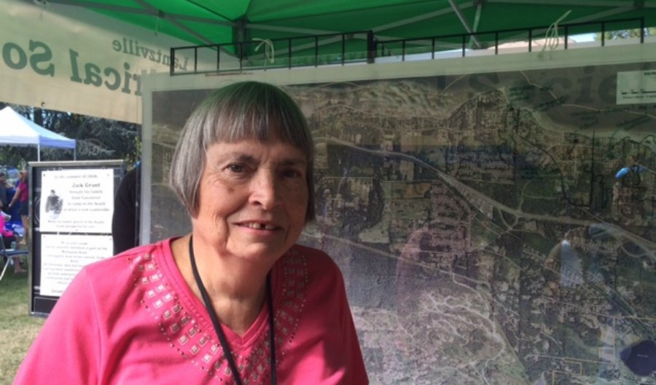

The Lantzville Historical Society (LHS) was incorporated on December 10th, 1982. The society grew out of a project initiated by Armand Caillet to locate past school photos. Armand was the first president of the society.

Current president, Lynn told us about past, present and planned work done by society members. Their first project was to assemble a collection of 300+ school pictures taken between 1917 – 1970. A book titled ‘Lantzville The First Hundred Years’ (1855-1955) was an early project, one that took 25 years to be completed and published. A second book covering more recent history is underway. Other projects include the collection & storing of historical pictures, artifacts & documents. At the foot of Jack’s Road, the Society created a mine monument, consisting of historical plaques attached to a large rock. The Society is currently working on a mine tour. For the past 44 years, LHS organized ‘Mine Town Days’.

The Society’s home is adjacent to the District of Lantzville municipal office. Annual membership is $ 10.

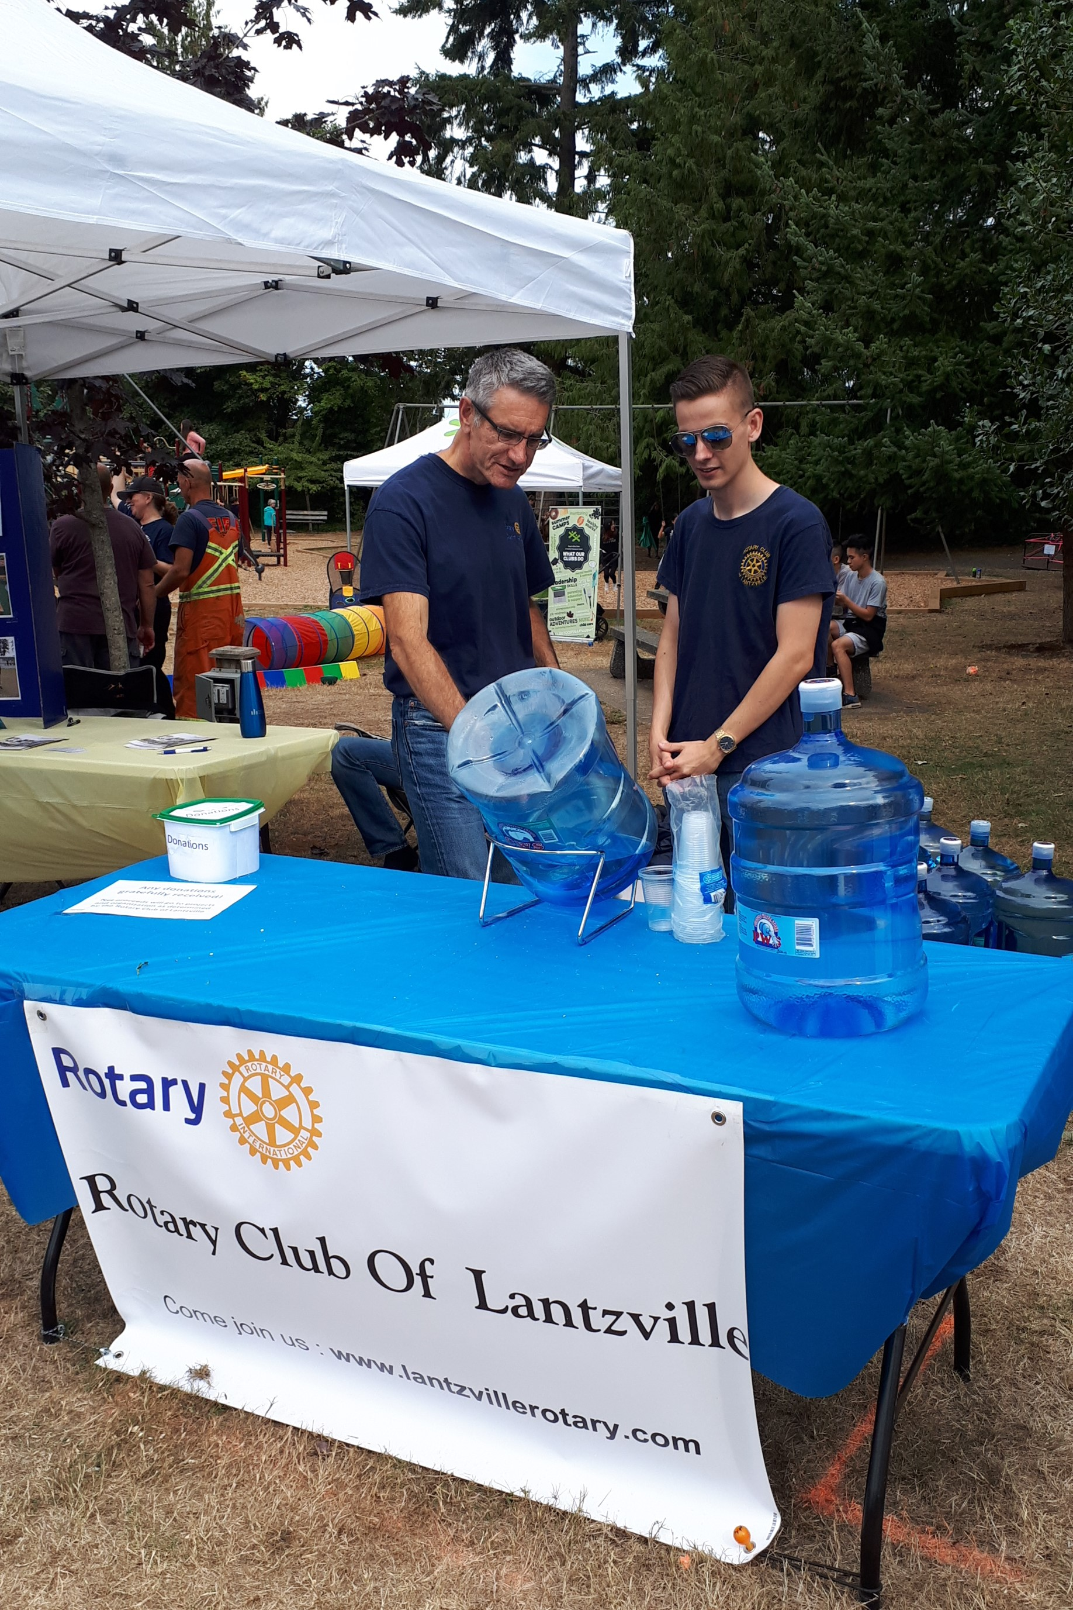

Mine Town Days – 2019

