“Rotary: Making a Difference”

July 5, 2018
Start of new Rotary Officers' Year

IN THE LANCE THIS WEEK

Jan begins term as Club President

RCMP in Nanaimo

Membership Ideas from a Visiting Rotarian

FUTURE EVENTS
Jul 9th-Board Meeting, Royal Lepage 5:00 pm
Jul 12th – NO Meeting
Jul 19th-Ev Boegh-History of Daybreak
Jul 22- Summer BBQ at the Tuckers
Jul 26th-NO Meeting
Jul 28th-Breakfast at 7-10 Club

“VISITING” ROTARIANS
Chris Nesmith-SW Yakima River Rotary Club

VISITORS and GUESTS
Superintendant Cameron Miller, Officer-in Charge, Nanaimo RCMP

BIRTHDAYS & ANNIVERSARIES
 |  | DUTY ROSTER
DATE | GREETERS |  | CASH | Sgt-At-Arms | Invocation | INTRO | Foundation | Rotary  Minute
Jul 12th | NO MEETING
Jul 19th | Cameron & Manikel |  | Elgie | Tamelin | Jodie Williams | Lobay | Cohn
Jul 27th | NO Meeting
Aug 2nd | Regular Meeting |  | TBD
If you cannot make your duty, it is your responsibility to find a replacement.
Tessa and Mark are celebrating their 34th Anniversary-Congratulations!
HEALTH of the CLUB
Not hearing anything to the contrary, we are assuming everyone is healthy (and happy)!

ROTARY CLUB OF LANTZVILLE
MISSION STATEMENT
Joining in fellowship to support growth and development in education and health for those less fortunate in our local and international communities.
Foundation
$98 Contributed today,
Brian Rodgers was big winner!

New Format for "Happy Bucks"
Ticket winner will draw a card from Jan's deck. A Joker wins the pot; otherwise pot is held over for one more week until joker is eventually drawn. Could be a big pot!

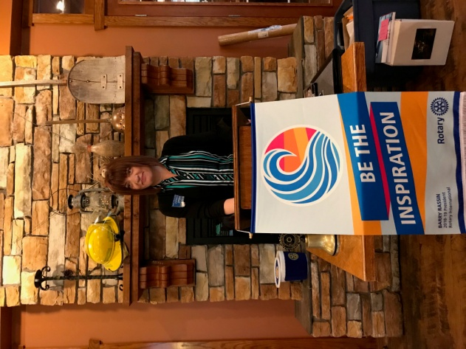

Jan Stromar takes the President's gavel -Officially!
Our Sergeant introduced our new president for the first time. Jan is looking forward to her term and she plans to follow up on the excellent points she made in her installation speech on June 27th.
Jan has the support and good wishes of our entire club as she begins this year!

Summer BBQ at the Tuckers
July 22nd
Mark your calendars for this great event at Jim & Diane Tucker's fabulous property (4811 McGuffie Rd).
It will start at 4:00 pm; steak & salmon BBQ at 6:00. Cost is $25 per person. Everything besides your own beverage will be provided.
This has always been a fun time; please invite former Rotarians, prospective members or friends.
Joy needs numbers by next meeting on July 19th. And she could use help in setting up and cooking.

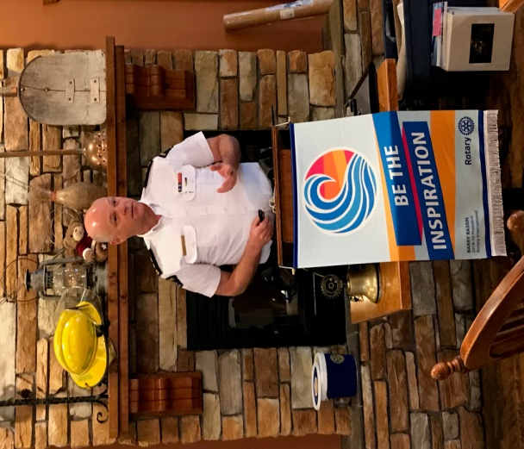

Superintendant Cameron Miller
RCMP Nanaimo

Superintendant Miller commands a force of 155 officers plus 75 civilian staff. This detachment provides professional and completely independent policing services to the City of Nanaimo and the Regional District including Lantzville. The policing priorities for 2018 are:
- Violence in Relationships
- Crime in Community
- Road Safety
- Youth Safety
- Community & Social Programs
Cameron outlined one of the challenges faced by the force here on the island: calls for service have increased from 38,000 in 2015 to 46,700 in 2017, but staffing has remained nearly static.
The Nanaimo detachment has instituted some innovative programs like "Positive Ticketing" where youth who have acted in a good way receive a citation and a reward. It is a way that members of the force can interact with children to develop trust and awareness.
There may be ways that our club could become involved in this or other youth or student activities organized by the force.
Cameron also related several interesting glimpses into security at the G-7, where he was the head of security detail.

"Kind-Of " Rotary Minute
President Jan asked our visiting Rotarian to tell us a bit about their club. Chris Nesmith is a member of SW Yakima River Club. This is one of 3 clubs in Yakima, and they meet for a 'cocktail hour' most weeks. Their club has about 60 members, many are young professionals. The majority are sponsored by their employers who pay the dues (and meeting fees??). These companies and organizations are expected to support all of the fundraising events by providing donations or prizes. Each of the 3 clubs support each others' fundraisers as well.
It was interesting to hear how this club deals with increasing their membership. Thanks Chris!
ROTARY INFO
You can find out where and when all the Clubs in District 5020 meet on the 5020 website:
www.clubrunner.ca/portal/Organization/Meetings.aspx?accountid=50092
Rotary International: http://www.rotary.org
Member’s access: https://www.rotary.org/myrotary/en
District 5020: www.rotary5020.org
Our website: www.clubrunner.ca/Lantzville
Our Facebook Page: www.facebook.com/RotaryClubofLantzville
Check it out – you might be surprised…



Our new Rotary International President for 2018-2019 is Barry Rassin, and he asks Rotarians to inspire change in the world and in each other.

The District 5020 District Governor for 2018-2019 is our friend, Craig Gillis from Campbell River.



