i

July 8th, 2021
‘New Leadership Month’

IN THE LANCE

President Jodi

Installation

Speaker Presentation

CELEBRATIONS

Birthday wishes to Cheryl Prince. Anniversary congratulations to Mike and Janice Walker.

ROTARY CLUB OF LANTZVILLE
MISSION STATEMENT
Joining in fellowship to support growth and development in education and health for those less fortunate in our local & international communities.
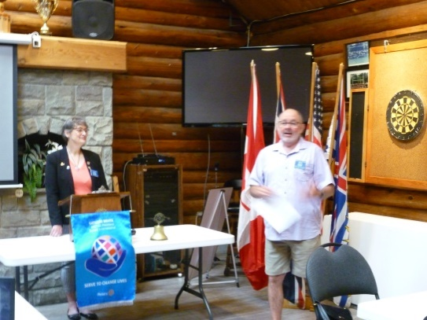

PRESIDENT JODI

With great flair, President Jodi guided us through many firsts – our first 2021-2022 Club meeting, a new banner, flags up, inperson greeter & cashier.

For the Rotary minute, Doug took the opportunity to tell us about his ‘passion’ – Air Cadets. A volunteer organization, the Air Cadet League provides financial support and oversight to Air Cadets. Doug was recently elected as the National VP of the Board of Governors. Today, there are 29,000 air cadets in 4,950 squadrons. Summer training covers a wide range of subjects at local day camps across Canada.

Working with Ryner@ Fairwinds Golf Club, Don and Randyhave organized a Mens’night RCL fundraiser.4 hours each Thursday, over five weeks, under the Rotary banner, we will display sponsor signageand supervise a free, fun putting contest. Once again, we Rotarianswill be seen as ordinary people doing extraordinary things.

Troy was very happy to report the 7-10 Breakfasts will continue through the summer. August 7th will see us host a full sit-down breakfast.

Rachel spoke about the August 21st Fitness in the Park event. More information to follow.

Going forward, if you help with weekly duties (Greeter, Cash, Sgt-At-Arms) &/or committee work, please let President Jodie know.

ROTARY CLUB OF LANTZVILLE
2021-2022 INSTALLATION

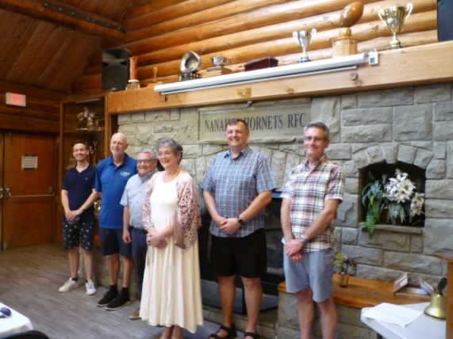

It was an amazing evening- great weather, a lovely buffet dinner and wonderful fellowship!

Many thanks to our MC Jan Stromar, our installation officer, assistant governor Ken Hammer and everyone who stepped up and made the evening such a success.

Outgoing President spoke about challenges and rewards this past year. President Jodi talked about our Rotary goals for the next year.

OFFICERS 2021-2022

President Jodie Williams
President-elect Lee Rowley
Past President Mark Taylor
Secretary Greg Devenish
Treasurer Cor Buys

DIRECTORS

International Service – Lee Rowley
Community Service – Doug Slowski
Administration – Michael Ribicic
Rotary Foundation – Jodie Williams
Membership – Mark Taylor
Public Image – Greg Devenish
Youth Service – Stephen Cochrane

ROTARIAN OF THE YEAR

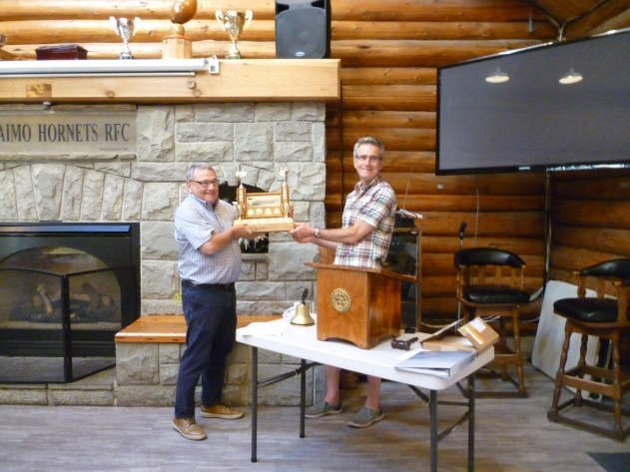

A member since 2018, Greg has always been an upbeat supporter of our club, our projects and our community. In addition to being Club secretary, Greg representsus on the 5 Club public relations committee, has worked many 7-10 breakfasts and regularly asks interesting, thoughtful questions to presenters at Club meetings. Greg is very proud to be a Rotarian and one sees this in everything he does. Congratulations Greg!

RACHEL ROBERTSON
OUR NEWEST PAUL HARRIS FELLOW

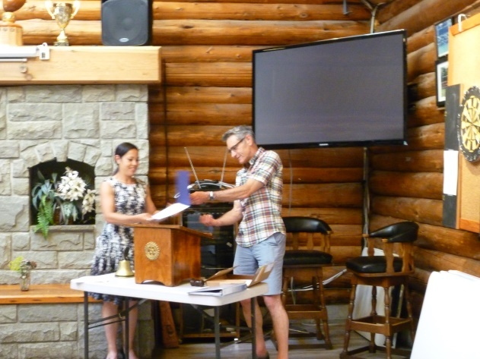

MY ROTARY JOURNEY

Ken Hammer, our Assistant Governor gave a fascinating overview of how, as a Rotarian, his life has been enriched & changed.

As a VIU professor, focusing on leadership & management development, looking to connect with the community, Ken joined Rotary in 2001. He is past president of Nanaimo Daybreak,has served in most Club positions, worked on many Area 4 committees and is a District World Community Service Chair. Each position has brought new experiences with new volunteer service opportunities.

As a youth exchange officer, Ken has hosted students & visited them in their homes. At VIU, he was instrumental in establishing Rotaract and helping them with their projects and partnerships in Ghana.

The World Community Service committee facilitated the formation of a 1st Rotary Club in Sunyani, Ghana – Canada exchanges and several Rotary projects/programs in Ghana.

Ken’s challenge to every Rotarian is to for us to welcome opportunities and enjoy the journey.

ASSISTANT GOVERNOR, AREA 4

GOALS AND ACTION PLAN

- Represent the 5 clubs at the District level & represent the District in Area 4.

- Support the 5 clubs in achieving their goals.

- Support collaboration among the 5 clubs.

- Cultivate a diverse, equitable, & inclusive culture in which people from underrepresented groups have greater opportunities to participate as members and leaders.
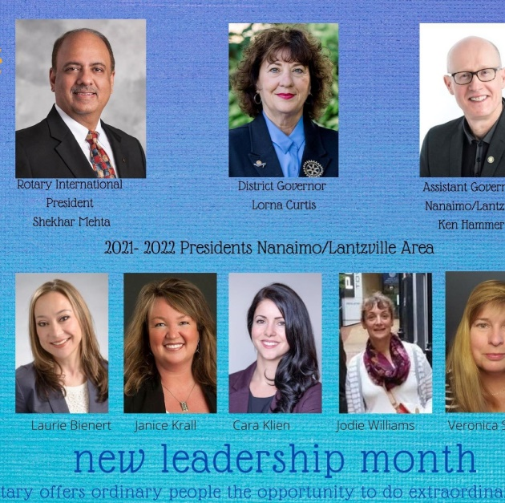

OLD FARMER’S ADVICE

Live simply, love generously, care deeply, speak kindly.

Every path has a few puddles

Good judgement comes from experience and a lot of that comes from bad judgement.

The best sermons are lived not preached.

If you find yourself in a hole the first thing to do is stop digging.

You cannot unsay a cruel word.

Most of the stuff people worry about is never going to happen.

