i

June 10th, June 17th,2021

IN THE LANCE THIS WEEK
President Mark
Speaker Presentation
Bits & Pieces

UPCOMING EVENT

June 25th Club Installation – 5:45 pm
Nanaimo Rugby Club

CELEBRATIONS
Birthday wishes to Jodie; to Randy & Anne, Harry & Maggie, Mike & Janice congratulations on your wedding anniversaries. June 24th marks the 33rd anniversary for our RCL.

HEALTH OF THE CLUB

On a sad note, Brian & Sandy Rodgers are moving to be closer to family in White Rock. They will be dearly missed. On a positive note, Sandy’s health is stable. Brian-Sandy - best wishes!

ROTARY CLUB OF LANTZVILLE
MISSION STATEMENT
Joining in fellowship to support growth and development in education and health for those less fortunate in our local & international communities.
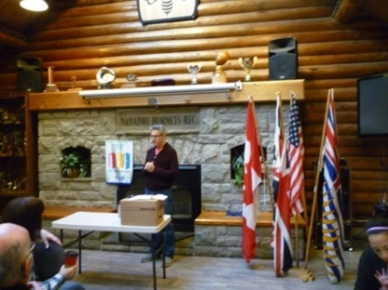
PRESIDENT MARK

After 10 very long months, June 17th marked our socially distanced, first in person RCL meeting.
It was great to see & talk with everyone and a double delight to have Brian McFadden, Rachel & baby Charlotte with us. Special thanks to Lee for facility arrangements, coffee and donots.

For his Rotary minute, Dale spoke about how much he enjoys being part of Rotary, learning about our community and working on service projects locally and worldwide. “It is nice that we can and do step up and help”.

With member input/discussion, it was decided to hold our RCL July 8, 15, 29 meetings at the Rugby Club. July 22nd will be a hybrid zoom/in person meeting. A cost per member for COVID cleaning, coffee, etc. will be addressed in July at the annual past presidents’ club policy review.

Today’s quote “if you’re not failing, you’re not trying.” ~anonymous.Mark, we all thank you ever so much for your work & an amazing year.

PHF PRESENTATION TO LEE
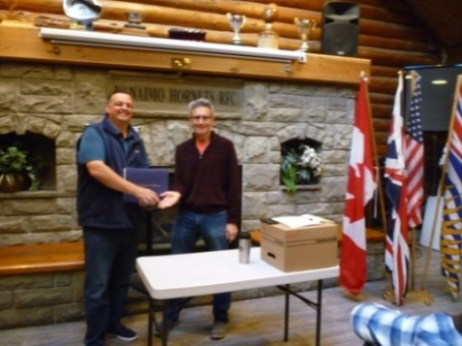
NANAIMO CHAMBER OF COMMERCE

President/CEO Kim Smythe spoke about current Nanaimo Chamber of Commerce challenges and opportunities.

For every community in BC, finding solutions for homelessness is a very serious problem with no one-size fits all answers. A small piece in the puzzle, the Province has announced funding for a 60 bed Navigation centre in Nanaimo. It will provide services for people who require higher levels of support for mental health issues & substance abuse. Also, coming on stream this year are 300 units of new supportive housing throughout the City. Nanaimo is in need of a further 300 units.

On a positive note, the newly approved Downtown Business Improvement Association is in the planning stages for special events (Farmer’s Markets, Christmas Festival) once pandemic restrictions ease. According to Kim, there is cautious optimism within the business community. Nanaimo is often top of mind for affordability and scenery and the 2022 opening of the new hotel will attract larger conventions. New residential construction at the Telus site and other inner City locations will bring more people to the streets and help create opportunities for business. Nanaimo’s excessively high commercial property tax rates are a key concern as is bureaucratic zoning&building permitting requirements.

Recently, Nanaimo Council adopted a new economic development strategy and endorsed the creation of the Nanaimo Prosperity Corporation. Immediate priorities include facilitating the Nanaimo-Vancouver passenger ferry, supporting Health & Housing initiatives, continuing to invest in Port Drive& the waterfront walkway, exploring transportation and logistics opportunities. Through corporate multi-shareholder commitment and wide spread community support this initiative will work to strengthen the region’s economy. Truly, we are in interesting, challenging times.

BITS AND PIECES

Lee is delighted to have soccer, rugby, golf back in his life. FYI, post WWII triggered a golden age for sporting activities. People were eager for entertainment and everywhere massive stadiums were built.

Don & Randy are working on a potential RCL supported golf event this summer at Fairwinds.

Due to building demolition, Nanaimo Loaves and Fishes arelooking for a new home. Please share with Troy any ideas, suggestions.

Delighted to be back in Nanaimo, Don loves our Downtown. For the best burgers ever, do check out Top Notch in the Dorchester Hotel.

Take note - Fitness in the Park with Rachel is on August 21st. A fun, family Rotary event for everyone.

Thanks to the PR committee Rotary Nanaimo is a one page monthly presentation in the Nanaimo News Bulletin. Greg is our RCL editor.

CHARLOTTE KEEPS US SMILING

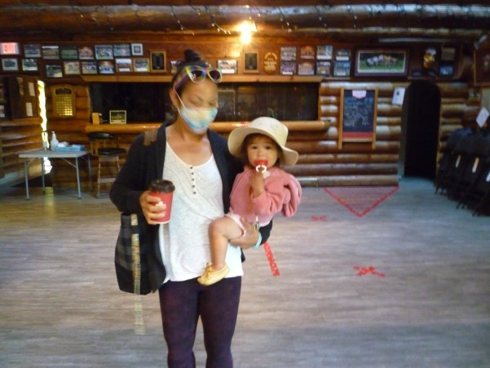

FAMOUS ROTARIANS

- ‘Colonel’ Hartland Saunders

- Dr. Charles H. Mayo

- Charles R. Walgreen

- J.C. Penney

- Raymond F. Firestone

- John F. Kennedy

- Sir Winston Churchill

- Walt Disney

- Thomas Edison

- Sir Edmund Hillary

- Pope Francis

INSPIRATION

Those who overcome
great challenges will
be changed, and often
in unexpected ways.
For our struggles enter
our lives as
unwelcome guests, but
they bring valuable
gifts. And once the
pain subsides, the
gifts remain. These
gifts are life’s true
treasures, bought at
great price, but cannot
be acquired in any
other way.

Steve Goodier
Author of:
One Minute Can Change a Life

About District 5020
We represent Rotarians on Vancouver Island, B.C. and Western Washington from Pierce County south to Woodland including the Olympic Peninsula. District 5020 is one of the largest districts in the world. There are 91 clubs (37 in Canada and 54 in USA) and almost 4700 Rotarians.

The 4-way Test

Consists of 4 short questions, 24 words, which can make a difference in our lives. It reads:
Is it the TRUTH?

Is it FAIR to all concerned?

Will it build GOODWILL and BETTER FRIENDSHIPS?

Will it be BENEFICIAL to ALL concerned?
The 4-Way Test encourages us to examine our patterns of choosing, evaluating and acting. It is an objective guide which we can use in deciding how best to respond in a given situation.
THOUGHTS FOR TODAY

- You cannot unsay a cruel word.

- Live simply, love generously, care deeply, speak kindly.

- The best sermons are lived not preached.

