i

May 27th, June 3rd2021

IN THE LANCE WEEK

Meeting Notes
Speaker Presentations
Doug Pearson

UPCOMING EVENTS

June 10th - Nanaimo Chamber of Commerce
Kim Smythe, President & CEO

25th Club Installation

DOUG PEARSON

Sadly, we have lost a long-time Rotary champion.

Doug was an honorary RCL member and good supporter of our club. For those who choose to honour Doug, a memorial donation to the Nanaimo & District Hospital Foundation or the (new) Doug Pearson Rotary Youth Leadership Scholarship would be particularly meaningful.

‘Friends are those rare people who ask how we are and then wait for the answer.’
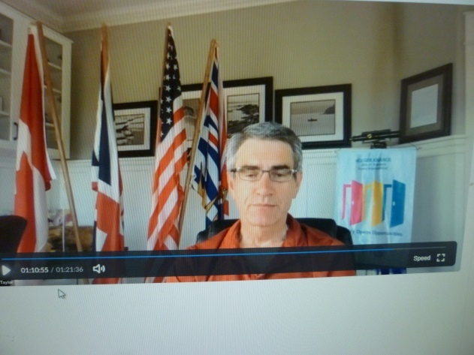

MEETING NOTES

Opening remarks, President Mark welcomed every to the weekly meeting of the RCL, which is located in the traditional territory of the Snaw-naw-as First Nation.

For his Rotary minute, Stephen spoke about the Rotary End Polio campaign. Over the past 35 years, including matching funds, Rotary has raised 2 billion dollars in the fight to end polio. In 2007, the Gates Foundation partnered with Rotary in this fight. Today, every $ raised by Rotary is matched by 2 additional Gates Foundation dollars.

Last week, Michael told us the history of the FOUR-Way Test. It was created in 1932 by Rotarian Herbert Taylor when he was asked to take charge of a company facing bankruptcy. Written as a guide for employees, the survival of the company is credited to this philosophy. Adopted by Rotary in 1943, The Four-Way Test has been translated into more than a hundred languages.

Assuming the provincial health plan is on track, we are planning for an in person Club meeting at the Nanaimo Rugby Club on June 17th. Hurrah!

Thank-you’s from Mark to the 7-10 crew; speaker Don T.; today’s duties – Neil, Randy & Stephen.

“Success is a lousy teacher. It seduces smart people into thinking they cannot lose.” ~ Bill Gates
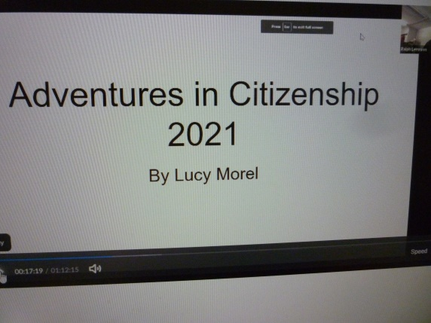
SPEAKER PRESENTATION

Sponsored by the Rotary Club of Ottawa, Adventure in Citizenship (AIC) is an annual event providing a unique opportunity for young Canadians to come together to gain a better understanding of our country.

Speakers for the 2021 four day ‘virtual’ event included the Swiss Ambassador to Canada, former PMs’ Joe Clarke & Paul Martin & Senator Joseph Day, the House of Commons Speaker, senior advisors to the office of the PM & the Minister of Innovation, Science & Economic Development, a House of Commons page, a conflict resolution specialist, a member of the Canadian Armed Forces and two members from the First Nation community. The speakers talked about their work.

Lucy was one of 100 + AIC participants. In addition to the presentations, there were games, debates & social events. Lucy shared her favourite speaker quote ‘peace must be in the heart, the home and the city’ and gave us highlights:
-To resolve conflict, you must listen, think and lastly act. It’s okay to be mad or sad – do not let feeling’s consume you.
- Do not take criticism personally, be positive, tell people what you are all about and how you are going to make things better.
-Speake to people in language people understand, make it engaging, make it simple, something that keeps people’s attention.
-“I really do believe this generation will be the one that puts racism to bed.”
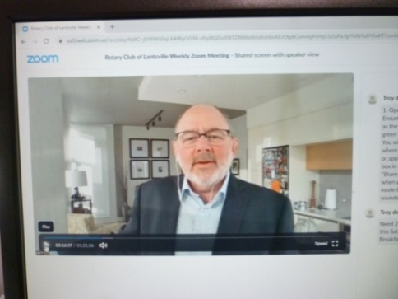

DON TAMELIN

With great enthusiasm and pride, Don gave us an overview of his 16 year employer, Coastal Community Credit Union (CCCU). From its’ opening in Nanaimo 75 years ago, today CCCU has 30+ locations and 600+ employees serving 120,000 members and clients and close to 9,000 community organizations and businesses. With 3 billion in assets under management, CCCU is the 9th largest credit union in Canada.

Having a focus on member/client, community and employee experiences, the organization is ‘Great Place to Work’ certified. This past year, CCCU donated over $ 500,000 to Island communities through grants, education awards and sponsorships & 7,600 volunteer hours.

Don, a chartered financial planner, is a member of the CCCU senior leadership team and leads the Private Wealth Group. This year on their website, they launched new digital tools - ‘Financial Wellness’ & ‘Retire Ready’. Already, Retire Ready has a loyal following and Don is very enthusiastic about showcasing the product to a larger audience. Of note, educational events are recorded and can be viewed on demand on the PWG website.

Don described March 2020 as the worst 30 days in his life – crashing markets, uncertainty, following
BC Financial Service regulations. Within 2 weeks, 1/3 of the employees were working from home. Today, Don and many employees continue to work from home. On the positive side, in recent CCCU surveys customer satisfaction is very high.
A special note from Don Dempson…

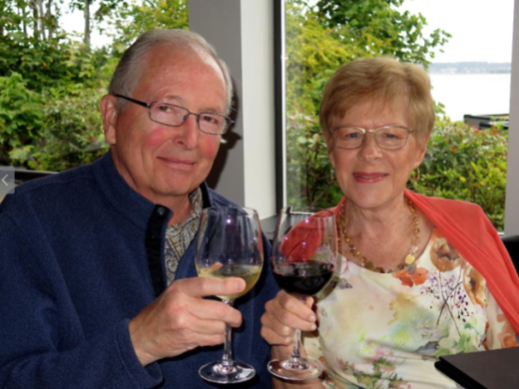
Doug Pearson

On May 29th, Rotary lost a special friend. Doug Pearson was a mainstay in the Nanoose Bay community and an over-the-top supporter of events, programs, community and people.

Doug’s almost sheepish, low-key style worked as his camouflage, while his focused, energetic and carefully planned actions paved the way for his unbounded enthusiasm. This man had an excitement for life, learning, giving and making things happen. He was a wealth of knowledge and had time for everyone. His passion for family, friends and Rotary as well as his never-ending hunger to learn and talk about the Romans, science, technology and government was legendary.

Almost 10 years ago, Doug had successfully come through a tough bout of cancer and was living as he always did – flat out. Like a whirling dervish he was always on the go and getting involved wherever he could so his skills, connections, experience and insight could ‘make a difference’ for those in his ever-expanding circle.

Recently though, a recurrence of his cancer flared and after an intense bout of chemo he was looking forward to more days being out and about. Unfortunately, complications resulted that last week culminated with his urgent rush to hospital. A fighter to the end, Doug put on a brave face and only saw the positive side and the day when he’d be back playing chess, controlling a bridge hand, sharing a wine with his tasting group, zooming with the different Rotary clubs, offering suggestions as to how Rotary can be more involved and effective and how we all should internalize the mantra “Service Above Self”. It’s what he believed in and what he practiced every day.

Doug was a committed Rotary supporter, and to some was called Mr. Rotary. He wasahonourary member of a number of clubs and consummate ambassador. Not one to miss a meeting, he went out of his way to promote our speakers, programs, special events and world-wide contribution to making this a better place live. He talked the talk and walked the walk. He will be sorely missed by all.

The final month of every Rotary year is Fellowship Month. This is a fitting designation since fellowship is particularly to the forefront with changeovers being very much the priority in June. Fellowship is one of the five core values of Rotary, the others being service, diversity, integrity and leadership. Fellowship is a fun way to make friends around the world, explore a hobby or profession, and enhance your Rotary experience. Fellowships are open to Rotarians, family members, program participants and alumni. There is an incredible diversity within the 75+ officially recognized Rotary fellowships. Groups are formed around one’s interest in meeting and sharing with others their hobby, sport, profession, musical taste, travel, etc. More information can be found at the Rotary International website.

