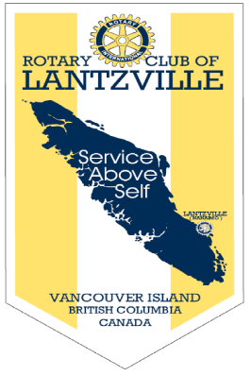

“Rotary: Be the Inspiration”

June 6th, 2019
Rotary Fellowships Month.

IN THE LANCE THIS WEEK

D-Day

Youth Protection Awareness Training

Lots of Rotary Information

FUTURE EVENTS

June 13th - Rotary Adventure in Citizenship
Participant, Grayson Mitchell

June 20th – Installation of 2019-2020
Club President, Directors
Nanaimo Golf Club, 6:00 pm
No Breakfast meeting

June 22nd 7-10 Breakfast

June 27th - Dave Hammond
100 years of Rotary in Nanaimo

July 28th - Club Social, BBQ @ Tuckers’

DUTY ROSTER –June 13th

Greeters: Werezak/Rowley Cash: Walker

Sgt-At-Arms: Lemmon Invocation: Tamelin
Introductions: Ribicic Foundation: Williams
Rotary Minute: Lobay
VISITORS AND GUESTS

Joining us for fellowship and food, Bonnie Murrell, Rotary Daybreak, Ashleigh Martinflatt, VIU Foundation & Hans Bischoff, Planners Financial.

ROTARY CLUB OF LANTZVILLE
MISSION STATEMENT
Joining in fellowship to support growth and development in education and health for those less fortunate in our local and international communities.

President Jan…
For sure, will miss her presidential duties. Very much looking forward to ongoing Rotary work and activities.

Happy Anniversary – June 9th
Bonnie & Barry Sparkes

No Birthdays

FOUNDATION
$ 107 contributed to the Rotary Foundation. Many thanks! Lucky holder of the draw for
$ 16.00 was Harry Helfrich
Current contributions directed to the PolioPlus Fund unless you tell Barry otherwise.

ROTARY MINUTE

Most appropriately, Brian McFadden spoke about the 75th Anniversary of D-Day and the Battle of Normandy. On June 6th, 1944, over 14,000 mostly very young Canadian soldiers came ashore at Juno Beach in occupied France. It was to be a very long day. D-Day was the opening chapter of the Battle of Normandy. The eventual Allied success in the battle was a pivotal step in the liberation of Western Europe and the end of the war. The Battle of Normandy saw an estimated 425,000 Allied & German troops killed, wounded or missing.

SERGEANT AT ARMS

Doug Slowski enjoyed his early morning duties.
Good picture of Greg in Nanaimo Bulletin in his role as a librarian at the Nanaimo Military Museum. Dave E. is looking forward to his upcoming fishing adventure. Coming soon is a roster call for the June 22nd 7-10 breakfast. With no internet for a couple of days, Rachel’s downtime is not one that most of us welcome. Mark’s very pleased that his son chose UBC for his computer engineering degree. Jamal thinks he’s finished with redoing his front yard. Best we check with Liz for confirmation. Jan’s not sure about a whole month without Tom. He is doing renovations on their Croatia home. Joy reported all is well with Anne & Randy. Doug is off to Newfoundland for an air cadet convention.

Mark did not draw the joker. Next week $ 260 in the pot.

COMMUNITY SERVICE

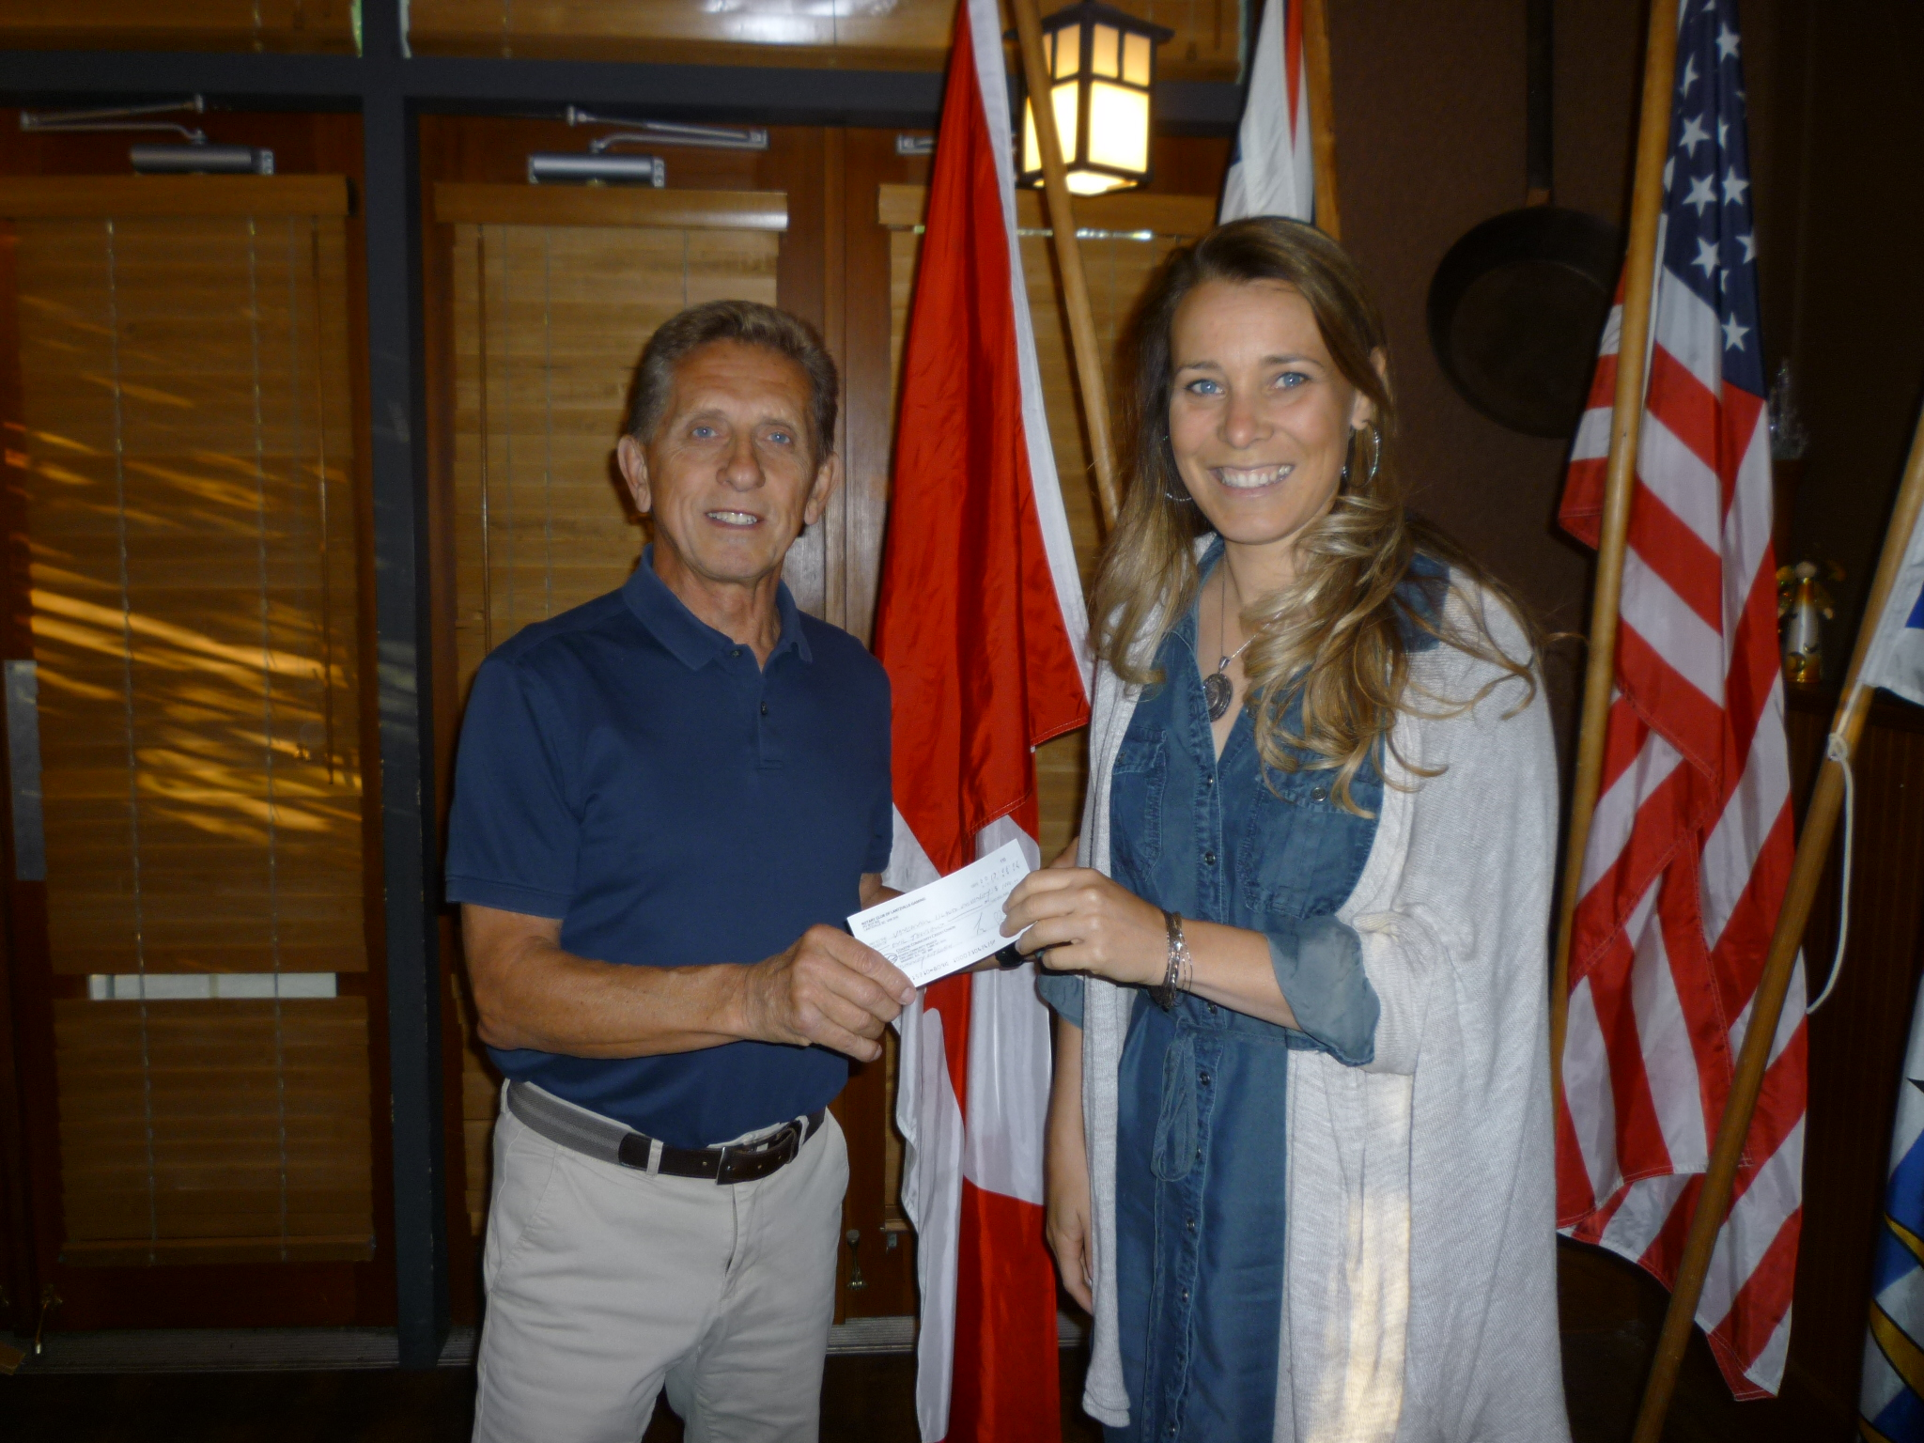

Cheque presentation by Dale to Ashleigh Martinflatt, VIU coordinator for the Centre for Community Outreach and Care. Established in 2013, the Centre’s focus is to provide meaningful learning opportunities for students committed to working with children, youth and families.

SATELITE CLUBS
A NEWER ROTARY CLUB OPTION

Most Rotarians are aware that Rotary’s membership numbers have been relatively stagnant for some time now. We have been at 1.2 Million members for more than 10 years with about as many Rotarians leaving Rotary as are joining. Of the 170,000 members that left Rotary last year 31% felt that Rotary was too expensive or took too much time, 21% were unhappy with the club environment and 15% had unmet expectations. This suggest that there is a large portion of the population that is interested in Rotary, but want to experience it in a different way than is currently offered. Now we can definitely work to make our club experiences more inclusive and welcoming, but perhaps another approach is needed in areas where the current club options still don’t reflect all of the community’s needs. This is where a Satellite Club can help us provide the opportunity for Rotary to many more people. By creating a satellite, a club allows members to meet at a different time and place from the rest of the club. Like all Rotary clubs, satellite clubs hold regular meetings, have bylaws and a board, and get involved in community service projects. A local Rotary club sponsors the club and provides advice and support. Satellite club members are Rotarians. Officially, they are members of the sponsor club. Some clubs have used the Satellite Club model to expand their club in ways that didn’t seem possible. Every month, our District 5020 gets leads for potential Rotarians that can’t find a club that meets their schedule or lifestyle. Satellite clubs could fill some of this void.

FOOD FOR THOUGHT
- I have learned that it is not what I have in life, but whom I have in life that matters most.

- Life is too short to waste time hating anyone.

- Frame every so-called disaster with these words “ in five years, will this matter?”



Bonnie Murrell

A big thank-you to Bonnie for leading us through the District Youth Protection Awareness training presentation. The 30 minute online training is meant to better prepare all of us for working with youth in our many programs. With some exceptions, the training is not mandatory; however District 5020 has asked all active Rotarian members to participate. Following the on-line training, members received a “true or false” exam that tested ones understanding of the issues. For 2019-2020, with member participation, our club has met District 5020 certification requirements for Youth Protection.

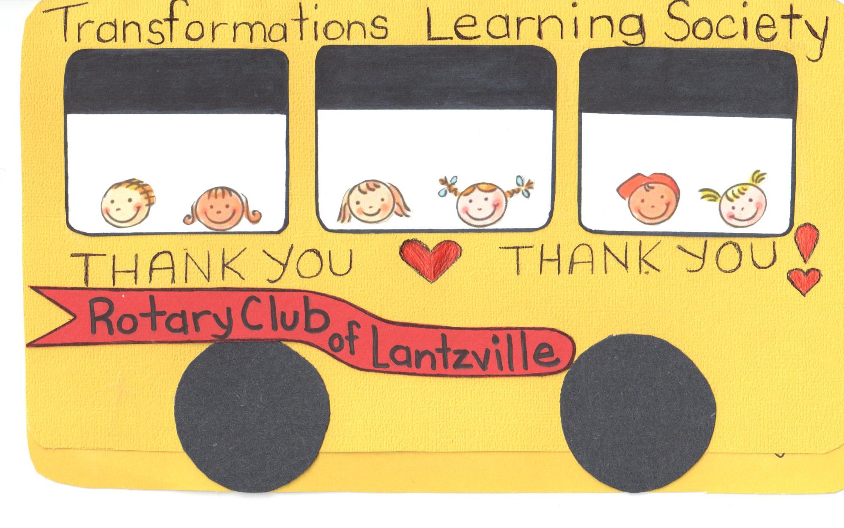

Club Notes

This week, we received thank-you notes from Liz Holme, Nanoose Community Services, Blain Wilkins, ROAR and the students at Transformations Learning Society.

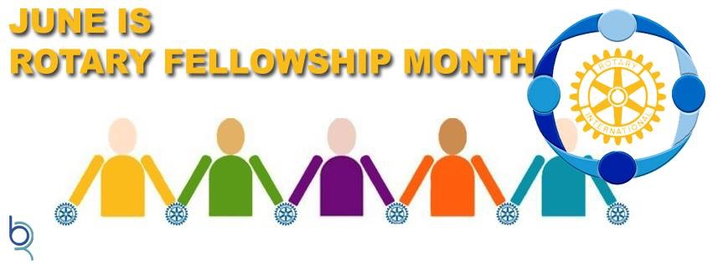

The final month of every Rotary year is Fellowship Month. This is a fitting designation since fellowship is particularly to the forefront with changeovers being very much the priority in June. Fellowship is one of the five core values of Rotary, the others being service, diversity, integrity and leadership. Fellowship is a fun way to make friends around the world, explore a hobby or profession, and enhance your Rotary experience. Fellowships are open to Rotarians, family members, program participants and alumni. There is an incredible diversity within the 75+ officially recognized Rotary fellowships. Groups are formed around one’s interest in meeting and sharing with others their hobby, sport, profession, musical taste, travel, etc. More information can be found at the Rotary International website.

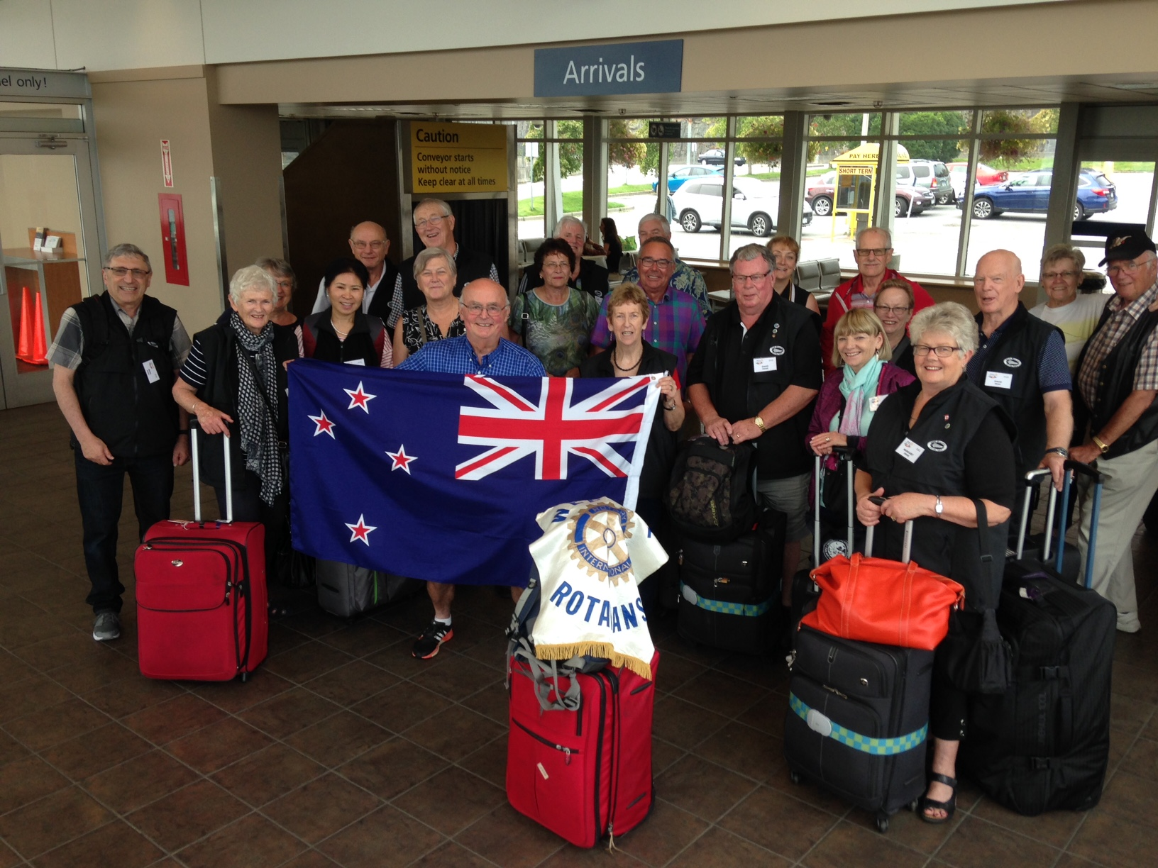

September 2018
The Kiwis’ arrival in Nanaimo

