March 11th, 2021
Water and Sanitation
Service Month

IN THE LANCE THIS WEEK

Club Meeting Notes
Nanaimo Hospital Foundation, CEO
Janice Perrino

FUTURE EVENTS

March 18th Club Information Meeting

25th Lantzville Boys & Girls Club
Jocelyn Dickson

VISITORS AND GUESTS

Rotarians, Doug Pearson – Nanaimo North, Linda Murray – Downtown Victoria; RCL honorary member – Barry Sparkes; Janice Perrino – CEO, Nanaimo Hospital Foundation.

CELEBRATIONS

Birthday wishes to Joy and Rachel; anniversary congratulations to William & Joani.

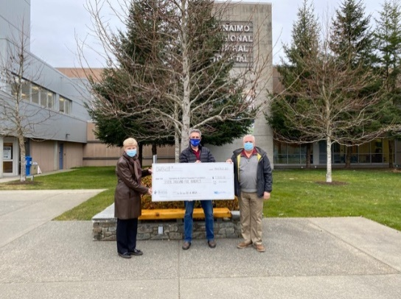
$ 7,500

Our Club Contribution for Equipment

AT NEW NRGH ICU

Pictured above, President Mark and Doug Slowski presenting ‘big’ cheque to Janice Perrino.

February 1st was the start date for construction of the new $ 42 Million ICU facility. In their most ambitious project ever, the Nanaimo Hospital Foundation accepted the challenge to raise $ 5 M for the equipment. Today, @ $ 4.5 million they are very close. A big thank you to Janice and the Foundation for all your hard work.

Janice talked about the need to upgrade NRGH in several areas. The current ICU is 50 years old, cramped and inadequate. The new build will double ICU bed capacity. The old ICU will be converted to hospital beds. Moving forward, NRGH needs more surgical suites, expansion of the cancer treatment clinic, a cardiac Cath lab, tertiary care capacity & replacement of the patient tower. Today, NRGH is the major care centre for more than 400,000 residents north of the Malahat.

Janice expressed high praise for the excellent care delivered by NRGH medical staff.

“What would life be if we had no courage to attempt anything?” - Vincent Van Gogh

Meeting Notes/ Club Business

Nanaimo North president, Glynnis Hayes joined our meeting, spoke about the March 27th Golf Ball drop. Tickets are $ 5 each & are available online at their club website.

As presented last week, general fund grants to the Vancouver Island Children’s Book Festival –
$ 1,500 and ‘Help Lesotho’ - $ 3,000 for educational supplies were approved.

President Mark facilitated a discussion on alternatives for distribution of funds the Club will receive from dissolution of the Harbour City Bingo Society.

Thank-you to Dave Lobay, inspiration; Doug, introductions; Ralph, seargeant @ arms!

Did you know…District 5020 has 258 PolioPlus Society members? Members receive a PolioPlus Society pin and have committed to contribute a minimum of $ 100 USD per year until the World Health Organization certifies that polio has been fully eradicated.

