

“Rotary: Making a Difference”

March 15^{h}, 2018
Water and Sanitation Month

IN THE LANCE THIS WEEK

More on our Golf Tournament

FUTURE EVENTS
Mar 21st – Rotary Fellowship at Simon Holt
Mar 22nd – No weekly meeting
Mar 24th – Breakfast at the 7-10 Club
Mar 29th – No weekly meeting.
Apr 5th – Mike Hooper, Nanaimo Airport
Apr 9th – BBQing with VIU Community Services
Apr 9th – Monthly Board Meeting (5PM)

VISITING ROTARIANS
Nice to see a couple of Club members who had been away for a while back in town…

VISITORS and GUESTS
No visitors this week. ☹ Shawn had it easy…

BIRTHDAYS & ANNIVERSARIES
 |  | DUTY ROSTER
DATE | GREETERS |  | CASH | Sgt-At-Arms | Invocation | INTRO | Foundation | Rotary  Minute
Mar 22nd | NO MEETING
Mar 29th | NO MEETING
Apr 5th | Litchfield & Sinn |  | Elgie | Lemmon | White | Litchfield | Sparkes | Werezak
If you cannot make your duty, it is your responsibility to find a replacement.

HEALTH of the CLUB
As far as we know, we’re doing okay…

ROTARY CLUB OF LANTZVILLE
MISSION STATEMENT
Joining in fellowship to support growth and development in education and health for those less fortunate in our local and international communities.

Presidential Observations
PE Jan went to PETS (Presidents-Elect Training Seminar) in Tacoma a couple of week ago … and came back INSPIRED! “It was really good!” Good, motivating speakers. Good training sessions. Easy to meet and talk with other Rotarians. PEs from about 600 other clubs in 12 other Districts … including lots of women and young people.

FOUNDATION
$325 contributed to the Rotary Foundation this week. THANK-YOU!

Sergeant-at-Arms
Dave E was the Sgt this AM – and quite critical of a missing greeter (a.k.a. Barry). Don T happy to be healthier … and chairing a grumpy old men’s hockey tournament. Mark disgruntled with Telus. David L enjoyed the beer in Thailand. Tessa is working in her garden. Don C in shorts – must be warm in Nanoose. Harry pointed out Don’s pale legs. ☺ Doug attended a “Western Front” Conference in Victoria – about WW1. Joy reminisced about being in the real estate industry some years ago. Shawn back from a problem-free visit to Myanmar – a beautiful country. Randy won the draw!

Breakfast at the 7-10 Club
Thanks for your support!
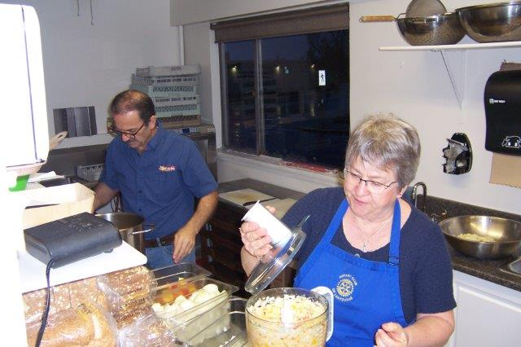
Early morning preparations…
Next breakfast – Saturday, March 24th.

News, Updates & Reminders
- FELLOWSHIP – join us at Simon Holt’s for some good Rotary fellowship, Wednesday, March 21st, from 5:30PM…It’s on Applecross, across from CostCo.


- Our Annual Easter Egg Hunt – will take place, behind Seaview School in Lantzville on Sunday, April 1st. [No fooling!] Mark your calendars! Volunteers at noon. The “HUNT” starts at 1PM.


After considerable discussion, the Board is proposing a trial for reduced weekly meetings over the next 6 months (starting in March):
  - March, April and May: meetings 1st, 2nd and 3rd Thursdays, one of which will be a golf planning. No meetings on the 4th and 5th Thursdays.
  - June, July and August: regular weekly meetings the 1st and 3rd Thursdays only.
What do you think?
- BBQ – we will be helping the VIU Community Services program with our BBQ at Sanala on April 9th. We’ll need a few ‘cooks’.

2018 Golf Tournament (our 22nd)
DATE. Friday, June 1st.
BENEFICIARY. Vancouver Island Compassion Dogs will be the major beneficiary [25% of net proceeds, up to $5,000] of our tournament this year.
https://vicompassiondogs.ca/
It’s never too late to start thinking about (and doing something about) prizes and sponsors, after all, it is our biggest [only] fundraising event of the year.
It takes “work” and a commitment from all Club members to make the tournament successful!

Rotary Minute
- Why did you join Rotary?
- Why have you stayed in Rotary?
- How have you benefited from being a Rotarian?

Community Service
NOTICE OF MOTION – that we donate $1,000 from Gaming Funds to the Boys & Girls Club of Central Vancouver Island for their Youth Early Prevention (YEP) program. [Carried over from March 8th.]

Golf Tournament Update
- Jodie – will be coordinating volunteers. If you can help on the day, let her know. Thanks.
- Brian R confirmed that Fairwinds confirmed that they will serve the same supper for the same price as last year.
- Sponsorship and Participation forms have been updated, will be on the website, and sent to all members – soon…
- Sponsors (the major source of funds) – Randy will be coordinating, but history shows that sponsors are much more responsive to “personal” requests … if you ask, they are more inclined to say “yes”…
- Prizes, for golfing prowess and for the Silent Auction – Dave Elgie will be coordinating, but it is an all-member effort to solicit prizes. “Good” prizes, please, not give-aways such as ball caps and knick-knacks. $25 gift cards are great.
- A “Mark Your Calendar” e-mail has been sent to 170 previous participants (which includes several sponsors)…
- Less than 3 months to go!!!


Rotaractors are young, gifted, and well-prepared to help lead Rotary into the 21st century. This year marks the 50th anniversary of Rotaract. For World Rotaract Week 12-18 March, expand your knowledge of the program by reading 7 things you did not know about Rotaract, and enjoy a stroll back through time with Rotaract: 50 years of changing lives.
Those of us who attended the Rotaract Club of Nanaimo’s presentation last Monday will certainly attest to the opening comment – as two energetic, enthusiastic young ladies talked about Rotaract.

ROTARY INFO
You can find out where and when all the Clubs in District 5020 meet on the 5020 website:
www.clubrunner.ca/portal/Organization/Meetings.aspx?accountid=50092
Rotary International: http://www.rotary.org
Member’s access: https://www.rotary.org/myrotary/en
District 5020: www.rotary5020.org
Our website: www.clubrunner.ca/Lantzville
Our Facebook Page: www.facebook.com/RotaryClubofLantzville
Check it out – you might be surprised…

Churchillism No 4
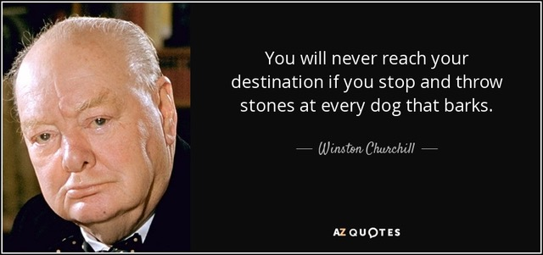

It only takes a little effort to bring a smile to someone…
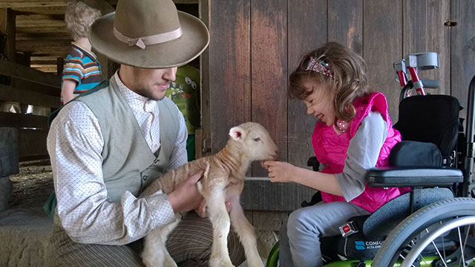

A distraught senior citizen phoned her doctor's office. "Is it true," she wanted to know, "that the medication you prescribed has to be taken for the rest of my life?"
"'Yes, I'm afraid so,"' the doctor told her.
There was a moment of silence before the senior lady replied, "I'm wondering, then, just how serious is my condition because this prescription is marked 'NO REPEATS'

An older gentleman was on the operating table awaiting surgery and he insisted that his son, a renowned surgeon, perform the operation.
As he was about to get the anaesthesia, he asked to speak to his son. "Yes, Dad, what is it?"
"Don't be nervous, son; do your best, and just remember, if it doesn't go well, if something happens to me, your mother is going to come and live with you and your wife...."

