March 25th, 2021
Water and Sanitation
Service Month

IN THE LANCE THIS WEEK

Club Meeting Notes
Rotary Minute
Speaker Presentation

FUTURE EVENTS

April 1st Luci Morel
RYLA North West

VISITORS AND GUESTS

Jocelyn Dickson, program leader
Lantzville Boys & Girls Club

ROTARY CLUB OF LANTZVILLE
MISSION STATEMENT

Joining in fellowship to support growth and development in education and health for those less fortunate in our local and international communities.
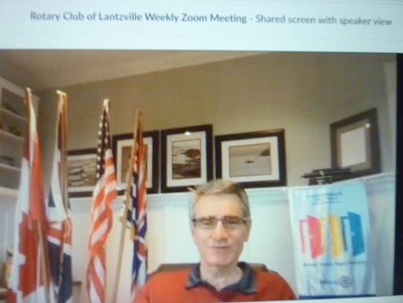
CLUB MEETING NOTES

President Mark received 19 responses to the ‘Club Member Meeting Survey’. Responses will help shape our go-forward plan for in person meetings.

April 15th is the due date for new applications for community service funds.

Members approved $2,000 from general funds to support the children and family outreach program at VIU.

“Life is change. Growth is optional. Choose wisely.” ~ Karen Kaiser Clarke

ROTARY MINUTE

Randy gave a very thoughtful presentation about the value of ‘Brands’. Organizations with strong brands can be more successful.

The Rotary wheel is one of the most recognized emblems in the world and one of the most important assets that Rotary possesses. When we talk about the Rotary brand, we’re talking about the qualities and goals that unite all Rotary clubs. Our brand reflects our identity, our vision, and our essence, as well as our values. People’s perception of Rotary comes from their experiences with our clubs and programs, along with what they see us doing or hear us saying as Rotarians. It is up to us as individual members to remember the importance of the Rotary brand and to ensure that nothing we do ever impairs or diminishes its value. That’s actually a pretty big and important responsibility!

(BGCCVI)

Jocelyn Dickson presented an overview of the Boys and Girls Club organization and their programs. BGCCVI is a non-profit society providing childcare, daycare, summer camps, teen and youth programs, family and parenting programs in several communities.

The Lantzville club offers before and after school childcare, full day-care during school breaks, drop in pre-school child care and summer programs.

Club leaders are currently working on updating and improving their outdoor space. They want to install a waterproof shade sail; to improve the retaining wall; to paint a mural on the cement walls; to build & install garden beds and to purchase new balls and equipment. Estimated cost for these improvements is $ 5,000.

Following her presentation, Jocelyn fielded several questions about Lantzville boys and girls club and the work they do.

INSPIRATION

“Your living is determined not so much by what life brings to you as by the attitude you bring to life; not so much by what happens to you as by the way your mind looks at what happens.”
~Khalil Gibran

REMEMBER WHEN…

Curry was a surname. All chips were plain.
Cubed sugar was posh.
Cooking outside was called camping.
Prunes were medicinal and stewed.
Healthy food consisted of anything edible!

