March 4th, 2021
Water and Sanitation
Service Month

IN THE LANCE THIS WEEK

Club Meeting Notes
VIU – Ashleigh Martinflatt
Rotary Minute

FUTURE EVENTS

March 11th CM – Nanaimo Hospital Foundation
Janice Perrino

18th Club Information Meeting

VISITORS AND GUESTS

VIU professor & coordinator of the Centre of Community Outreach and Care (CCOC) Ashleigh Martinflatt joined us.
.

CELEBRATIONS

Happy Birthday to Sheila and William.

CLUB BUSINESS

President Mark introduced a notice of motion, that we consider how we want to distribute funds from the dissolution of Harbour City Bingo Society. Mark followed up with an email to RCL members detailing our options.

From Dale, Community Service, notice of motion that we fund the Vancouver Island Children’s Book festival with $ 1,500 from general funds.

From Tessa, International Service, notice of motion that we send $ 3,000 to ‘Help Lesotho’ for the purchase of educational supplies at a primary school in Lesotho.

Help wanted – not kidding! For 2021-2022, we need to fill our International Service and Youth Service director positions.

For the Saturday 7-10 breakfast, thank-you to everyone who came forward.

FOUNDATION UPDATE:

$ 237,378 (US) All Time Club Giving (WOW!)
18 Paul Harris Fellows
2 Paul Harris Benefactors

Annually, we’d love to see everyone contribute at least $ 100 US.

FYI, until March 31st, US $ 25 contributions up to US $ 100 earn bonus Paul Harris points.

ASHLEIGH MARTINFLATT - CCOC

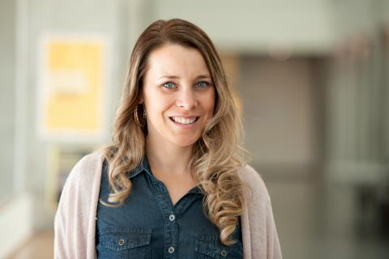
In 2013, VIU’s Child and Youth Care Program developed the CCOC to provide community programs for at-risk and marginalized children and youth and their families in Nanaimo, while at the same time offering enriched practical and experiential learning opportunities for VIU students.

Pre-COVID every year, the CCOC produced activities and resources for over 1,200 marginalized children, youth & parents/caregivers. Activities included barbecues, Friday evening socials, the ‘I have a Dream’ program, mentorships and providing healthy food and supplies.

And today, the need is perhaps even greater. With no outside activities and limited relational connections, increasing emotional trauma is very evident. Food and healthy food drop-offs still happen. A current focus, through zoom, is giving aging out students’ employability skills and help in dealing with food insecurity and homelessness. Post COVID planning is a work in progress with everyone looking for new and improved delivery of the CCOC services.

From President Mark-“thank you Ashleigh for all you (and the students) do in our community to help improve the lives of those who need help and support, and making sure they’re not falling through the cracks. Great to hear some past ‘clients’ are now students in the program – your team has obviously instilled a strong sense of community and giving back in those you have helped and are helping.”

ROTARY MINUTE

In Lee’s busy work world, his company is doing increasinglymore environmental work. With that in mind, Lee researched what Rotary is doing with our newest avenue of service – supporting the environment. Break this down into smaller pieces and we find Rotarians, with the help of the Rotary Foundation are already doing a lot.

In a list, compiled in a book called “Drawdown”, projects are ranked according to their impact on the environment. Family planning, drawdown ranking (7) is targeted by Rotary Clubs through training and counseling and access to contraception. Girls’ education (6), with a huge impact on population growth, is supported by Rotary Clubs in several third world countries. Rotary clubs have supported projects to reduce food waste (3) resulting in better uses for energy, land and fertilizer and less methane in landfills. Regenerative agriculture (11) increases organic matter in the soil and reduces the need for fertilizer. In Taiwan, Rotary trained workers with organic farming techniques. The loss of tropical forests (5) accounts for up to 19 percent of greenhouse gas emissions caused by humans. Several Rotary clubs partnered with a nonprofit in a reforestation project in Madagascar.

More information, about Rotarians work on environmental projects can be found at the Environmental Sustainability Rotarian Action Group website.

INSPIRATION

Steve Job’s once said…“Your work is going to fill a large part of your life, and the only way to be truly satisfied is to do what you believe is great work. And the only way to do great work is to love what you do. If you haven’t found it yet, keep looking. Don’t settle. As with all matters of the heart you will know when you find it.”

Cor – Thanks for sharing!

SERGEANT @ ARMS, DAVID LOBAY

Recently, Dave spoke with RCL past president Don White who sent us his greetings.

What’s up…

-Don T., loving his new Victoria home and the long walks in Oak Bay.

-Neil is currently working on the Patulla bridge replacement. As to golf, Neil has learned that Lee is a much more experience player. Sadly, for 2021, our RCL golf tournament is a no go.

-Doug is having great fun with his woodworking.

-Soon, Tessa will need more space for her boat cushion re-upholstery work.

-Dale’s April 6th meeting with the surgeon will determine his next ‘steps’.

-Janice loves the market. Prices are up 20%.

ROTARY WATER AND SANITATION
Clean water is a basic human right that many are often denied. There are 2.5 billion people in the world that lack access to improved sanitation and 748 million people that don’t have clean drinking water. Nearly 1400 children die each day from diseases caused by lack of sanitation and unsafe water. When people have access to clean water, they live healthier and more productive lives. Worldwide, Rotarians are working with partners to address community water and sanitation needs.

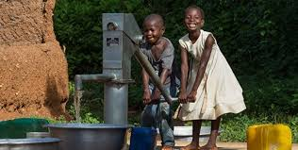

March 22nd is World Water Day

LIFE LESSONS

When it comes to chocolate, resistance is futile.

Forgive everyone everything. Believe in miracles.

Growing old beats the alternative – dying young.

The best is yet to come. Yield.

If we all threw our problems in a pile and saw everyone else’s, we’d grab ours back.

Friends are the family that we choose for ourselves.

