“Rotary: Making a Difference”

May 10th, 2018
Youth Services Month

IN THE LANCE THIS WEEK

Lantzville Fire Department

FUTURE EVENTS
May 12th – AM – Moving dirt at Sanala
May 17th – Brent Barootes, Sponsorships?
May 22nd – PM – Moving sod at Sanala
May 23rd – PM – Fellowship at SimonHolt
May 24th – NO MEETING
May 31st – Paul Giffin, CECA
Jun 4th – Monthly Board Meeting
Jun 7th – United Way Update

“VISITING” ROTARIANS
No one came to visit ☹

VISITORS and GUESTS
Neil Rukus – Lantzville Fire Dept.
Christy – Randy’s daughter.

BIRTHDAYS & ANNIVERSARIES
 |  | DUTY ROSTER
DATE | GREETERS |  | CASH | Sgt-At-Arms | Invocation | INTRO | Foundation | Rotary  Minute
May 17th | Slowski & White |  | Cohn | Lemmon | Bell | Slowski | Sparkes | Cameron
May 24th | NO MEETING
May 31st | Sparkes & Williams Ja |  | Elgie | Lobay | Cameron | Sparkes | Walker | Cohn
If you cannot make your duty, it is your responsibility to find a replacement.
Tessa – ticks off another year on May 11th.

HEALTH of the CLUB
It looks like we’re healthy – having received no news to the contrary. ☺

ROTARY CLUB OF LANTZVILLE
MISSION STATEMENT
Joining in fellowship to support growth and development in education and health for those less fortunate in our local and international communities.

“Presidential” Observations
President Lorie observed that “it’s another great day in Paradise”.
Last Saturday, with Michael R and others, she participated in Jane’s Walk. https://www.nanaimobulletin.com/opinion/column-janes-walk-showed-downtown-from-different-perspectives/ advocating for community decision-making in city planning.

FOUNDATION
$80 contributed to The Rotary Foundation this morning. THANK-YOU!

Sergeant-at-Arms
Dave E was the Sgt – holding off on his ornery warning about prizes – although we do need a few more for the golf tournament. Brian R had trouble finding money. Brian McF was pleased that the VIMM is recognized as one the top tourist attractions in the city. Ralph had paper money!! Doug S is going to Victoria for the “National [Cadet] Marksmanship Championship” and celebrated 48 years with Heather yesterday. Randy happy to have Christy home, but he’s stressed by the Jets… Dave E happy that Harry took charge – moving dirt and stones at Sanala on Saturday. Mike W is going back to Bangkok for some more badminton. Dale reminded us that it is Mothers’ Day on Sunday. Don C went to Canmore and is very happy to be back on the Island. Tessa is “working” at Chemainus, getting ready for ‘Grease’. James won at the casino and bought some new shoes. William reported that it is very busy at VIU – lots of construction. Lorie is getting a new car. Michael R won the big draw!

Installation – of Pres Jan and her Board for 2018-2019 will be held Wednesday, June 27th at the Nanaimo Golf Club. More details i.d.c.

Breakfast at the 7-10 Club
Thanks for your support!
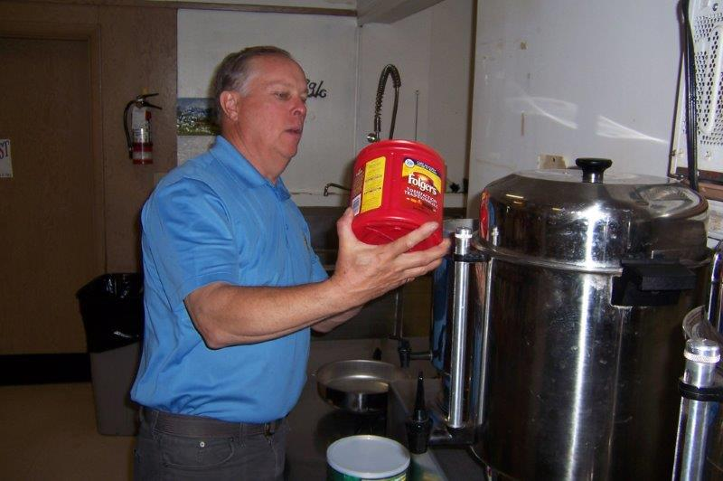
Coffee! Can’t forget the coffee, eh?
Next breakfast – Saturday, May 26th.

News, Updates & Reminders

2018 Golf Tournament (our 22nd)
DATE. Friday, June 1st.
BENEFICIARY. Vancouver Island Compassion Dogs will be the major beneficiary [25% of net proceeds, up to $5,000].
https://vicompassiondogs.ca/
Less than a month to go – but still some time to collect prizes and solicit sponsors, after all, it is our biggest [only] fundraising event of the year.
Golfers, sponsors (including some firms who have been very good to us over many years) and prizes are trickling in, but with three weeks to go - we NEED some more of all of the above.

An evening of Fellowship
Join your fellow Rotarians (and partners) for some good Rotary Fellowship at SimonHolt, Wednesday, May 23rd, at 5:30PM.
(off Applecross, behind Costco)

The Lantzville Fire Department
The Lantzville Fire Department (Lantzville Fire Rescue) consists of approximately 30 members dedicated to providing not only fire protection but emergency assistance to the 3600-plus residents of their community. Paid on-call firefighters serve the community in many different ways including emergency response, fire prevention, and education and support at community events.
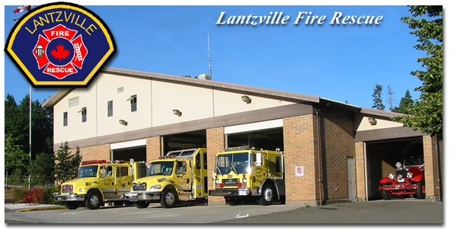
Neil Rukus, Chief of the Lantzville Fire Department, comes from a family of firefighters. After 27 years in various fire units around the island, he has been Chief in Lantzville since last November.
The Department handles about 260 calls a year, the majority of which are medical. The members, now paid-on-call, no longer ‘volunteers’, undergo weekly and weekend training and are working toward National certification. Not surprisingly, they are huge fans of fire protection
Check them out at: http://viffa.org/lantzville/

Rotary Minute
- Why did you join Rotary?
- Why have you stayed in Rotary?
- How have you benefited from being a Rotarian?
Tessa joined Rotary because of three little girls – AIDs orphans in Africa. Rotary gave her an avenue to help. Also, in a world with so much negativity, Rotary provides an optimistic option. And, she enjoys the friendships developed through Rotary.

Community Service
Sanala Garden/Playground Update:
- Dirt and stones moved last Saturday – the playground is taking shape.
- Dirt for the garden boxes will be delivered this Saturday AM – a few extra hands would be useful getting it into the boxes.
- Sod for the playground will be delivered Tuesday, May 22nd. Again, a few willing bodies would finish the job in a few hours. At noon!
- 564 5th St (next to University Heights Shopping)

Rotary in Nanaimo

Rotary Club of Nanaimo (Daybreak)
http://www.daybreakrotary.ca/
Nine-and-Dine Golf Tournament, Nanaimo Golf Club, May 25th.

Rotary Club of Nanaimo (Oceanside)
http://www.oceansiderotary.ca/
Bond Night, Coast Bastion Hotel, June 2nd.

ROTARY INFO
You can find out where and when all the Clubs in District 5020 meet on the 5020 website:
www.clubrunner.ca/portal/Organization/Meetings.aspx?accountid=50092
Rotary International: http://www.rotary.org
Member’s access: https://www.rotary.org/myrotary/en
District 5020: www.rotary5020.org
Our website: www.clubrunner.ca/Lantzville
Our Facebook Page: www.facebook.com/RotaryClubofLantzville
Check it out – you might be surprised…

Beautiful BC:


It can be fun getting on in years!

An elderly gentleman had serious hearing problems for a number of years. He went to the doctor and the doctor was able to have him fitted for a set of hearing aids that allowed the gentleman to hear 100%
He went back in a month to the doctor and the doctor said, 'Your hearing is perfect. Your family must be really pleased that you can hear again.'
The gentleman replied, 'Oh, I haven't told my family yet. I just sit around and listen to the conversations. I've changed my will three times!'
…………………………….
An elderly couple had dinner at another couple's house, and after eating, the wives left the table and went into the kitchen.
The two gentlemen were talking, and one said, 'Last night we went out to a new restaurant and it was really great. I would recommend it very highly.'
The other man said, 'What is the name of the restaurant?'
The first man thought and thought and finally said, 'What is the name of that flower you give to someone you love? You know - the one that's red and has thorns.'
'Do you mean a rose?'
'Yes, that's the one,' replied the man. He then turned towards the kitchen and yelled, 'Hey, Rose, what's the name of that restaurant we went to last night?'

