i

May 20th, 2021
Youth Service Month

IN THE LANCE THIS WEEK

Meeting Notes
Rotary Minute
Bits and Pieces

FUTURE EVENTS

May 25th– Adventures in Citizenship
Lucy Morel

VISITOR – Rotarian Ken Hammer

CELEBRATIONS

Our birthday wishes to Brian McFadden;
David & Gayle, congratulations on your38th
wedding anniversary.

Chuckle, Giggle, Laugh Out Loud
Find the humourous in humilty and the hilarious in the Nefairius. Let alughter transform the serious and lighten feelings of heaviness. Laugh often! A cheerful heart will turn fear into frolic and anger to ashs. Thank you Jodie!

MEETING NOTES

President Mark shared information about registration/participation in the May – June E-Club 5020 Virtual Golf Tournament. Proceeds will go towards funding an agriculture project in Kenya.

In celebration of 25 years of service in Nanaimo, Daybreak Rotary is replicating their first fundraiser of 25 years ago – the Parkway Challenge – with a virtual challenge to run, walk or cycle 25 kms between May 25th and June 25th. Ken Hammer spoke about the event.

Congratulations to President Mark! Effective July 1st, Mark has been appointed to the board of directors of the Nanaimo Airport Commission.

ROTARY MINUTE

Drawing on his work experience, Troy gave an excellent presentation on ‘The Top 10 Personal Cyber Security Tips.’

- Keep your Software & Firmware Up to Date
- Use Ant-Virus Protection & Firewall
- Use Strong Passwords & Use a Password Management tool
- Use Two Factor or Multi-Factor Authentication
- Learn About Phishing Scams
- Protect Your Personal Identifiable Information
- Use Your Mobile Devices Securely
- Backup Your Data Regularly
- Do not Use Public WI-FI
- Review your Online Accounts & Credit Reports Regularly for Changes

Hacking, phishing, and malware incidents are becoming the number one cause of security breaches today. Education and awareness are critically important in the fight against cybercriminal activity and preventing security breaches. Troy, many thanks!
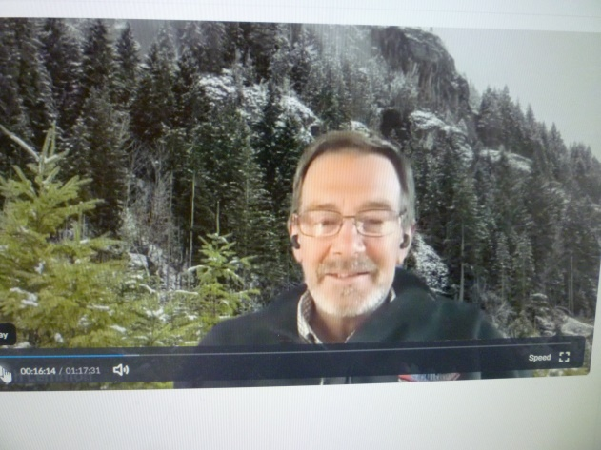

BITS AND PIECES

Happy $ from Doug. For the June AGM, he has been nominiated to be a national VP for the Air Cadet League of Canada.

Don T. is very happy about his Nanaimo condo purchase with a June 15th move date.

Dale spoke about the generous donations to the homeless by Panago Pizza and Little George’s. Coco Café in Cedar and the Nanaimo Clippers help
Wisteria Community Association with delivery.

Greg always looks forward to the 7-10 breakfast - a feel good social outing.

For relaxation, Ralph keeps busy building Adirondack chairs. He is delighted his grandson enjoyed the 2 hour ride aboard the motorcycle.

Jody keeping busy with online Pres. Elect training.

Sad $ from Mike on the loss of a fellow badminton worker who died from COVID in India.

Happy $’s from Mark. His COVID vaccine is booked for Friday. Helen has had hers.

“Loving people live in a loving world. Hostile people live in a hostile world. Same world.”

