

“Rotary: Be the Inspiration”

May23rd, 2019
Youth Service Month

IN THE LANCE THIS WEEK

Community Service Presentations

Golf Tournament Wrap-up

FUTURE EVENTS

May 25th - 7-10 Club Breakfast, 7:00 am
May 29th - Directors’ Meeting
May 30th - Help Lesotho, Dr. Peg Herbert

June 6th - Bonnie Murrell,
Youth Protection Awareness
8th - Foam Fest, Arbutus Meadows

13th - Our Rotary Adventure in Citizenship
Participant, Grayson Mitchell

June 20th – Installation of 2019-2020
Club President, Directors
Nanaimo Golf Club, 6:00 pm

DUTY ROSTER –May 30th

Greeters: Robertson/Valsangkar Cash: Sparkes

Sgt-At-Arms: Lobay Invocation: Bergin
Introductions: Walker Foundation: Rodgers
Rotary Minute: Bell

VISITORS AND GUESTS

Joining us for fellowship and food , Pam Bjornson, Chris Stephens, Michael La Fortune and Isabel Van Grootheest.

ROTARY CLUB OF LANTZVILLE
MISSION STATEMENT
Joining in fellowship to support growth and development in education and health for those less fortunate in our local and international communities.

Barry Sparks…filling in for President Jan

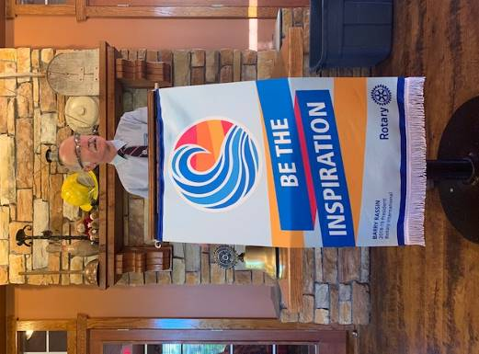

FOUNDATION
$ 110 contributed to the Rotary Foundation. Many thanks! Lucky holder of the draw for
$ 16.00 was Dale Werezak
Current contributions directed to the PolioPlus Fund unless you tell Barry otherwise.

Don’t Judge each day by the harvest you reap but by the seeds you plant.

~Robert Louis Stevenson~
SERGEANT AT ARMS

With great enthusiasm, Dave E. collected mostly happy bucks. Jamal was very happy that Harry retrieved his lost glasses on the Mt. Benson trail. Amazingly, this happened two weeks after his loss. Greg D. had a grand time caving at Horne Lake with his Scout troop. A timely reminder from Ralph, do check for ticks after visiting wooded areas. Don T. needed a rest after his fun filled week-end in Quesnel with relatives including 3 children under 3. On his recent trip to Saskatchewan, Dale told us the leaves there were just starting to bud. This week, Tess finished her costume work for the Chemainus Theatre. The ‘Mama Mia’ Tickets are being snapped up, already sold out for many shows. We thank Tess for renewal of our Rotary aprons. Steve gave an update on the Alpacas at Favour Valley Acres. Dave E. very happy his son has found work in Alberta. Barry showed us the joker and then buried it. Brian M.’s draw was unsuccessful. Next week,
$ 240 in the pot.

Rotary Minute



Lee Rowley gave a timely update on Shelter Box. This organization, through Rotary, provides emergency disaster relief kits to families made homeless by natural disaster and conflict. Most recently kits have been sent to Malawa (floods), Ethiopia, Syria, N. Nigeria (conflict) and Somalia (drought). 91 cents of every $ 1 raised is spent on disaster relief. Annually, our club contributes money to support 1 or more kits.



Don Tamelin – Pam Bjornson

Nanoose Community Service volunteers worked with us on the golf course on tournament day. Now in its 25 year, this non-profit organization offers unique programs to families in the area. Their food support program provides Quality Food gift cards, once a month, for a week of food for 50 needy families. They are a go to resource for emergency services. The well attended Sunday @4 Community Education events present opportunities for community discussion on topical issues. The Nanoose Bay Elementary school subsidy enables all children to attend after school activities, field trips & special programs. Nanoose Community Services is about neighbors helping neighbors from the heart. We are proud to help them do their work.

ISLAND CRISIS CARE SOCIETY…

Specifically Samaritan House was this year’s major golf tournament beneficiary. They are in the process of raising $ 2 million dollars to house women in crisis. Joining us for the day was Corrie Corfield, resource development coordinator.

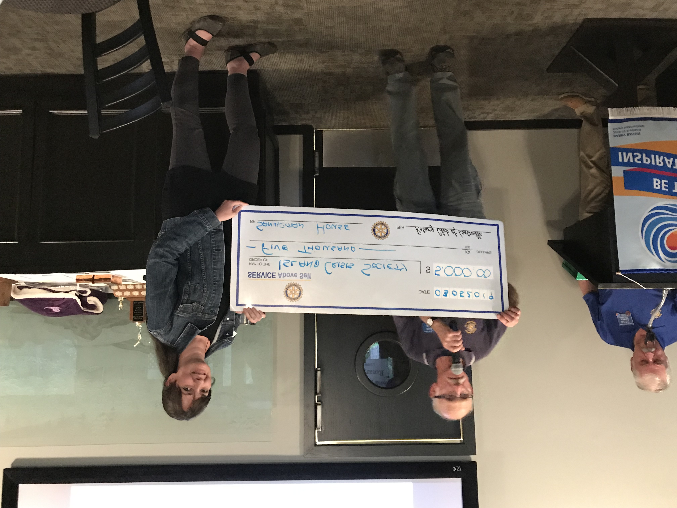
Golf Tournament Wrap-up
Don lead us through a lively discussion on what went well at the tournament and lessons to be learned for the May 29th, 2020 tournament. For sure the entire event was a team event and everyone in many different ways, was a team player. Bottom line, we made slightly more than 2018. Dave E. was particularly pleased with the member support for the silent auction. Randy does thank-you’s for sponsors. Club members are responsible for TY’s to their contributors. Helping Harry sell super tickets, Rachel learned how to scratch. Sheila described golfer registration as being akin to catching cats. Don reminded us that our well-oiled ‘machine’ makes for a great day for golfers and recognition that the Rotary Club of Lantzville makes happen a premier Nanaimo golf tournament. Thank-you Don for your hard work and enthusiastic leadership!

COMMUNITY SERVICE

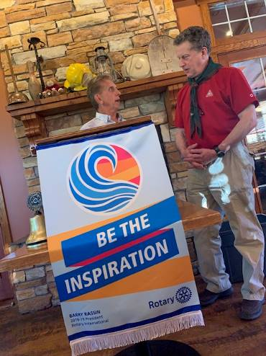

Dale presented cheques this morning to Chris Stephens, Scouts Canada Camp Caillet and Isabel Van Grootheest ‘Supporting grieving youth through Rainbows.’

Chris commented on their recent very successful, 350 participant event at Camp Caillet.
"Every Rotarian an Example To
YOUTH"
These words were adopted in 1949 by the Rotary International Board of Directors as an expression of commitment to children and youth.
Worldwide, youth service projects take many forms. Rotarians sponsor Boy Scout and Girl Guide troops, athletic teams, handicapped children's centers, school safety patrols, summer camps, recreation areas, safe driving clinics, county fairs, child care centers and children's hospitals. Many clubs provide vocational counseling, establish youth employment programs and promote use of The 4 -Way Test. Increasingly, drug and alcohol abuse prevention projects are being supported by Rotarians.
In every instance, Rotarians have an opportunity to be role models for the young men and women in their community. One learns to serve by observing others. As our youth grow to become adult leaders, it is hoped each will achieve that same desire and spirit to serve future generations of children and youth.
Fast forward to 2019, this slogan is a thoughtful challenge to all of us and every bit as vital.
Fun Stuff

A wife invited some people to dinner. At the table, she turned to their six-year-old daughter and said, “Dear, would you like to say the blessing?” The girl replied “I wouldn’t know what to say”. “Just say what you hear Mummy say,” the wife answered. The daughter bowed her head and said, “Lord, why on earth did I invite these people to dinner?”

Life Lessons…

-Life isn’t fair, but it’s still good;
-You don’t have to win every argument. Agree to disagree;
-Friends are the family we choose for ourselves.

