“Rotary: Be The Inspiration”

May 2nd, 2019
Youth Service Month

IN THE LANCE THIS WEEK

Rotary Golf Tournament

‘Favour Valley Acres’

FUTURE EVENTS

May 9th - Bookfest, Andrea Bava
May 9-11 - District 5020 Conference, Victoria
May 16th - RCMP Sgt. Jay White
Underwater Recovery Training Ct.
May 23rd - tba
May 30th - Help Lesotho, Dr. Peg Herbert

DUTY ROSTER –May 9th

Greeters Lemmon/Rowley; Cash Walker;
Sgt-At-Arms McFadden; Invocation Bergin;

Introductions Sparkes; Foundation Elgie;

Rotary Minute Ribicic

VISITORS AND GUESTS
Representing Favour Valley Acres‘ Deborah Vanderwork and Vic Anderson Joined us for breakfast. .

BIRTHDAYS & ANNIVERSARIES
On May 2nd, Vojyto Sinn was another year wiser.

ROTARY CLUB OF LANTZVILLE
MISSION STATEMENT
Joining in fellowship to support growth and development in education and health for those less fortunate in our local and international communities.

President Jan…

As always, leading us in her cheerful way and with a lovely smile.
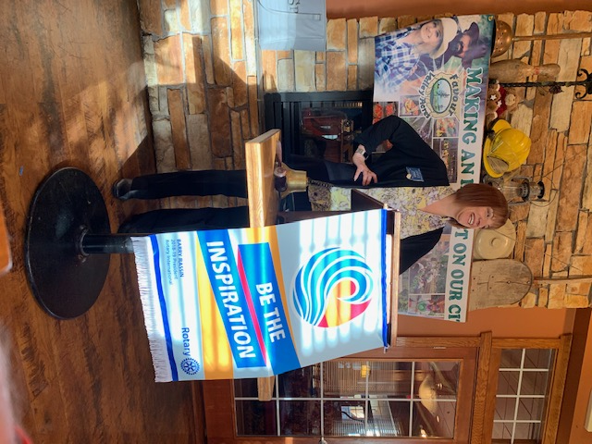

FOUNDATION
$ 120 contributed to the Rotary Foundation. Many thanks! Lucky holder of the draw for
$ 19 was Don Tamelin.
Current contributions directed to the PolioPlus Fund unless you tell Barry otherwise.

Food for thought…for every minute you are angry, you lose 60 seconds of happiness.

Sergeant At Arms

With great humour, Dave coached more than a few happy dollars from us. Dave is very happy with the many prizes we have for the silent auction. Dale had a big TY to Brian Rodgers for the Friday weather forecast. Brian M. had a lovely Easter with family in Kelowna. While in Vancouver, Greg & Susan took in the Ian Tyson concert. Don T. was thrilled to attend the sold out VI Symphony ‘Star Wars & Holst’ concert. Past week marked the end of the rugby season and maybe??? Lee’s last played game. Mike was very happy to have his passport returned. Don T. suggested we might need ‘Sunny Ways’ to step in with Mike’s return from China. Jamal was looking forward to an overnight with the grandchild and finishing work in their yard. Looking for a good laugh, Barry highly recommended ‘The Foreigner’, currently in production at the Chemainus Theatre. Steve was looking forward to ‘Curious ComicCon’ on Saturday at Country Club Centre. The comic book convention is a big day all day family affair with fund raised going to Big Brothers Big Sisters. The new puppy is settling in. Tom is sharing looking after the ‘puppy’.

Winning ticket was held by Don T. Once again, no joker. Next week the pot will be $ 200.

Community Service

Four motions for $ 1,000 from club gaming funds were approved - that we support the Vancouver Island University Foundation community outreach program; Nanaimo Community Kitchens; Vancouver Island and Rainbows Society.

Don T. expressed his encouragement for us to be more involved, hands on with local organizations such as Rainbows and Big Brothers/Sisters.

Rotary Golf Tournament

Under the direction of our Chair, Don Tamelin, our last golf tournament meeting was a run-through of everything needed for tomorrow’s event. With 96 golfers and a full complement of volunteers (TY Jodie), we are prepared for a very successful, fun filled day. Sheila, Harry and Barry have ID’ d the golfers. Barry picked up the tents; Randy delivered the sponsor signs to Fairwinds and he has our ‘big cheque’. Dave E. is putting the final touches on the silent auction and tomorrow will work with Tess, Greg, Brian, Jan, Doug & Mark on table set-up. Barry & Randy are greeters. Working registration is Joy, Susan, Sheila & Jan. Len, Rachel & Harry are selling super tickets & tracking money. Starting at noon, Dale is in charge of the putting contest. Jamal is bringing dilly bars for 2:00 pm. Doug S. is ready for his emcee duties.

Team Supporter George!

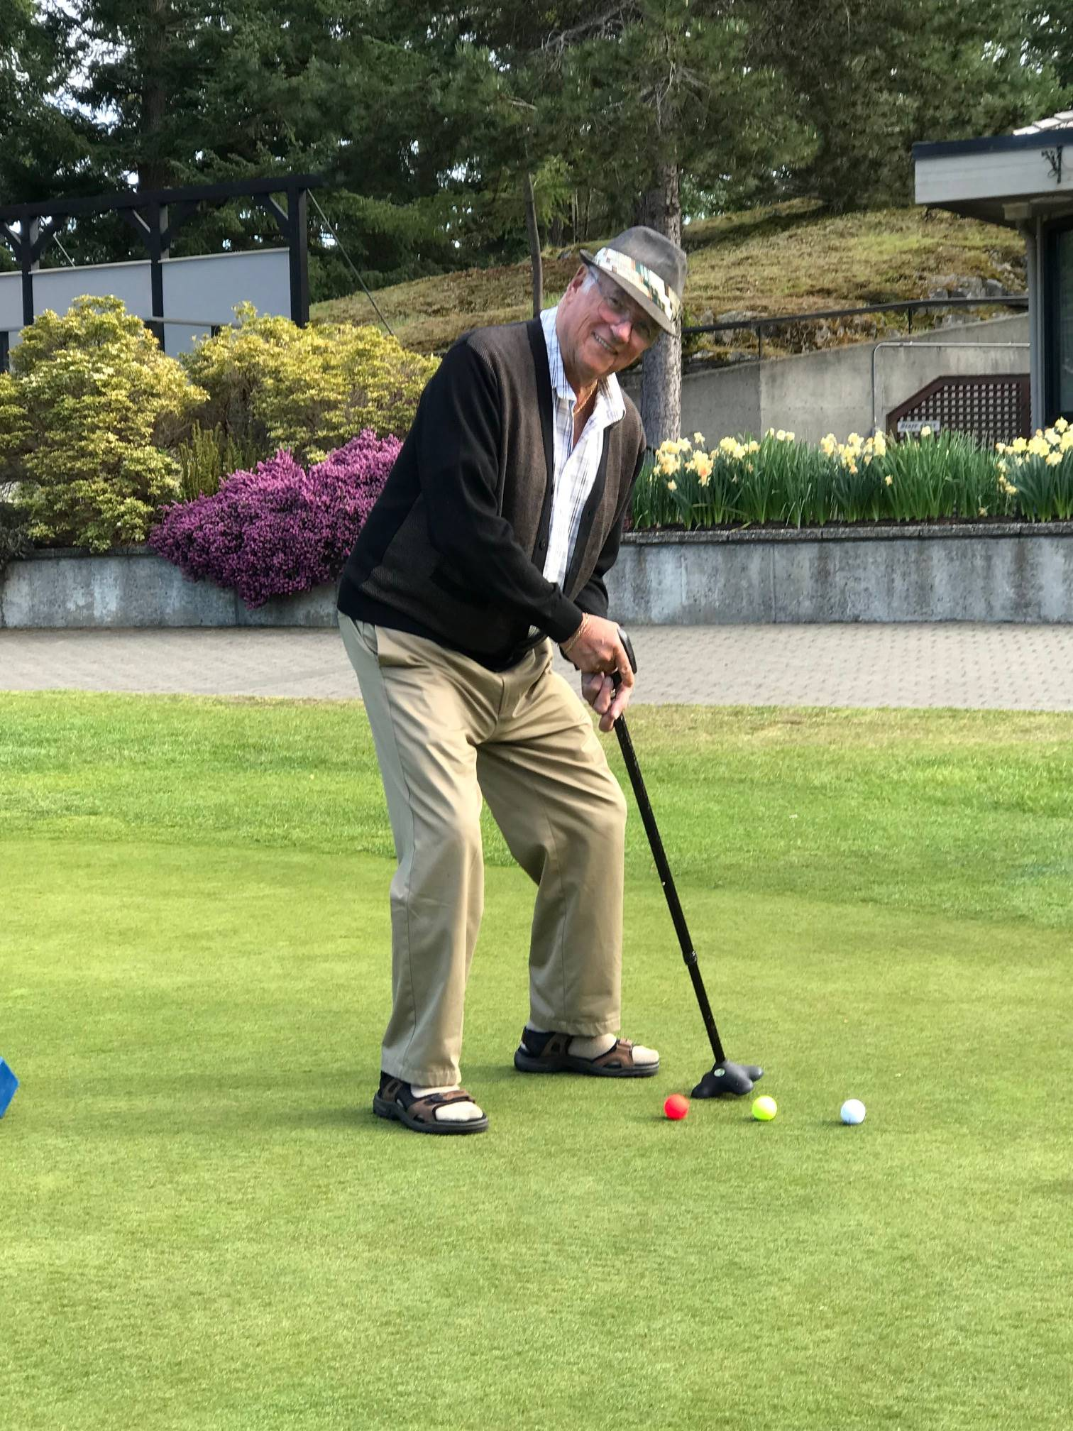

Zen teachings…good judgment comes from bad experience…and that comes from bad judgement; some days you are the dog, some days you are the tree.
.
Rotarians at Work

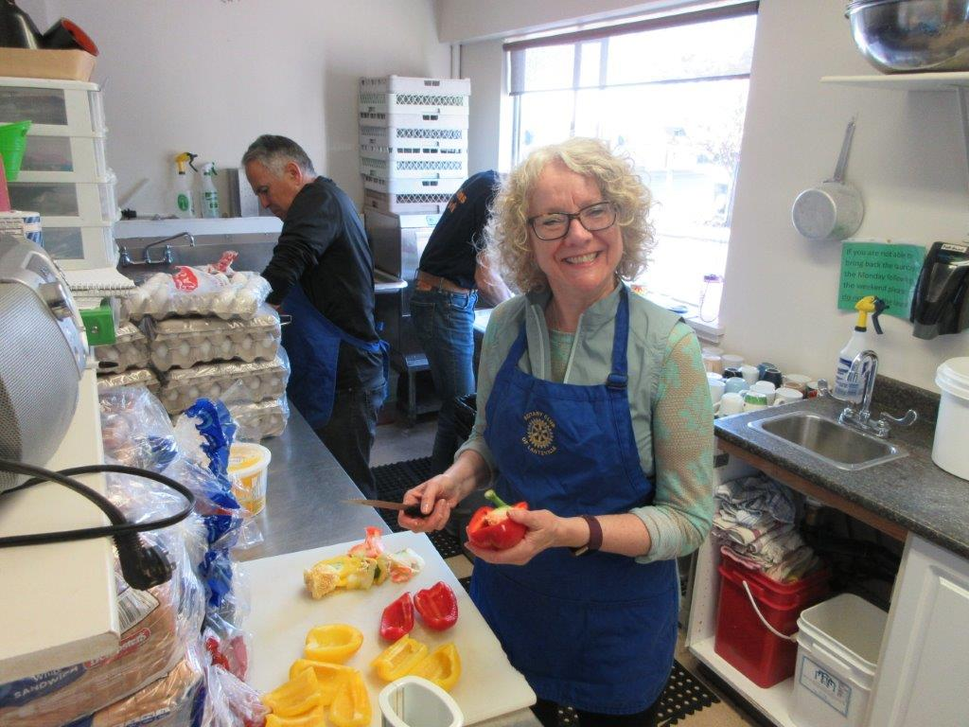

Many thanks to Steve, Barry, Don, Randy for submitting pictures.

This week past, once again, a very successful, busy morning at the 7-10 Club. Below is the why of what we do.

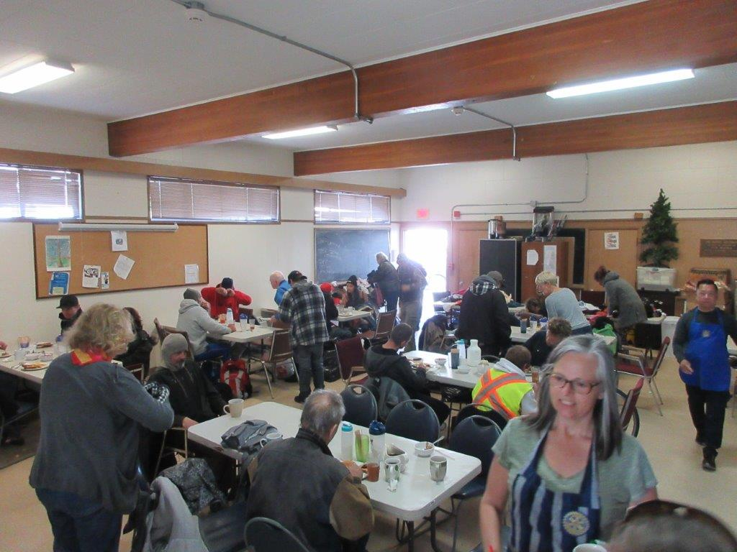

Wonderful Word Definitions!

Nurse: a person who wakes you up to give you sleeping pills.

Divorce: Future tense of Marriage.

Life insurance: A contract that keeps you poor all your life so that you can die rich.

Youth Service Month

Worldwide in May, Rotarians focus on Rotary programmes that support the development of young people up to the age of 30. For those of us in District 5020 these activities include Rotaract, Interact, Youth Exchange, RYLA, scholarships, school programmes and youth driven sports, social and life skill events. “We cannot talk about the future without talking about children. They are our future.” - PRIP, James Lacy

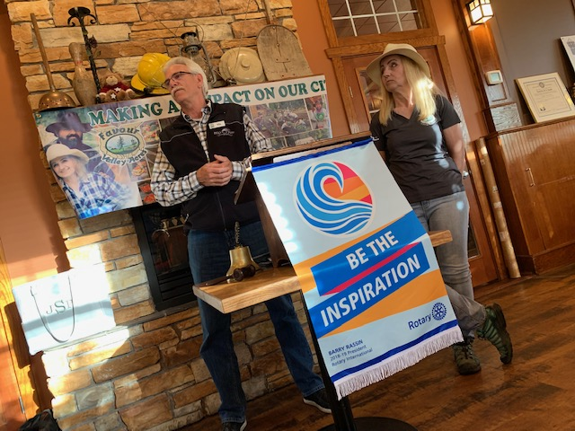
FAVOUR VALLEY ACRES
VIC ANDERSON, DIRECTOR

Favour Valley Acres is a non-profit society working a small acreage in Extension. Deborah and Randy Vanderwolf undertook their project with goals of producing good healthy food in sustainable gardens, teaching others where food comes from, mentoring young people with the development of life skills. Most of the farm produce goes to Nanaimo Food Share and SD 68 food programmes. Their small budget has the support in kind of several Nanaimo businesses. On the farm, they teach animal husbandry skills and they sell packaged Alpaca manure. Looking to the future, the plan is to work perma culture into the farm growing beds. Currently, Favour Valley Acres is hoping to purchase a sea can for on-site storage and sale of garden produce. With a big heart and great passion, Deborah is very proud of their work and their ‘making a difference’ impact on our city.

