“Rotary: Making a Difference”

May 31st, 2018
Youth Services Month

IN THE LANCE THIS WEEK

Coastal Emergency Communications Association

FUTURE EVENTS
June 1st – Our Golf Tournament
Jun 4th – Monthly Board Meeting
Jun 7th – United Way
Jun 9th – FoamFest (Beer & Hot Dogs)
Jun 14th – NO Meeting
Jun 21st – Biomass Consulting
Jun 23rd – Breakfast at the 7-10 Club
Jun 27th – Our 2018 Installation Evening

“VISITING” ROTARIANS
No one came to visit ☹

VISITORS and GUESTS
Len Olson – former member, PP & PHF
Paul Giffin - CECA

BIRTHDAYS & ANNIVERSARIES
 |  | DUTY ROSTER
DATE | GREETERS |  | CASH | Sgt-At-Arms | Invocation | INTRO | Foundation | Rotary  Minute
Jun 7th | Tamelin & Williams Jo |  | Lemmon | McFadden | Cohn | Tamelin | Cohn | Elgie
Jun 14th | NO MEETING
Jun 21st | Tamelin & Cameron |  | McFadden | Slowski | Elgie | Jodie | Rodgers | Helfrich
If you cannot make your duty, it is your responsibility to find a replacement.
David & Gayle Lobay – their 45th on May 26th ☺
But, no one is celebrating this coming week.

May 31st, 2016 – the Battle of Jutland. It was the largest naval engagement of World War I between the British Grand Fleet and the German High Seas Fleet which killed 8,645 men in an inconclusive battle but strategic British victory. German fleet never puts to sea again in WWI.

HEALTH of the CLUB
It looks like we’re still healthy – having received no news to the contrary. ☺

ROTARY CLUB OF LANTZVILLE
MISSION STATEMENT
Joining in fellowship to support growth and development in education and health for those less fortunate in our local and international communities.

“Presidential” Observations
Long-time-Past President Barry was disappointed that no one knew the answers to the questions posed in last week’s Lance:
Some knew RI President Ian Riseley, but no one admitted knowing Sgt 1st Class Orville P. Snorkel (from the Beetle Bailey comic strip).

FOUNDATION
$104 contributed to The Rotary Foundation. Thank-you!

Sergeant-at-Arms
The Sgt this AM was David L – back from Vegas and looking for cash! Randy looking for some sun tomorrow. James & Jodie getting a new dog! William’s honey bees have shown up. Mike W back from hot & humid Bangkok. Nice to see Len O – looking well. Michael R has been busy. Ralph is going racing in Seattle … with an AED. Don T went to 7 ball games down east … and a couple of good museums. Brian McF reminisced about joining the RN in ’58. Doug S was the big winner.

Installation – of Pres Jan and her Board for 2018-2019 will be held Wednesday, June 27th at the Nanaimo Golf Club. More details i.d.c.

Breakfast at the 7-10 Club
Thanks for your support!
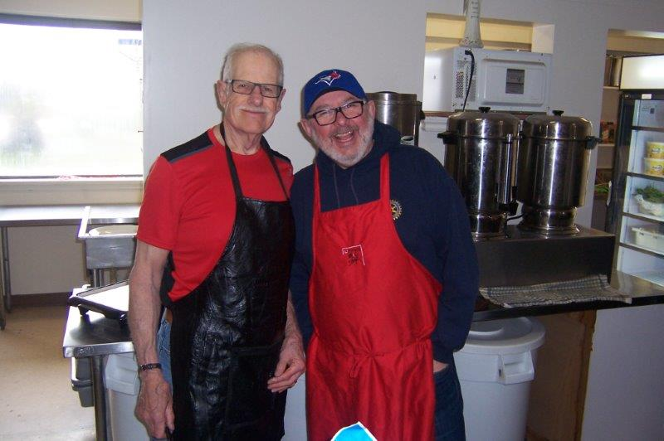
Our very own “2 Dons”!
Next breakfast – Saturday, June 23rd.

News, Updates & Reminders

2018 Golf Tournament (our 22nd)
DATE. Friday, June 1st.
BENEFICIARY. Vancouver Island Compassion Dogs will be the major beneficiary [25% of net proceeds, up to $5,000].
https://vicompassiondogs.ca/
10AM – Set-up at Fairwinds, including Silent Auction
11AM – ready for Registration, which opens at 11:30AM.
Lunch (burger & salad) available for $12.95
Putting Contest – Michael R and Mark T (sponsored by Tilray – but no samples ☹ )
1PM – volunteers in place for the…
1:30PM – Shotgun start.
3:30PM (more-or-less) – Dilly Bars by Jamal
6:30PM – All golfers finished. Dinner, presentations, & awards
8:30PM (hopefully) - Thank-you (by all Rotarians, at the door, to all golfers)
Currently 33 sponsors (thanks), 102 golfers (if they all show up), and some great items for the Silent Auction. No 50/50.

FoamFest 2018
Saturday, June 9th: As our second most productive fundraiser, we will be operating a Beer Tent and Hot Dog Stand at FoamFest 2018 – at Arbutus Meadows (just before Parksville).
Harry has arranged a liquor event license and a food license.
…But, we need volunteers – from 10:30AM…
You can get your Special Event Server Certificate on line (takes 30 minutes) at: https://www.specialeventserver.com/
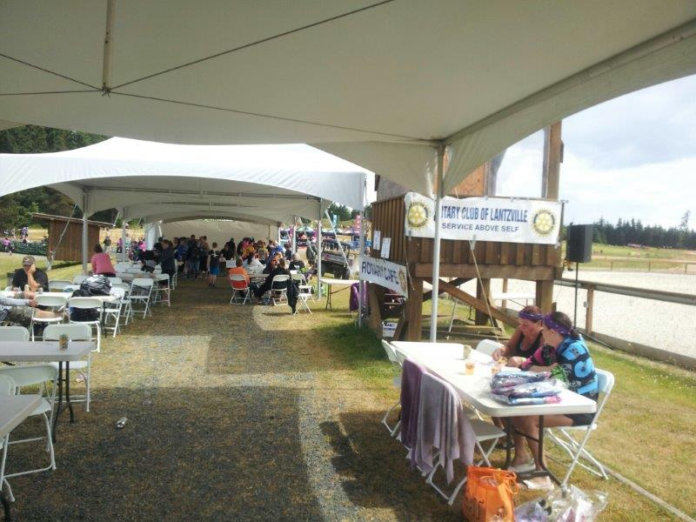

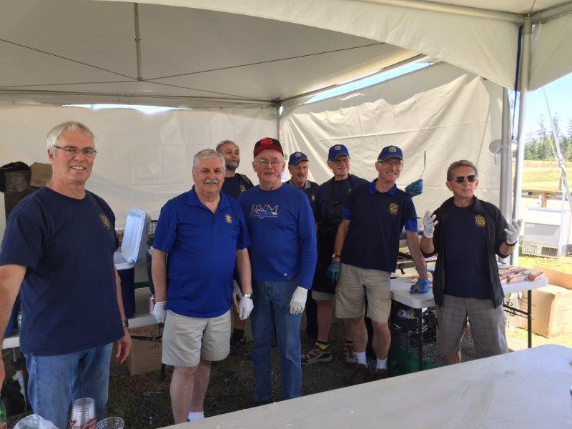
From FoamFest 2017

Rotary Minute
- Why did you join Rotary?
- Why have you stayed in Rotary?
- How have you benefited from being a Rotarian?
Joy joined Rotary in 2004 out of curiosity and at the invitation of a Rotarian. She liked what she saw and wanted to learn more. She enjoys Rotary because we’re non-political, we get along, we’re involved and she enjoys the stories and keeping in touch with our community.

Coastal Emergency Communications Association
(CECA)
http://va7eca.ca/

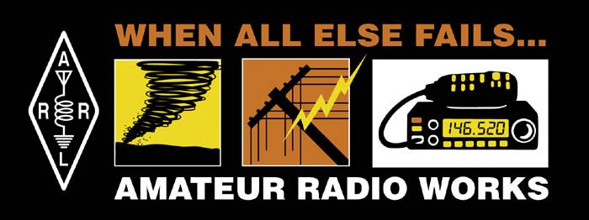
Paul Giffin, President of CECA, explained what CECA is and what it does.
With 36 members, all licensed amateur radio operators, it provides a communications capability to Nanaimo and the RDN when ‘normal’ communications (cell phones, land lines, etc) fail – usual in an emergency situation.
Formed in 2008, CECA is part of the Provincial Emergency Radio Communications Service. Depending on the situation, they take their “Grab-and-Go” kits (radios, batteries, and antenna) and set-up self-sufficient stations at pre-determined locations – with access to relay stations.
They exercise regularly with BC Ferries, City Emergency Preparedness, RDN Fire interfaces and the BC Gov’t. They also work with the Civilian Air Search and Rescue Association (CASRA) and with Nanaimo Ground SAR.
CECA is looking for financial support to develop a realistic training capability/facility. Can we help?

ROTARY INFO
You can find out where and when all the Clubs in District 5020 meet on the 5020 website:
www.clubrunner.ca/portal/Organization/Meetings.aspx?accountid=50092
Rotary International: http://www.rotary.org
Member’s access: https://www.rotary.org/myrotary/en
District 5020: www.rotary5020.org
Our website: www.clubrunner.ca/Lantzville
Our Facebook Page: www.facebook.com/RotaryClubofLantzville
Check it out – you might be surprised…

BEAUTIFUL BC (Verney Falls)
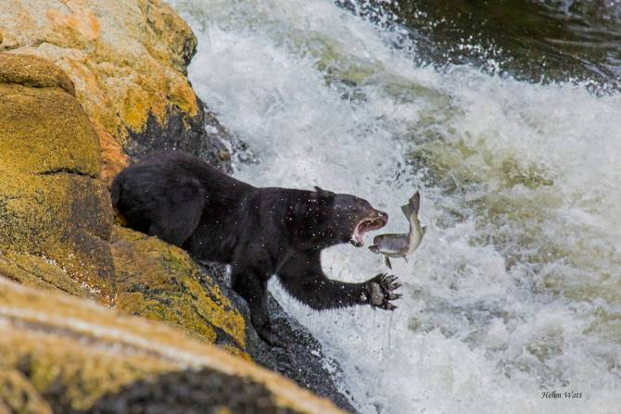

Courtesy of our non-political Rotarian:
A guy walking along a beach comes across a lamp partially buried in the sand; he picks it up and gives it a rub.
A large genie appears and says he has been granted one wish.
The guy thinks for a moment and says, "I want to live forever."
"Sorry," said the genie, "I'm not allowed to grant eternal life."
"Alright then - I want to die after a Liberal government balances the budget and eliminates the debt."
The genie stares at him and then answers… "You crafty little bugger."

