i

May 6th, 2021
Youth Service Month

IN THE LANCE THIS WEEK

Meeting Notes
Speaker Presentation
Rotary Minute

FUTURE EVENTS

May 13thReal Estate 2021
Jan& Tom Stromar

VISITORS AND GUESTS

Linda Murray, Downtown Victoria; RCL honorary member, Barry Sparkes; Camp Caillet chair, Chris Stephens.

CELEBRATIONS

Birthday wishes on May 10thto Randy,May 11th to Tessa and Cor; congratulations on May 9th to Doug & Heather on their 51st anniversary.

MEETING NOTES

SPEAKER PRESENTATION

One of his many hats, President Mark has a scouting background and he is the current treasurer for Camp Caillet. Thank-you to Mark & Chris for aninformative, interesting presentation followed by an extensive Q&A.

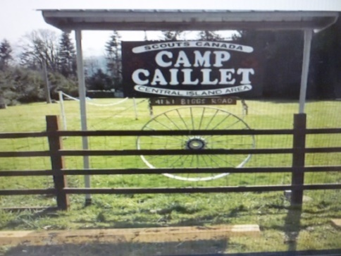

In 1985, in memory of scouter Gloria Caillet, the Biggs Road property was deeded for scouting use.
The 5 acre, heavily treed site has 2 fields, 2 bunk houses, camping areas, a full commercial kitchen, picnic shelters, toilet trailer & a fire pit that sits 100. A volunteer committee of 11 looks after site maintenance & camp administration. The site is one of 176 active scout properties in Canada.

In March 2020 all revenue activities - camping, reunions, special events, Camp Skeeter - stopped.
With approved COVID protocols andlimited access, the camp re-opened in late September. With careful planning, current operating expenses of $ 350 per month are met through donations, selling wood & countless volunteer hours spent on maintenance. Camping re-opening is thought to be late Fall 2021.

The Scouting movement was founded in 1908 in England by Lord Baden-Powell. Scout programs are for boys and girls age 5-26. Scouts were first established in Nanaimo in 1910.

“Courts and camps are the only places to learn the work in.” ~Lord Chesterfield in a letter to his son.
ROTARY MINUTE – NEIL VALSANGKAR

Neil’s engineering company assists clients on major capital infrastructure projects. For the next 4 years, he and his team are working with Island Health to oversee the procurement, design & construction of the nine hundred million dollar Cowichan District Hospital Replacement.

When finished, the new hospital will be three times larger than the current facility and will have 201 beds, up from 34. The emergency department spaces will increase from 17 to 36. A new birthing unit will have 10 beds. There will be 7 operating rooms, an increase of three. Mental health services will have a 17-bed inpatient psychiatry unit. Culturally safe spaces will accommodate traditional healing and cultural practices for loved ones to support patients during stays.

When completed, the new hospital will significantly improve the delivery of health care for everyone north of the Malahat. Thank-you Neil for telling us about this major VI capital project.

I’ve learned…

- That it’s those small daily happenings that make life so spectacular.

- That love, not time, heals all wounds.

- That everyone you meet deserves to be greeted with a smile.
INSPIRATION

- From Jan, several bits of unsolicited advice:

- What you get by achieving your goals is not as important as what you become by achieving your goals. At your funeral people will not recall what you did; they will only remember how you made them feel.

- The greatest rewards come from working on something that nobody has a name for. If you possible can, work where there are no words for what you do.

- Don’t create things to make money; make money so you can create things.

- Just because it’s not your fault doesn’t mean it’s not your responsibility.

- Being wise means having more questions than answers.

- Be strict with yourself and forgiving of others. The reverse is hell for everyone.

- To be wealthy, accumulate all those things that money can’t buy.

- To succeed, get other people to pay you; to become wealthy, help other people to succeed.

- Train employees well enough they could get another job, but treat them well enough so they never want to.

- Be the change you wish to see.

- Bad things can happen fast, but almost all good things happen slowly.

- Be nice to your children because they are going to chose your nursing home.
CONGRATULATIONS

DON TAMELIN

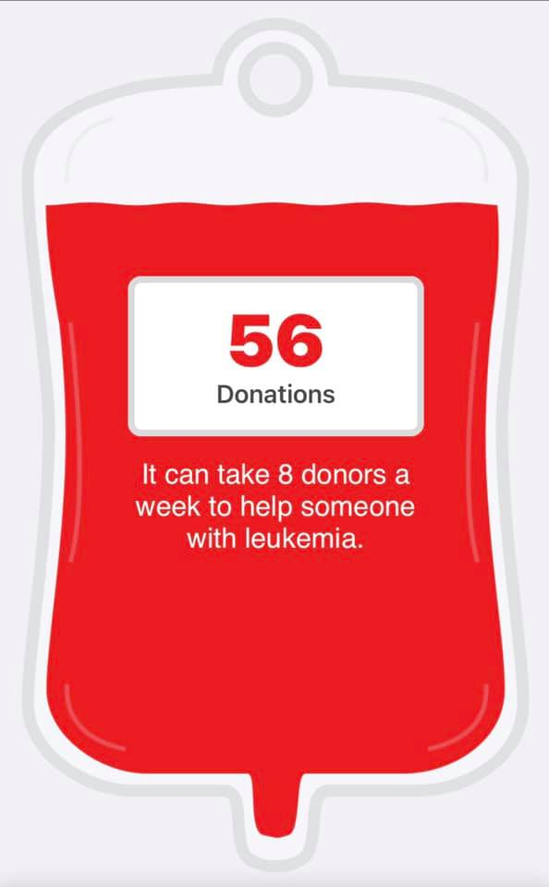

7-10 BREAKFAST

OUR RCL VOLUNTEERS

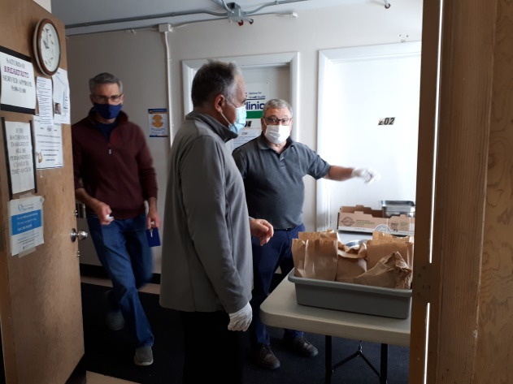

ROTARY THEME – YOUTH SERVICE MONTH
May is Youth Services (formerly called New Generations) Month when Rotary Clubs, around the world focus on youth services, Rotaract, Interact, RYLA and Youth Exchange.
Rotary helps young adultsdevelop leadership skills, build lasting friendships, and create positive change.

“We cannot talk about the future without talking about children. They are our future.” PRIP James L. Lacy 1998-99

ROTARACT TRIVIA QUESTIONS

1. How many men were at the first Rotary meeting?
A. 4
B. 6
C. 8
D. 10

2. What year was Rotary Rotaract and Interact founded?
A. 1905,1962,1968
B. 1905,1968,1962
C. 1910,1968,1962
D. 1910, 2000, 2010

3. What year did Rotary become International?
A. 1908
B. 1910
C. 1912
D. 1914

4. Where was the first Rotary club in Canada?
A. Vancouver - 1912
B. Ottawa - 1930
C. Kelowna - 1922
D. Winnipeg - 1910

Answers: 1. A; 2. B; 3. B; 4. D

