

“Rotary: Be The Inspiration”

May 9th, 2019
Youth Service Month

IN THE LANCE THIS WEEK

Rotary Golf

‘Bookfest’

FUTURE EVENTS

May 16th - RCMP Sgt. Jay White
Underwater Recovery Training Ct.

May 23rd - Rotary Information
- Nanoose Community Services
May 30th - Help Lesotho, Dr. Peg Herbert
June 6th -Bonnie Murrell,
Youth Protection Awareness

June 20th – Installation of 2019-2020
Club President, Directors
Nanaimo Golf Club, 6:00 pm

DUTY ROSTER –May 16th

Greeters: Youssef/Taylor Cash: Elgie
Sgt-At-Arms: Lemmon Invocation: Cochrane

Introductions: Tamelin Foundation: Sparkes
Rotary Minute: McFadden
VISITORS AND GUESTS

Andrea Bava, volunteer public relations coordinator, representing BookFest VI joined us for breakfast.

BIRTHDAYS & ANNIVERSARIES

Celebrating birthdays this week are Randy Manikel and Tessa Bell. Also today, marked Doug & Heather’s wedding anniversary.

ROTARY CLUB OF LANTZVILLE
MISSION STATEMENT
Joining in fellowship to support growth and development in education and health for those less fortunate in our local and international communities.

President Jan…looking forward to DLTA training and District 5020 Conference Friday and Saturday in Victoria. Jan, Joy, Barry & Greg will be joining 490+ members signed up for what promises to be an interesting, educational, event filled two days.
FOUNDATION
$ 119 contributed to the Rotary Foundation. Many thanks! Lucky holder of the draw for
was Dave Elgie
Current contributions directed to the PolioPlus Fund unless you tell Barry otherwise.

Nanaimo’s Floral Emblem
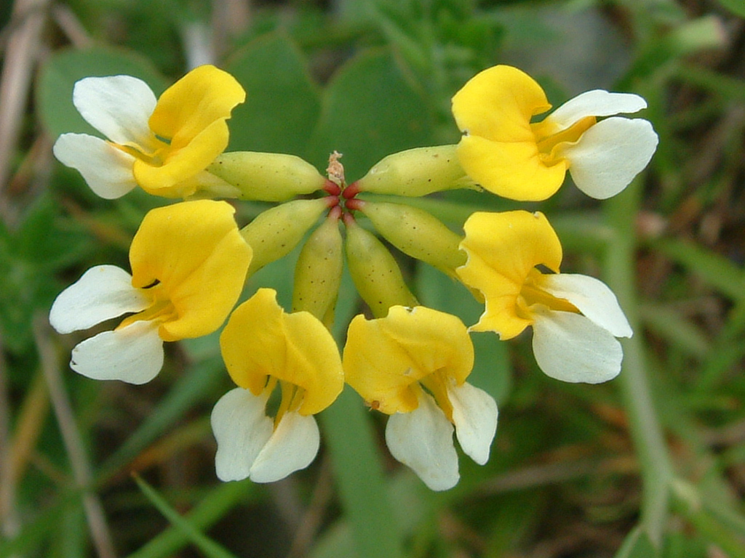
Lotus pinnatus
SERGEANT AT ARMS

Brian M. cheerful went about coaching most of us to speak up and perhaps contribute a buck or two to the pot. No surprise, many happy bucks on our golf tournament. Dave E. had a special TY for all of us and especially for our newer members who stepped up with contributions for the silent auction. ‘Mike Harrigan’ we continue to very much miss you. Mike’s wife Janice was delighted with their golf tournament ‘wins’. Don T. said the day was ‘Fantastic’. Next week, we will have a wrap up – what went right, what needs to be changed. Rachel enjoyed the Dilly Bar gig. Rachel also reminded us about the upcoming Saturday Rotaract clean-up at Piper’s Lagoon. Steve reported, the past Saturday Big Brothers – Big Sisters Volunteer Appreciation event was a huge success. In a recent presentation, Greg D. learned about Lotus pinnatus (also known as ‘bog bird’s-foot trefoil’), Nanaimo’s official flower. George & Joy’s filly Exorbitant, won her maiden at Hastings Park. Harry confirmed our June 8th club participation at Foam Fest. This is an all day, hands on event where we sell beer and hot dogs. Via Brian M., former member Stan Mackey, sends his best wishes.

Winning ticket was held by Jan. Ongoing, no joker was drawn. Next week the pot will be $ 210.
Mmm…I wonder if there really is a joker in this deck.

ROTARY MINUTE

Michael Ribicic encouraged us to read ‘The Four-Way Test in a post-truth era’ article in the most recent edition of the Rotarian. One of Rotary’s central principles, the Four-Way Test is of special interest in the current day, when truth – or more precisely, truthfulness – seems to be losing its prestige in public life. It is a good read and helpful in understanding our ever changing world.

Worth repeating – do not let anyone’s ignorance, hate or negativity stop you from being the best person you can be!

Our Golf Tournament

Once again, we made it work and we made it work well. Our tournament is a success thanks to each and every person in our club. You are the glue that makes it happen – logistics, golfers, prizes, ideas and inspiration, volunteers, sponsors, signage and many, many hours of grunt work. To our sponsors, golfers, prize donors, volunteers, Fairwinds Golf Club, we say thank-you, thank-you. We invite you to mark May 29, 2020 in your calendar for your participation in a Rotary Club of Lantzville super golfing day.

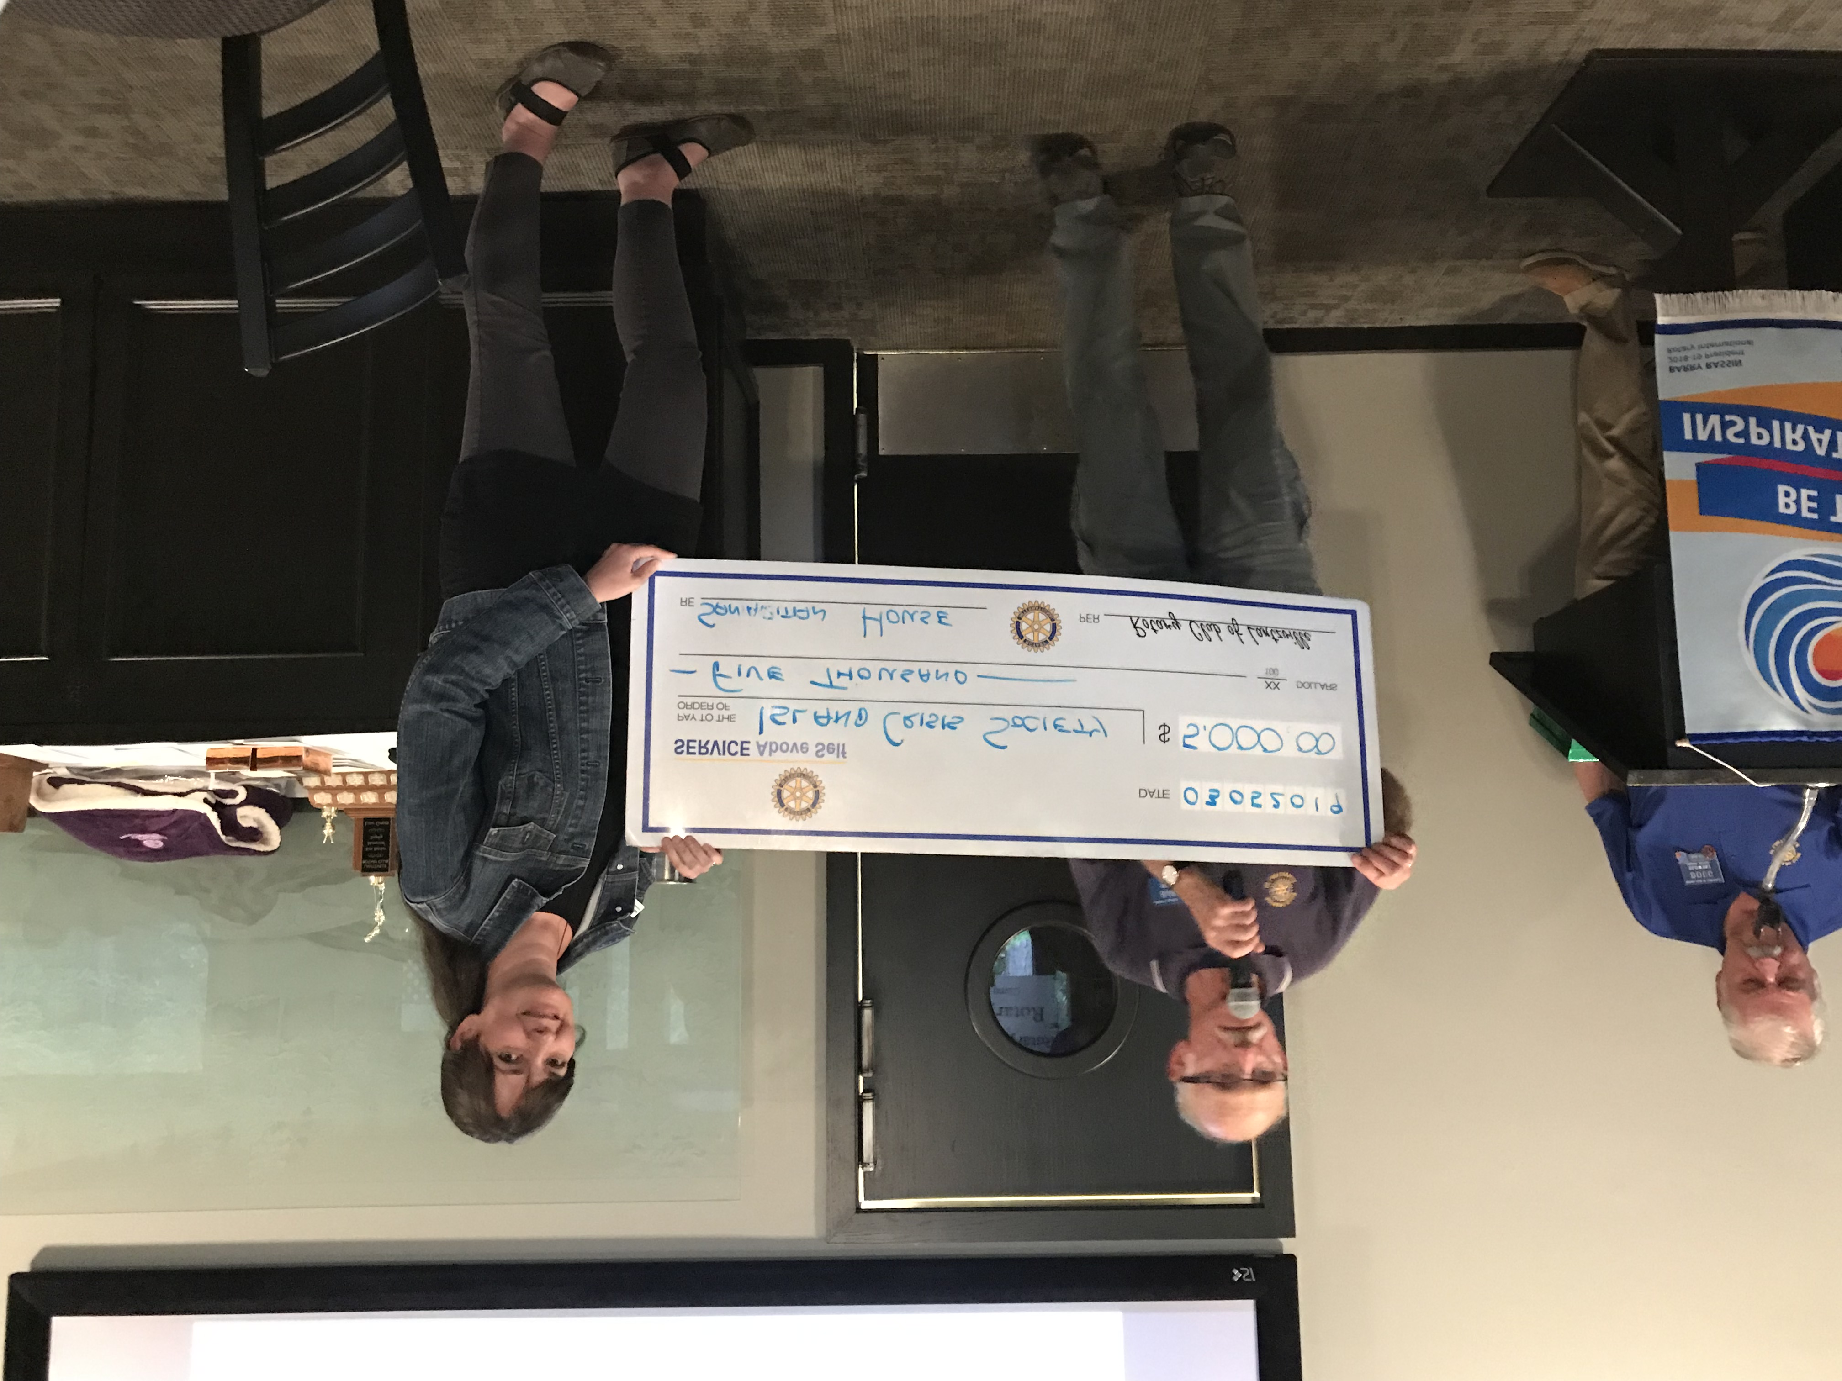
Island Crisis Centre $ 5,000
Cheque Presentation To Society
Coordinator Corrie Corfield

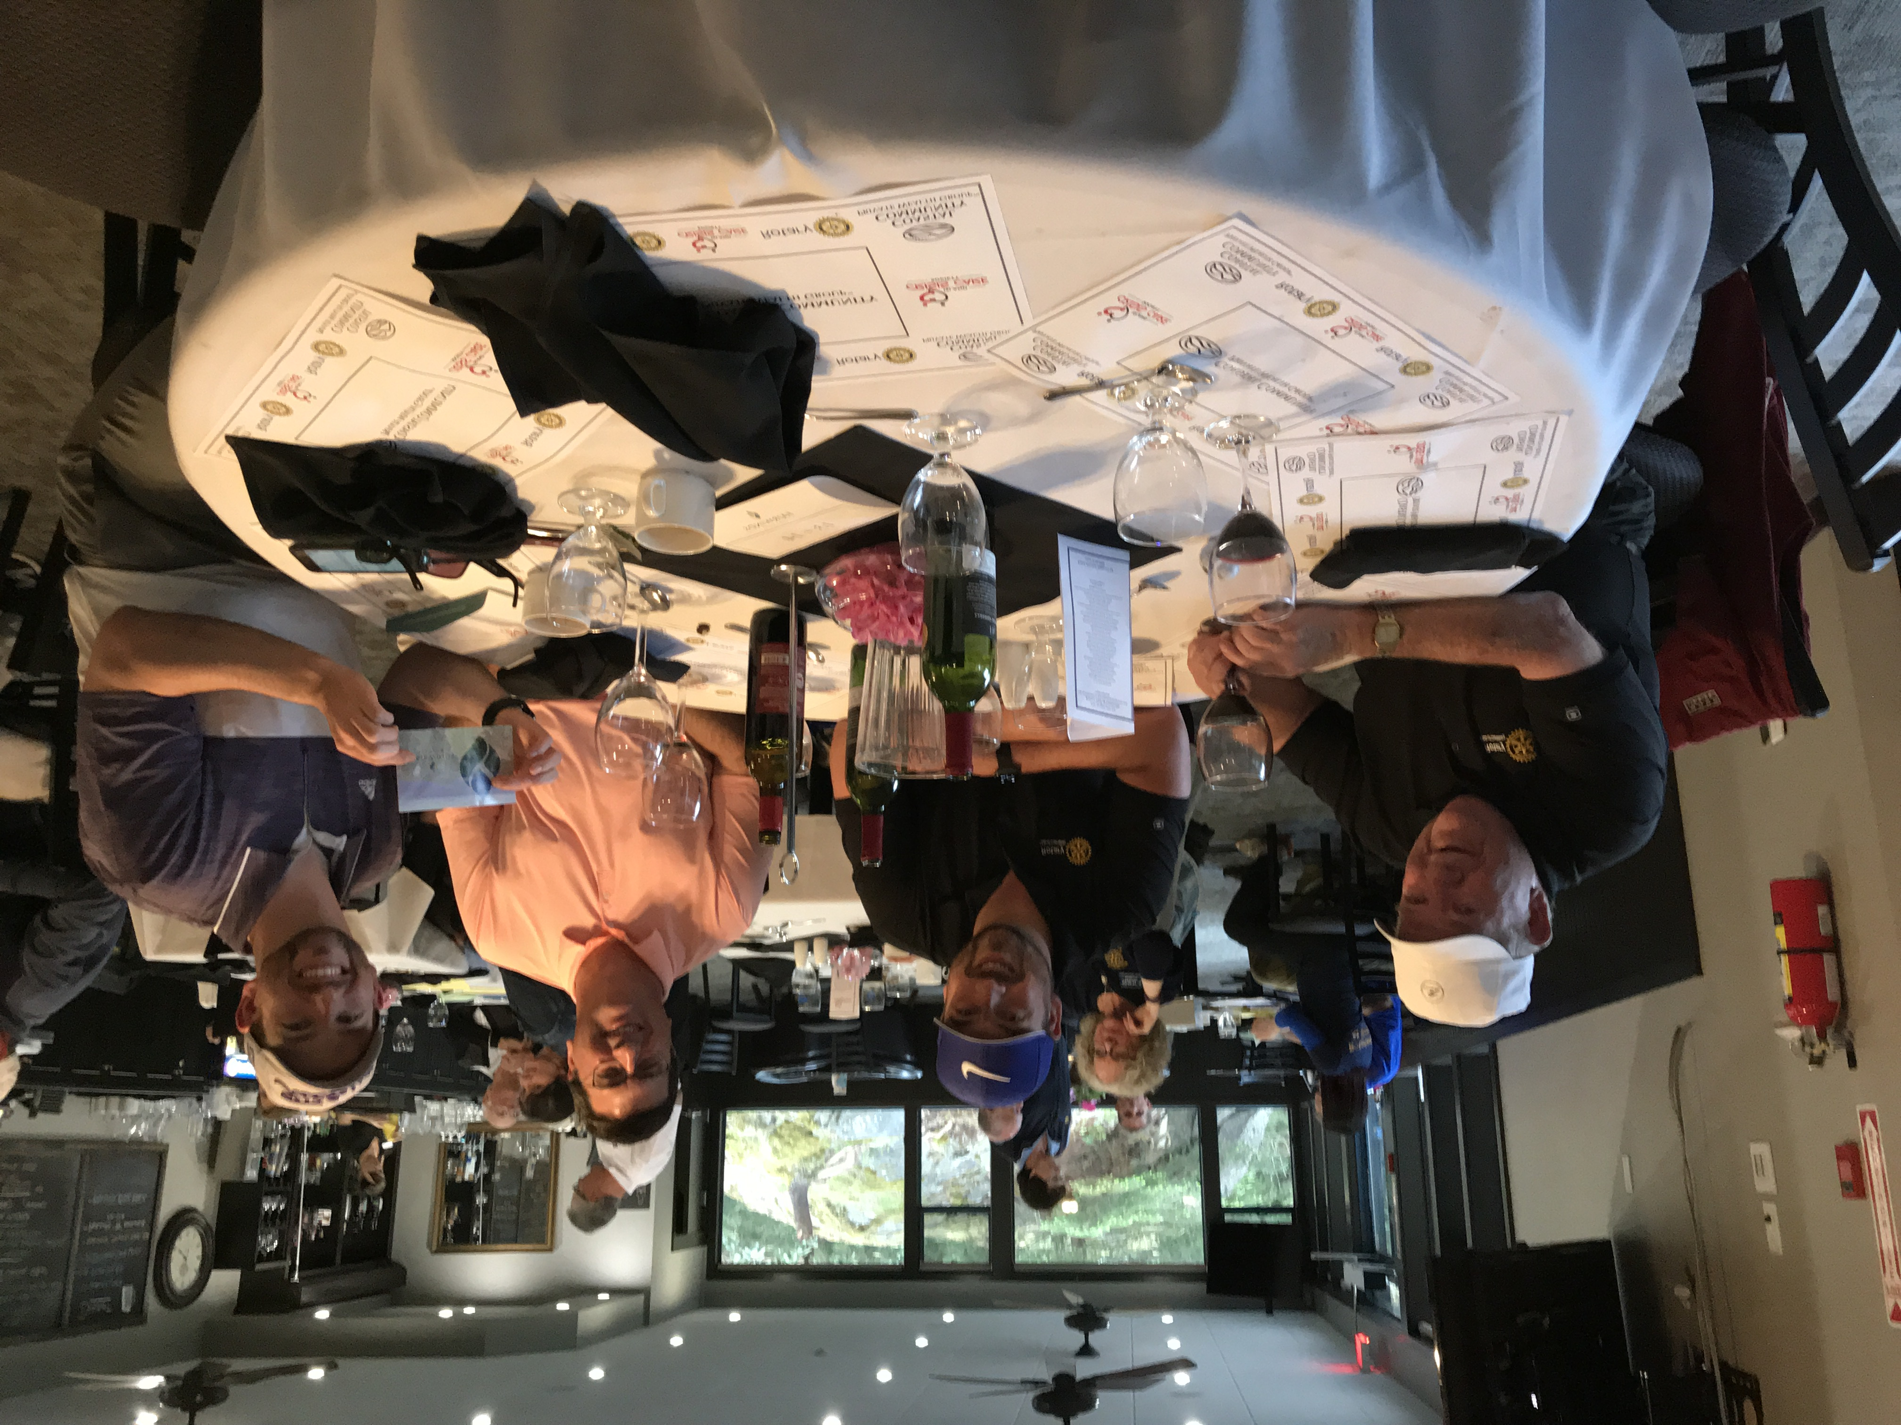
It was a great day!

BOOKFEST VI - 2019

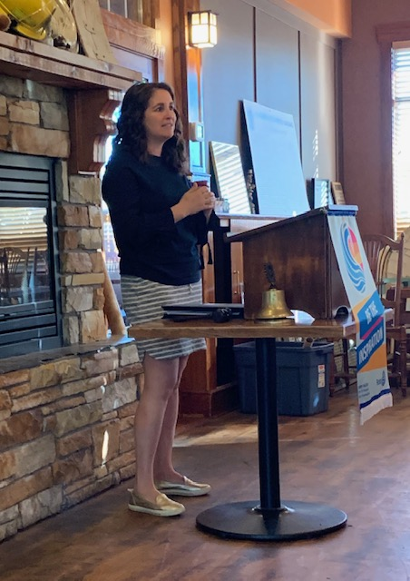

With a public relations background, Andrea Bava enjoys putting her marketing skills to work promoting Bookfest VI. This is an organization totally run by volunteers. And like all volunteer organizations, they always welcome new people with warm hearts & friendly faces.

Now in its 33rd year, Bookfest VI is a series of wonderful, fun-filled events for children and adults alike. Renowned authors and illustrators come from across Canada to present their work, tell stories about their creations and lives, and inspire youth through literature and art.

On the day of the festival, this year - June 1st, at Diana Krall Plaza, there are multiple presentations and lots of things to see and do. It is a fun family event with face painting, arts & crafts, live entertainment, food stalls and a book market. 2018 had 700+ attendees.

As part of the festival, authors and illustrators promote literacy through their presentations in our schools. In 2018, 105 presentations were given to 5,700 children and parents.

The Rotary Club of Lantzville is one of 8 major sponsors & partners for Bookfest VI. Andrea expressed many thanks for our yearly financial contribution.

Youth Service Month

Worldwide in May, Rotarians focus on Rotary programmes that support the development of young people up to the age of 30. For those of us in District 5020 these activities include Rotaract, Interact, Youth Exchange, RYLA, scholarships, school programmes and youth driven sports, social and life skill events. “We cannot talk about the future without talking about children. They are our future.” - PRIP, James Lacy

D 5020 Inbound 2018-2019 YE STUDENTS
Having Fun!!!

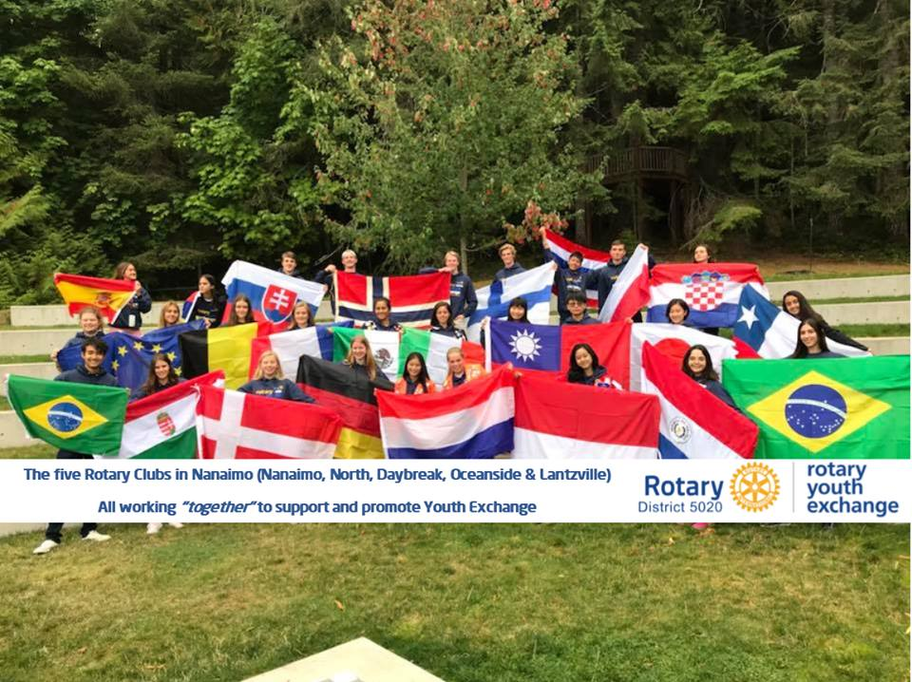

On a lighter note…these fit so well they should be in a dictionary

Beauty Parlor – a place where women curl up and dye.

Committee – a body that keeps minutes and wastes hours.

Raisin – a grape with a sunburn.

Dust – mud with the juice squeezed out.

Tomorrow – one of the greatest labor saving devices of today.

