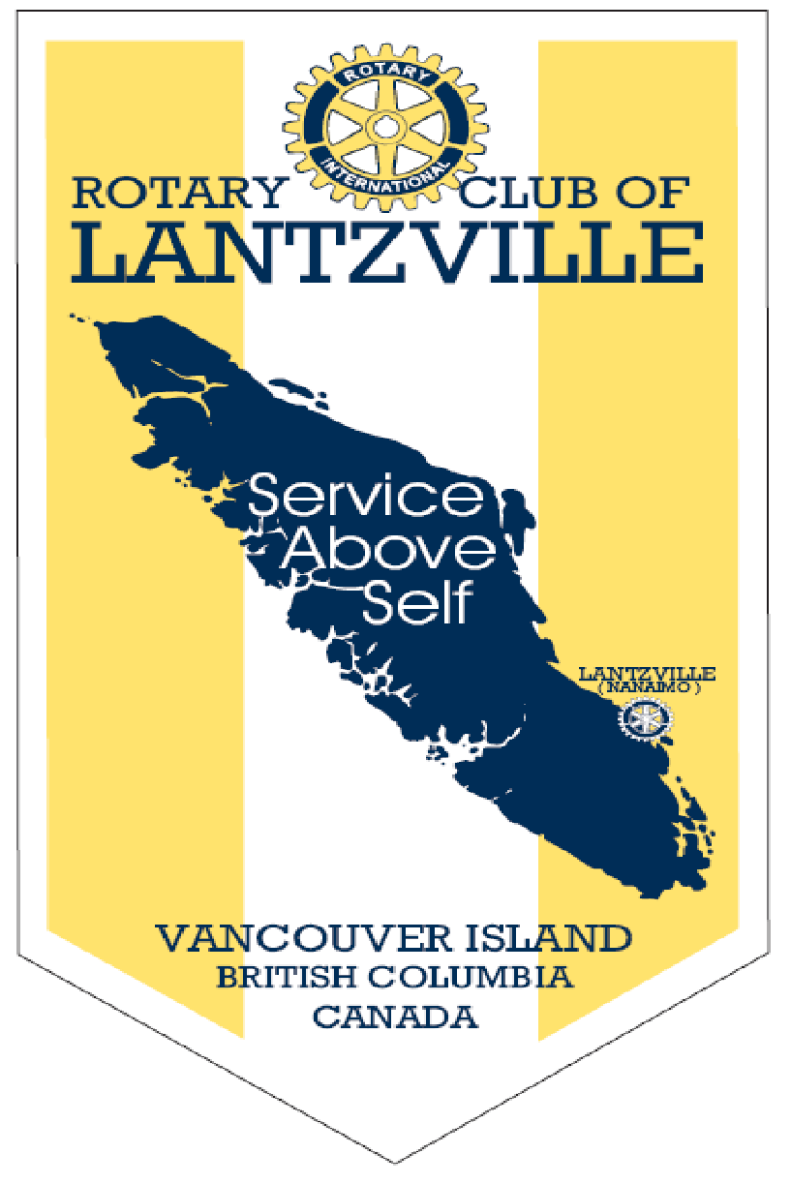

Rotary: “Be the Inspiration”

Thursday Nov. 14, 2019

IN THE LANCE THIS WEEK

Presentation by Barry Sparkes on the Rotary Foundation.

FUTURE EVENTS

Nov. 23rd - 7-10 Club Breakfast.
Nov. 26th Salvation Army –Kettle Station
Nov. 28th –Christmas Social –Simon Holt
Dec. 7. “Breakfast with Santa”. Costin Hall
Dec. 26th No meeting

“VISITING” ROTARIANS
No guests

VISITORS and GUESTS
Janice Perrino Hospital Foundation
Dawne Anderson Salvation Army

BIRTHDAYS & ANNIVERSARIES

HEALTH of the CLUB
We’ll presume that no news is good news!

ROTARY CLUB OF LANTZVILLE
MISSION STATEMENT
Joining in fellowship to support growth and development in education and health for those less fortunate in our local and international communities.

“Presidential” Observations
Pres Barry commented on the turn out to Remembrance Day Service in Lantzville.
On this date in 1896 Power Plant opened in Niagara Falls. In 1975 Production of coins for 1976 Olympic Coins began.
Reminders: Club will math recognition points up till Dec. 3 for the Foundation.
If one needs a Rotary Roster Booklet 2019-2020 – see Barry.

FOUNDATION
$480 contributed to the Rotary Foundation. THANKS!!!!!
James the winner!

Sergeant-at-Arms
Dave was the Sgt this AM. Joy has gift certificates for Grand Hotel and Grand Pacific see her if interested. David had an extra ticket to caribou Express for Sunday the 17th. See Dave if interested. Jody commented that she and Stephen will be attending RILA this weekend with young people (40 in attendance).Neil mentioned that his son attends film school. He had completed a video on his interview with a WWII veteran and this won an award from CBC. James commented on the beautiful weather. Dale thanked Joy on her work with Samaritan House. Dale reminded members of Kettle Salvation Army sign –up Nov. 26. He also reminded that there is a Grey Cup Pool. Please sign up- $5 a square. Contributions to the Polio Fund. Troy commented on the great Chambers lunch meeting. Doug commented on great turn out for Remembrance Day Service downtown. Rachel asked members to consider giving coats and pajamas to Havenhouse for single moms. Greg happy about CFL playoffs this weekend. Jodie did not pull the Joker, so the pot next week will be $480!

Breakfast at the 7-10 Club
Thanks for your continuing support
Next breakfast – Saturday, Nov, 23rd, 2019

News, Updates & Reminders
Barry reminded members of Christmas Social at Simonholt on Nov. 28th -$10.00 see Joy.
Need volunteers for “Breakfast with Santa” on Sat Dec. 7.
Ralph thanked members for the 32 “Shoe Boxes” which were collected this am.

Rotary Minute
No Rotary minute today. Mark Taylor Nov. 21

FUNDING APPROVALS
DALE: DIRECTOR COMMUNITY SERVICE

- Motion to approve $2500 for “Big Brothers and Big Sisters”
Motion/seconded Dale/Tracy -carried
- Motion to approve $1000 for “ Kids Sports”
Motion/seconded Dale/ Greg- carried
- Motion to approve $1250 to Tides Canada Foundation. Dave spoke to this Foundation which supports Inuit young people.
Motion/ seconded Dale/Dave - carried

PRESENTATIONS
Michael presented Dawne Anderson from the Salvation Army with a cheque
For $300. Dawn thanked Lantzville Rotary and appreciated volunteer support for Kettle Stations. This year people will be able to give a cheque in the kettle and receipts given by Salvation Army. Any member you would like to volunteer at more kettle stations contact Dawne @ dawne_anderson@sananaimo.org.

Jodie presented a cheque to Janice Perrino from The Hospital Foundation for $2000. Janice thanked members and spoke about the need to build a colonoscopy suite.
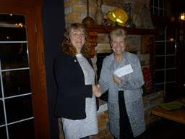
Jodie presenting cheque to Janice Perrino from the Hospital Foundation.

PRESENTATION

Barry (President) delivered a power point
presentation on the Rotary Foundation.
It is a charitable foundation, a non- profit
Corporation and supported by Rotary members and friends of the Foundation.
Five percent of all funds collected go to admin costs. Weekly donations are added up and monthly donations goes to Toronto. Tax Receipts are issued. Rotary Foundation tracks in American dollars. Local Clubs can access funds through District. There are three funds: Endowment Fund, Annual Fund and Global Polio Eradication Fund. More than 1.8 million dollars have been raised to fight polio. Last year District 5020 raised $380000. Lantzville Club gave $3100 for the Annual Fund and $1600 to fight Polio.
Since 1988 Lantzville Rotary has raised $228 777 from its members!

