



***November 19th, 2020***

***Rotary Foundation Month***

**IN THE LANCE THIS WEEK**

**District Governor Greg Horn**

**Rotary Minute**

**Club Notes**

**VISITORS AND GUESTS**

Visiting Rotarians – ADG Wayne Anderson, RCL honorary member Barry Sparkes, PDG Graham Carey, Cornwall England

**BIRTHDAYS – ANNIVERSARIES**

|  |
| --- |
| ***ROTARY CLUB OF LANTZVILLE***  ***MISSION STATEMENT***  *Joining in fellowship to support growth and development in education and health for those less fortunate in our local and international communities.* |

**DISTRICT GOVERNOR GREG HORN**

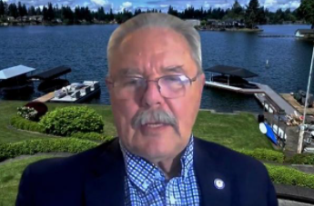

DG Greg has had a thoroughly interesting and varied career. He has been a competitive water skier, tunnel boat racer, manufacturer and is a lifelong snow skier. Greg joined Lakewood Rotary in 1996. Since joining he has been an active participant in many club and district initiatives. In 2018 Greg and wife Mary co-chaired the district conference and training in Tacoma.

Greg spoke about how Zoom has changed our world and helped ‘Rotary Open Opportunities”. He also spoke about benefits to both organizations arising from our new Toastmasters’ partnership.

Greg has three wishes for his year:

-increase participation in Rotary Direct donations. $ 10 a month from all Rotarians adds up to a great deal of money that can be used to change the world.

-increase community knowledge about Rotary. A recent survey found 4 out of 10 people have never heard of Rotary and only 2 in 10 actually know what Rotary is all about.

-that we attract members with more diversity - different colours, backgrounds, ages, cultures.

Looking to the future, DLTA 03/27/21 will be virtual. Starting in 2021, RI has added ‘Supporting the Enivironment as an additional area of focus. For projects, clubs will be able for matching grants. Youth Exchange 2020 was cancelled. A final decision for 2021 will be made in April.

**MEETING NOTES – ANNOUNCEMENTS**

Great news, we have 27 Christmas shoeboxes.

Graham Carey’s club is using zoom meetings for new experiences with worldwide. Their December 1st meeting is 10:30 am PST. Contact President Mark for connection information. Graham also sent Mark their November 13th 37 page club newsletter.

DG Greg Horn highly recommended we check out Friday a.m. Gig Harbor Rotary.

Brief update and thank-you from Lee as to our November Foundation contributions.

Thank-you’s from President Mark to everyone who participated in today’s meeting.

**ROTARY MINUTE – CHERYL STEVENS**

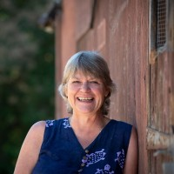

It would be fair to say that Cheryl is passionate about many things. Top of the list might be educating and getting people to focus on caring for our own physical and mental health as we age. Food security and local community initiatives are also very important. In 2012, Cheryl left nursing to pursue her passion in food and holistic health. She does consulting, coaching and speaking engagements about diet changes, lifestyle changes and self-confidence. When not busy with her practice she assists her son in running their farm market and cottage bakery. Cheryl looks forward to sharing her skills and passions with Rotary members.

**ALDEA MAYA UPDATE**

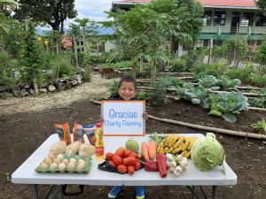

Aldea Maya is a non-profit organization that fights poverty through education, nutrition, water and employment projects in rural Guatemala. In 2018 our RCL donated sewing machines.

From their recent newsletter “Dear supporters…I hope you are staying healthy and save during these very different times.

As you can imagine it has been extremely hard to raise money for our projects when all the spring, summer, fall and winter craft fairs have been cancelled. We are, however, still selling our Christmas cards designed by students on Vancouver Island and in Squamish. These lovely cards make the perfect Christmas ( or Hanukkah) present. “ The contact person is Louise Sosa [js0922@telus.net](mailto:js0922@telus.net).

From Tessa “$20 gives you a Christmas card for you to send to a person of your choice that says a gift of $20 has been given in your honour to provide a child with a fruit tree and vegetable seeds for the coming year.

$40 gives you a Christmas card for you to send to a person of your choice that says a gift of $40 has been given in your honour to provide a child with school supplies for the coming year.”

**FOOD SHARE PACKAGING**

Thursday, November 19th, 16 volunteers participated in packaging 382 food bags for families which contained potatoes, carrots, onions, garlic, fruit, zucchini, apples, oranges etc.

December 3rd is the next date volunteers are required from 8:30 to 12:00 (approx) at the Centennial Building at Beban Park. Great CoVid protocols are covered before the process begins (a basic job briefing) and maintained during the course of the morning.

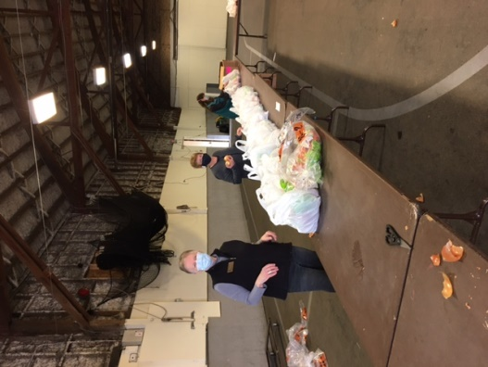

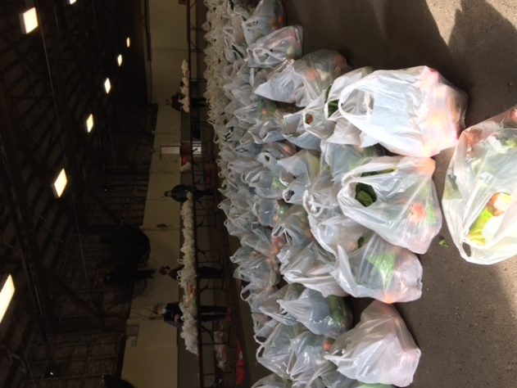

Sleigh Full of Deals

From Troy and the public image committee, this is an opportunity to support local business and local Rotary clubs.

Business can add a coupon to the Sleigh Full of Deals and Rotarians will publicize the book in hopes of bringing more customers to your business.

**To Participate:**

**Visit https://www.rotaryinnanaimo.com/ to add your coupon.**

**[**

**DG GREG’S RECOMMENDED WEBSITES**

**Rotary5020.org is our District website**

**dacdb.com – to log in to DACdb.  Just use your e-mail you use to log in to ClubRunner, then click “Forgot password.”  You may reset it with any new one.**

**rotary.org/learn – to get to the Rotary Learning Center**

**rotary.org/donate – to sign up for Rotary Direct donations**

**Zone2627.org is the Zone website.  Lots of great information here.**

**Also highly recommended reading is UD5020, our District newsletter. Chock full of good, interesting information and pictures. Consider sharing with family and friends.**

*“Patience is not the ability to wait, but the ability to keep a good attitude while waiting”. Joyce Meyer*