“Rotary: Be The Inspiration”

November 1st, 2018
Foundation Month

IN THE LANCE THIS WEEK

The Canadian Letters and Images Project

FUTURE EVENTS
Nov 8th – Seaview Elementary Principal
Nov 9th – Rotary Awareness Evening at VIU
Nov 11th – Remembrance Day
Nov 13th – Board Meeting, 4:30PM
Nov 15th – Walking to Santiago
Nov 22nd – Nanaimo Search & Rescue
Nov 24th – Breakfast at 7-10 Club
Dec 3rd – Christmas Social at Simon Holt

“VISITING” ROTARIANS
Bob Wall – Nanaimo Daybreak

VISITORS and GUESTS
Stephen Davies – VIU & Guest Speaker
Lee Rowley – probable new member.
Stephen Cochrane – probable new member.

BIRTHDAYS & ANNIVERSARIES
 |  | DUTY ROSTER
DATE | GREETERS |  | CASH | Sgt-At-Arms | Invocation | INTRO | Foundation | Rotary  Minute
Nov 8th | Devenish & Taylor |  | McFadden | Elgie | Werezak | Devenish | Rodgers | Slowski
Nov 15th | Robertson & Werezak |  | Sparkes | Lemmon | Williams | Robertson | Elgie | Sparkes
Nov 22nd | Williams & Manikel |  | Cohn | Lobay | Youssef | Williams | Sparkes | Tamelin
If you cannot make your duty, it is your responsibility to find a replacement.
Lee & Caroline – their 23rd on Nov 4th.

HEALTH of the CLUB
Several suffering/recovering from the flu to various degrees…

ROTARY CLUB OF LANTZVILLE
MISSION STATEMENT
Joining in fellowship to support growth and development in education and health for those less fortunate in our local and international communities.

“Presidential” Observations
Past-President Barry reminded us that November is Foundation Month on the Rotary Calendar.
- The mission of The Rotary Foundation of Rotary International is to enable Rotarians to advance world understanding, goodwill, and peace through the improvement of health, the support of education, and the alleviation of poverty.
- With your help, we can make lives better in your community and around the world.

FOUNDATION
$75 contributed to the Rotary Foundation this morning. THANKS!
We will match your total November contributions to TRF with Recognition Points towards your next Paul Harris Fellowship – minimum $100, maximum $200.

Sergeant-at-Arms
Don T was the Sergeant today and noted Ralph’s posture during the singing of O Canada. Shawn back from Egypt – it was busy and fascinating. Bob W thinks our club is a friendly one – and who could argue with that, eh? Don C says he can [used to be able to?] do pushups. Lees’ Mom’s birthday is today. Dale invited us to sign up for a shift with a Salvation Army Kettle. Jodie went to RYLA in Crofton with some great young people. Michael missing school (Dr Davies’ class) today ☹ Shawn K did not find the joker, so the pot at our next meeting will be $20!

News, Updates & Reminders
- Friday, November 9th, 6:30PM - A 5-Club PolioPlus Awareness event, to promote Rotary in Nanaimo - at VIU, in the Malaspina Auditorium, Bldg 310. For you and your spouse/partner. Guest speaker is Joan Toone – a Rotarian and a Polio Survivor. Bring a non-Rotarian who might like to learn a little about Rotary. Pass the invitation far and wide. Tickets, only $10, are available on line: https://www.eventbrite.ca/e/rotary-awarenessevent-end-polio-now-tickets-51211008505?aff=ebdssbdestsearch
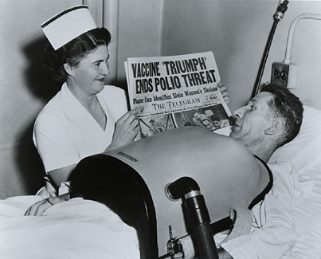
Please bring a bottle of wine to next Thursday’s meeting for a “Wheelchair Full of Wine” to be raffled off – proceeds to PolioPlus.

- Shoeboxes. Sponsored by Samaritans’ Purse. You fill ‘em – before November 15th. Ralph collects them. We pay the postage. https://www.samaritanspurse.ca/pack-a-shoebox/
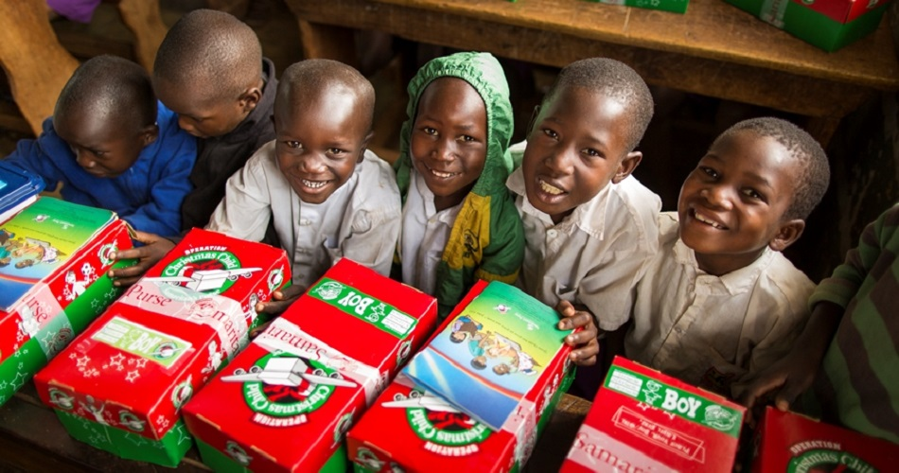

- Saturday, November 24th – our next breakfast at the 7-10 Club.
- Monday, December 3rd – our Christmas Social – Happy Hour (5PM) at Simon Holt. Please let Joy know that you will be coming.
- Saturday, December 8th – Breakfast with Santa in the Costin Hall, Lantzville.

Youth Exchange
After a good update from Jodie and Joy about the program, we undertook to be the sponsor club for an Outbound and an Inbound Exchange student in 2019-2020
We (Area 4 clubs) have 4 Outbound students for the coming year and expect to have 3 Inbound students visiting us. With the other clubs, we contribute financially – monthly stipend to host families and some spending money for the students. There is a strong 5-Club Committee that does most of the work, but it is our ‘turn’ to sponsor one of the students. Youth safety is the primary concern – Jodie will be our “Youth Exchange Officer” and Joy is our “Youth Protection Officer”.
A host family need not be a “Rotarian” family. The commitment is for 3 to 4 months. Usually a very positive experience for all. Would you be willing to be a host family? Talk to Jodie.

Rotary Minute
Starting next week -- just tell us a little bit about something to do with Rotary…

The Canadian Letters and Images Project
https://www.canadianletters.ca/
Dr Stephen Davies, of VIU, is the creator and curator of the “Canadian Letters and Images Project”. It was started in 2000 by the History Department of VIU and the majority of work is undertaken by students and volunteers.
The Project is an online archive of the Canadian war experience from all periods of Canada’s past. Through the digitization of contemporary letters, diaries, photographs and other materials, it permits Canadians to tell their story, and Canada’s story, in their own words and images.
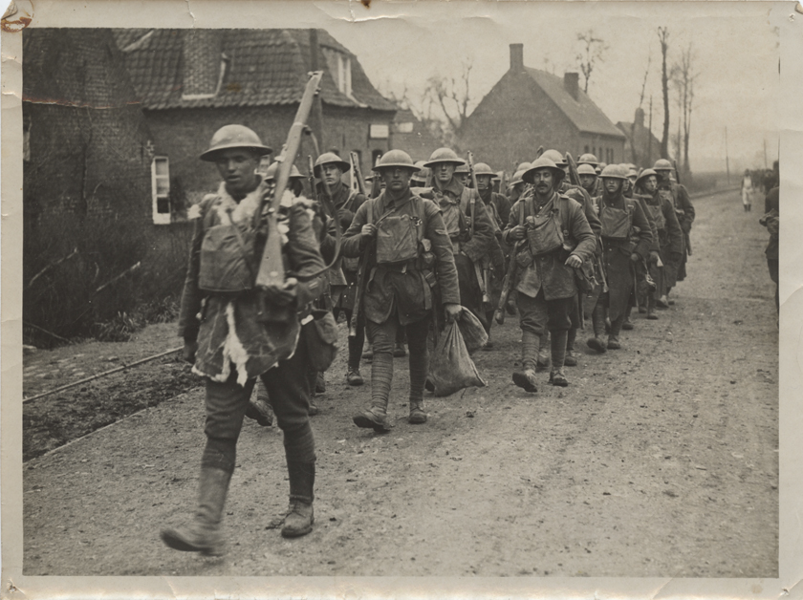
The Project contains 1000s of letters and photos from the South African War, World Wars 1 and 2, and the Korean War – from the ‘front’ and from the home-front. It is funded by VIU (for student researchers) and by donations (through the VIU Foundation).

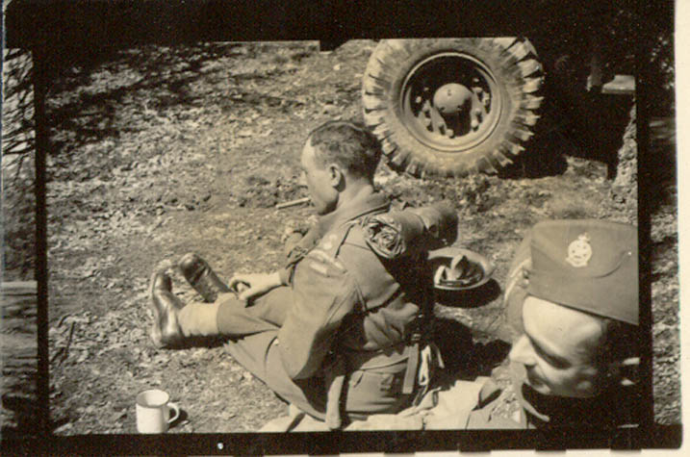

ROTARY INFO
You can find out where and when all the Clubs in District 5020 meet on the 5020 website:
www.clubrunner.ca/portal/Organization/Meetings.aspx?accountid=50092
Rotary International: http://www.rotary.org
Member’s access: https://www.rotary.org/myrotary/en
District 5020: www.rotary5020.org
Our website: www.clubrunner.ca/Lantzville
Our Facebook Page: www.facebook.com/RotaryClubofLantzville
Check it out – you might be surprised…

Beautiful BC – Rose Prairie
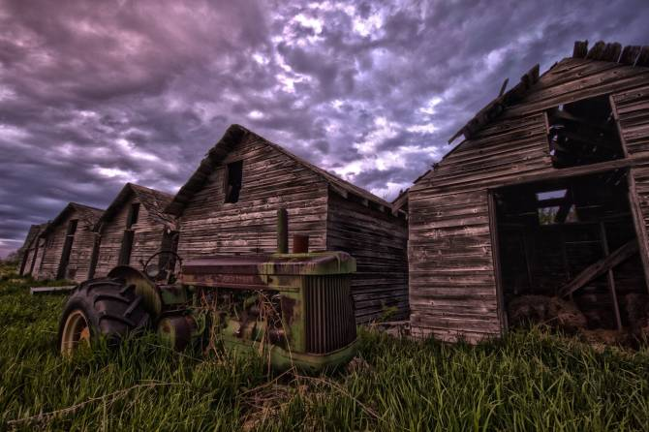

More advice from an old farmer:
* Sometimes you get, and sometimes you get got.
* The biggest troublemaker you'll probably ever have to deal with, watches you from the mirror every mornin'.
* Always drink upstream from the herd.
* Good judgment comes from experience, and a lotta that comes from bad judgment.
* Lettin' the cat outta the bag is a whole lot easier than puttin' it back in.
* If you get to thinkin' you're a person of some influence, try orderin' somebody else's dog around.
* Live simply. Love generously. Care deeply. Speak kindly. Leave the rest to God.

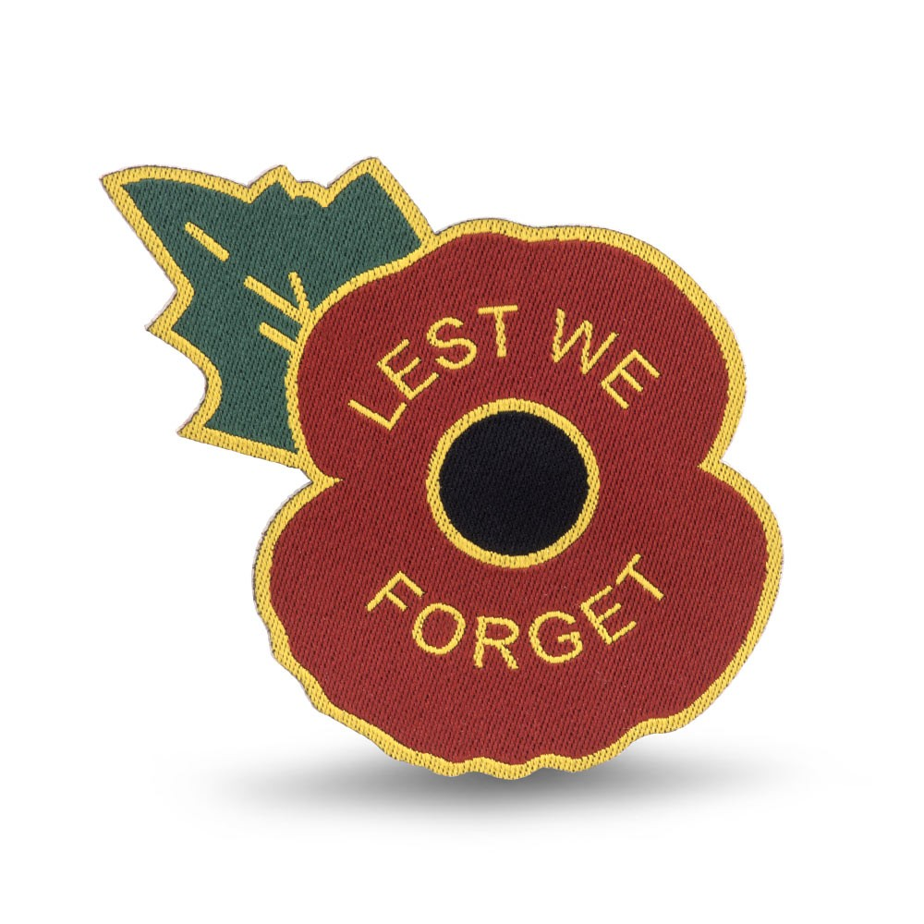
November 11th.

