



***November 2021***

***‘Rotary Foundation Month’***

**IN THE LANCE**

**Club News**

**The Rotary Foundation**

**Speakers**

**CELEBRATIONS**

Congratulations to Lee & Carolyn, Greg & Susan, Rachel & Solly on their wedding anniversary. Birthday wishes to James Williams.

**VISITORS**

Rotarians: Joan & Terry Toone

Colby Scott, VIU Alumni Association

Dawne Anderson, Nanaimo Salvation Army

**UPCOMING EVENTS**

December 6th – Club Social @ Simon Holt

11th – Santa Breakfast @ Costain Hall

12th – Lantzville Food Drive

**CLUB NEWS**

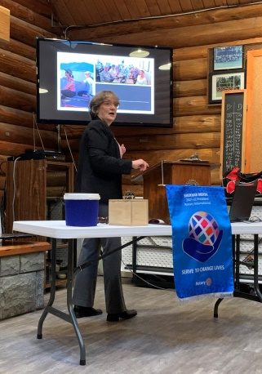

Weekly, President Jodie brings us up to date on Rotary activities happening within Nanaimo and within our District 5020. November was very busy!

Youth exchange director Stephen tells us several students applied for both the short term and long term 2022/2023 Youth Exchange programs.

Thanks to coordinator Ralph and the generous support of our members, we donated 32 Christmas Shoe Boxes.

A contribution of $ 1,400 to support the Rwanda high school completion project was approved.

Ongoing, Mark & Neil are working with Seaview School to supply shoes to students in need.

Twice, we had fun preparing and serving food to team players at the Nanaimo Rugby Club.

**RI VISION STATEMENT**

*“Together we see a world where people unite and take action to create lasting change – across the globe, in our communities, and in ourselves.”*

**THE ROTARY FOUNDATION**

In 1917, RI President Arch Klumph told delegates to the Atlanta Convention:

“*It seems eminently proper that we should accept endowments for the purpose of doing good in the world”.*

A year later the “Rotary Endowment Fund,” as it was first labeled, received its first contribution of

$ 26.50 from the Rotary club of Kansas City, which was the balance of the Kansas City Convention account following the 1918 annual meeting. Additional small amounts were annually contributed and after 6 years the endowment fund had reached $ 700. In 1928 the Rotary Foundation was formally established at the Minneapolis Convention. Over the next four years the Foundation fund grew to $ 50,000. In 1937, a $2 million goal was announced but these plans were cut short and abandoned with the outbreak of WWII.

In 1947, upon the death of Paul Harris, a new era opened for the Rotary Foundation as memorial gifts poured in to honor the founder of Rotary. From that time, The Rotary Foundation has been achieving its noble objective of furthering “understanding and friendly relations between peoples of different nations.”

Today, the Foundation receives more than $ 85 million each year in donations for educational and humanitarian work around the world. Worldwide Rotarians and Rotaractors unite in service to improve communities. Together, we promote peace; provide clean water, sanitation, and hygiene; support education; fight disease; save mothers and children; grow local economies; protect the environment; provide disaster relief; and eradicate polio.

Since it was founded, the Foundation has spent more than $ 4 billion on life changing sustainable projects.

**VIU Alumni Association**

*By Sheila Bergin*

Early November, we were lucky to have two presenters – Colby Althouse and Michael Ribicic. In addition to her day job as a Business Account Manager with RBC, Colby is the President of VIU’s Alumni Association. Michael, as well as being a teacher in School District 68, is the Vice President of the Alumni Association.

The Alumni Association connects alumni and students to build lifelong relationships to enhance VIU’S goals. The first Assoc meeting was in 2009. Since its inception VIU (including Malaspina College) has graduated 57,000 students. The Alumni Association donates to VIU through the Giving Tuesday program and with $ 1,000 scholarships and bursaries.

With the easing of COVID restrictions, the Alumni Association expects to ramp up information dispersal through the Alumni magazine & the reinstatement of the Call Centre. The goal is to connect with all graduates to not only ask for donations but to get more mentors to connect with students. The Association will be finalizing their action plan in December. The goal is to put on more events, including bringing in special speakers that will connect with the students and community and bring them to the campus.

.

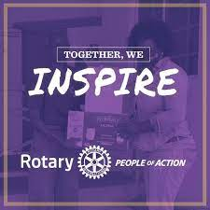

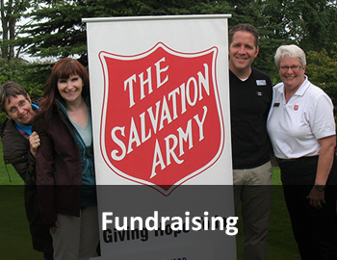

Dawne Anderson (above right) has been the fundraising and promotions coordinator for the Salvation Army (SA) for 26 years. Dawne spoke about their Nanaimo programs and services.

The SA has been active in Nanaimo since 1988. Some of the services provided through the New Hope Centre include the provision of emergency shelter, transitional housing, hot meals, box lunches, haircuts & showers. Monthly, they serve 10,000-13,000 meals.

Major fundraisers are the two Thrift Stores and the Kettle Campaign. Important to note, money raised @ Nanaimo events stays in Nanaimo. $ 295,000 is this year’s target for the Kettle Campaign.

Christmas fundraising events include the by donation, Nanaimo Concert Band performance @ Beban Park, the Give & Go Toy drive @ Steve Marshall Ford and the Santa Shuffle. These events facilitate Hamperville and the delivery of Senior’s Christmas Meals. If you are able to help with any of these, give Dawne a call @ 250-716-6595

**Rotary’s Vision Statement**

Together, we see a world where people unite and take action to create lasting change — across the globe, in our communities, and in ourselves.

**DID YOU KNOW?**

**Rotary’s Four Roles in Promoting Peace**

**Rotary and its members are:**

* **Practitioners:** Our work fighting disease, providing clean water and sanitation, improving the health of mothers and children, supporting education, and growing local economies directly builds the optimal conditions for peaceful societies.
* **Educators:** Our Rotary Peace Centers have trained over 1,300 peace fellows to become effective catalysts for peace through careers in government, education, and international organizations.
* **Mediators:** Our members have negotiated humanitarian ceasefires in areas of conflict to allow polio vaccinators to reach children who are at risk.
* **Advocates:** Our members have an integral role as respected, impartial participants during peace processes and in post-conflict reconstruction. We focus on creating communities and convening groups that are connected, inclusive, and resilient.