November 5th, 2020
Rotary Foundation Month

IN THE LANCE THIS WEEK

Rotary Foundation
Rotary Minute
Club Notes

VISITORS AND GUESTS
Visiting Rotarians – ADG Wayne Anderson; RCL honorary members Doug Pearson, Barry Sparkes; Craig Gillis, Campbell River Daybreak Rotary.

REMEMBRANCE DAY FELLOWSHIP

Invitation to Rotarians, Family, Friends
November 11th, 4:00-5:00 pm
Speaker Presentation: Lt. Col. (Ret) D.E. Slowski
For zoom link, email joycameron@shaw.ca

ROTARY CLUB OF LANTZVILLE
MISSION STATEMENT
Joining in fellowship to support growth and development in education and health for those less fortunate in our local and international communities.

ROTARY FOUNDATION-CRAIG GILLIS
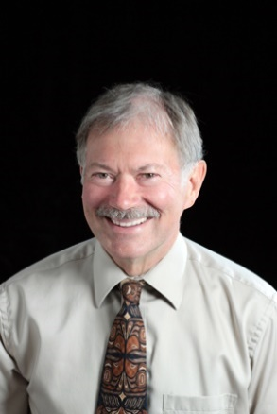

Craig gave an interesting, information presentation about the Rotary Foundation: how it works, how clubs benefit, ways for club members to contribute, Rotary Direct, how Foundation Recognition points work, and a review of Foundation reports available on the RI website. For a copy of the presentation including notes send joycameron@shaw.ca an email.

* The Rotary Foundation has three buckets: Annual Fund, Polio Plus, and Endowment Fund. For 2020-2021, the club has a goal of $3,623 for the annual fund. These contributions fund future District Community Grants, Global Grants, Rotary Peace Centres and Polio Plus.

* Rotary Club of Lantzville members all time giving is $ 233,246 to the Annual Fund.

* The generosity of our members and the good work we do is recognized and valued. Consistently, the Foundation is given top rating for how it uses donations, sustains its programs and services, and practices good governance and openness.

* The end is ‘close’ in the fight against polio. Today, 19 million people are walking because of polio eradication efforts over the past 32 years.

* Rotary Direct is an easy to use online way for
members to contribute to the Foundation.

Our thanks Craig, for your presentation!
MEETING NOTES

With PE Jodie at the helm & with good attendance, we enjoyed a productive early morning hour of Rotary fellowship. Thanks to the help of our more technically informed members, each and every meeting, we learn more about zoom meeting logistics.

Business update from Troy and Lee on the twice monthly 7-10 breakfast – attendance (and costs) are increasing. Approved by Club Directors, approved at our today member meeting is an email/mail/telephone call outreach in January 2021 to Rotary supporters for additional donations to fund this initiative.

From Dale, Salvation Army Kettles, with COVID protocols are a go. More information to follow.

ROTARY MINUTE – NEIL VALSANGKAR

Neil gave us an update on a recently approved initiative – revitalization of the District of Lantzville village core. The improvement plan encompasses Lantzville Road from Caillet to Dickinson Road with projects reflecting new community branding, improving walkability and creating new public gathering spaces. Plan implementation will create a pocket plaza with seating pods, interpretive content posts and wayfinding signage in front of Municipal Hall as well as other area projects designed to encourage business expansion & investment. The budgeted
$ 400,000 funding is in place and the project is expected to get underway this year.

NATURAL HIGHS

*Being in love. *Laughing hard

*Hot showers&Bubble baths
*Hearing your favourite song on the radio
*Holding hands with someone you care about

*Knowing you’ve done the right thing, no matter what other people think

