“Rotary: Be The Inspiration”

November 1st, 2018
Foundation Month

IN THE LANCE THIS WEEK

Two New Members

Thoughts about Remembrance Day

FUTURE EVENTS
Nov 11th – Remembrance Day
Nov 13th – Board Meeting, 4:30PM
Nov 15th – Walking to Santiago
Nov 22nd – Nanaimo Search & Rescue
Nov 24th – Breakfast at 7-10 Club
Nov 29th – Peter Ward, London Drugs
Dec 3rd – Christmas Social at Simon Holt

“VISITING” ROTARIANS
No one came to visit ☹

VISITORS and GUESTS
Lee Rowley – soon to be new member.
Stephen Cochrane – soon to be new member.

BIRTHDAYS & ANNIVERSARIES
 |  | DUTY ROSTER
DATE | GREETERS |  | CASH | Sgt-At-Arms | Invocation | INTRO | Foundation | Rotary  Minute
Nov 15th | Robertson & Werezak |  | Sparkes | Lemmon | Williams | Robertson | Elgie | Sparkes
Nov 22nd | Manikel & Rowley |  | Cohn | Lobay | Youssef | Manikel | Sparkes | Tamelin
Nov 29th | Youssef & Cochrane |  | Williams | McFadden | Walker | Youssef | Taylor | Taylor
If you cannot make your duty, it is your responsibility to find a replacement.
Congratulations to Greg & Susan – celebrating their 42nd on Nov 13th!

HEALTH of the CLUB
President Jan down-and-out with a bad flu bug.
Several others still suffering/recovering from the flu to various degrees…

ROTARY CLUB OF LANTZVILLE
MISSION STATEMENT
Joining in fellowship to support growth and development in education and health for those less fortunate in our local and international communities.

“Presidential” Observations
Past-President Joy – said she is looking forward to working in her garden, again, this afternoon…
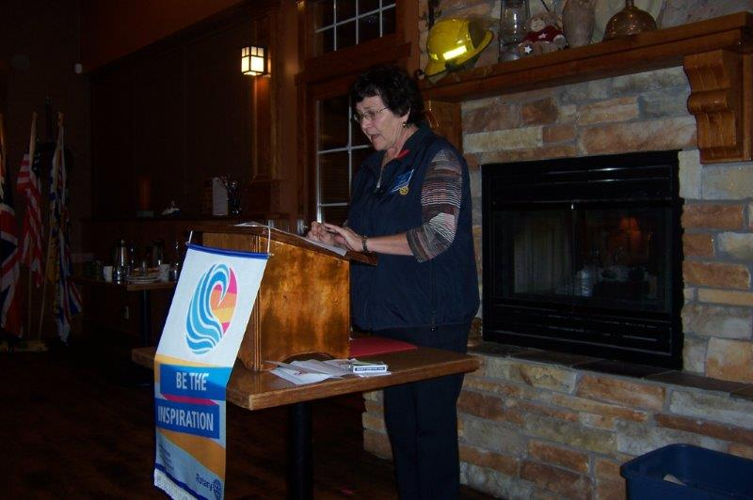

FOUNDATION
$545 contributed to the Rotary Foundation this morning. THANK-YOU!
We will match your total November contributions to TRF with Recognition Points towards your next Paul Harris Fellowship – minimum contribution $100, up to $200.

Sergeant-at-Arms
Dave E was the Sergeant and noted that David L was happy, politically speaking. Randy missed Rotary. Barry is fed up with Mother Nature. Mark gave paper money for a couple of announcements. Rachel is collecting warm clothing. Lee paid paper money to say nothing. Michael R is enjoying reading break (a long-past memory for most of us). Mike W is going back to Asia – this time with his wife. Brian R found the joker – for $20 – and gave it to TRF! Next meeting we start again with $10 in the pot…

News, Updates & Reminders
- The Rotary Awareness event planned for November 9th at VIU has been cancelled – not enough Rotarians signed up to make it viable.
- Shoeboxes. Sponsored by Samaritans’ Purse. You fill ‘em – Ralph collects them. Last day will be Nov 15th. We pay the postage. https://www.samaritanspurse.ca/pack-a-shoebox/
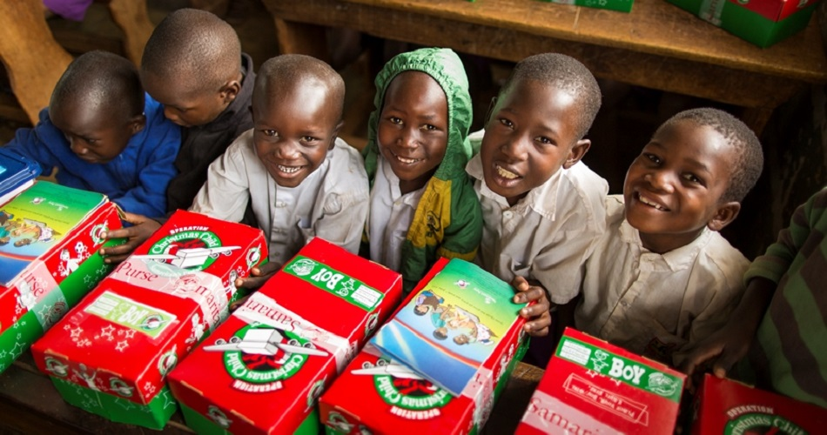

- Christmas Backpacks for people experiencing homelessness through LIFE Church Nanaimo. If you have some spare, warm clothes (scarves, socks, gloves, jackets, etc) – bring them to our next meeting and Rachel will pass them along.
http://www.vilifechurch.com/pages/giving--6

- Saturday, November 24th – our next breakfast at the 7-10 Club.
- Monday, December 3rd – our Christmas Social – Happy Hour (5PM) at Simon Holt. Please let Joy know that you will be coming.
- Saturday, December 8th – Breakfast with Santa in the Costin Hall, Lantzville.

LETTERS OF THANKS RECEIVED:
- From the VI Compassion Dogs for our contribution of $600.
- From Big Brothers and Big Sisters of CVI for our donation of $2,500 towards their “Game On” in-school mentoring program.
- From Sara Fulla, the 2018 recipient of our annual $500 VIU Award.

Two New Rotarians
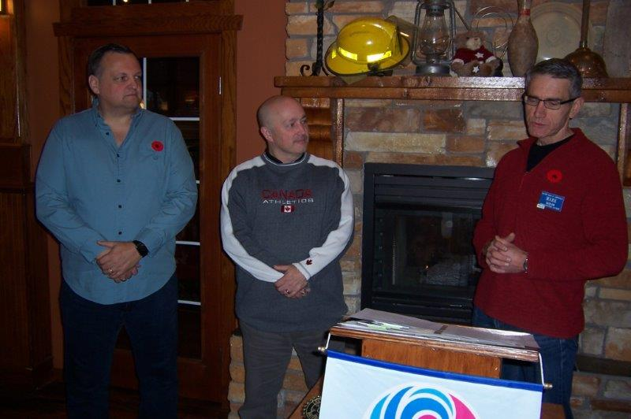
Our Director for Membership Mark T (on the right) led the induction of two new members into our Club – Lee Rowley (an engineer, on the left) and Stephen Cochrane (a social worker with BBBS, in the centre).
Welcome to Rotary, Stephen and Lee. ☺

Rotary Minute
Doug S talked about his involvement in the Air Cadet program. He is the Immediate Past President of the Air Cadet League of BC and a current National Governor. It’s a great organization that starts preparing future leaders for Canada. There are about 53,000 Army, Navy and Air Cadets in Canada; 29,000 Air Cadets, 4,600 in BC.
The Department of National Defence spends about $250M on the program – primarily on salaries for Cadet Instructor Officers and for training. The individual Corps must raise funds for ‘operating’ costs – by sponsorships and fund raising events.
Check them out: http://aircadetleague.com/

Thoughts about Remembrance Day
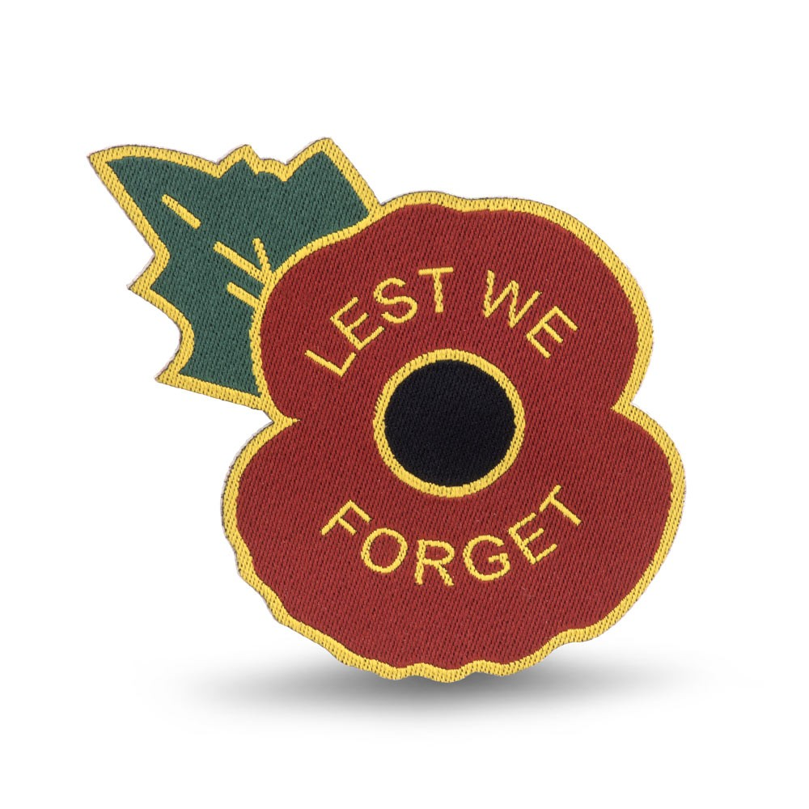
Brian McFadden noted that it has been a busy week at the Vancouver Island Military Museum with visits everyday from youth groups, including 65 Navy League Cadets (ages 9-11) last night. A great experience for all.
The Museum will be open, at no cost, from 11AM this Sunday for all visitors.
Sunday, November 11th, is the 100th Anniversary of the signing of the Armistice that ended the First World War.
From 1914 to 1919, the governments of the British Empire gave 1,160,000 “Dead Man’s Pennies” to the next of kin of men and women who died during the First World War.
LCol John McRae was a doctor and a teacher who served as a doctor in the Canadian Artillery and believed in the duty to fight for his country but was appalled by the carnage on the battlefield. In May 1915, after witnessing the death of a close friend, he wrote “In Flanders Fields”.

In Flanders fields the poppies blow
Between the crosses, row on row,
That mark our place; and in the sky
The larks, still bravely singing, fly
Scarce heard amid the guns below.

We are the Dead. Short days ago
We lived, felt dawn, saw sunset glow,
Loved and were loved, and now we lie
In Flanders fields.

Take up our quarrel with the foe:
To you from failing hands we throw
The torch; be yours to hold it high.
If ye break faith with us who die
We shall not sleep, though poppies grow
In Flanders fields.

ROTARY INFO
You can find out where and when all the Clubs in District 5020 meet on the 5020 website:
www.clubrunner.ca/portal/Organization/Meetings.aspx?accountid=50092
Rotary International: http://www.rotary.org
Member’s access: https://www.rotary.org/myrotary/en
District 5020: www.rotary5020.org
Our website: www.clubrunner.ca/Lantzville
Our Facebook Page: www.facebook.com/RotaryClubofLantzville
Check it out – you might be surprised…

Beautiful BC – Lanezi Lake, Bowron Lake Prov. Park

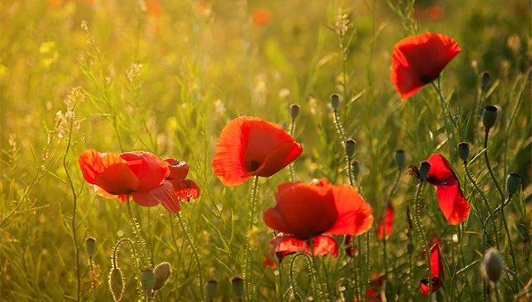
Take a few minutes on Sunday to remember those who served and died to protect our way of life – in many conflicts since Canada became a country.

