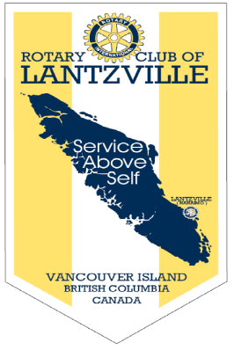

“ROTARY CONNECTS THE WORLD”
October 10th, 2019
Economic & Community Development Month

IN THE LANCE THIS WEEK

Nanaimo Foodshare – Jen Cody

Rotary Information

FUTURE EVENTS

October 15th -Club Fellowship
Boston Pizza – 5:00 pm

October 17th - Classification Talks
Troy DeJong, James Williams

October 24th - KidSport Nanaimo
Virginia Brucker

DUTY ROSTER – October 17th, 2019
Greeters: Rodgers/Cameron Cash : Valsangkar
Sgt-Arms: McFadden Invocation : Bergin
Introductions: Ribicic Foundation: Walker
Rotary Minute: Manikel

ROTARY CLUB OF LANTZVILLE
MISSION STATEMENT
Joining in fellowship to support growth and development in education and health for those less fortunate in our local and international
Communities.
VISITORS AND GUESTS
Jen Cody, executive director, Nanaimo Food Share, former club member and club president (x2) Len Olson and Bob Wall, Nanaimo Daybreak Rotary joined us for breakfast.

BIRTHDAYS, ANNIVERSARIES

This week, happy birthday to Shawn Kilner. Congratulations to Jamal & Liz on their 36th wedding anniversary.

HEALTH OF THE CLUB
No news = good news!

CLUB PRESIDENT
BARRY SPARKES

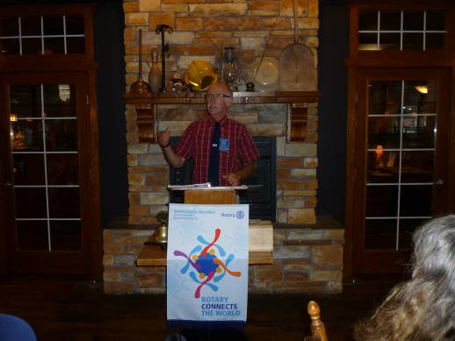
Despite the change in weather, we had a good meeting turn-out and as always great fellowship.
Paying close attention to our pet owner members, Barry suggested we add a new pet owner member category.

Keeping together is progress. Working together is success. If money is your hope for independence, you will never have it. The only real security that a person can have in this world is a reserve of knowledge, experience and ability. - Henry Ford

FOUNDATION
$ 100 contributed to the Rotary Foundation. Many thanks! Barry Sparkes had the lucky ticket drawn for $ 16.
SERGEANT AT ARMS – RALPH LEMMON

Ralph started off by teasing Steve. Thanks to an incorrectly set alarm, at 5:15 a.m., Steve was the only person in the restaurant parking lot. Troy is enjoying Nanaimo – but still very much missing the Calgary snow. Doug did not enjoy his recent 2 ½ hour journey over 65 kilometers in Southern Alberta. Harry let us know, thanks to our Fall single digit temperature, he and Maggie are off to warmer places. Bob Wall was happy to hear us correctly sing O’Canada. Seems that is not happening at the NHL. Michael was happy to have behind him his first practicum. Mike and others happy to see Len, hope he comes more often. On the home front, Lee was very happy to have his running water restored. Barry and Bonnie enjoyed their Nova Scotia visit – beautiful Fall colours, lovely weather and a good time shared with friends.

And then there was a big drum roll. Pictured below, looking for the joker and this week’s pot of $ 410. Alas, it did not happen!

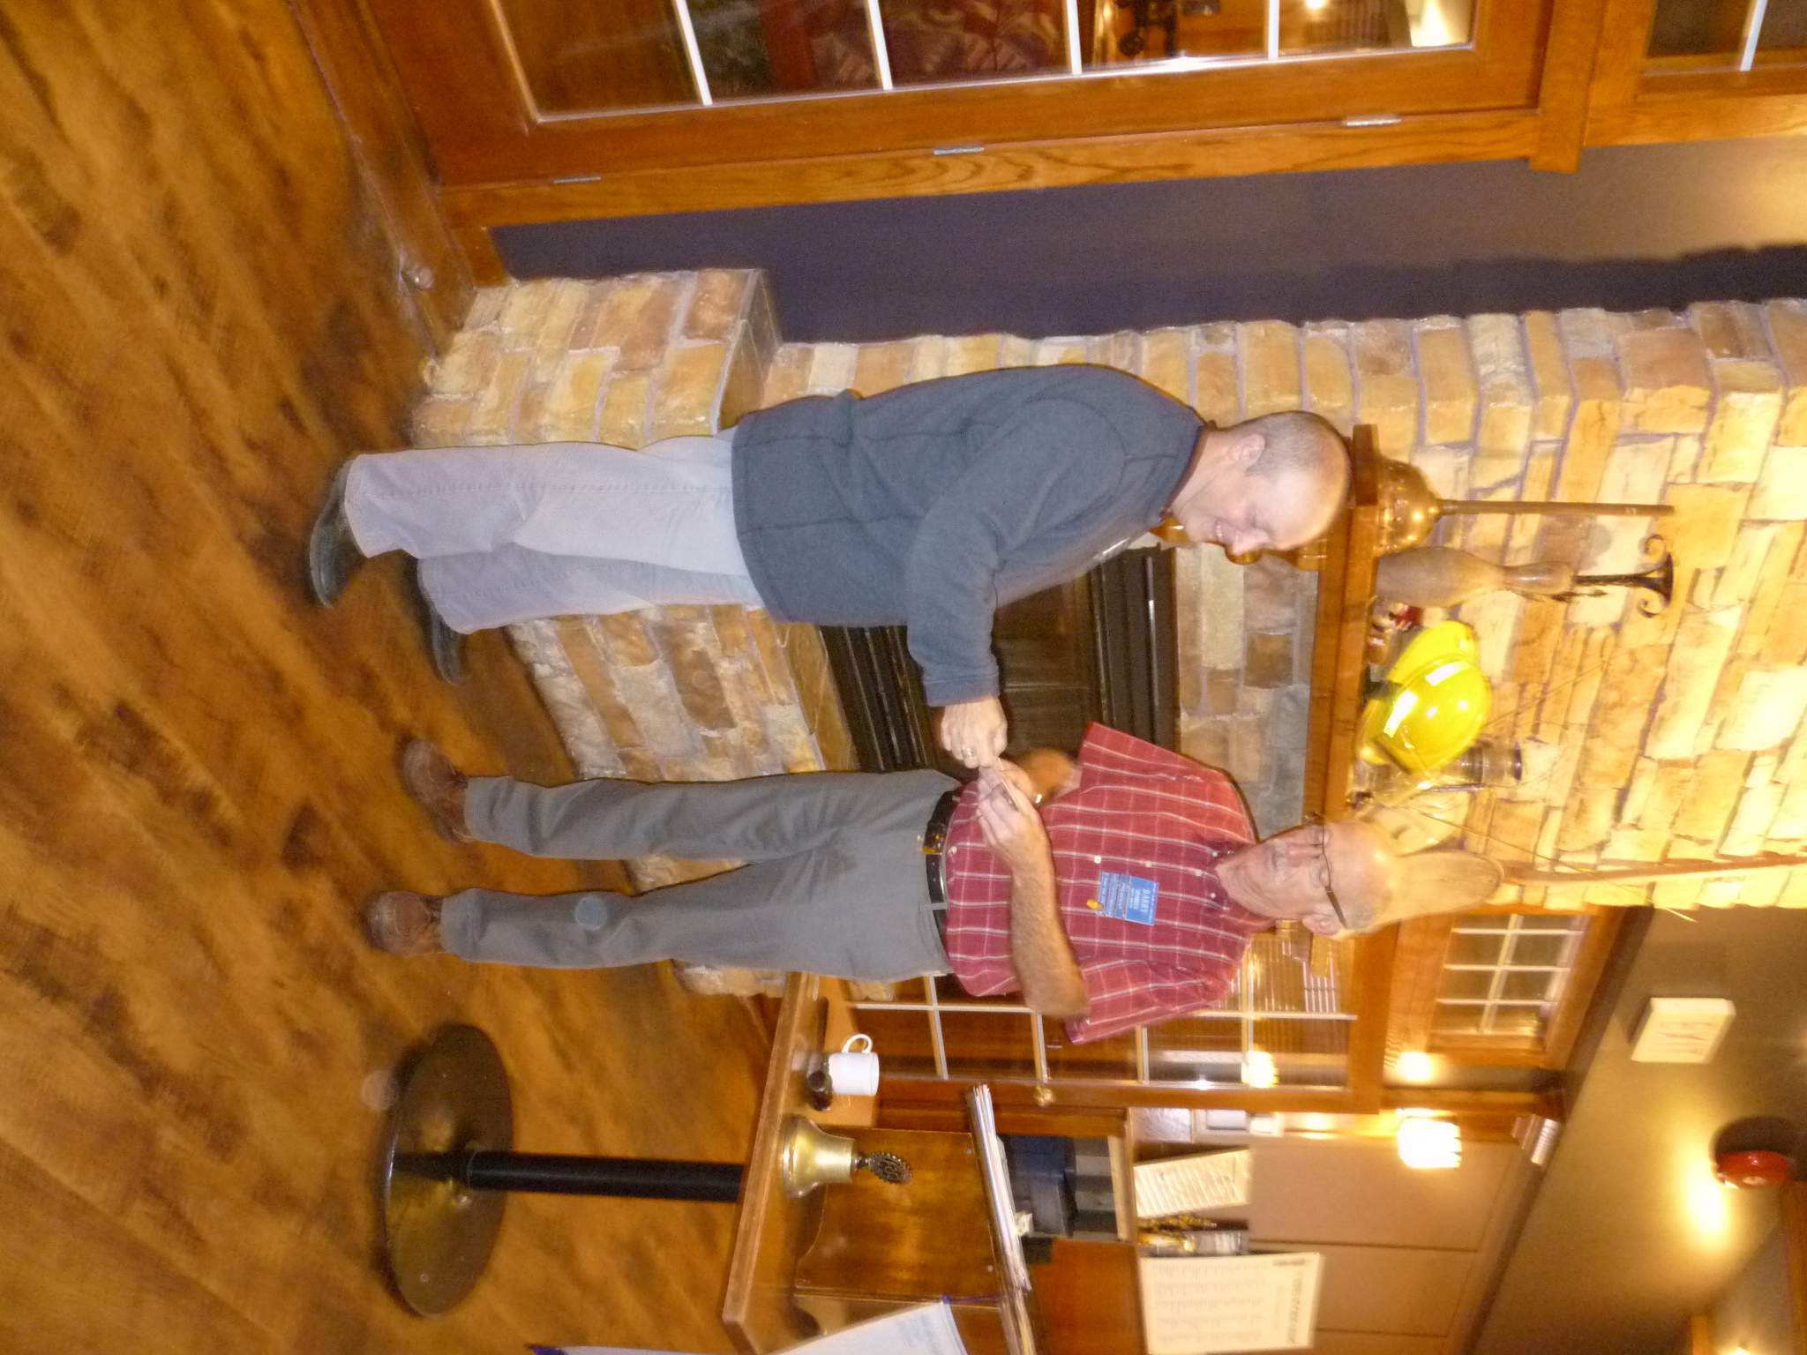

HAPPY THOUGHTS…being your own boss is great because you get to choose which 16 hours of the day you will work.

HAPPY THANKSGIVING!
THE GOOD FOOD BOX
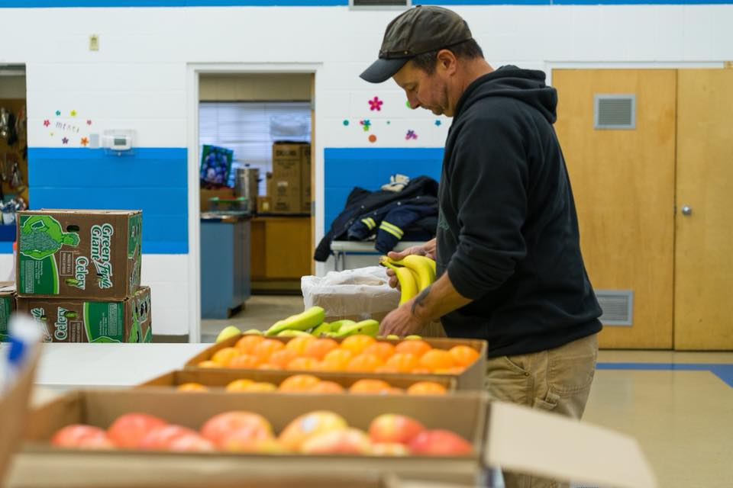
NANAIMO FOODSHARE

As a former 7 year Nanaimo Foodshare (NF) employee, it was most appropriate that Stephen introduced our guest speaker. Jen Cody is the executive director of Nanaimo Foodshare, a nonprofit that supports programs and community development related to food security and sustainable local food systems. Jen is a community nutritionist and registered dietitian.

The Nanaimo Foodshare centre is located @ 271 Pine Street. NF began in 1997 and it is a registered non-profit charitable organization. The Society operates under the direction of an 11 member volunteer board and 3 full time employees. Their funding comes through grants and generous community supporters.

NF is engaged in multiple community initiatives designed to educate, facilitate and support sustainable community food systems. One program, the $ 10 Good Food Box, helps participants stretch their food dollars while providing affordable access to fruits and vegetables. The Urban Farms programme combines teaching employment skills with learning about small scale food production. Other programs include gleaning, Seedy Sunday, kids get cooking and overseeing community school gardens.

From her presentation, one learns that everyone involved in NF is very passionate about their good works. Our community is much blessed to have so many caring people, like Jen making sure we know how much “Local Food Matters.”
SUBMISSIONS, UPCOMING EVENTS

October 18th - Interact Fun Fair @ Pleasant Valley
Contact Jodie for details

October 19th - YOUTH-A-PALOOZA
John Barsby, 10-5 pm
Stephen Cochrane 250-616-9949

October 19th - Oktoberfest, Beban Park, $ 30
Nanaimo Daybreak Rotary

October 24th -World Polio Day

MEMBER HOBBIES

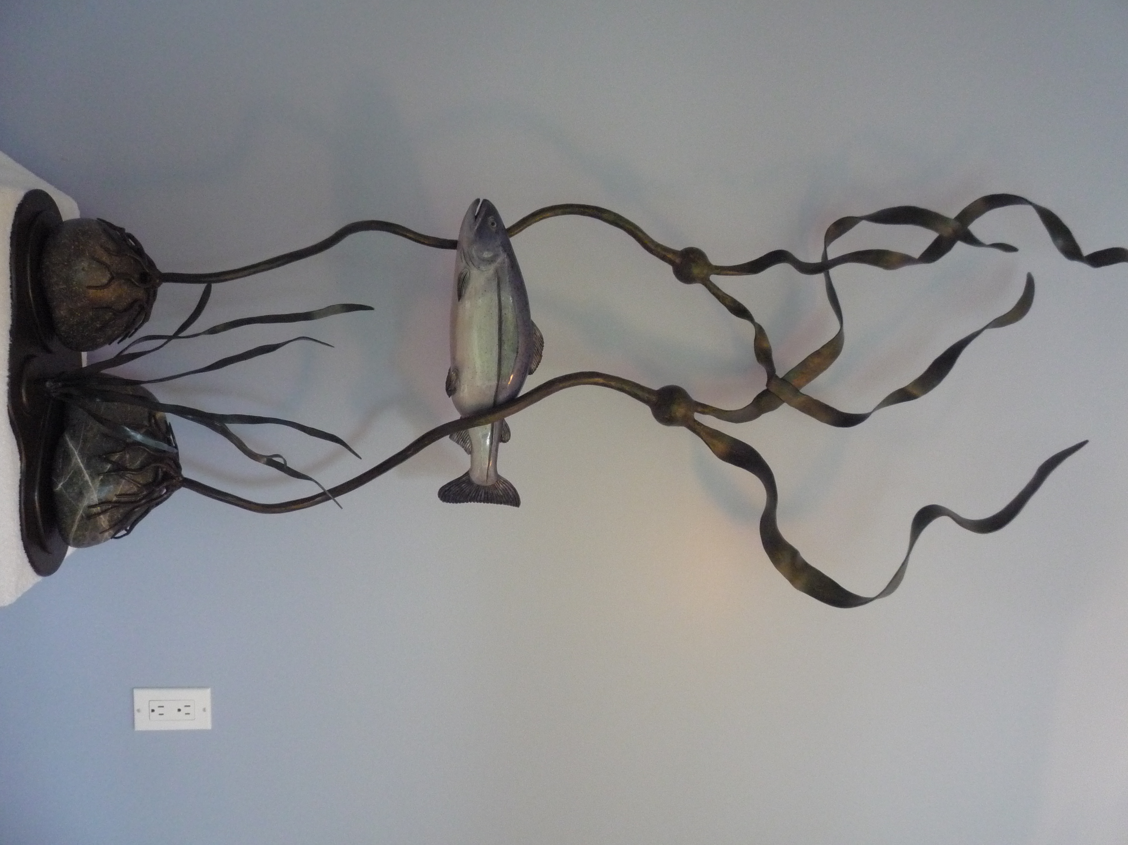

HARRY HELFRICH - BLACKSMITH

“When I retired, I took a basic blacksmith course and started making tools, knives, furniture and art out of any kind of scrap metal I could find. In this kelp sculpture I used found material including trailer hitch balls, beach rocks, garage door springs, dock pins, etc. Along the way, working with my blacksmithing skills, I have also learned how to weld. In all, today I have a great time banging on steel.”

Thank you Harry for sharing!
OCTOBER IS ECONOMIC AND COMMUNITY DEVELOPMENT MONTH

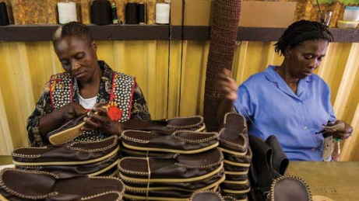
Rotary supports investments in people to create measurable and enduring economic improvement in their lives and communities.

The Rotary Foundation enables Rotarians to invest in people by creating sustainable, measurable and long term economic improvements in their communities and livelihoods by:

1. Building the capacity of entrepreneurs, community leaders, local organizations, and community networks to support economic development in impoverished communities;
2. Developing opportunities for productive work;
3. Reducing poverty in under-served communities;
4 Supporting studies for career-minded professionals related to economic and community development.

MEETING NOTES

Steve needs 8:00 am help with set-up for the October 19th event.

Next month, our club is sponsoring two RYLA students at Camp Qwanoes in Crofton.

A reminder about the Nanaimo Rotary Club fellowship event at Chemainus theatre on December 5th. See Dale Werezak for more info.



