October 15th, 2020
Economic & Community Development Month

IN THE LANCE THIS WEEK

Syrian Kraydi Family
Fund Raising Drive

VISITORS AND GUESTS

Visiting Rotarian – Rod Mont – Daybreak; guests Jill Mont& Doha Alkhatib

BIRTHDAYS & ANNIVERSARIES

Anniversary congratulations to Jamal & Liz.

HEALTH OF THE CLUB

Greetings to everyone from Brian Rodgers!

ROTARY CLUB OF LANTZVILLE
MISSION STATEMENT
Joining in fellowship to support growth and development in education and health for those less fortunate in our local and international communities.

MEETING NOTES

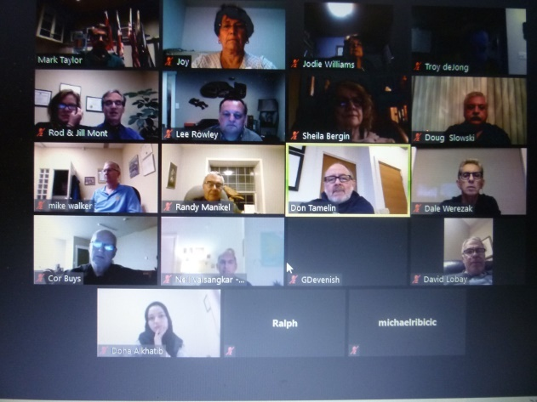

President Mark started by welcoming us to the Rotary Club of Lantzville, located in the traditional territory of the Snaw-naw-as First Nation, followed by our national anthem.

Troy presented details (and sent by email) about our October ENDPOLIONOW fundraiser. TY Troy & Lee.

Jodie reports, Interact had their 1st zoom meeting

Congratulations to Don T on his re-appointment as the Canadian representative on the District Finance committee.

Thought for the day…Example is not the main thing in influencing other people; it’s the only thing. ~~~Abraham Lincoln

~~~~~~~~~~
Four Way Test

1. Is it the TRUTH?
2. Is it FAIR to all concerned?
3. Will it build GOODWILL and BETTER FRIENDSHIPS?

4. Will it be BENEFICIAL to all concerned?

DOHA ALKHATIB

Doha, together with Rod and Jill Mont, gave an interesting and inspirational review of her family’s journey from Syria to Nanaimo.

Her family of 7 have lived in Nanaimo for three years. Doha has completed dental hygienist training, her younger siblings are in school and Dad works in the trucking industry.

The family is desperately concerned about the safety and well-being of their relatives who have been refugees in Lebanon for ten years. The goal is to see them relocated to a safe and secure home in Nanaimo.

Jill & Rod have undertaken to help the Alkhatib family achieve their goal. Financially the family has raised $ 17, 632 towards the $ 33,715 required by Immigration, Refugees and Citizenship Canada
to support the Kraydi family when it arrives.

As a legacy gift to Rod’s Dad, Rod and Jill have committed to match contributions up to $ 8,000.To date $2,700 has been donated. Donations can be made by E-transfer,stating your name and address, to rotarysyriafamily@gmail.comor by cheque to St. Philip-by-the-Sea Refugee Fund with Kraydi SG in the memo line. Donors will receive a Charitable Donation receipt.

Following the presentation, there was lively dialogue and questions about immigration, sponsorship and family re-settlement. TY Rod, Jill and Doha for bringing this story & opportunity to us.FYI…attached to the Lance is a letter to Members of the Rotary Club of Lantzville from Rod & Jill Mont.

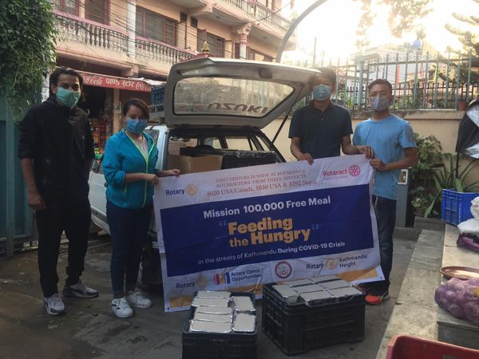

KATHMANDU, NEPAL

Found on Facebook…
“We Rotaractors of Kathmandu Mid-Town and the young Rotarians of RC Kathmandu Height play a key role working with Ms Indira R Magar to feed the hungry in the streets of Kathmandu.

We were delighted to have the support from our members who had committed their time throughout the day on assisting with the entire process (from cooking meal to packaging to final phase of delivery).

We would like to express our gratitude to all the International Rotarians from USA and CANADA for their financial aid on our mega event.

Thank you Rtn. Dr. Chandra Lekha Tuladhar ma’am for your continuous support and coordinating with the sponsors.”

From a September 27th email, we learned food distribution happens on Friday’s and Sunday’s in several different locations. Each day 4 Rotarians and 8 Rotaractorsworked from 10:00 am till 8:00 pm. A veg meal consisting of rice, veg curry, green salad and water was served to a mixed group of children and elderly citizens.

UD5020 MAGAZINE

At an ‘In Celebration of 50 years’ work party, Ladysmith Rotary is featured on the cover of the October edition.

ROTARY OPENS OPPORTUNITIES

According to RI President, Holger Knaack, “Rotary is not just a club you join, it is an invitation to endless possibilities.” Rotary opens opportunities to make a positive difference and connect with others in our communities throughout the world. Here’s a short list of some reasons to join Rotary: FRIENDSHIP AND NETWORKING;
PERSONAL GROWTH AND DEVELOPMENT;
THE OPPORTUNITY TO SERVE; - FUN AND ENTERTAINMENT.

CONGRATULATIONS & TY

Michael’s well written submission ‘Former PM Zooms into the Rotary Club of Lantzville’ can be read on page 92.

Produced monthly, UD5020 is an interesting, informative read.

JENNIFER JONES
EVANSTON, Ill. (October 1, 2020) — Jennifer Jones, member of the Rotary Club of Windsor-Roseland, Ontario, Canada, will become Rotary International’s president for 2022-23. She will be the first woman to hold this office.
Jones, whose confirmation comes at a unique time in history, is inspired by how the organization and its global members continue to adapt, connect and serve their communities in new ways during the coronavirus pandemic. Jones says she wants to harness this moment of change to develop metric-driven goals that challenge us to innovate, educate and communicate opportunities that reflect today’s realities.
As Jones looks ahead to her presidential term, she confirms that she’s prepared to take on existing and new challenges as society continues to evolve at a rapid pace, and like Rotary presidents before her, is eager to set Rotary on course for a robust and vibrant future.
“Years ago, I asked one of our incoming presidents what he wanted his legacy to be. He very quickly told me he wasn’t interested in building a legacy and that he was interested in getting to work,” said Jones. “Those words have always stuck with me, and I too simply want to get down to work.”
Jennifer is the Founder and President of Media Street Productions Inc., a twenty-five-year old, award-winning media company in Windsor, Ontario.
Jennifer has strengthened Rotary’s reach and impact through her service in many roles including as Trustee of the Rotary Foundation, RI Vice President, and co-chair of the End Polio Now: Make History Today campaign. Jennifer is married to Rotarian Nick Krayacich, a family physician.

