

“ROTARY CONNECTS THE WORLD”
October 17th, 2019
Economic & Community Development Month

IN THE LANCE THIS WEEK

Troy DeJong, James Williams

Rotary Information

FUTURE EVENTS

October 24th - World Polio Day

KidSport Nanaimo
Virginia Brucker

October 26th - 7-10 Breakfast

October 31st - Royal Canadian Search & Rescue
Shawn Petriw

DUTY ROSTER – October 24th, 2019
Greeters: Lemmon/Devenish Cash : DeJong
Sgt-Arms: Tamelin Invocation : Cochrane
Introductions: Bell Foundation: Valsangkar
Rotary Minute: Devenish

ROTARY CLUB OF LANTZVILLE
MISSION STATEMENT
Joining in fellowship to support growth and development in education and health for those less fortunate in our local and international
Communities.
NO VISITORS OR GUESTS

BIRTHDAYS, ANNIVERSARIES
On October 14th, Jamal & Liz celebrated their
36th wedding anniversary.

CLUB PRESIDENT
BARRY SPARKES

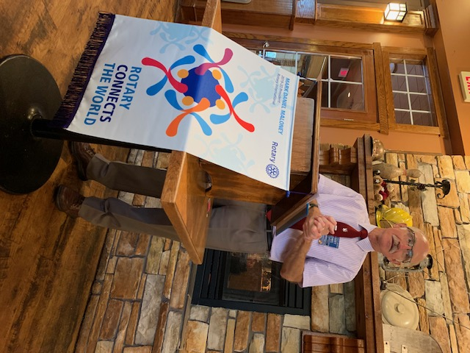

A warm welcome to everyone. Our numbers were small, energy was good.

Barry knew, on this date in 1878, Sir John A. Macdonald was reelected; 1973 was the beginning of the OPEC oil war. This caused the cost of fuel to double overnight.

“Learn from yesterday, live for today, hope for tomorrow. The important thing is not to stop questioning.” …Albert Einstein

FOUNDATION
$ 76 contributed to the Rotary Foundation. Many thanks! Mike Walker had the lucky ticket drawn for $ 14.
SERGEANT AT ARMS – DOUG SLOWSKI

Happy $’s for our Boston Pizza social and a big TY to George. Barry came away intrigued with the fund raising possibilities of a Rotary Club of Lantzville horse racing syndicate. Michael R. challenged each of us to bring a guest to a Rotary meeting this year. This week, Don T. is off to play hockey with his ‘grumpy old men’s’ team in Campbell River. Both Barry and Jan are enjoying their curling activities. Dale is delighted with the Club support for the Community Service committee. Sad $ from Michael R., very disappointed about the dissolution of the Nanaimo Youth Advisory Council. This morning, Doug will participate in the world wide “Drop, Cover and Hold On” Earthquake Drill at the Nanaimo Fire hall.

Disappointingly, Mike did not find the joker. Next week’s pot is $ 420.

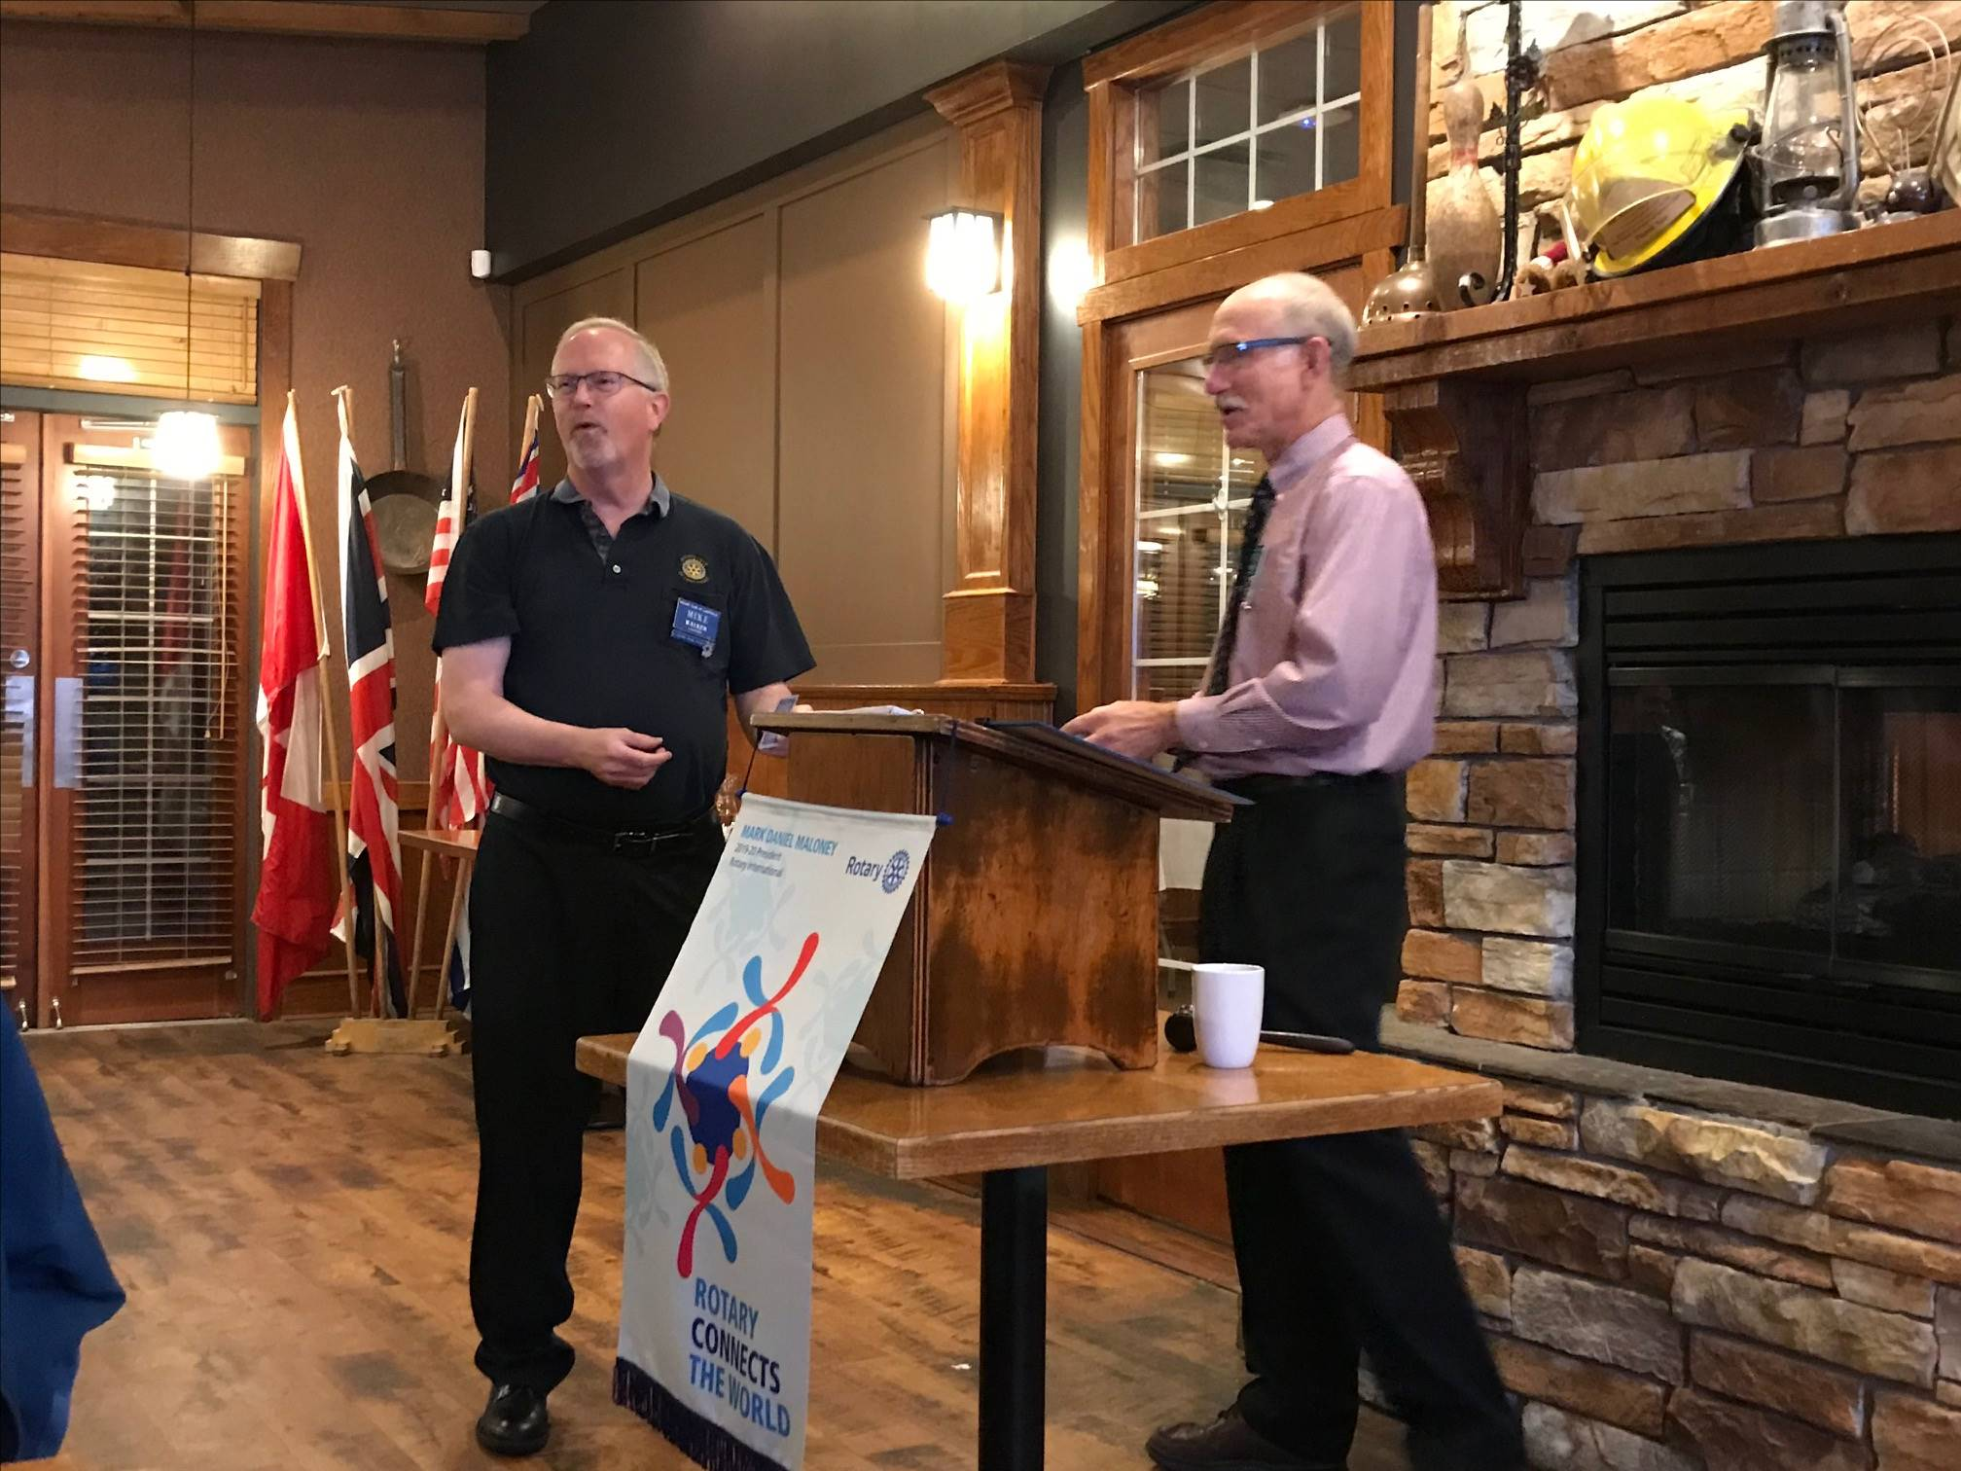

Rotary Youth Exchange in Nanaimo - Facebook
Check this out - Dorien Abbekerk, our 2018-2019 exchange student from Netherlands has posted an amazing 6 minute video with all the fun videos and moments she could find. “ Soooo many things to be thankfull for. Miss you guys sooo much on the other side !! And hope you enjoy seeing how much fun my year was. ❤”

JAMES FRANCIS WILLIAMS

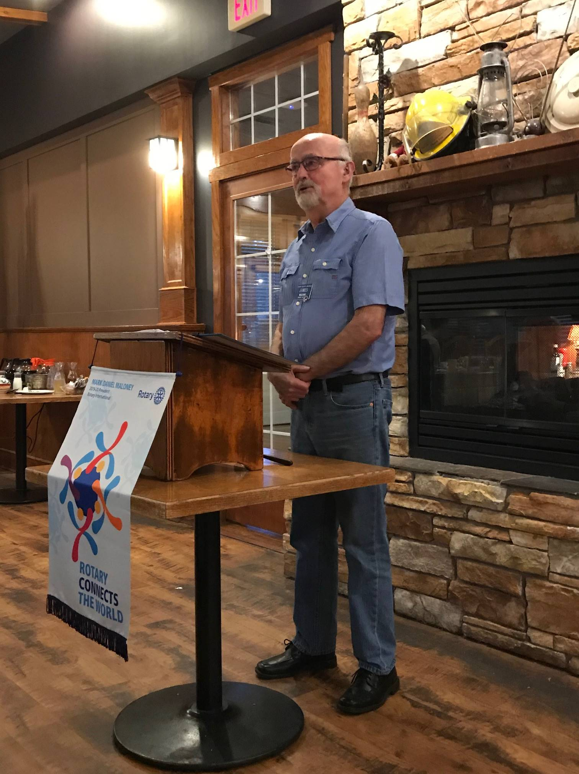

Also known as ‘Frank’, James was born in Victoria. With inherited health problems, his early school years were challenging. Looking for adventure and travel, at 17 James joined the Navy. For 10 years he got to see the world and also received ‘quite an education.’ Wanting a change, James earned his Bachelor of Education degree from the University of Victoria. For 30 years, he taught math and science in Terrace, Campbell River and Chemainus. The ups and downs of everyday life triggered stress, heart problems and depression. With perseverance and good friends, fortunately, these issues were overcome. Jodie changed his life and together marathon running became a shared passion. James has always enjoyed sports and physical actives. Today, his first love is hiking. Very few of us will ever know the thrill of climbing a glacier. James did it!!!

James has an awesome sense of humour. We like that James was missing us and chose to re-join the Club. This past year, James and Jodie attended the RI convention in Hamburg. In 2017 they participated in a District 5020 New Zealand Friendship Exchange.

SUBMISSIONS, UPCOMING EVENTS

October 24th - World Polio Day
October 27th - Grant Management Seminar
October 29th - Rotary North Beer & Burger
White Spot, Woodgrove, $ 25

NANAIMO ROTARY BOOK SALE
NANAIMO NORTH TOWN CENTRE
DAILY UNTIL OCTOBER 27TH

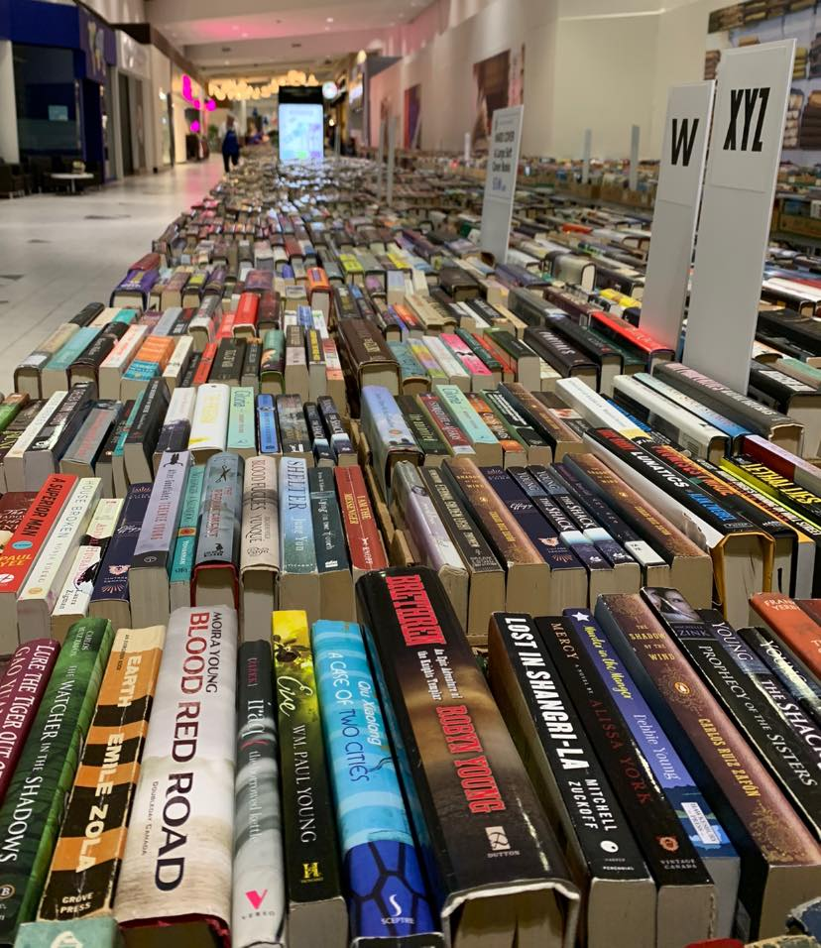

ROTARY MINUTE – RANDY MANIKEL

Starting in 1990, the RI Board of Directors urged Rotarians to identify new projects serving the elderly that emphasize intergenerational activities and the integration of seniors into society and the workplace. The Board called for an approach that stressed service “with” the elderly as well as “for” them.

Many Rotary clubs seek ways to serve the older persons of their community who often face a multitude of challenges. The greatest need of aging individuals is frequently a mere expression of real caring and concern by thoughtful friends.

Loneliness is a huge stress for a significant number of people. Randy’s challenge, echoed by fellow members was for us to give thought as to how we could focus on addressing the needs of our aging population. Without doubt, there is a growing possibility that each of us may someday be on the receiving end.
TROY DEJONG

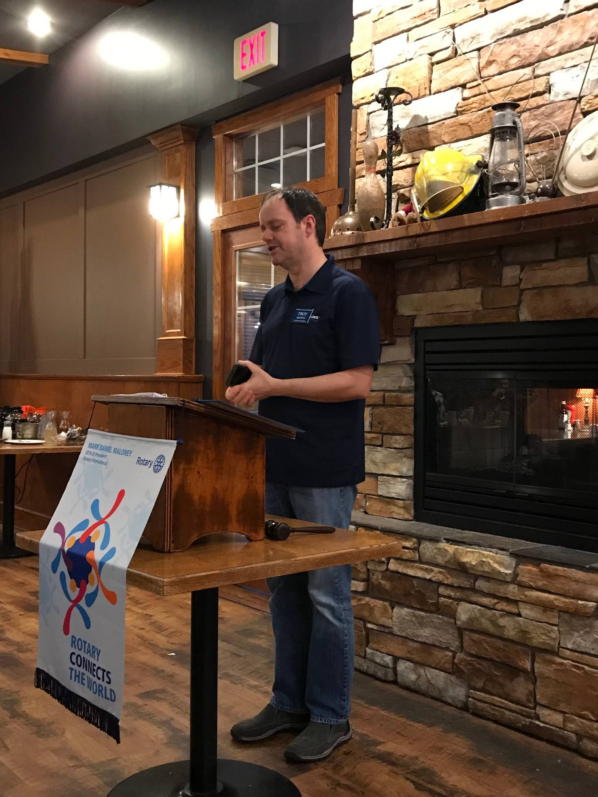

Last year, wanting to be closer to family, Troy moved from Calgary to Nanaimo. Prior to that he has lived in Edmonton, Vancouver & Kelowna. Troy is an enthusiastic Calgary Flames supporter, having graduated the same year they won the Stanley Cup. After High School, Troy graduated from a business program at Okanagan College. In his work world, he designs, sells and installs security systems for business clients. He has also worked as a manufacturers’ representative. Troy’s hobbies include biking, kayaking and scuba diving. On days off, he regularly visits his extended family in North Vancouver.

We are delighted that Troy chose to join Rotary and the Rotary Club of Lantzville. He very much is looking forward to learning more about each of us and more importantly, about the ‘workings’ of Rotary. Like many of us, Troy sees Rotary as a way to give back to community.



