



***October 2021***

***‘Economic & Community Development Month’***

**IN THE LANCE**

**Club News**

**Inspiration**

**Bits and Pieces**

**Speakers**

**CELEBRATIONS**

Birthday wishes to David& Shawn

**VISITORS**

Rotarians: ADG Ken Hammer, Joan & Terry Toone, Linda Murray; Cheryl Nixon, Spice of Life Catering; Sophia Maher, Nanaimo Museum; Carolyn Holmes, Nanaimo Art Gallery; Isabel VanGrootheest, RN Society

Charlotte

**NOVEMBER 4TH CLUB MEETING**

6:45 a.m. Nanaimo Rugby Club – Speakers

Colby Scott & Michael Ribicic

VIU Alumni Association Board

**CLUB NEWS**

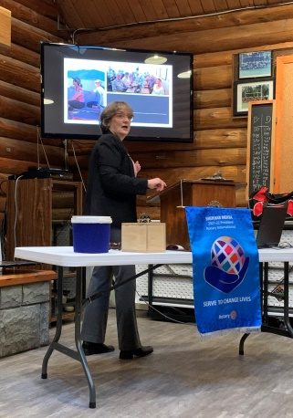

At our early October meeting, President Jodie spoke about participating in 2017 on a District 5020 Rotary Friendship Exchangeto New Zealand.Jodie shared lots of interesting pictures & several unique stories about this travel opportunity.

**Club Business…**Our RCL approved support in the amount of $ 2,000 to the RNSociety for facilitator training for grief support to children and $ 1,500 to Literacy CVI for their Literacy by Radio Youth project.

ADG Ken presented Troy with aPolioPlus Society pin. Amazing news, the Taliban has agreed to a November polio campaign restart with a 5 day nationwide goal to reach 10 million children.

Brought to our attention by Stephen, many thanks to club members who were able to respond to the dire needs of a local family.

Don and others greatly enjoyed picking grapes at Enrico Winery. At the Lantzville Centennial Garden we re-installed the newly painted Rotary wheel, planted daffodils & did minor clean-up. Our cooking support at the Hornets triple header was much appreciated.

Despite the rain, a few hardy souls met at the fire pit, participated in a tour of McNabb’s corn maze and enjoyed dinner at the Crow & Gate.

**INSPIRATION – STEPHEN COCHRANE**

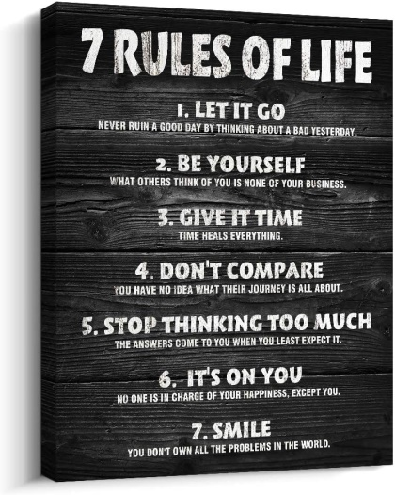

**ROTARY MINUTE – MARK TAYLOR**

For September 30th, the National Day of Truth & Reconciliation, Mark spent several hours researching the history and legacy of Indian Residential Schools (IRS) in Canada. Also known as Orange Shirt day, this wasthe 1st day in 1973 of IRS for 6 year old Phyllis Webster andthe removal of all her personal clothing including a new orange shirt.

Federally funded IRS’s were created in 1884 in amendments to the Indian Act. In 1920, attendance became mandatory for every child 7 – 16. With an estimated attendance of 150,000 children, the last of 139 IRS’s closed in 1996.

In a summary of its findings, the 2015 Truth and Reconciliation Commission listed 94 calls to action regarding reconciliation.

Truth & Reconciliation Day honours the lost children and survivors of IRS’s, their families and communities. Thank-you Mark for sharing your research and for the video presentation!

**NANAIMO MUSEUM**

**SOPHIA MAHER**

In her presentation, Nanaimo & District Museum Societygeneral manager, Sophia Maher, spokepassionately about the history of the Nanaimo Museum, the permanent & feature exhibits, school & family programs & community engagement.Sophia and her staff work closely with Community Archives and Snuneymuxw First Nation.

In addition to the many Museum exhibits, Society responsibilities include the Bastion, Piper’s Park Miner’s Cottage & the adjacent restored 1889 Dunsmuir coalsteam locomotive, a destination gift shop filled with work from local artists & the Nanaimo Sports Hall of Fame.

Open 10:00 am – 4:00 pm, Tuesday – Saturday, a visit to the Nanaimo Museum is an interesting and fun adventure!

**NANAIMO ART GALLERY (NAG)**

Carolyn Homes, ED, NAG gave an interesting & informative presentation about work being done today to deliver enriched exhibition & education programs. Each year there are 4 exhibitions.NAG delivers a variety of art programs in schools &offers a wide variety of on-site art activities and classes.

Founded in 1976 by a group of dedicated faculty at Malaspina College, now VIU, the ‘Madrona Exposition Centre’ was housed in a purpose built gallery on campus. In May 2015, the Exposition Centreamalgamated facilities &moved to the Downtown Nanaimo location @ 150 Commercial Street.Currently, a feasibility study is underway as to improving exhibit size and infrastructure. Research stats indicate Nanaimo is under serviced in its exhibition capability.

FYI… Current NAG directors include Rotarians Ken Hammer & Michael Ribicic.



We had a wonderful guest speaker at our October zoom meeting! Victoria Rotarian Joan Toone! Joan

is an avid supporter of Rotary’s commitment to eradicating polio and regularly speaks to Rotarians from around the world about polio and Post-Polio Syndrome. Joan’s husband Terry is District 5020 chair for PolioPlus.

Joan spoke about the history and impact of polio from a personal perspective. Diagnosed with polio, at the age of 7, in 1951, Joan spent 3 months in isolation in the hospital. Today, she and her family must deal with post-polio syndrome every day.

Beginning in 1954, the 1st polio vaccine was administered to US school children resulting in a dramatic drop in polio cases. Because polio is human spread, total eradication is achievable.

Rotary launched PolioPlus in 1985 and was a founding member of the GPEI in 1988. Through decades of commitment and work by Rotary and our partners, more than 2.5 billion children have received the oral polio vaccine. While today polio remains endemic in Afghanistan and Pakistan, it is widely believed the goal for worldwide eradication will be reached in 2023.

In her presentation, Joan spoke about the comparisons between polio and COVID 19 – the unknowns, the isolation, the grief, the lessons learned and shared worldwide by Rotarians in this pandemic.

Today, one child dies every 20 seconds from a vaccine preventable disease. In addition to stopping the spread of polio, the “plus” in PolioPlus means Rotarians are building a legacy of infrastructure and partnerships to support the fight against infectious disease long after polio is gone. Society membership is $ 100 per year, matched 2 for 1 by the Bill & Melinda Gates Foundation.

**Bits and Pieces**

For 2022-2023, the Nanaimo 5 clubs have selected 2 primary and 2 alternates to participate in the long term youth exchange program.

Congratulations to Lee Rowley, ‘Fellow of Engineers Canada, 2021’.

Once again, many thanks – Ralph Lemmon is our Christmas Shoe Box coordinator.

Rainbows (RN) has a 31 year history in Nanaimo.

Happy $$$

-Stephen, daughter engaged, wedding plans are underway.

-Dale& Geri very much enjoyed picking grapes at Enrico’s.

-Jodie – James, highly recommends Qualicum Theatre. The recent presentation was very good.

-Jan, looking forward to Toronto trip.

-Doug, had fun time meeting new in-laws.

-Rachel, 25 participants at the Kettle Bell event.

-Sheila, 10 women did the Art walk.

-Randy, happy to visit family.

**EVERYBODY LOVES CHARLOTTE!**

