“ROTARY CONNECTS THE WORLD”
October 3rd, 2019
Economic & Community Development Month

IN THE LANCE THIS WEEK

Mayor of Nanaimo – Mark Swain

Rotary Information

FUTURE EVENTS

October 10th - Jen Cody
Nanaimo Foodshare

October 15th -Club Fellowship
Boston Pizza – 5:00 pm

October 17th - Classification Talks
Troy DeJong, James Williams

DUTY ROSTER – October 10th, 2019

Greeters: Ribicic/Cochrane Cash : Robertson Sgt-Arms: TBA Invocation : Bell
Introductions: Stromar Foundation: Rodgers
Rotary Minute: Manikel

ROTARY CLUB OF LANTZVILLE
MISSION STATEMENT
Joining in fellowship to support growth and development in education and health for those less fortunate in our local and international
Communities.
VISITORS AND GUESTS
Mark Swain, Mayor of Lantzville, joined us for breakfast.

BIRTHDAYS, ANNIVERSARIES

HEALTH OF THE CLUB
No news = good news!

CLUB PRESIDENT
BARRY SPARKES

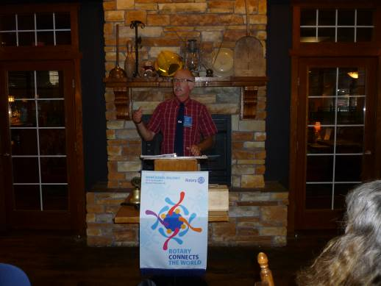
Barry started the program with a warm thank-you to members working our 54th 7-10 breakfast. From everyone in the Club, thank-you Lee for stepping forward to be Foundation Chair.

Barry knew, on this day, in 1913, President Wilson signed the bill that introduced a 1% income tax on income over $ 3,000; in 1945 at the age of 10, Elvis Presley made his first public performance.

“A person’s value to the community depends primarily on how far feelings, thoughts, and actions are directed towards promoting the good of others.”…Albert Einstein

FOUNDATION
$ 100 contributed to the Rotary Foundation. Many thanks! Brian McFadden had the lucky ticket drawn for $ 15.

SERGEANT AT ARMS – DAVE ELGIE

Happy $ from Jamal – totally enjoying his biking activities. From Greg, good to be home. Their travels to Amsterdam, Berlin and Prague were wonderful. Sad $ from Lee. Canada’s soccer game was depressing. Once again, soon Mike Walker is away to China for badminton duties. James is looking forward to visiting sons and grandchildren in Campbell River and Comox. Troy willing contributed $1 for the mess he made at the Saturday breakfast. Tess was very happy with her participation at the Wellness expo. Dave Elgie’s ticket was drawn and he did not draw the joker. Next week’s pot is $ 410.

ROTARY MINUTE – JOY CAMERON
The Rotary Flag
In September of 1914, Rotary National Association President Frank Mulholland of Toledo, Ohio, in compliance with the instructions of the 1914 Houston Convention, appointed a committee to design a flag for all Rotary clubs.
An acceptable design had been sketched and was used as a starting point. The main portion was to be white in color which is the banner of internationalism and is looked upon as the "Lilly White Banner" of international amity and goodwill. In the center of the flag appears the official wheel emblem in gold and blue colors and containing the words "Rotary International." The blue stands for constancy of purpose and the gold for the pure standard upon which rotates the wheel of eternal progress.
The first time the Rotary flag was flown was at the Baltimore Hotel in Kansas City on January 4th, 1915. The first official flag was formally adopted by Rotary International at the 1929 RI Convention in Dallas, Texas. In 1929 Admiral Richard Byrd flew the Rotary Flag over the South Pole and 4 years later over the North Pole. The flag flown By Admiral Byrd is now displayed at RI world headquarters in Evanston, Illinois.

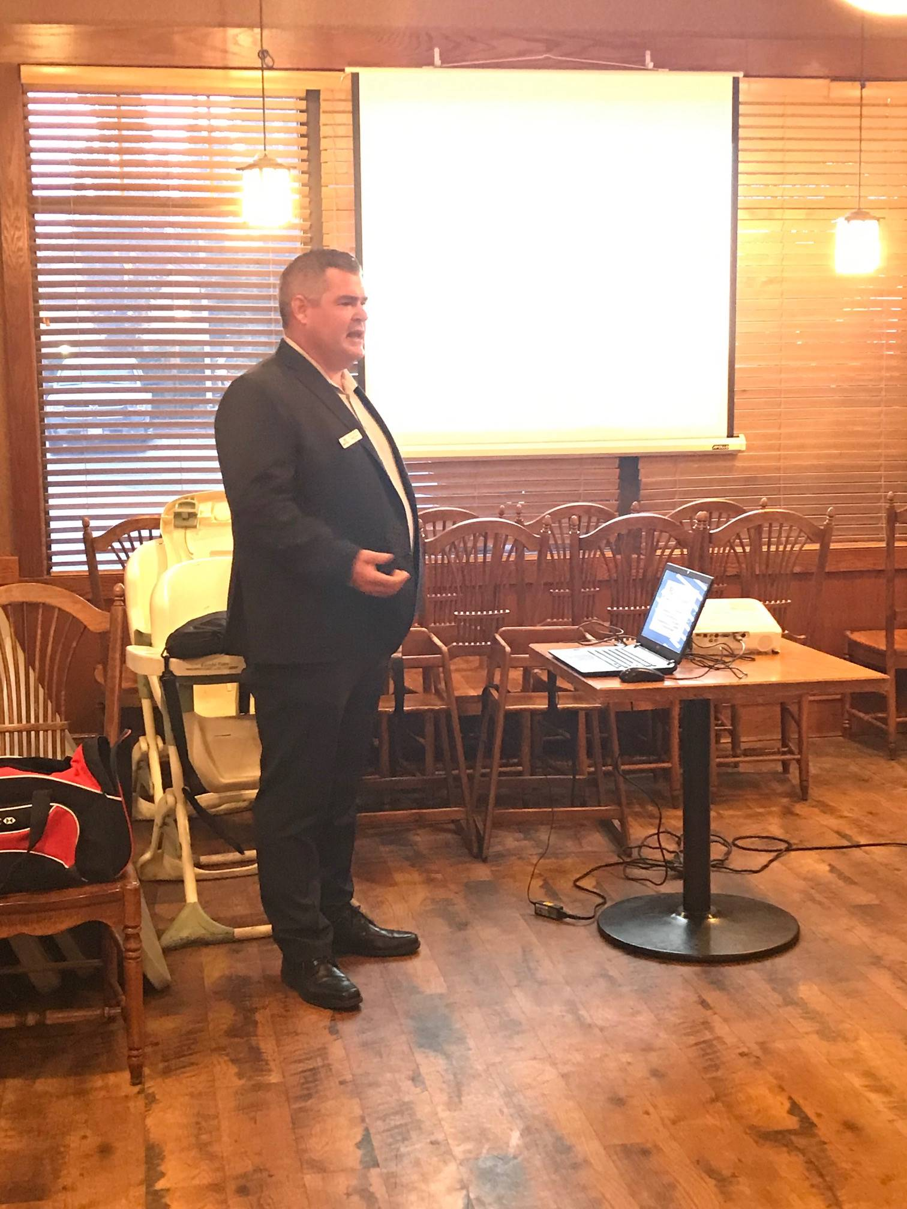

MAYOR MARK SWAIN
In 2018, Mark Swain was elected Mayor of Lantzville. The past year has been very busy for him and his fellow councillors. One of the newly elected councils’ first priorities was to update the 2005 official community plan (OCP). An OCP is a policy document that describes a community’s long-term plans for change and how these plans will be achieved. It contains the goals and aspirations of the community, the policies that will guide the decisions of the municipal council and the tools to implement policies. Following numerous public workshops, community meetings and surveys, the OCP was adopted in June 2019.
For the past 15 years, because of a lack of water and a limited service area for the municipal sanitary sewer collection system, the population of Lantzville has been stagnant at 3,600 +/-. The signing of a water agreement with Nanaimo will enable future growth. As well, over time, the municipality plans to build a new reservoir and expand the sewer collection system. A new zoning bylaw is in the works. In 2018 the community developed a comprehensive economic development strategy to enhance business retention and expansion. Currently, 90% of the operating budget comes from residential property taxes.

We thank Mayor Swain for his presentation and his great passion for Lantzville.

SUBMISSIONS, UPCOMING EVENTS

October 18th - Interact Fun Fair @ Pleasant Valley
Contact Jodie for details

October 19th - YOUTH-A-PALOOZA
John Barsby, 10-5 pm
Stephen Cochrane 250-616-9949

October 19th - Oktoberfest, Beban Park, $ 30
Nanaimo Daybreak Rotary

October 24th -World Polio Day

MEETING NOTES
We received a thank-you from Jamie, a Rotary Club of Lantzville, and VIU scholarship recipient.

New this year, is a ‘Rotary in Nanaimo’ website. The site has a calendar for upcoming local Rotary activities, contact and meeting times for the five Rotary clubs and information about who we are, what we do.

Tess reported on International service. Her committee approved $ 400 for a project in Guatemala and $ 5000 for a literacy project.

Congratulations to Barry Sparkes for his successes at the 55+ BC Games in Kelowna in September. Barry came away with four gold medals, one silver and one bronze.

FUN STUFF
LOOK FOR THE GOPHER


OCTOBER IS ECONOMIC AND
COMMUNITY DEVEPMENT MONTH

Nearly 1.4 billion employed people live on less than $1.25 a day. Rotarians promote economic and community development and reduce poverty in underserved communities through training, well-paying jobs, and access to financial management institutions. Projects range from providing people with equipment to vocational training. Our members work to strengthen local entrepreneurs and community leaders, particularly women, in impoverished communities.

Rotary International and the Rotary Foundation have adopted six area of focus as organizational priorities…

- Peace and conflict prevention/resolution
- Disease prevention and treatment
- Water and sanitation
- Maternal and child health
- Basic education and literacy
- Economic and community development
There are countless ways that Rotary clubs address these issues both locally and internationally.

GETTING OLDER, I’VE REALIZED:

- I talk to myself, because sometimes I need expert help.
- There’s nothing wrong with my social behavior. It’s the idiots that are to blame.
- When I was little, I saw taking a nap was punishment. Now I see it as a mini- holiday.
- Not even duct tape helps with stupidity, but it does help to muffle the sound.
- It would be wonderful if we could put ourselves in the dryer for 10 minutes and come out three sizes smaller.
- “Getting lucky” means entering a room and remembering what I went in for.

