“Rotary: Be The Inspiration”

October 4, 2018
Basic Education & Literacy Month

IN THE LANCE THIS WEEK

Big Brothers Big Sisters

Nanaimo Community Hospice

FUTURE EVENTS
Oct 10th – Board Meeting.
Oct 11th – Presentation-Cambie Park Funding
Oct 16th--Social NY Pizza 5:00 PM
Oct 18th – Club Business Meeting
Oct 25th – What is the Rotary Foundation?

“VISITING” ROTARIANS
No one came to visit. ☹

VISITORS and GUESTS
Rachel Robertson – prospective new member
Stephen Cochrane-Big Brothers Big Sisters
Paul Sibley-Nanaimo Community Hospice

BIRTHDAYS & ANNIVERSARIES
 |  | DUTY ROSTER
DATE | GREETERS |  | CASH | Sgt-At-Arms | Invocation | INTRO | Foundation | Rotary  Minute
Oct 11th | Ribicic & Manikel |  | Williams | Lobay | Slowski | Ribicic | Sparkes | Lobay
Oct 18th | Slowski Rodgers |  | Cohn | McFadden | Ribicic | Slowski | Walker | Ribicic
Oct 25th | Sparkes& Lemmon |  | Elgie | Slowski | Tamelin | Sparkes | Williams | McFadden
If you cannot make your duty, it is your responsibility to find a replacement.
No celebrations coming up this week.

HEALTH of the CLUB
We’re healthy – as far as we know…

ROTARY CLUB OF LANTZVILLE
MISSION STATEMENT
Joining in fellowship to support growth and development in education and health for those less fortunate in our local and international communities.

“Presidential” Observations
President Jan's alarm "'mal-functioned" and she barely made the meeting. She was glad she made it, and so were the rest of us!

FOUNDATION
$90 contributed to the Rotary Foundation this morning. THANKS! Greg D. registered his first 'win'!

Sergeant-at-Arms
Ralph was the Sergeant today and issued Greg with first fine: posture during National Anthem. Rachel locked her keys in car. BCAA on the way, but Ralph could have done it.
Sad Buck: Don & Shirley Cohn will be moving to Victoria by the end of December. We're going to miss them a lot.
Jamal & Liz off to Italy, Dave & Gayle just returned.
Harry picking mushrooms this month. He was also draw winner, but didn't pull a Joker.

News, Updates & Reminders
- There will be a 5-Club PolioPlus Awareness event, to promote Rotary in Nanaimo, November 9th, at VIU, in the Malaspina Auditorium. For you and your spouse. Bring a non-Rotarian who might like to learn a little about Rotary. Who do you think we should recognize with an honorary Paul Harris Fellowship?? Let Barry know.
- Rotary Youth Leadership Awards (RYLA) Vancouver Island takes place in Crofton October 26th to 28th. We can (should) sponsor local young people (Grades 9 and 10). https://portal.clubrunner.ca/50092/sitepage/ryla-vancouver-island (Our guest Stephen Cochrane had a student in mind and will talk to Jodie.)
- Joy has organized a Club Social Evening at NY Pizza on Dover Road, Tuesday Oct 16th starting at 5:00 PM. Join us for a meal, or simply a drink and visit.
- Breakfast with Santa – December 8th.

Rotary Minute
Brian Rodgers is in his 30th year of Rotary. He first joined Rotary in Campbell River. Upon being transferred to Nanaimo, Brian joined our Lantzville club in 1989. He served as Club President in 1996-1997 as well as Secretary, Treasurer and 'almost every other position' during these years. He has been our liason with Fairwinds ever since we began golf tournaments.
He enjoys a member of the Rotary Club of Lantzville, in part because he likes getting up early. And we enjoy having him as a member!

Community Service Funding Presentation
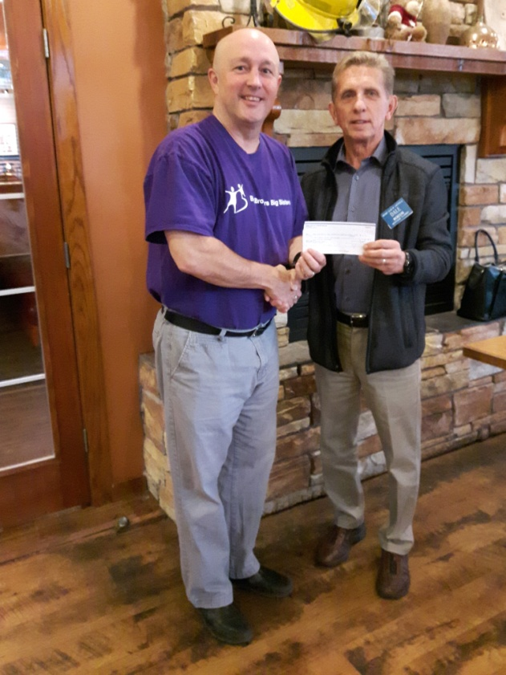

Stephen Cochrane, Director of Service Delivery for Big Brothers Big Sisters Central Vancouver Island accepts our club's gift of $2,500 from Dale W.
This funding will be used for the 'Game On' after school program. Stephen explained how this program for Grades 5,6 & & 7 focuses on healthy living and eating. The program lasts 7 weeks and is offered 3 times each year.
Mentorship opportunities are always available. To find out more: https://cvi.bigbrothersbigsisters.ca/enrol-a-little/



Nanaimo Community Hospice Society
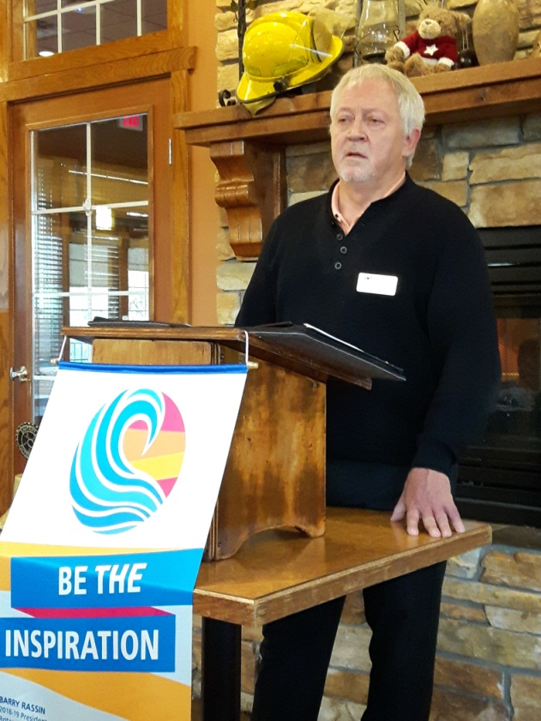

Our guest speaker this morning was Paul Sibley, the Executive Director of Nanaimo Community Hospice.
The Rotary Club of Lantzville has had a long relationship with Hospice and Paul acknowledged the contributions made by our club.
Paul admitted that when he took this job, he was not quite sure what Hospice did. Hospice does not offer residential care but instead concentrates on offering support to those facing terminal illness, caregivers and those who have lost someone close to them.

Paul mentioned that over 40 children are enrolled in a play therapy program offered at their beautiful facility at 1080 St George Crescent.
About 40% of their $1,000,000 budget is met through revenue from the Hospice Thrift Shops. Government grants and legacy givings and Island Health funding contribute the balance.

Hospice provide the volunteers for the Palliative Care Centre at Nanaimo Regional General Hospital. In total, Hospice has over 250 dedicated volunteers, some who receive more than 100 hours of specialized training.

Paul says that Hospice is always looking for people who would like to volunteer, not only at the Palliative Care unit, but also with walking groups or work at one of their Thrift Shops.

ROTARY INFO
You can find out where and when all the Clubs in District 5020 meet on the 5020 website:
www.clubrunner.ca/portal/Organization/Meetings.aspx?accountid=50092
Rotary International: http://www.rotary.org
Member’s access: https://www.rotary.org/myrotary/en
District 5020: www.rotary5020.org
Our website: www.clubrunner.ca/Lantzville
Our Facebook Page: www.facebook.com/RotaryClubofLantzville
Check it out – you might be surprised…

