October 8th, 2020
Economic & Community Development Month

IN THE LANCE THIS WEEK

PEACE INTERNATIONAL SCHOOL
GORDON & JOYCE GRAHAM

2019 – 2020 ROTARY CITATION

PAUL HARRIS SOCIETY

VISITORS AND GUESTS

Visiting Rotarians – DG Greg Horne, ADG Wayne Anderson, Sam Purdy-Sooke, Linda Murray - Cathy Graham- Daybreak; visitor Barry Sparkes.

BIRTHDAYS & ANNIVERSARIES
Birthday wishes to Shawn Kilner & David Lobay.

HEALTH OF THE CLUB
Harry reported that Jamal is out and about.

ROTARY CLUB OF LANTZVILLE
MISSION STATEMENT
Joining in fellowship to support growth and development in education and health for those less fortunate in our local and international communities.
MEETING NOTES

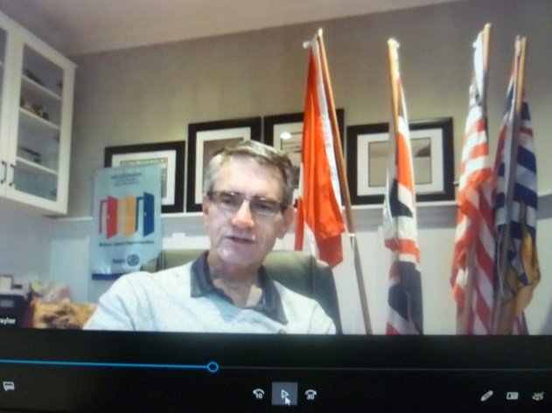

President Mark started by welcoming us to the Rotary Club of Lantzville, located in the traditional territory of the Snaw-naw-as First Nation, followed by the US and Canadian National anthems.

Following our speaker presentation, DG Greg Horne presented 2019-2020 president Barry Sparkes with a club Rotary Citation. This award recognizes clubs that achieve identified goals related to Rotary’s strategic priorities. From Barry, a thank-you for the work of everyone in our Club.

Sam Purdy, Paul Harris Society coordinator, presented a certificate to Joy Cameron for her generous and ongoing support of the Rotary Foundation. From Joy “Thank-you Rotary for providing the opportunity to support the work we do.”

From Troy and Mark, many thanks to the Saturday breakfast helpers. They served food to 70 people.

Stephen is working with Neil on Shoes for Kids @ Seaview School. Also, Stephen –Big Brothers – Big Sisters, @ 2030 Northfield Road,are in need of Winter and Christmas clothing donations.

From Don Tamelin, thank-you for your thoughts and kind words. And a big-thank-you to those joining me later today @ Enrico Winery.

ROTARY MINUTE – SHEILA BERGIN

Sheila spoke about the evolution and meaning of the Rotary motto. Service Above Self, adopted in 1989, was thought to best convey the philosophy of unselfish service. Perhaps this is too simplistic. People making the Saturday breakfasts also like that the work makes them feel good. They enjoy the banter as much as the pride in providing breakfast and lunch to the less fortunate. Connecting with fellow Rotarians and the community feels good, feels normal. Is that being selfish?

“Studies show that isolation and loneliness can increase the risk of dying by 45%. Connection with others is not selfish, it’s necessary. Studies also suggest that pure altruism is rare, meaning those who go out of their way to assist others are motivated by something more than just providing social support. This additional something is an internal, personal benefit that comes from feeling good about completing a moral act – essentially a personal kickback from acting altruistically. “

Sheila suggests Service Strengthens Self more accurately describes the outcome of our volunteer work – and that’s not selfish!

Thought for the day…
RWANDA PEACE SCHOOL.

Cathy Graham and her father, Gordon, provided an informative and highly interesting PowerPoint presentation on the Peace International School in Rwanda and how we could choose to support their work to get the high school building completed.

The school began following the 1994 Rwandan civil war. Over a period of 100 days an estimated 800,000 people were slaughtered. Left behind were starving orphans and street children of many ages. Bishop Denis Mugabo and his wife Dativa undertook and continue to care for children in Nyanza, Rwanda with food, education, and trauma counseling.

An elementary school was started in 2009, using a grant from the Japanese government. It currently educates Grades Nursery through to Grade 6 at full capacity of 369 students. In order to complete the partially built high school, Gordon and Cathy are working on collecting approximately $ 108,000 CDN. An amazingly ambitious undertaking, Gord can be reached at piscompletionfund@gmail.com.

Rotary District 5020 will mark historic progress toward a polio-free world while urging the community to help end the paralyzing disease. Rotary members in District 5020 are taking action, virtually, on October 17 2020 to raise awareness, funds, and support to end polio, a vaccine-preventable disease that still threatens children in parts of the world today.

Visit https://www.justtwodrops.com/ for more information.

While October 24th is known as World Polio Day, a date selected by Rotary International to commemorate the birth of Jonas Salk, who led the first team to develop a vaccine against poliomyelitis, we have an amazing opportunity to celebrate World Polio Day, early, with a collection of speakers who will truly inspire you. Join us! Register now: https://www.justtwodrops.com/.
Tickets are only $30 and All proceeds, minus the credit card processing fee, from this event, will go directly towards PolioPlus and is eligible to receive Paul Harris points/credit. Please make sure to have your Rotary Member number available when you sign up!

Club Contacts

President, Mark Taylor
Past President, Jan Stromar

Vice President, Lee Rowley
President Elect, Jodie Williams

Secretary, Greg Devenish
Treasurer, Harry Helfrich

2020-2021 Club Committees

Administration/fellowship: Community Service:
Joy (Director) Dale (Director)
Sheila David L
Randy Doug
Michael R Greg
James Brian McF
Rachel

International Service: Youth Services:

Tessa (Director) Stephen (Director)
William Jodie
Ralph Mark
Shawn

Foundation: Fundraising:

Lee (Director) Troy/Lee (Directors)
Mike W Randy
Brian R Doug
Neil

Membership: Public Image:

Troy (Director) Greg (Director)
Lee Michael R
Jamal Jan

