September 10th, 2020
Basic Education & Literacy Month

IN THE LANCE THIS WEEK

DISTRICT GOV. GREG HORN (visiting via Zoom)
OTHER VISITORS AND GUESTS

Linda Murray and Barry Sparkes joined us from Victoria. District Governor Wayne was also in attendance.

BIRTHDAYS & ANNIVERSARIES

President Mark celebrated his birthday last week on Quadra Island.
Troy de Jong’s 50th birthday is this coming week. His planned celebration in Las Vegas will be post-poned.

ROTARY CLUB OF LANTZVILLE
MISSION STATEMENT
Joining in fellowship to support growth and development in education and health for those less fortunate in our local and international communities.

MEETING NOTES
President Mark opened the meeting with the recorded national anthems of Canada and the USSR (Google always has lots of surprises.) District Governor Greg who was very graceful about this funny mishap. He said it was a pretty catchy tune!

President Mark related the sad news that the ABC Restaurant is now closed permanently. The executive will be having a special meeting to discuss when, where and what kind of meetings we will be having in the future. We are all concerned for Voyto who has been a strong supporter of our club.
Troy reported that our 7-10 Club hand-held breakfasts are becoming know in the downtown community. Our club has committed to providing take-out breakfasts on the 1st and 3rd Saturday of each month. Captain Dave L. managed very well last Saturday with 50 breakfast muffins distributed. Captain Sheila will be looking for volunteers for Saturday Sept 19th.
Tessa reported that our Nepal project is nearing completion.
Brian R. joined us today. He says he has had a poor year with no golf, but he is hanging in there.
Mark reminded members that they need to sign up for committees. Even if we are meeting remotely, the work of our club continues, and we must all do our part.
Linda M’s small club in Victoria has been very successful with different fundraising efforts in past few months.
Don T’s Mom is having health issues and so he will be in Trail for a bit.
Stephen’s Mom is also having health issues, and so he will be travelling to Ontario.
These are difficult times for many of our members and our thoughts and prayers are with them all.
Baby Charlotte continues to add sunshine to our meetings now that Dad Solly is in classes.
Joy C and George are away at the horse sales this week and we will hear the results next week.
The rest of us are either busy with work, gardening, fixing cars and just enjoying the last bits of summer.

DISTRICT GOVERNOR GREG HORN

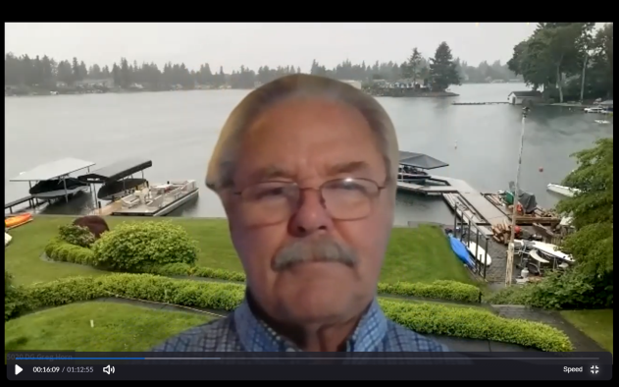

Greg has been a member of the Rotary Club of Lakeland, WA since 1996. His 4 Rotary Passions are: Polio Eradication, Public Image, Membership Growth and The Rotary Foundation.
Although this wasn’t his ‘official’ visit, Greg offered us his prospective of how clubs in our district are dealing with carrying on during the pandemic. The entire district is meeting by Zoom now, although several have started holding hybrid (in person with zoom connection for those at home) which seems to be working well for them. The District will be offering technical support to those clubs who might need some extra help in setting this up.
Greg wonders if these types of meetings will continue even after things return to normal. People are finding that remote meetings do offer certain advantages. Rotary clubs need to continually adapt to circumstances and this is one good way. Greg also stressed the need for supporting students with books. Many underprivileged kids are in dire need of reading material. Simple ‘little libraries’ are popping up in many communities which are a good start to encouraging literacy.
Greg also invites us to a couple of online District events:
October 3rd, 9:00 to noon there will be a RYLA and Youth Services workshop. It’s free, to learn more go to ‘ismyrotaryclub.org’
District 5020 Polio Day will be on October 17th. Your $30 USD offers 6 great speakers. Go to ‘justtwodrops.org’ to register for the event.

ROTARY MINUTE

Editors note: Michael R sent his regrets for missing the meeting and the minute he had prepared appears below:

For my Rotary Minute, I was planning on just talking about how Rotary connects. We all know this well and I have talked about this a few years ago. However, the story I was going to share was about a recent event. My brother was in the Vancouver hospital recently and there was a man in his room that had an accident somewhat similar to his. They got talking and became friends. He had a Nanaimo connection...his sister lives here and works at VIU. His sister just happened to turn out to be our past member, Leanne! She just happened to be there when my mom and sister were visiting as well. It’s a small world, but even a smaller one when you’re in Rotary.

Thanks Michael!

OTHER NOTICES

The Daybreak RC works with the Nanaimo Aboriginal Centre to package and distribute Good Food Boxes each Thursday at 8:30 AM at the Centennial Building at Beban Park.
They can use a few more hands, so please contact Mark if you would be interested in helping.

The Hub City Rotaract Club is hoping to obtain a charter-they require at least 10 members to do so.
Please put the word out to young people in your circle who might be interested.

