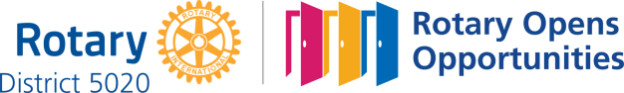

September 17th, 2020
Basic Education & Literacy Month

IN THE LANCE THIS WEEK

CLUB BUSINESS MEETING

VISITORS AND GUESTS

Soon to be new member, Cheryl Prince joined our zoom meeting.

BIRTHDAYS & ANNIVERSARIES

Birthday wishes this week to Lee and Barry.

HEALTH OF THE CLUB

Condolences to Don Tamelin in the loss of his Mom.

ROTARY CLUB OF LANTZVILLE
MISSION STATEMENT
Joining in fellowship to support growth and development in education and health for those less fortunate in our local and international communities.

MEETING NOTES

Troy opened the meeting with a recorded ‘Canada’. Turns out this is not an easy to do task on Zoom.

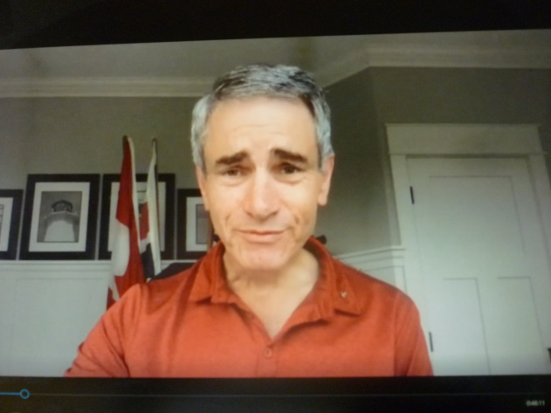

President Mark gave an update on Club goals – where we are, where we want to go with member service participation, membership, foundation and social events. Given current & ongoing pandemic, our results three months into the Rotary year are positive. Thankfully, for most of us, we and our loved ones are healthy and safe.

Club rosters are available next week. Everyone needs to think about new fund raising ideas. Soon, we will circulate an order form for Rotary shirts.

Brief discussion & minor revisions to our Club policies. Mark will circulate 2020-2021 policies in advance of our September 24th meeting.

We received a TY note from scholarship award recipient Madeline. She is enrolled in sustainable energy engineering at SFU.

Michael is looking for our ongoing input for the club social media platforms.

For October, Club meetings will be via zoom. We will investigate the option of adding a hybrid meeting. TBA, we need a venue and much more importantly, equipment and technical assistance.
ROTARY MINUTE – DAVID LOBAY

David spoke about his membership in Rotary, how it has impacted his life, why he continues.

In 1993 David moved from Edmonton to Nanaimo. New to town, looking for business connections bank manager Brian Rodgers introduced David to Rotary – an organization that gets out and does good things. Individually, helping community is a big mountain. Working with other like-minded people giving back to community makes helping easier and significantly more successful. One of many ‘Rotary’ perks is meeting truly inspiring ‘good’ people. Added plus, the work we do makes us feel good.

Many thanks David for sharing your thoughts!

UPCOMING EVENTS

September 24th – 7:00 Rotary Zoom Meeting
Speaker –former Nanaimo councillor George Anderson

October 1^{st _} 5:00 pm Club Social
Simon Holt, Happy Hour
To follow = details, protocols

“Courage is what it takes to stand up and speak; courage is also what it takes to sit down and listen.’ ~~~ Winston Churchill

