



***September 2021***

***‘Basic Education and Literacy’ Month***

**IN THE LANCE**

**Club News**

**Inspiration**

**Bits and Pieces**

**Speakers**

**CELEBRATIONS**

Belated happy birthday to Troy (16th), Lee & Barry (19th), & Stephen (26th)

**VISITORS**

David Welch, president Kintama Research Services &SamanthaLetourneau, ED Literacy Vancouver Island.

**OCTOBER7th CLUB MEETING**

6:45 a.m. Nanaimo Rugby Club - Speaker

Nate Stevenson, Teacher & Coach

N.D.S.S. Islanders Football Team

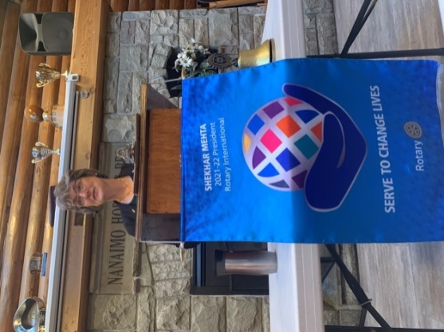

**SEPTEMBER CLUB NEWS**

Weekly, President Jodie leads our Club in fun-filled interesting meetings and represents us at Rotary and community events. Perhaps the most fun was Club participation at Mine Town Day. RCL members conducted hay rides, judged the dressed bicycle competition, conducted a water melon eating contest and distributed to children several hundred sun flower seed filled bags.

Bringing culinary skills into play, our team served hamburgers at the 1st game of the rugby season for the Hornets and again on the National Day of Truth and Reconciliation for the Salish Storm hockey team and family.

At the business meeting - Cor gave an update on Club finances and the 2021 gaming grant application; Lee spoke about the MIGS high school construction project in Rwanda; Stephen reported 60+ people attended the Youth Exchange information meeting; Community Services has no current applications; member discussion about finding new hands on community service opportunities. Thank you letters received from Alexandria Mitchell, B. Sparkes bursary recipient and Kathmandu, Nepal Rotary clubs for our food distribution support.

**INSPIRATION**

Dale spoke about the amazingly, powerful influence on music and the inspiration to generations of musicians given by one person - world renown, heroin addict, guitarist Keith Richards.

James’ compared personal relationships to the life of a flashlight. Some need **AA Attention** and **Affection**; some need **AAA** add**Acceptance;** some need **CCompassion**: some need **DDirection**. If they still don’t seem to shine - simply sit with them quietly and share your light.

The Charles Shultz Philosophy…the people who made a difference in your life are not the ones with the most credentials…the most money...or the most awards. The differences are simply made by the ones who care the most and are there for you.

**SERGEANT AT ARMS– BITS AND PIECES**

A big thank-you to James & Jodie for hosting the Club picnic. A good time was had by all!

Don T. was looking forward to fishing and exploring in Haida Gwaii.

A big change for Mark’s family, son Cameron is now living in Vancouver, attending UBC.

Rachel, Charlotte & Sollyare delighted to have visiting grand-parents.

Greg & Susan greatly enjoyed the ‘Imagine Van Gogh’ exhibit in Vancouver.

Exciting to see the Canadian women’s hockey team win gold in overtime against the US; ditto for Canada’s success’s at the 2021 US Open tennis competitions.

Next week, remember to buy your ticket for a chance to ‘Chase the Joker’ jackpot.

**Dr. David Welch – Kintama Research**

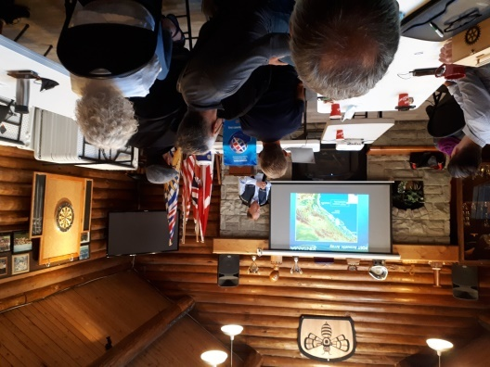

Dr. Welch gave a very interesting presentation about research on the movement and survival of Pacific salmon stocks. Using acoustically tagged fish and underwater acoustic telemetry arrays, researchers are able to track fish movement, find mortality hotspots and understand migration behaviors. Dr. Welch described how they track animals along the Continental shelf, spoke about the Columbia River Studies and research at Cultus Lake.Founded in 2000, Kintama is a world leader in this field and their methodologies are applicable to many marine populations and environments throughout the world.

Dr. Welch holds a B.Sc. in biology and Economics and he has worked in fisheries research since 1985.

**ROTARY MINUTE**

Cor spoke about how much he enjoyed seeing our RCL pictures and activities on Facebook. Helping hands at community events is a big part of what being a Rotarian is about.

Rachel encouraged us to be more aware of the mental health of people we meet and work with. Keep that smile…be kind…listen with a receptive ear. Be respectful of other people’s journey.

‘***You miss 100% of the shots you never take.’***

~ Wayne Gretzky

**Samantha Letourneau – Literacy Central Vancouver Island**

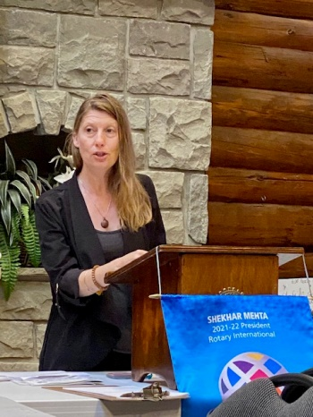

Literacy Central Vancouver Island (LCVI) started 30 years ago as an adult literacy program in Nanaimo. With that same focus, LCVI has expanded to include(at no charge) family, youth, Indigenous, AESL and specialized literacy programs in Central Vancouver Island communities.

Executive Director, Samantha showed us two annual print publications. ‘In Our Own Words’, is an annual printed celebration of learners and their tutors work. ‘PLACE’ is a collection of writing and artwork submitted by Indigenous youth. She also spoke about ‘Express Yourself booklets for people living on the street &multiple language literacy lamination cards.

LCVI is a volunteer non-profit organization with broad community support. Book donations are always welcome as are used laptop computers. The $ 20 annual membership provides 25% off on all used books. For a more hands on experience, the bookstore offers many opportunities.

Samantha has a Master of Adult Education degree and she is a graduate of the International Women’s Human Rights Institute.

**SHEKAR MEHTA**

**Rotary International President**

**2021-2022**

RI President Mehta sent each of us a focus message WITH subject line: Four ways to change lives this Rotary year. In summary, we are asked to:

**Commit to Diversity and Equity** (explore what we can do to make our club more inclusive and forward looking);

**Serve to Change Lives** (share our passion for doing good);

**Each One, Bring One** (introduce one friend, neighbor, or colleague to Rotary);

**Be a brand ambassador!**

**MINETOWN DAY**

