September 24th, 2020
Basic Education & Literacy Month

IN THE LANCE THIS WEEK

GEORGE ANDERSON

VISITORS AND GUESTS

We were joined by ADG Wayne Anderson, Oceanside PE Veronica Szick& from Victoria Barry Sparkes.

BIRTHDAYS & ANNIVERSARIES

Birthday wishes to Stephen Cochrane.

HEALTH OF THE CLUB

ROTARY CLUB OF LANTZVILLE
MISSION STATEMENT
Joining in fellowship to support growth and development in education and health for those less fortunate in our local and international communities.

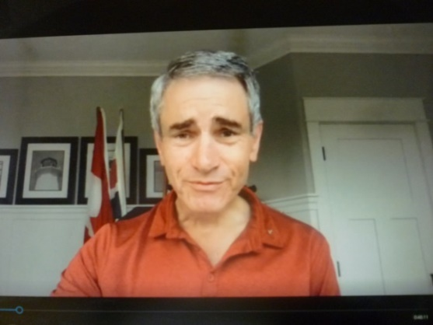

PRESIDENT MARK

President Mark had thank-you’s for the 7-10 ‘well-oiled’ breakfast team.

Veronica Szick, Rotary Oceanside, spoke about their ‘Running of the Balls ’October 17th fundraiser. All proceeds to support local children & youth programs. Tickets @ $ 20 can be purchased by calling Bev @ 250-667-2497.

ADG Wayne Anderson was happy to announce Ken Hammer as his 2021 successor. Congratulations Ken…we look forward to working with you!

Late morning from Mark to George - thanks so much for joing us this morning and for leaving us all – personally and as a club –with a lot to think about.

As a follow-up, George sent the link to a recent Shaw spotlight recording ‘Race Relations In Canada.’ It is informative and well done (Joy).https://youtu.be/xq3cwsEEo6U

Quote for today…”It is not the strongest of the species that survives, not the most intelligent. It is the one that is most adaptable to change.”
~Charles Darwin~~

SPEAKER PRESENTATION

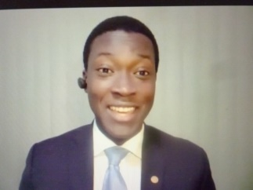
George Anderson, BA, JD

“Too often in Canada we parade our moral superiority by comparing ourselves with the US, which is problematic. It creates a tendency to minimize or forget about the deep-rooted issues here at home. The reality is racism, prejudice and inequality are alive in Canada.”

George Anderson was born and raised in Nanaimo. He is a former city councillor, volunteer with several charitable organizations, a practicing lawyer and an accomplished musician. In 2016 he was presented with a BC Community Achievement Award. George is passionate about community involvement and is an active, vocal spokesperson promoting anti-racism education and black history.

In his presentation, George identified his observations on racism related events. He asked club members to consider their recollection of a first connection with police. Early in his life, this was not a pleasant experience. While racism is more visible in other places in the world, it does happen here. In the last federal election there was more concern about a new leader being American than about a leader who repeatedly appeared in black-face, brown-face. George spoke about the furor surrounding the placement of Viola Desmond’s image on the $ 10 bill; the freezing deaths of the starlight tours and the attempted censorship in Wikipedia by the Saskatoon Police department; the re-naming of the Deas Tunnel.

The Q&A session following George’s presentation was insightful. In George’s words “It’s okay for people to be different. You are entitled to your own opinions but not to your own facts.”

