“Rotary: Making a Difference”

December 21st, 2017
Disease Prevention & Treatment Month

IN THE LANCE THIS WEEK

Our Annual General Meeting

FUTURE EVENTS
Dec 23rd – Breakfast at 7-10 Club
Dec 26th – BD Golf at Fairwinds
Dec 28th – NO regular Thursday meeting…
Jan 1st – NYD Golf at Fairwinds
Jan 4th – t.b.a.
Jan 8th – Monthly Board Meeting
Jan 11th – Update on Eden Gardens

VISITING ROTARIANS
Brent Barootes, RC of Nanaimo

VISITORS and GUESTS
No one came to visit ☹

BIRTHDAYS & ANNIVERSARIES
 |  | DUTY ROSTER
DATE | GREETERS |  | CASH | Sgt-At-Arms | Invocation | INTRO | Foundation | Rotary  Minute
Dec 28th | NO MEETING
Jan 4th | Slowski & Cameron |  | Elgie | Lemmon | Taylor | Slowski | Walker | Stromar
Jan 11th | Walker & Cohn |  | Lemmon | McFadden | Negrin | Walker | Sparkes | Tamelin
If you cannot make your duty, it is your responsibility to find a replacement.
Lorie another year wiser on December 25th !!

HEALTH of the CLUB
Don T, Don W and Jan S down-and-out with a flu bug. We wish them all a speedy recovery...

ROTARY CLUB OF LANTZVILLE
MISSION STATEMENT
Joining in fellowship to support growth and development in education and health for those less fortunate in our local and international communities.

Presidential Observations
President Lorie encouraged us to get our Christmas shopping done.
She also admitted to having a BIG birthday coming up in 4 days! But, bragged that she still feels like a kid!!

FOUNDATION
$95 contributed to the Rotary Foundation this week. THANK-YOU!
As of December 21st, all donations will be directed to the PolioPlus Fund. If you’d like your contribution to go elsewhere talk to Barry.

Sergeant-at-Arms
Dave E was the Sergeant this AM – and observed that it was too close to Christmas to be fining miscreants… Thanks to Michael R for the Christmas cards! Randy back from Thailand (+30ºC) and going to Portage (-30ºC). James & Jodie took the Clipper to Seattle & Leavenworth, along with lots of other people. Doug welcomed Lorie to the CPP/OAS Club. Ralph is happy that there’s snow in the forecast. Joy shared a happy story – her neighbour shoveled her driveway. Lorie’s grandchildren are ready for Christmas. Doug S was the winner of this morning’s draw!

Breakfast at the 7-10 Club
Thanks for your support!
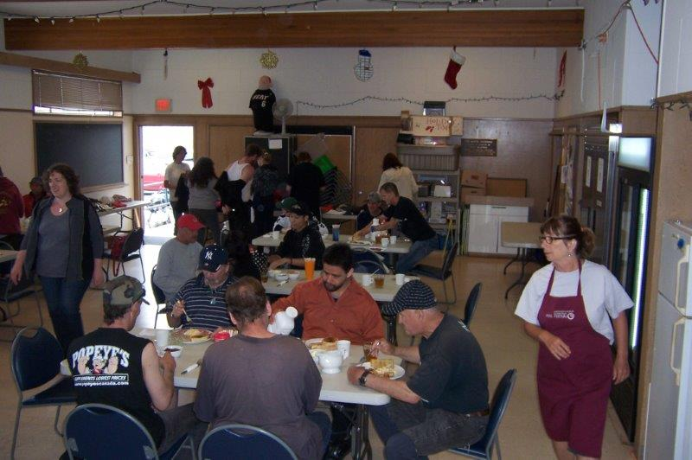
Even the day before Christmas, we expect lots of ‘clients’…
Next breakfast – Saturday, December 23rd.

News, Updates & Reminders
New weekly dues. The ABC Restaurant has raised the cost of breakfast. So, very reluctantly, we have had to raise our weekly dues, the first time since 2010.
Effective Jan 4th, 2018 the cashier will be looking for $15 for the “regular” breakfast and $12 for the “continental/light” breakfast.

2018 Golf Tournament: The Committee met last Monday and asks for your input on two items (for decision January 4th):
- DATE? Friday, May 25th or June 1st. June 1st might have better weather but May 25th would cost us less…
- BENEFICIARY? 25% of net proceeds up to $5,000 to Island Crisis Care Society (towards their Samaritan House expansion project) or to Vancouver Island Compassion Dogs (towards their program costs)?

Rotary Minute
- Why did you join Rotary?
- Why have you stayed in Rotary?
- How have you benefited from being a Rotarian?
…we’ll have to hear Barry’s story another time.

Short Notes from AGM
(the formal minutes will be available soon)
(with only 16 members present ☹ )
- President Lorie is almost halfway through her year and thanked the Board for their hard work.
- Treasurer: As of November 30th we have:
  - $27,743 in the General Account
  - $2,596 in the Gaming Account
  - $18,000 coming from BC Gaming in 2018
- Administration – sowed some seeds for thought:
  - Randy needs your ideas for weekly speakers.
  - When & where should we have a social evening in January?
  - Should we reduce our weekly meetings to two per month?
  - What should we do with our old BBQ?
- Secretary – we have 29 active members.
- Foundation – as of December 14th:
  - About $3950USD contributed to the Foundation’s Annual Fund
  - About $430USD to the PolioPlus Fund
  - Expect 4 PHFs in the New Year and, hopefully, 4 more before the end of the RY.
  - But, 4 members have not contributed, yet…
  - We have approval to proceed with the Sanala Garden Project. ☺
- International Service:
  - $1,000 given to Shelterbox Canada
  - $850 to the Mid-Island Group [for International Service Projects]
  - Have received $1,250 from the MIG for our 2016 Ghana Project
  - Pursuing repairs to a well in Lesotho, supported by two other Clubs
  - In the past we have been involved in Ghana and Guatemala – what do you suggest for projects elsewhere??
- Membership. How can we make Rotary more financially palatable to younger people??
- Youth Service: Should we continue to be engaged in the Youth Exchange Program? It will be our turn to “sponsor” an Inbound Student next year…
- Election of the Board for 2018/2019 (by acclamation):
    - President – Janice Stromar
    - Treasurer – Harry Helfrich (incumbent)
    - Secretary – Barry Sparkes (incumbent)
    - Foundation – Barry Sparkes (incumbent)
    - International Svc – Tessa Bell (incumbent)
    - Youth Svc – Jodie Williams (incumbent)
    - Past President – Lorie Heshka (by precedent)
  - Vacancies:
    - President-Elect
    - Vice-President
    - Administration
    - Community Service
    - Membership
    - Public Relations.
  - We need to fill them. Will you help our Club?

A Rotary Challenge
Don’t forget DG Tom’s wife, Laurie’s, challenge to every Rotarian in district 5020 to donate two children’s books to a worthy cause. Dawne N has talked to Seaview in Lantzville – about books to support their anti-bullying campaign – and will get more details.


ROTARY INFO
You can find out where and when all the Clubs in District 5020 meet on the 5020 website:
www.clubrunner.ca/portal/Organization/Meetings.aspx?accountid=50092

Rotary International: http://www.rotary.org
Member’s access: https://www.rotary.org/myrotary/en
District 5020: www.rotary5020.org
Our website: www.clubrunner.ca/Lantzville
Make sure to check out Events and Speakers.
Our Facebook Page: www.facebook.com/RotaryClubofLantzville

Does she look familiar?
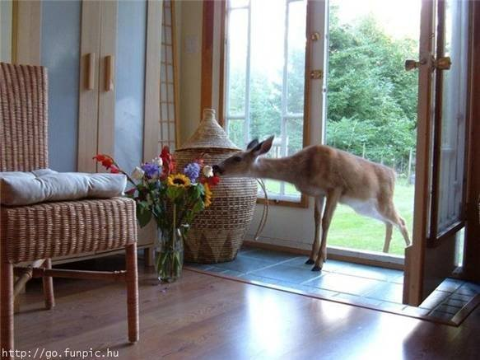

THE FOUR STAGES OF LIFE:
1) You believe in Santa Claus.
2) You don't believe in Santa Claus.
3) You are Santa Claus.
4) You look like Santa Claus.





