“Rotary Serving Humanity!”

February 16th, 2017
Peace & Conflict Resolution Month

IN THE LANCE THIS WEEK

Notes from our Business Meeting

FUTURE EVENTS
Feb 23rd – Mid-Island Abilities
Feb 25th – Breakfast at 7-10 Club
Mar 2nd – Tsawalk Learning Centre
Mar 6th – Monthly Board Meeting
Mar 9th – VI Mental Health Society
Mar 16th – CVI Multicultural Society
Apr 1st – Celebrate the Rotary Foundation

VISITING ROTARIANS
No one this week.

VISITORS and GUESTS
No one. ☹

BIRTHDAYS & ANNIVERSARIES
 |  | DUTY ROSTER
DATE | GREETERS |  | CASH | Sgt-At-Arms | Invocation | INTRO | Foundation | Rotary  Minute
Feb 23rd | Cohn & Penner |  | Lemmon | Milne | Sparkes | Heshka | Elgie | Penner
Mar 2nd | Elgie & Rose |  | McFadden | Slowski | Unger | Kilner | Snyder | Rodgers
Mar 9th | Grose & Snyder |  | Penner | Zurbrigg | Walker | Lemmon | Sparkes | Rose
If you cannot make your duty, it is your responsibility to find a replacement.
Dave E – 6 years a Rotarian on Feb 11th.
Harry H – 7 years a Rotarian on Feb 11th.
Dale W – One year a Rotarian on Feb 25th.

HEALTH of the CLUB
Bob Bevis, former member of the Club, is in the NRGH recovering from a stroke.
Bob Fenty, long-time member of the ‘Downtown’ Club, is seriously ill.
We wish both of them well.

ROTARY CLUB OF LANTZVILLE
MISSION STATEMENT
Joining in fellowship to support growth and development in education and health for those less fortunate in our local and international communities.

Presidential Observations
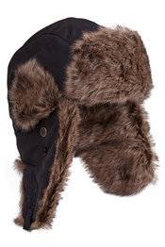
- Pres Don is happy there’s no snow. He noted that Robert has a new son-in-law, that Ralph has a new granddaughter and that Melina is heading off to PETS at the end of the month.
- Tip of the Presidential Hat to Lorie Heshka who is ‘digging into things’ and doing a fine job.

FOUNDATION
$85 donated to the Rotary Foundation this week. THANK-YOU!
Your donations to The Rotary Foundation will be going to the PolioPlus Fund – unless you ask Barry to direct them elsewhere!

Sergeant-at-Arms
Brian McF was the Sgt this AM, and glad to see the snow gone. Robert spent all his pesos at the Duty Free in Mexico (there were 3 shops). Leanne happy to be back [with us?]. Don T going to Florida for a little baseball and some golf. Lorie had samples from our sewing factory in Guatemala. Barry sad that the Vinyl Café has closed for good. ☹ Doug said thanks for all the empties. Bob M received a late Christmas card from Bass (former Exchange Student). Jamal was the lucky winner.

Breakfast at the 7-10 Club
Thanks for your support.
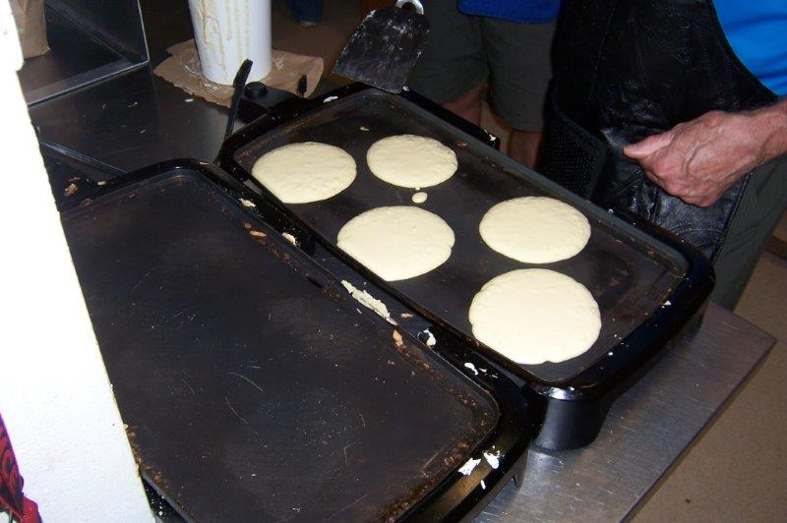
Great pancakes made to order…
Next Breakfast – Saturday, February 25th.

News, Updates & Reminders
Celebrate the Centennial of The Rotary Foundation – April 1st, 6:30PM. At Beban Park. No cost. All members and spouses encouraged to attend. The Club is asked to invite 20 non-Rotarians who have supported us, one way or another. Of those 20, 2 (or 3) should be nominated to be recognized with an Honorary Paul Harris Fellows. Suggestions to President Don or Barry.


GWCTD is a go for Saturday (18th). Thanks to Bob M for organizing it. It’s great Rotary fellowship.

Dinner at Christina’s On the Lake (formerly the Bistro at Westwood Lake). Tuesday, March 21st. 3-course meal. Let Jamal know that you’ll be attending. Limited seating so the sooner the better.
http://www.christinasonthelake.com/

Rotary Minute
Len challenged us to name Rotary’s Six Areas of Focus which are:
- Promoting Peace in the World
- Fighting Disease
- Providing Clean Water
- Saving Mothers and Children
- Supporting Education
- Growing Local Economies

Notes from our Business Meeting
- Pres Don – has enjoyed the challenges so far this year. Thanks to everyone for their support.
- Treasurer – Don C reported there is money in the bank.
- Foundation – Barry elaborated on the plans for celebrating the Centennial of the Rotary Foundation, 6:30PM, Saturday, April 1st, at Beban Park.
- Community Service – in response to Dale’s motions, seconded by Dave L, the members approved:
  - $2,000 from General Funds to the 205 Collishaw [Air Cadet] Support Committee for Citizen trip to Victoria, Survival Training, Glider Familiarization Training and Effective Speaking.
  - $500 from Gaming Funds to the VIU Mental Health Society for retreats & camping trips.
  - $1,000 from Gaming Funds to the NUKO for an oven and dishwasher.
  - $1,500 from Gaming Funds to Nanaimo Children’s Literature Round Table for Bookfest 2017.
- PR/PI – will be supporting the Foundation Centennial by letting the public know what we do, will be updating our website, is getting a couple of new banners and has a new “Rotary Meets Here” sign to hang outside the restaurant.
- Golf Tournament – is coming up in a few months. We need sponsors, prizes and golfers.
- Youth Exchange – we will be sponsoring an outbound student going to France in August. Because she is a District Alternate, we will not be expected to support an Inbound Student this year.
- District Community Grant:
  - Ultrasound Equipment to a hospital in Ghana. Project completed. Project report submitted to the District. Expect a cheque from the District, soon.
  - Sewing Machine “Factory” in Guatemala. Project 95% complete. Training will be complete by April. We need to reimburse Aldea Maya for expenses incurred, approximately $7,200 (Cdn) to date.
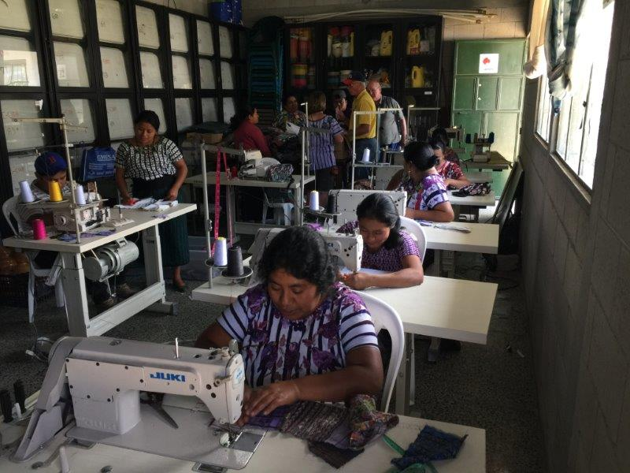

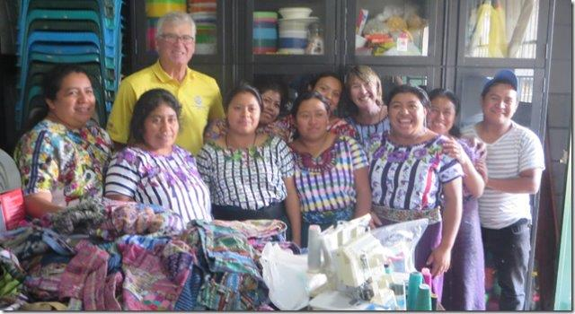

ROTARY INFO
You can find out where and when all the Clubs in District 5020 meet on the 5020 website:
www.clubrunner.ca/portal/Organization/Meetings.aspx?accountid=50092
Rotary International: http://www.rotary.org
Member’s access: https://www.rotary.org/myrotary/en
District 5020:
www.rotary5020.org
Rotary Club of Lantzville:
- “ www.clubrunner.ca/Lantzville
Make sure to check out Events and Speakers.
- “Facebook” - www.facebook.com/RotaryClubofLantzville


Are you going to attend the District Training Assembly and Annual Conference May 4th to 7th?
Registration is now open on-line:
http://portal.clubrunner.ca/50092/Page/ShowSitePage?ClassCode=SitePage&Slug=2017-district-training-and-conference





PARENTS & GRAND-PARENTS
A grandmother was telling her little granddaughter what her own childhood was like. "We used to skate outside on a pond. I had a swing made from a tire; it hung from a tree in our front yard. We rode our pony. We picked wild raspberries in the woods."
The little girl was wide-eyed, taking all this in. At last she said, "I sure wish I'd gotten to know you sooner!"?"

