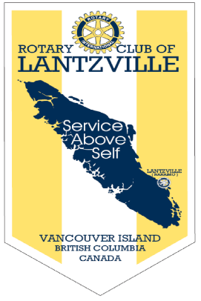

“Rotary Opens Opportunities”

July 9th, 2020

IN THE LANCE THIS WEEK

LYLA M. & JIM E.
ALCHOLICS ANONYMOUS
MID-VANCOUVER ISLAND

STEPHEN COCHRANE
ROTARY MINUTE

VISITORS AND GUESTS

Visitors included Victoria Rotarian, Linda Murray and Cor Buys. Returning to Nanaimo from the North, Cor is a former Rotarian.

HEALTH OF THE CLUB

Delighted to hear Jamal is very slowly on the mend.

ROTARY CLUB OF LANTZVILLE
MISSION STATEMENT
Joining in fellowship to support growth and development in education and health for those less fortunate in our local and international communities.
CLUB BUSINESS

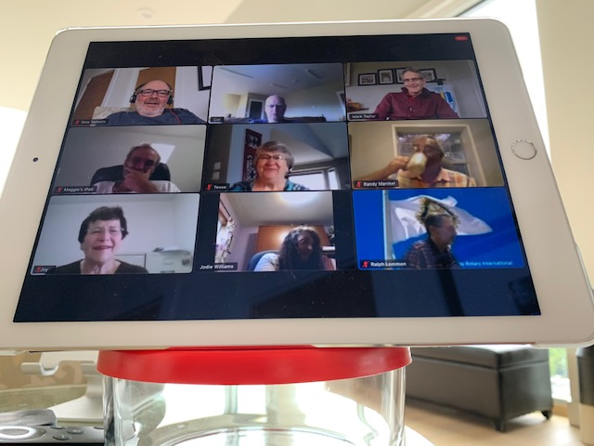
President Mark began the meeting with a warm welcome to everyone on what was a very soggy morning.

Invocation by Randy; thank-you’s to our speakers; congratulations to Mark & Tessa in their 36th wedding anniversary celebration.

Congratulations to Rachel. Her business was the July Community Futures business of the month.

A (world-wide to Rotary) request for financial support from a Rotary Club and Rotaract Club in Nepal for their COVID crisis meal programme was discussed. Tessa will explore further how we can support this request.

President Mark reported on the July board meeting. He asked all of us to think about innovative fund raising ideas; increasing what we do at the 7-10 Club; think of ways to make the production of the Lance more efficient.

Dave E. suggested that as a Club we ask our community for financial support.

NEXT WEEK, John McCormick, John Howard Society is our speaker.

“A pessimist sees the difficulty in every opportunity; an optimist sees the opportunity in every difficulty.’ – Sir Winston Churchill

Alcoholics Anonymous Nanaimo

250-753-7513 nanaimoaa.org aa.org

Lyla and Jim spoke about the history of A.A., how the organization is structured, their work, success stories and A.A. within mid Vancouver Island.

A.A. had its beginnings in 1935 in Akron, Ohio. It has no political or religious affiliations. Members believe alcoholism is a treatable disease. The A.A. programme is about support and recovery. Today there are 2 million participants in 180 countries. Within mid Vancouver Island there are 40 groups with different meeting days and times.

Lyla & Jim welcome the opportunity to meet with the professional/business community. Many thanks!

STEPHEN COCHRANE - THOUGHTS
CHALLENGES FOR ROTARY MEMBERS

- What advice do you have for the Club president; how can you/ do you contribute to club activities?
- Is our club Family Friendly?
- How can Rotary attract new members and how can we members help in that process.
- For you, what are our most important PR activities i.e. service above self, peace ambassadors, leadership, international projects?
- How did you get started with Rotary and what keeps you motivated to stay?
- How have you benefitted as a Rotarian?
- As a Rotarian how have you provided Service i.e. volunteering, helping out community groups; what is the reach of our club and what are our strengths.
- How can Rotary stay relevant to our younger members i.e. exchange , RYLA, interact/Rotaract
- What have you learned from being a Rotarian?

PICTURES FROM RECENT 7-10
BREAKFAST

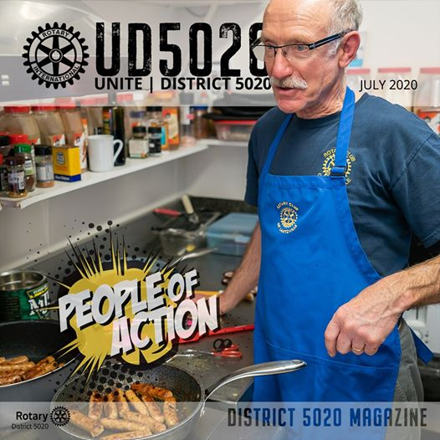

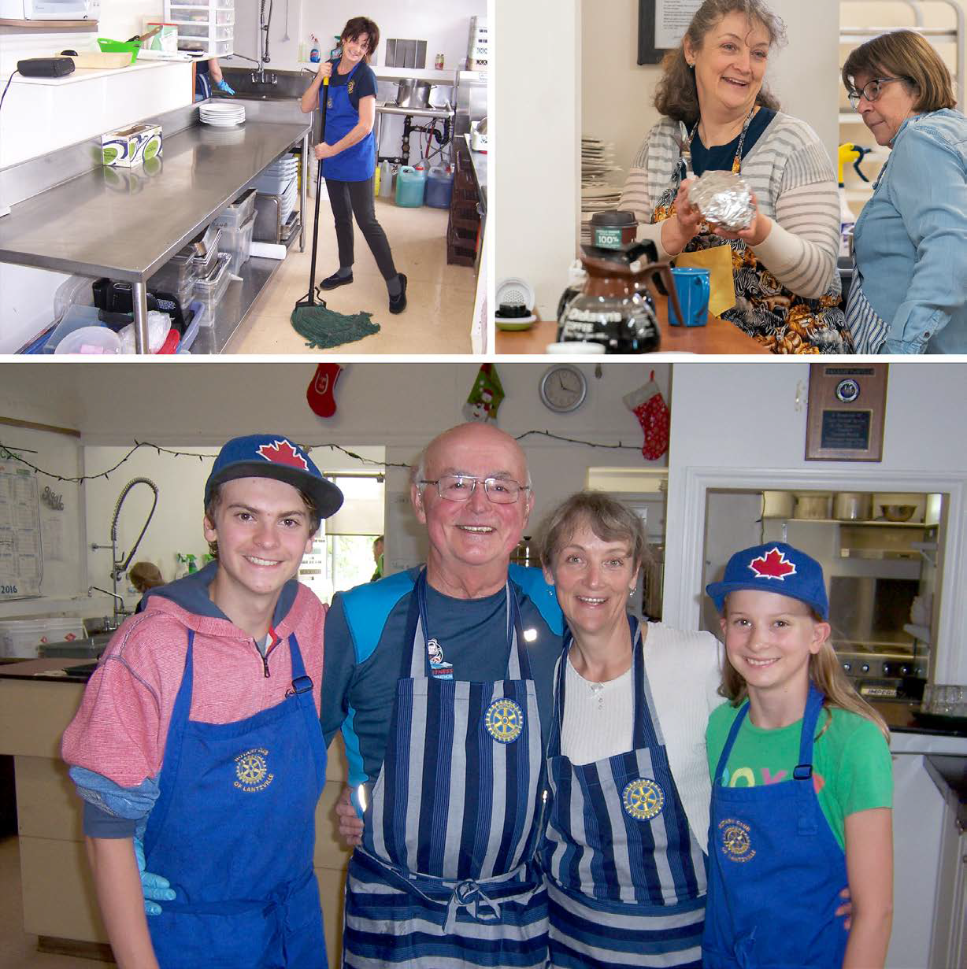

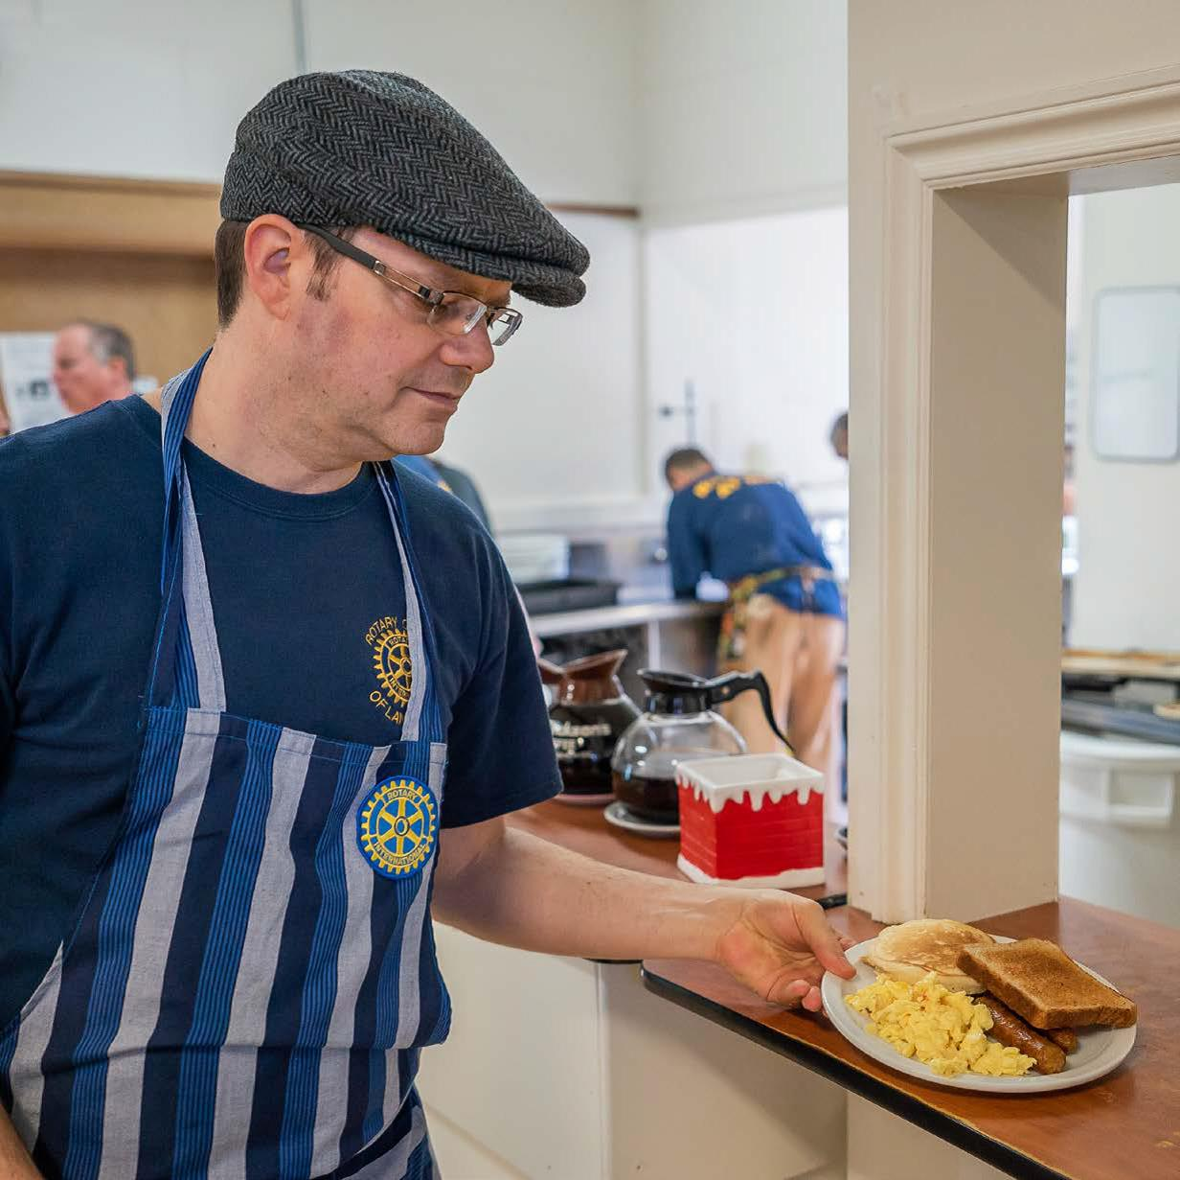

COMMUNITY FUTURES - 07/2020 FEATURE BUSINESS


Congratulations Rachel!

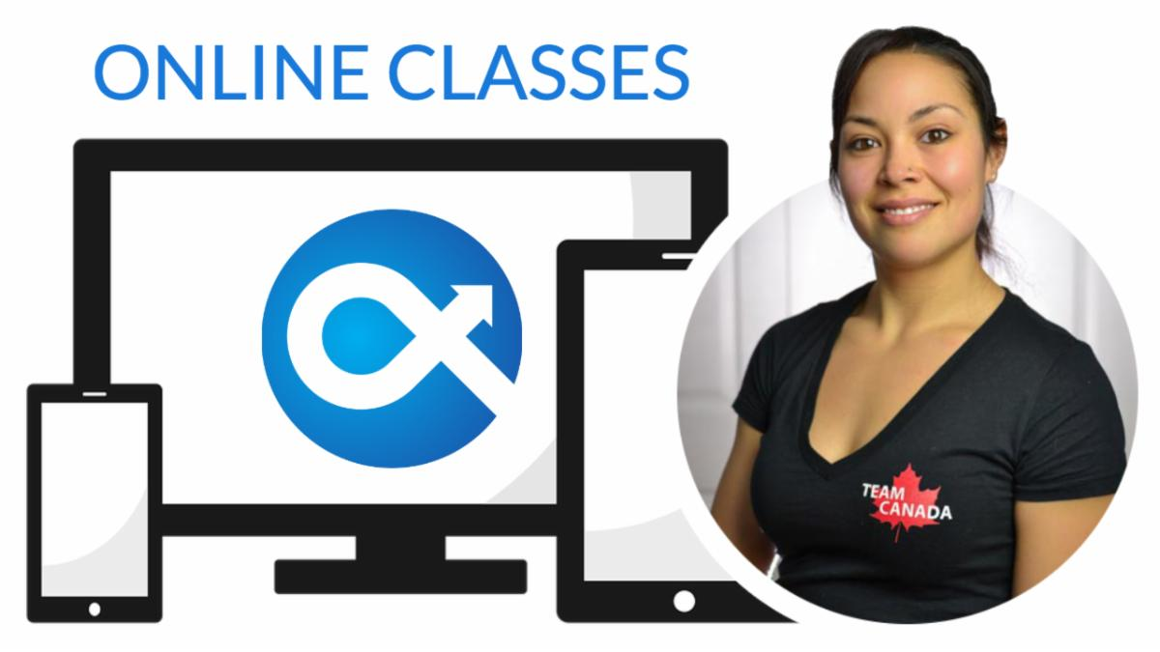
‘One would think that online personal training is a common and an easy thing to do. But as a Kinesiologist, there were policies in place that were preventing me from doing this as part of my business model.

So when COVID-19 restrictions occurred, how was I going to pivot my business to provide for my family with a new born of 2 months and provide service to my clients who now had restricted access to equipment and may also struggle mentally being at home? First, we offered out our equipment to anyone who wanted/ needed equipment to get their workouts in. There was no cost in equipment rental as we just wanted people to keep moving for their physical and mental health. We offered free online classes for 2 weeks while we tested different platforms. At the moment, we offer classes online through YouTube. The client purchases their class and we send them link, they can participate live or they can save the link and do the workout when it suits their schedule. Even better, they can repeat the workout too! This is only the start of our online presence!’



ROTARY IS ABOUT PEOPLE MAKING A BETTER COMMUNITY & A BETTER WORLD!

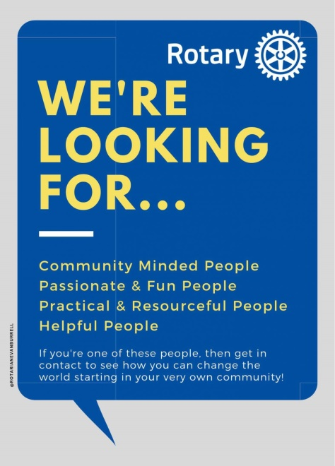

Becoming a Rotarian lets you tackle local issues that are important to you, explore new ideas, become more involved in your local community, meet interesting people in your area and from around the world and with plenty of opportunities for personal development. For more information, club member Troy deJong can be reached by telephone @ at 250-616-2667 & email at trdejong@shaw.ca. We look forward to hearing from you.

TODAY’S SMILE

A little girl had just finished her first week of school. 'I'm just wasting my time,' she said to her mother. 'I can't read, I can't write, and they won't let me talk!'

