“Rotary Serving Humanity!”

June 22nd, 2017
Fellowship Month

IN THE LANCE THIS WEEK

Important Things to Think About

FUTURE EVENTS
June 24th – Breakfast at 7-10 Club
June 27th – Installation Evening at Fairwinds
June 29th - No Thursday Meeting
July 6th - New President Melina -next year's plans
July 10th – Board meeting
July 13th – Aspengrove School

VISITING ROTARIANS
No one came to visit ☹

VISITORS and GUESTS
No visitors either ☹ ☹

BIRTHDAYS & ANNIVERSARIES
 |  | DUTY ROSTER
DATE | GREETERS |  | CASH | Sgt-At-Arms | Invocation | INTRO | Foundation | Rotary  Minute
Jun 29th | NO MEETING
Jul 6th | Unger & Elgie |  | Sparkes | Zurbrigg | Milne | Unger | Tucker | Cameron
Jul 13th | Werezak & Heshka |  | Walker | Lemmon | Olson | Werezak | Elgie | Cohn
Jul 20th | White & Kilner |  | Williams | Lobay | Rodgers | White | Rodgers | Elgie
If you cannot make your duty, it is your responsibility to find a replacement.
Richard Z another year wiser on June 24th.
Mike & Janice celebrating their 33rd on June 30th!
- The Rotary Club of Lantzville was chartered 29 years ago on June 24th.

HEALTH of the CLUB
Melina is mending – we hope.

ROTARY CLUB OF LANTZVILLE
MISSION STATEMENT
Joining in fellowship to support growth and development in education and health for those less fortunate in our local and international communities.

Presidential Observations
- President Don – this was his last meeting. He has had a lot of fun, as President, the past year. There are a lot of good people in our Club who provided lots of support and encouragement
- THANKS!

FOUNDATION
$75 donated to the Rotary Foundation this week. THANK-YOU!

Sergeant-at-Arms
The Sgt this morning was Doug S who reported he had found cheap gas in the ‘Peg and he is now a new ‘governor’ with the Air Cadets. Randy enjoyed wearing sunglasses this AM. Barry had a good trip to Beaverlodge. Robert has submitted an article to the “Nanaimo Magazine” about FoamFest. Tessa went to the Comox Seafood Festival –it was awesome! Lorie toured Craigdarroch Castle – it’s quite the house. Joy’s George’s Herbie has a girlfriend. Harry is looking for a pirate hat. Don W is an expectant grandfather. And, Robert was the lucky winner!!

Breakfast at the 7-10 Club
Next breakfast – Saturday, June 24th.
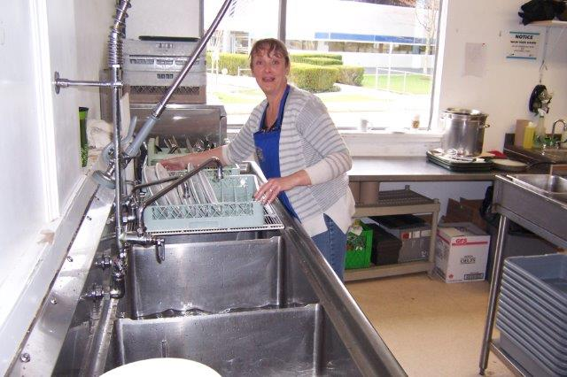
Somebody has to do the dishes, eh!
Thanks for your support.

News, Updates & Reminders
Annual Dues – are due. Payable to Harry. $220. By cheque, cash or credit card. Sooner rather than later – please & thank-you.

INSTALLATION BANQUET
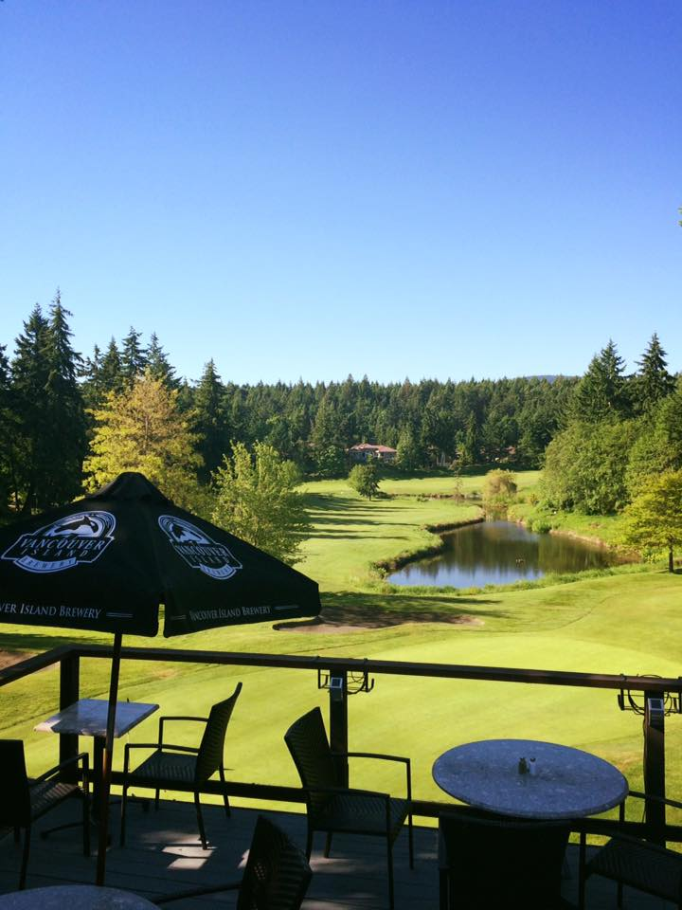
June 27th – Let's all celebrate the installation of our new President Melina and Board. We will have a great meal at beautiful Fairwinds; 6:00 pm
Cost for members (and family) is only $25 per person (guests of Rotarians slightly more). Please email Randy this week: rmanikel@shaw.ca

July 25th – visit by DG Tom Carroll. A 5-Club BBQ at the Nanaimo Golf Club. It would be great to have a good turnout from our Club.


September 7th – 10th. We will be hosting 12 Rotarians from New Zealand on a Rotary Friendship Exchange. James has put together a program to keep them busy, learning about our community.

Community Service
The members approved a motion to donate $1,000 to the John Howard Society – as a contribution to their Ryan Berkley Memorial Slo-Pitch Fundraiser – to fund/support various programs in our community that help people return to the workforce and re-engage with society.

Rotary Minute
No minute this morning…but some less-than-good news:
- Sadly, Robert G, after 17 years an active member of our Club, will not be renewing his membership in the Club this coming year. We will miss him, his humour, his work and his ‘great’ ideas.
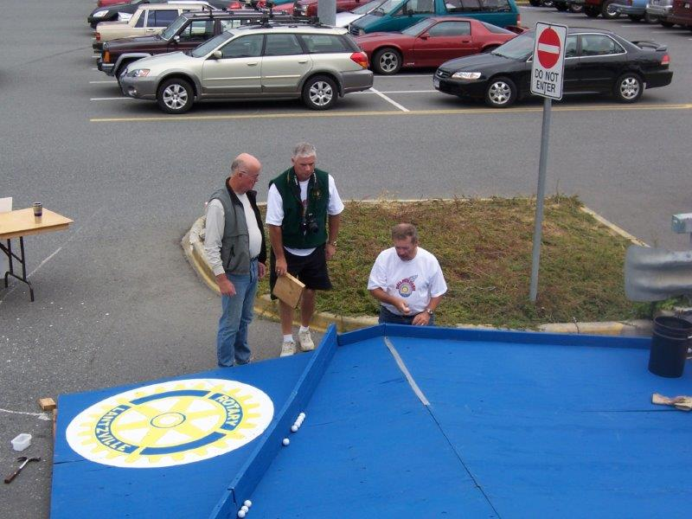
Who could forget “Ball-der-Dash” in 2006, eh?
5,000 leftover, well-used golf balls were given to SOS in Parksville yesterday…☺
Also, sadly, two of our younger members will not be renewing their membership this coming year:
- Alex Penner is finding it difficult to find time for Rotary, and
- Renato Anacleto has moved to Parksville and is going back to school…
Thanks to Robert, Alex and Renato for all they have contributed to our Club.

Some things to Think About
From an Admin/Fellowship perspective, Randy reported that we had enjoyed two “banquets”, 7 social events and cooked numerous hotdogs over the past year. From a “Speakers” perspective, we heard from 17 local organizations, 13 local businesses and 14 Rotarians – a good variety.
However, it would be nice to get more members joining in fellowship/social events. Perhaps an ‘activity’, before an informal potluck – including families???
Which led to a serious discussion about the future of our Club – how to get more members engaged and members more engaged…
We need to do more things beyond just meeting for breakfast. Perhaps get more involved with Rotaractors – an enthusiastic group of younger people.
Could we, as a group, get involved with Habitat for Humanity (see last week’s Lance)?
What would the 50% not-quite-so-engaged members of the Club like us to become involved with?
Your feedback would be much appreciated ☺

ROTARY INFO
You can find out where and when all the Clubs in District 5020 meet on the 5020 website:
www.clubrunner.ca/portal/Organization/Meetings.aspx?accountid=50092

Rotary International: http://www.rotary.org
Member’s access: https://www.rotary.org/myrotary/en
District 5020:
www.rotary5020.org
Rotary Club of Lantzville:
- “ www.clubrunner.ca/Lantzville
Make sure to check out Events and Speakers.
- “Facebook” - www.facebook.com/RotaryClubofLantzville

At a wedding ceremony, the pastor asked if anyone had anything to say concerning the union of the bride and groom.
It was their time to stand up and talk or forever hold their peace.
The moment of utter silence was broken by a young beautiful woman carrying an infant. She started walking toward the pastor slowly.
Everything quickly turned to chaos.
The bride slapped the groom.
The groom's mother fainted.
The groomsmen started giving each other looks and wondering how best to help save the situation.
The pastor asked the woman, “Can you tell us why you came forward? What do you have to say?"
The woman replied, “We can't hear in the back."

Once all the villagers decided to pray for rain.
On the day of prayer all the people gathered, but only one boy came with an umbrella.
That's FAITH.
When you throw babies in the air, they laugh because they know you will catch them.
That's TRUST.
Every night we go to bed without any assurance of being alive the next morning, but still we set the alarms to wake up.
That's HOPE.
We plan big things for tomorrow in spite of zero knowledge of the future.
That's CONFIDENCE.
We see the world suffering, but still we get married and have children.
That's LOVE.
On an old man's shirt was written a sentence 'I am not 80 years old; I am sweet 16 with 64 years of experience.'
That's ATTITUDE.

