“Rotary: Making a Difference”

June 25th - Month Theme is
Rotary Fellowship.

IN THE LANCE THIS WEEK

PRESIDENT BARRY

OFFICERS & DIRECTORS
INSTALLATION

President – Elect Mark Taylor

VISITORS AND GUESTS

Visiting Rotarians were incoming club presidents, Bob Janes, Glynis Hayes, Anna Jones & Emeka Udeagha; ADG Wayne Anderson, Doug Pearson & Linda Murray.

ROTARY CLUB OF LANTZVILLE
MISSION STATEMENT
Joining in fellowship to support growth and development in education and health for those less fortunate in our local and international communities.

CLUB BUSINESS

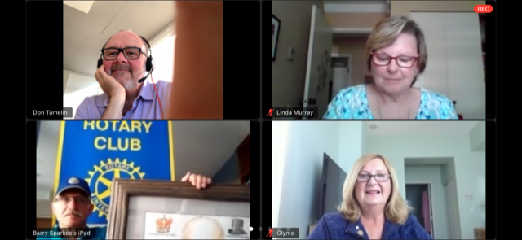

Don Tamelin did an excellent job as our ‘zoom’ meeting administrator and as chair of our annual installation.

President Barry began the meeting by welcoming our guests. Dale confirmed our participation with the July move of the Island Crisis Care Society. Joy and Harry commented on ‘next’ steps with the Lantzville Rotary Centennial garden. Harry confirmed our membership renewals. Dues invoices will be sent in July.

INSTALLATION PROGRAMME

Each of the incoming Nanaimo Rotary presidents gave welcoming remarks to our Club and incoming president Mark.

President Barry presented an amazing power point review of his presidential year. In conclusion he presented the Governor Volunteer Excellence award and the Rotarian of the Year award. In closing, he expressed his gratitude for the support and work of everyone this year and over the past 17 years.

ADG Wayne Anderson conducted the Installation of the officers and directors.

Incoming president Mark Taylor gave a thoughtful presentation on his goals and vision for us over the next year.

The programme concluded with a surprise presentation to a very surprised Barry Sparkes.

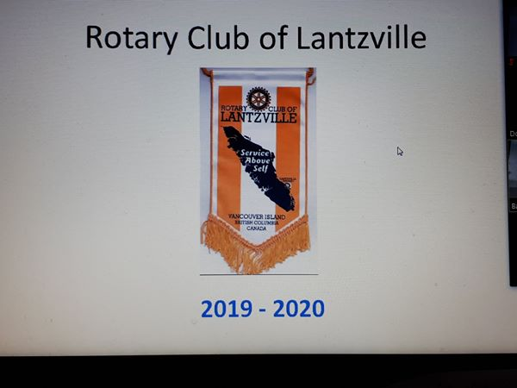
PRESIDENT BARRY’s REMARKS

‘It’s been a good year and a challenging year.’

July – Organized by the PR committee, we participated, had a lot of fun at the Silly Boat Regatta. On the 28th, we held our Summer BBQ @ Jim and Diane Tuckers. Great fellowship!

August - We welcomed new member, Troy deJong & returning member James Williams.
September - We had a Rotary information booth @ Minetown Days.

November - Christmas Social @ Simon Holt.
December - Our breakfast with Santa was well attended.

January - saw the arrival of Charlotte; Jamal won the ‘pot’. We made the Cambie Park project a reality.
February - club members toured the VIU Library, enjoyed a great meal in the Discovery Room.

March - our world changed, perhaps forever. On the positive side, we learned how to ‘zoom’. We modified and continued our breakfast programme, we did work projects at Nanaimo Food Share & Lantzville Park and we attracted new and interesting speakers for our weekly meetings.

In this Rotary year, we made significant contributions to the Rotary Foundation. And with our funds, we helped many groups in small and big ways. ‘In conclusion, TY to everyone for your support. It has been a privilege to serve.’

PRESIDENT BARRY’s REMARKS

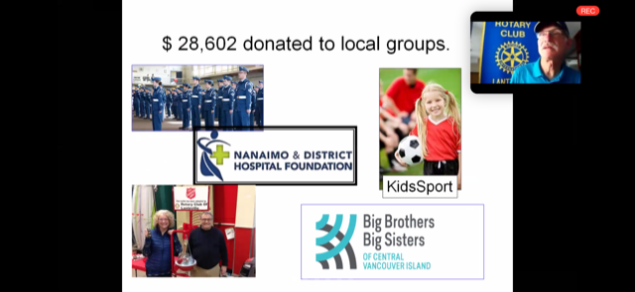

Locally, 2019-2020 our Club donated $ 28,602, Internationally, $ 7,050 and locally an additional
$ 5,295 for Youth activities.

GOVERNOR AWARD
VOLUNTEER EXCELLENCE

Presented by Barry Sparkes to Joy Cameron, this award was created by the District Governor. Club Presidents’ can make this one time award to active club members who support the Rotary Foundation and have made a significant contribution to their club and community. (Thank-you Barry!)

ROTARIAN OF THE YEAR

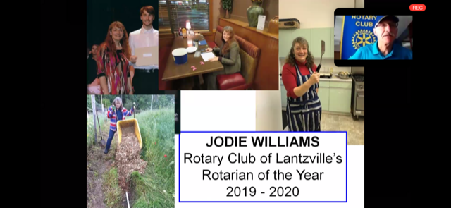

A member since 2017, Jodie has always been an upbeat supporter of our Club, our projects and our members. This past year, she represented our club on Youth exchange, Interact and Rotaract. Jodie is a willing, active, regular, energetic participant at club meetings and with everything we do in the community. Congratulations Jodie!

ASSISTANT DISTRICT GOVERNOR
WAYNE ANDERSON

Wayne began our installation with a quote:

‘Rotary unites more than a million people. Together, we see a world where people unite and take action to create lasting change – across the globe, in our communities, and in ourselves.’

He talked about the enormous changes we have encountered this past year and how well we managed to adapt.

For the installation of each officer and director, Wayne had a brief ‘history’ followed by the duties and responsibilities for their respective positions.

A big thank-you to the outgoing executive for their work and leadership and to the incoming executive who will be leading the club through the next 12 months.

ROTARY CLUB OF LANTZVILLE

OFFICERS 2020-2021

President Mark Taylor
President-Elect Jodie Williams
Vice President Lee Rowley
Past President Jan Stromar
Secretary Greg Devenish
Treasurer Harry Helfrich

DIRECTORS

International Service - Tessa Bell
Community Service - Dale Werezak
Administration - Joy Cameron
Rotary Foundation - Lee Rowley
Membership -Troy deJong
Public Image - Greg Devenish
Youth Service - Stephen Cochrane

PRESIDENT ELECT – MARK TAYLOR



From Mark, a big thank you to Wayne and the board members for taking on the roles essential to enabling our club to do what we do.

For 2020-2021, the RI presidential theme has 3 open doors. In the current world situation and relevant today for Rotary and our club = COVID-19 and Black Lives Matter (at its root this is about equality and inclusivity). Within RI and at the Club level, a third door is the challenges we face going forward – not able to meet in person, limited finances, static membership. Mark intends that over the next 12 months we identify our open doors and use them to open opportunities.

Looking ahead, Mark shared the areas he wants to focus on – surviving to the end of the Rotary year, keeping club members safe, building the connection between RCL and the Lantzville community, finding new ways where we can exemplify our ‘service above self’ motto and building the stage for our long term success.

Working together, the Rotary Club of Lantzville is the Little Club that believes it can….and it DOES!

BARRY’S SURPRISE

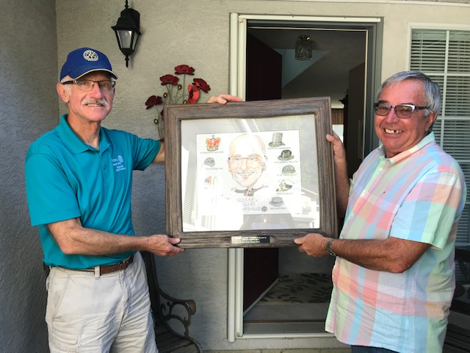
WE WILL MISS YOU DEARLY!

