“Rotary Serving Humanity!”

March 23rd, 2017
Water & Sanitation Month

IN THE LANCE THIS WEEK

The Nanaimo Foundation

FUTURE EVENTS
Mar 25th – Breakfast at the 7-10 Club
Mar 30th – Rotaract Club of Nanaimo
Apr 1st – Celebrate the Rotary Foundation
Apr 6th – President of VIU
Apr 13th – Debbie Ryan, Life Coach
Apr 16th – Easter Egg Hunt in Lantzville
Apr 20th – James Williams from down-under

VISITING ROTARIANS
Linda Murray – Yaletown
Laurie Bienert – Nanaimo and our Guest Speaker

VISITORS and GUESTS
Gillian Baker – VI Mental Health Society

BIRTHDAYS & ANNIVERSARIES
 |  | DUTY ROSTER
DATE | GREETERS |  | CASH | Sgt-At-Arms | Invocation | INTRO | Foundation | Rotary  Minute
Mar 30th | Lemmon & Stromar |  | Williams | Lobay | Youssef | McFadden | Heshka | Slowski
Apr 6th | Litchfield & Tamelin |  | Elgie | McFadden | Zurbrigg | Milne | Rodgers | Sparkes
Apr 13th | Lobay & Tucker |  | Heshka | Milne | Anacleto | Manikel | Snyder | Stromar
If you cannot make your duty, it is your responsibility to find a replacement.
No celebrations this week that we’re aware of…

HEALTH of the CLUB
We’ll take no news as good news. ☺

ROTARY CLUB OF LANTZVILLE
MISSION STATEMENT
Joining in fellowship to support growth and development in education and health for those less fortunate in our local and international communities.

Presidential Observations
- President Don – still working on getting Spring onto the Island.
- Len will be the point man for breakfast at the 7-10 Club in lieu of Dave E. Thanks to everyone who has volunteered to help out.
- Dinner at Christina’s on Tuesday was excellent. Thanks Jamal.
- Tip-of-the-Hat to Doug S – always involved and always on the go…

FOUNDATION
$90 donated to the Rotary Foundation this week. THANK-YOU!

Sergeant-at-Arms
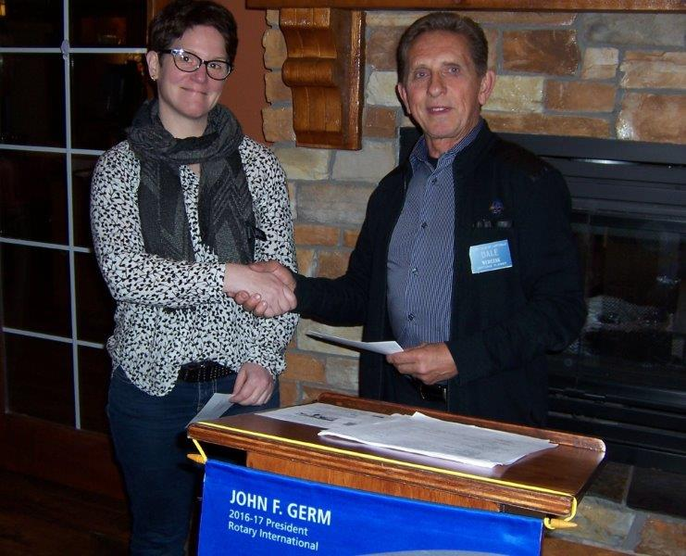
Ralph was the Sgt this morning – and pointed out two trouble makers who said they had a lovely evening at Christina’s on Tuesday. Very nice to see Linda M looking good. Barry recited a poem about Spring. Doug’s cataract surgery was successful. Harry liked Linda’s attitude. Bob is going skiing on Mt Washington. [Hope he comes back in one piece. ☺]. Brian R was the lucky winner!

Breakfast at the 7-10 Club
Thanks for your support.
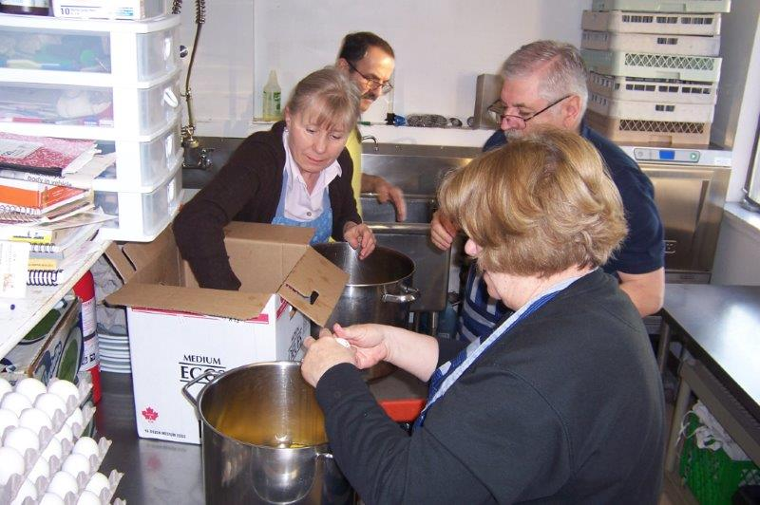
Let’s get crackin’ …
Next Breakfast – Saturday, March 25th

News, Updates & Reminders


April 1st - Celebrate the Centennial of The Rotary Foundation – 6:00PM. At Beban Park. No cost. All members and spouses encouraged to attend.
April 16th – Easter Egg Hunt at Seaview School in Lantzville.
June 2nd – Our Golf Tournament. Waiting for Don T to provide updated Sponsorship and Registration Forms. Waiting for you to come up with some sponsors and prizes. PLEASE!
June 9th – a beer tent at the 5K Foam Fest near Parksville?? Waiting to hear back from the organizers that they’d like us to be involved again.

Community Service
This morning we gave a cheque for $500 to the VI Mental Health Society who provides housing and rehabilitation for people suffering from mental health issues. Our donation will go towards a retreat for some of their residents … where they can have a bit of fun … which they don’t get very often. It’s a community-sponsored program and Gillian very much appreciated our support.
https://www.vancouverislandmentalhealthsociety.org/

Rotary Minute
Missed Melina this AM. Next week we’ll hear from Doug S about a special Canadian anniversary.

The Nanaimo Foundation
http://www.nanaimofoundation.com/

For Laurie Bienert it’s been an exciting year-and-a-half since becoming the ED for the Nanaimo Foundation. It is a Community Foundation – gifts are invested in endowment funds and interest earned is used to support organizations in our community (Nanaimo, Lantzville, Cedar, Gabriola Island and Ladysmith).
Established 35 years ago, they have given 325 grants totaling $3M to meet local needs, including $491K last year. They support capital projects and pilot projects but, generally, do not subsidize program or administration costs.
They have a strong board of community leaders plus the Nanaimo Foundation Community Engagement Committee to provide guidance.
The Foundation also supports a Community Legacies program where donors can choose to create their own endowment fund that will be administered by the NF for a small fee.
Tools for giving include:
- Outright gifts
- Appreciated securities
- Bequest
- Life Insurance beneficiaries
- Charitable Remainder Trusts.
The Foundation also has access to the Federal Government’s Community Fund for Canada’s 150th:
http://www.nanaimofoundation.com/150-fund/

ROTARY INFO
You can find out where and when all the Clubs in District 5020 meet on the 5020 website:
www.clubrunner.ca/portal/Organization/Meetings.aspx?accountid=50092

Rotary International: http://www.rotary.org
Member’s access: https://www.rotary.org/myrotary/en
District 5020:
www.rotary5020.org
Rotary Club of Lantzville:
- “ www.clubrunner.ca/Lantzville
Make sure to check out Events and Speakers.
- “Facebook” - www.facebook.com/RotaryClubofLantzville


Are you going to attend the District Training Assembly and Annual Conference May 4th to 7th?
Registration is now open on-line:
http://portal.clubrunner.ca/50092/Page/ShowSitePage?ClassCode=SitePage&Slug=2017-district-training-and-conference

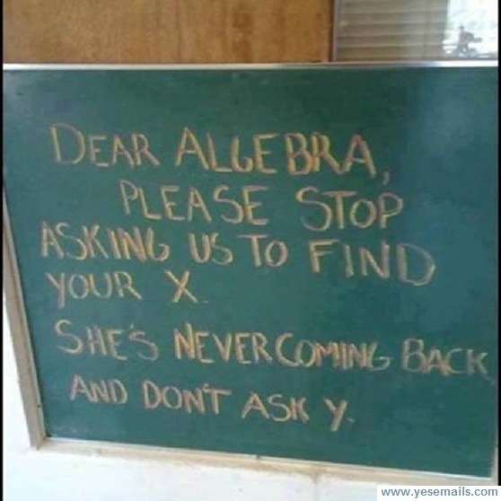

A good meal and some great Rotary fellowship at Christina’s on the Lake last Tuesday:
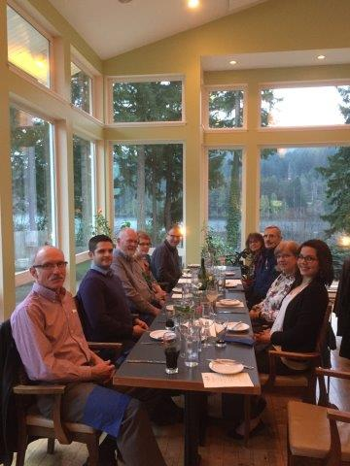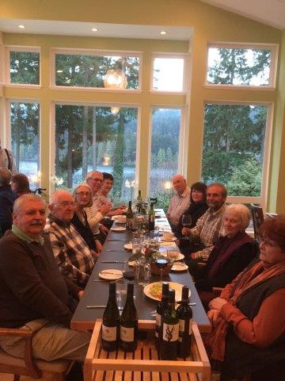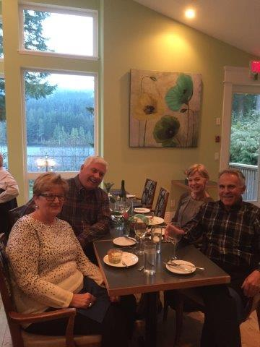

The best minds are young minds, eh:

- While I sat in the reception area of my doctor's office, a woman rolled an elderly man in a wheelchair into the room. As she went to the receptionist's desk, the man sat there, alone and silent. Just as I was thinking I should make small talk with him, a little boy slipped off his mother's lap and walked over to the wheelchair. Placing his hand on the man's, he said, “I know how you feel. My Mom makes me ride in the stroller too.”
- As I was nursing my baby, my cousin's six-year-old daughter, Krissy, came into the room. Never having seen anyone breast feed before, she was intrigued and full of all kinds of questions about what I was doing. After mulling over my answers, she remarked, “My mom has some of those, but I don't think she knows how to use them.”
- Out bicycling one day with my eight-year-old granddaughter, Carolyn, got a little wistful. “In ten years,” I said, “you'll want to be with your friends and you won't go walking, biking, and swimming with me like you do now. Carolyn shrugged. “In ten years you'll be too old to do all those things anyway.”



