“Rotary Serving Humanity!”

March 2nd, 2017
Water & Sanitation Month

IN THE LANCE THIS WEEK

Tsawalk Learning Centre

FUTURE EVENTS
Mar 6th – Monthly Board Meeting
Mar 9th – VI Mental Health Society
Mar 16th – CVI Multicultural Society
Mar 21st – Dinner at Christina’s on Westwood Lake
Mar 23rd – The Nanaimo Foundation
Apr 1st – Celebrate the Rotary Foundation

VISITING ROTARIANS
No one this week.

VISITORS and GUESTS
James Lemmon – Guest Speaker

BIRTHDAYS & ANNIVERSARIES
 |  | DUTY ROSTER
DATE | GREETERS |  | CASH | Sgt-At-Arms | Invocation | INTRO | Foundation | Rotary  Minute
Mar 9th | Grose & Snyder |  | Penner | Zurbrigg | Walker | Lemmon | Walker | Snyder
Mar 16th | Heshka & Slowski |  | Olson | Grose | Werezak | Litchfield | Sparkes | Rose
Mar 23rd | Kilner & Sparkes |  | Williams | Lemmon | Youssef | Lobay | Elgie | Slowski
If you cannot make your duty, it is your responsibility to find a replacement.
Ralph & Valerie Lemmon – their 37th on Mar 1st!
Len – another year wiser on March 1st.
William – another closer to CPP on Mar 6th.

HEALTH of the CLUB
It seems like most have recovered from the flu bugs that were making the rounds. Fingers crossed.

ROTARY CLUB OF LANTZVILLE
MISSION STATEMENT
Joining in fellowship to support growth and development in education and health for those less fortunate in our local and international communities.

Presidential Observations
- Pres Don encouraged members to register for the District Training Assembly, May 4th to 7th in Suquamish WA.
- Great turnout for breakfast on Saturday – so busy that we ran out of food!
- He visited Loaves & Fishes where we were recognized for our contributions. They are very well organized and are making great use of the food contributed by local food stores.
- Tip of the Hat to David L – for his sparkling personality that livens up procedures. ☺

FOUNDATION
$95 donated to the Rotary Foundation this week. THANK-YOU!

Sergeant-at-Arms
Doug S was the Sgt this morning – said he’d enjoyed meeting up with some “old” friends (52 years ago they rode the school bus together) at Fairwinds. Caitlin (new President of the Rotaract Club) went to PETS with Melina and learned a lot! Dave L pointed out the IGFR is a great way to network. Barry quizzed the members about last week’s anniversary. Tessa hopes we’ve seen that last of the snow. Lorie noted that Shawn was on the front cover of the Nanaimo Magazine! Dave E thanked everyone for showing up at breakfast last Saturday. Robert reported on “our” benches at Eden Garden. Mike W – some good sporting news for VIU, including Janice being recognized as “Coach of the Year” in Nanaimo. Tessa was the lucky winner!!

Breakfast at the 7-10 Club
Thanks for your support.
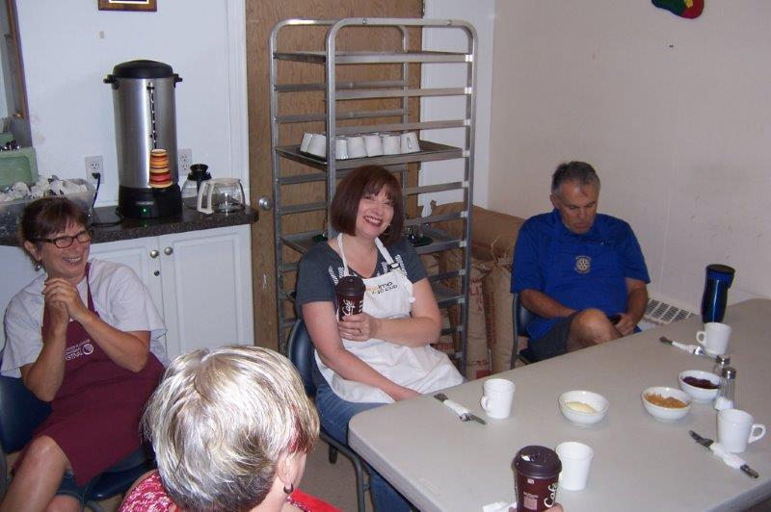
A moment’s rest before the crowd arrives…
Next Breakfast – Saturday, March 25th

News, Updates & Reminders
Celebrate the Centennial of The Rotary Foundation – April 1st, 6:30PM. At Beban Park. No cost. All members and spouses encouraged to attend. The Club is asked to invite 20 non-Rotarians who have supported us, one way or another. Of those 20, 2 (or 3) should be nominated to be recognized with an Honorary Paul Harris Fellow. Suggestions to President Don or Barry.

We will be recognizing Jeff Lott and Peter Sinclair with Honorary PHFs.

Dinner at Christina’s On the Lake (formerly the Bistro at Westwood Lake). Tuesday, March 21st. 3-course meal. Let Jamal know that you’ll be attending. Limited seating so the sooner the better.
http://www.christinasonthelake.com/

Rotary Minute
Brian R talked a bit about The Rotary Foundation (TRF) which transforms your gifts into projects that change lives both close to home and around the world. As the charitable arm of Rotary, TRF taps into a global network of Rotarians who invest their time, money, and expertise into priorities such as eradicating polio and promoting peace.
Foundation grants empower Rotarians to approach challenges such as poverty, illiteracy, and malnutrition with sustainable solutions that leave a lasting impact.
Strong financial oversight, a stellar charity rating, and a unique funding model mean that TRF makes the very most of your contributions!

Tsawalk Learning Centre
James Lemmon is the Vice-Principal at the Tsawalk Learning Centre – which helps young people who have been out-of-school for a while and face a variety of challenges in their lives.
The Centre opened this past August and is supported by School District 84.
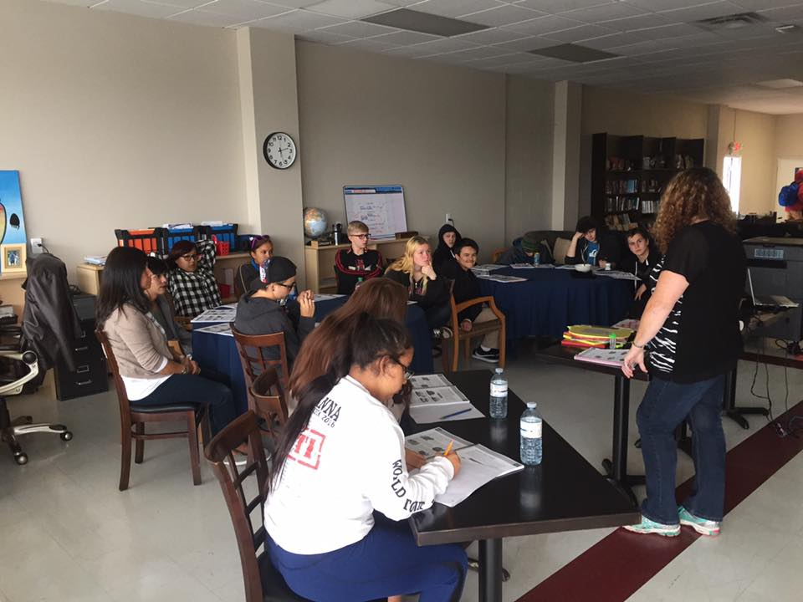
Tsawalk means “One” and the Centre is based on three pillars: Trust. Community. Family.
It provides educational assistance and outdoors experiences building mutual trust for 52 children aged 13 to 19 years.
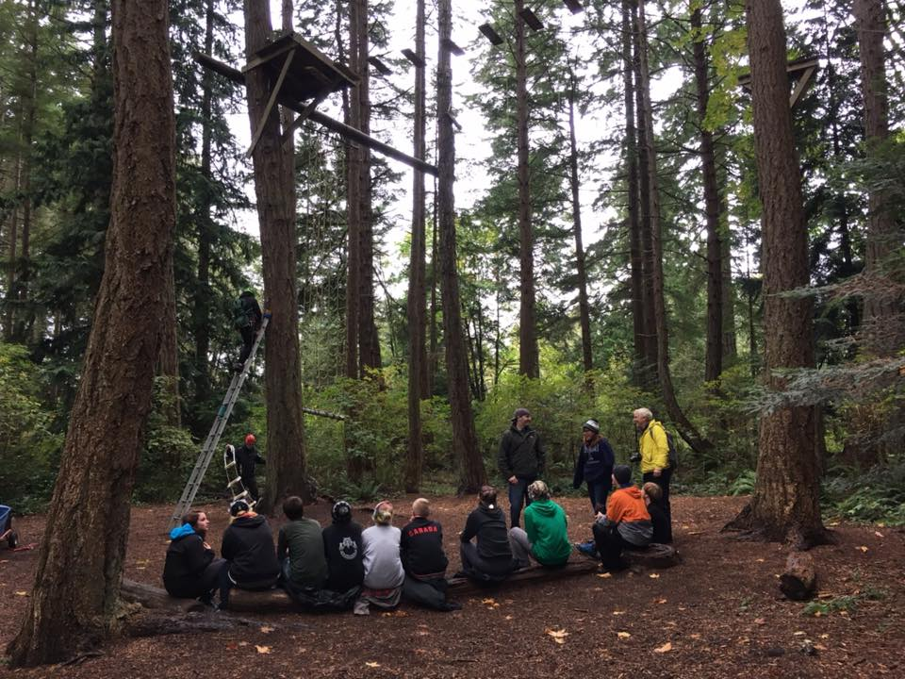
James noted that the children need positive adult experience and invited us to drop by any time and say “Hi!’.

ROTARY INFO
You can find out where and when all the Clubs in District 5020 meet on the 5020 website:
www.clubrunner.ca/portal/Organization/Meetings.aspx?accountid=50092
Rotary International: http://www.rotary.org
Member’s access: https://www.rotary.org/myrotary/en
District 5020:
www.rotary5020.org
Rotary Club of Lantzville:
- “ www.clubrunner.ca/Lantzville
Make sure to check out Events and Speakers.
- “Facebook” - www.facebook.com/RotaryClubofLantzville


Are you going to attend the District Training Assembly and Annual Conference May 4th to 7th?
Registration is now open on-line:
http://portal.clubrunner.ca/50092/Page/ShowSitePage?ClassCode=SitePage&Slug=2017-district-training-and-conference



I didn't know if my granddaughter had learned her colors yet, so I decided to test her.
I would point out something and ask what color it was. She would tell me and was always correct. It was fun for me, so I continued.
At last, she headed for the door, saying, "Grandma, I think you should try to figure out some of these colors yourself!"

When my grandson Billy and I entered our vacation cabin, we kept the lights off until we were inside to avoid attracting pesky insects. Still, a few fireflies followed us in.
Noticing them before I did, Billy whispered, "It's no use Grandpa. Now the mosquitoes are coming after us with flashlights."

IRISH FATHER’S FIRST DRINK WITH HIS SON..
I was reading an article last night about fathers and sons, and memories came flooding back of the time
I took my son out for his first drink. Off we went to our local bar, which is only two blocks from the house.
I got him a Guinness Stout. He didn't like it – so I drank it. Then I got him an Old Style, he didn't like it either, so I drank it. It was the same with the Coors and the Bud.
By the time we got down to the Irish whiskey, I could hardly push the stroller back home.



