

“Rotary: Making a Difference”

November 23rd, 2017
Rotary Foundation Month

IN THE LANCE THIS WEEK

Everything Retirement

FUTURE EVENTS
Nov 30th – Youth Protection
Dec 7th – Guatemala Update
Dec 9th – Breakfast with Santa
Dec 14th – AM: Come and be surprised!!
Dec 14th – PM: Club Christmas Dinner
Dec 21st – AGM (please plan to attend)

VISITING ROTARIANS
No one came to visit… ☹

VISITORS and GUESTS
Rebecca Pattison – former Exchange Student

BIRTHDAYS & ANNIVERSARIES
 |  | DUTY ROSTER
DATE | GREETERS |  | CASH | Sgt-At-Arms | Invocation | INTRO | Foundation | Rotary  Minute
Nov 30th | Sinn & White |  | Sparkes | McFadden | Lobay | Sinn | Walker | Rodgers
Dec 7th | Taylor & Sparkes |  | Walker | Slowski | Manikel | Taylor | Zurbrigg | Rose
Dec 14th | Stromar & Youssef |  | Williams Ja | Tamelin | McFadden | Stromar | Elgie | Slowski
If you cannot make your duty, it is your responsibility to find a replacement.
James Williams another year wiser Nov 29th!

HEALTH of the CLUB
Ralph continues to mend…
Leanne struggling with a bad back…
Dawne’s husband, Gary (former member of the Club) had a heart attack but is doing okay.
We wish all three a full recovery.

ROTARY CLUB OF LANTZVILLE
MISSION STATEMENT
Joining in fellowship to support growth and development in education and health for those less fortunate in our local and international communities.

Presidential Observations
President Lorie has had enough rain, enjoyed a very pleasant evening at the Nanaimo & District Hospital Foundation’s Appreciation Evening, and expressed sincere thanks to Jan for filling in last week.

FOUNDATION
$565 contributed to the Rotary Foundation this week. Wow! THANK-YOU!
November is Rotary Foundation Month. The Club will match contributions to the Foundation during the month of November (Nov 30th is last opportunity) with Club Recognition Points – to help you towards your next PHF. Minimum contribution - $100, maximum $250.

Sergeant-at-Arms
Bob M was the Sergeant this week and extended his commiserations to Riders’ Fans. Randy is going to Thailand. Tessa’s son is coming for Christmas (but he doesn’t know it). Barry reported that coffee is good for you. Don T recognized the good work of the Hospital Foundation, smiled that Patsy was back to work and paid big $$s for some advertising to come. Michael R arrived late – something about a paper being due! Mark thanked everyone for their positive response to his request for help and advertized that his wife is a “crafty photographer”. James was the winner of this morning’s draw!

Breakfast at the 7-10 Club
Thanks for your support!
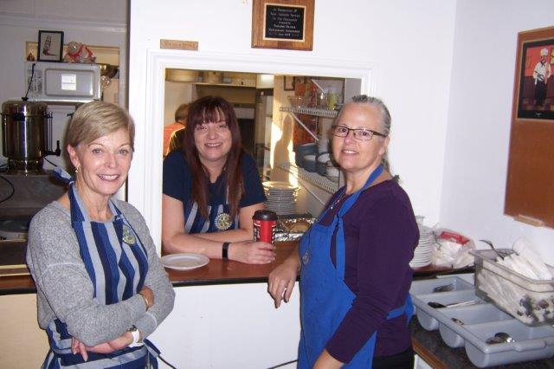
Our ever-so friendly ‘front of house’ staff…
Next breakfast – Saturday, November 25th.

News, Updates & Reminders
December 14th – our annual Christmas Dinner at the Nanaimo Golf Course. Please confirm with Don C your intention to attend or not. We need to know the numbers, soon. Cost: $30/person (members & partners), $40 for other guests. Payable to Don Cohn – please!


Brian R confirmed that Fairwinds confirmed that we can ‘use’ their golf course for Boxing Day Golf (December 26th) and New Year’s Day Golf (January 1st, 2018) again. With some generous golfers and good weather (cross your fingers) we raise a few dollars for Community Service. Pass the word to your family and friends, especially those ‘down east’…

- Breakfast with Santa. Saturday, December 9th at the Costin Hall in Lantzville. An enjoyable way to spend a few hours – service to our community and great Rotary fellowship.

- The Salvation Army Christmas Kettle Campaign starts this week. You can sign up for a shift or two or more, online, at: http://salvationarmynanaimo.com/fund-raising/kettle-information/online-sign/
- Golf Committee Meeting. The kick-off meeting for our 2017 Tournament will be Monday, December 18th. It’s our biggest fund raising event of the year and we need your support and input – in particular, who do you think should be the major beneficiary this year?

Rotary Minute
Starting next week, for your Rotary minute you are asked to answer three questions:
- Why did you join Rotary?
- Why have I stayed in Rotary?
- How have I benefited from being a Rotarian?

THANK-YOU LETTERS RECEIVED
- From DG Tom – for our hospitality when he and Laurie visited last month.
- From Habitat for Humanity (Nanaimo) – for our contributions of labour and cash.

Everything Retirement
Our very own Don Tamelin leads Coastal Community Private Wealth Group with over 7,000 clients on the Island – and this morning he talked to us about “Everything Retirement”.
https://everythingretirement.com/
Life evolves: from becoming a spouse to becoming a parent to becoming a grandparent … and eventually you must answer the question “What are you going to do when you retire?” Retirement planning is much more than money. It’s all about you, your family and your community. Socialization is important! Isolation is deadly!
Retirement is one of the most important transitions in life – a transition with significant financial, psychological and physical changes. Everything Retirement is one-stop shopping to help you prepare for and enjoy your retirement:
Work Wellness Finances Relationships Recreation Lifestyle

A Rotary Challenge
President Lorie reminded us of DG Tom’s wife, Laurie’s, challenge to every Rotarian in district 5020 to donate two children’s books to a worthy cause. Dawne N will be talking to Seaview Elementary – how can we best help them…?


ROTARY INFO
You can find out where and when all the Clubs in District 5020 meet on the 5020 website:
www.clubrunner.ca/portal/Organization/Meetings.aspx?accountid=50092

Rotary International: http://www.rotary.org
Member’s access: https://www.rotary.org/myrotary/en
District 5020: www.rotary5020.org
Our website: www.clubrunner.ca/Lantzville
Make sure to check out Events and Speakers.
Our Facebook Page: www.facebook.com/RotaryClubofLantzville

I’ll bet you thought only our PM was a Photo Bomber…


Some Points to Ponder

If you've worn shorts and a parka at the same time,
You may live in Canada.

If you've had a lengthy telephone conversation with someone who dialed a wrong number,
You may live in Canada.

If you measure distance in hours,
You may live in Canada.

If you know several people who have hit a deer more than once,
You may live in Canada (probably on Vancouver Island).

If you have switched from 'heat' to 'A/C' in the same day and back again,
You may live in Canada.

If you carry jumper cables in your car and your wife knows how to use them,
You may live in Canada.

If you design your kid's Halloween costume to fit over a snowsuit,
You may live in Canada.

If you know all 4 seasons: Almost winter, Winter, Still winter, and road construction,
You may live in Canada (well maybe not on Vancouver Island). ☺

