“Rotary: Making a Difference”

October 5th, 2017
Economic & Community Development Month

IN THE LANCE THIS WEEK

From Coast to Coast and Back Again

FUTURE EVENTS
Oct 12th – Vulnerable Children in School
Oct 17th – Visit with DG Tom Carroll
Oct 19th – Regular Morning Meeting…
Oct 26th – Island Crisis Care Society

VISITING ROTARIANS
Michael Ribicic – Nanaimo Rotaract and potential new member (of our Club) ☺

VISITORS and GUESTS
Glynn Currie, PP, PHF – Guest Speaker

BIRTHDAYS & ANNIVERSARIES
 |  | DUTY ROSTER
DATE | GREETERS |  | CASH | Sgt-At-Arms | Invocation | INTRO | Foundation | Rotary  Minute
Oct 12th | Manikel &Tamelin |  | Sparkes | Lobay | Zurbrigg | Manikel | Rodgers
Oct 19th | McFadden & Taylor |  | Walker | Tamelin | Cameron | McFadden | Sparkes | McFadden
Oct 26th | Milne & Ribicic |  | Williams | Zurbrigg | Elgie | Milne | Walker | Negrin
If you cannot make your duty, it is your responsibility to find a replacement.
Shawn Kilner – another year (?) on Oct 10th

HEALTH of the CLUB
We seem to be doing okay.

ROTARY CLUB OF LANTZVILLE
MISSION STATEMENT
Joining in fellowship to support growth and development in education and health for those less fortunate in our local and international communities.

Presidential Observations
Lorie invited us to go to Saskatchewan to see the Northern Lights; walked around Westwood Lake (with Dawne) for a bit of exercise; and commented on the great job Rotarians (and others) did at Habitat for Humanity’s build-site on Saturday. ☺

FOUNDATION
$110 contributed to the Rotary Foundation this week. THANKS-YOU!

Sergeant-at-Arms
Doug S was the Sergeant this week – and extended a warm GOOD MORNING to Harry! Dawne participated in Youth Exchange interviews of 6 excellent candidates but noted her dog was failing obedience class. Glynn happy to see everyone. Don W going to Germany. Dave E went fishing and appreciated everybody’s efforts at our last Saturday breakfast. “Uncle” Don T going to see family in Calgary. William is getting into chicken farming. Jamal evacuated the mall in 9+ minutes. Mike W refereed some more badminton – in Nanaimo no less. Doug S is happy to be a Past President. Barry was the (very ☺ ) worthy winner of this morning’s draw!

Breakfast at the 7-10 Club
Thanks for your support!
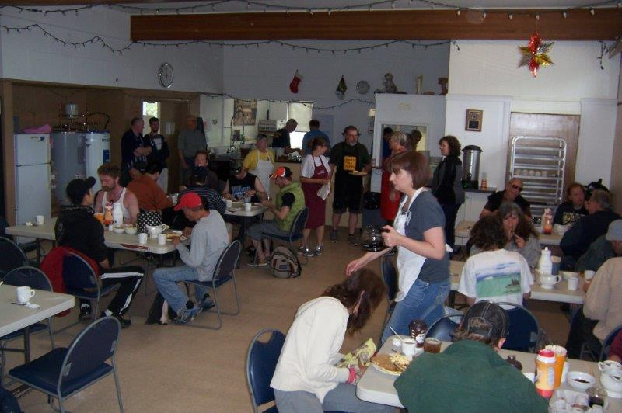
Just a few of our many diners…hopefully happy.
Next breakfast – Saturday, October 28th.

News, Updates & Reminders

DG Tom Carroll has re-scheduled his visit to Area 4 – Tuesday, October 17th. It will be a casual get-together at the Nanaimo Hornets Rugby Club Fieldhouse on Dover (behind Cabelos). All Rotarians are encouraged to come out and give the DG and his wife, Laurie, a warm welcome.

Note - we will have a regular morning meeting on Thursday, October 19th.

Christmas Shoeboxes – please fill them and give them to Ralph before November 16th.

December 14th – our annual Christmas Dinner at the Nanaimo Golf Course. More details to come but, please, mark your calendar. The more, the merrier.
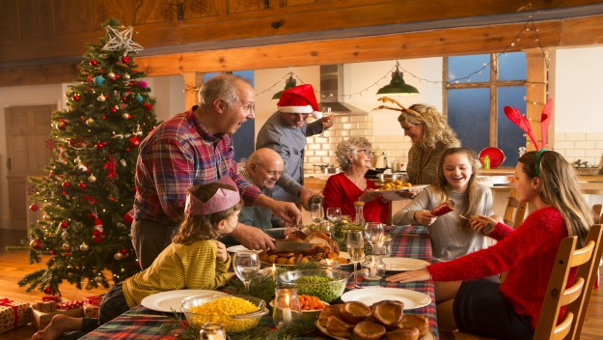

ROTARY MINUTE
David L talked a bit about doing Make-Ups with E-Clubs. They started in 2002 and have members from all over the world. Good for Rotarians on the go. There are several E-Clubs where you can do Make-Ups for missing a regular club meeting, e.g. Rotary E-Club of Canada One: https://portal.clubrunner.ca/8529

SERVICE
- The members approved a donation of $1,000 (Cdn) to Shelterbox Canada – to fund a Shelterbox to one of the hurricane-ravaged islands in the Caribbean.
- The Board approved a proposal to sponsor two local students ($250 each) to attend the Rotary Youth Leadership Awards (RYLA) in Crofton October 27th – 29th.
https://portal.clubrunner.ca/50092/sitepage/ryla-vancouver-island
- Lots of work done last Saturday by 7 Rotarians and 4 spouses/friends at the Habitat for Humanity build-site in Nanaimo.
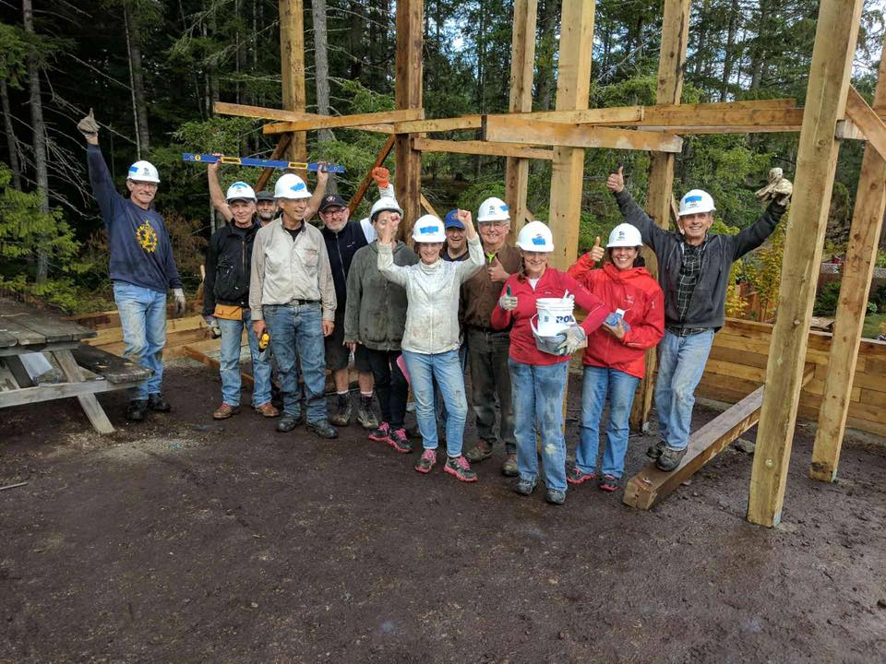
- We also donated $5,000 towards the playground being built on site – preparation work going on above.

Coast to Coast and Back Again
This summer Glynn Currie, PP & PHF, managed to check one thing off his “Bucket List” – visit all 10 provinces, see the sights and meet the people of our great country. This morning he shared some of that adventure with us.
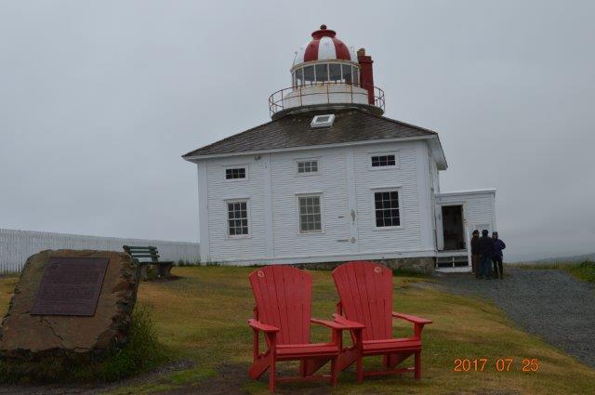
Cape Spear – NL. The most eastern point in Canada.
It must have been quite the trip because he confessed it took him 3 months and 22,000km to drive from Ucluelet to Parksville. But, it did include a few (many?) side trips and a diversion to L’Anse Aux Meadows in N-L.
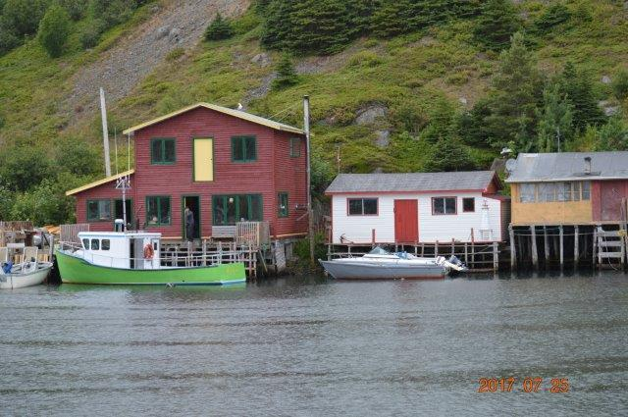
Quidi Vidi Village - NL
Travelling with a cousin, it was a great trip. They camped most nights, talked to many people, took over 1000 photos and Glynn maintained a Facebook page as they motored along.
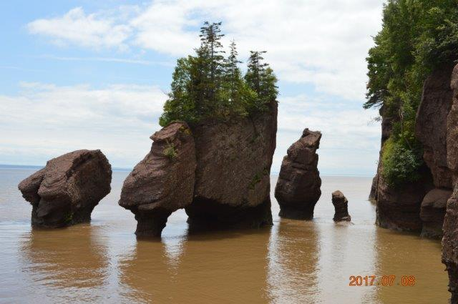
Hopewell Rocks – NB – (Eroded by the Bay of Fundy)
Glynn is now convinced that Canada is a beautiful country with a lot to see and a lot to offer.
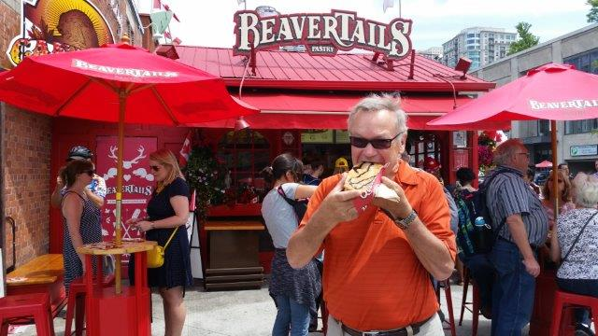
Enjoying a “Beavertail” in Ottawa

ROTARY INFO
You can find out where and when all the Clubs in District 5020 meet on the 5020 website:
www.clubrunner.ca/portal/Organization/Meetings.aspx?accountid=50092

Rotary International: http://www.rotary.org
Member’s access: https://www.rotary.org/myrotary/en
District 5020:
www.rotary5020.org
Rotary Club of Lantzville:
- “ www.clubrunner.ca/Lantzville
Make sure to check out Events and Speakers.
- “Facebook” - www.facebook.com/RotaryClubofLantzville

------------------------------ ------------------------
WHY GOD MADE MOMS
Answers given by 2nd grade school children to the following questions:

Why did God give you your mother and not some other mom?
1. We're related.
2. God knew she likes me a lot more than other people's moms like me.
What kind of a little girl was your mom?
1. My mom has always been my mom and none of that other stuff.
2. I don't know because I wasn't there, but my guess would be pretty bossy.
3. They say she used to be nice.

