

The Lantz January 2026

President’s New Year’s Message
As we turn the calendar to a new year, it’s a great moment to pause and appreciate what makes our Rotary club so special: us. We are a small club, but our impact is anything but. Time and again, we’ve shown that when we work together with flexibility, good humour and a shared sense of purpose we can accomplish wonderful things.

Over the past year members have stepped up, supported one another and pitched in wherever needed. Whether it was planning events, lending a hand behind the scenes or simply offering encouragement, our teamwork and camaraderie made the work lighter and successes sweeter.

Looking ahead, the new year brings fresh opportunities to serve, to connect and to continue making a difference in our community. With the strong spirit of cooperation that defines our club, there’s no doubt we’ll meet whatever comes our way.

Thank you for your dedication, your kindness and your willingness to pull together. Here’s to a happy, healthy New Year and another year of Rotary fellowship and shared success.
December 2025 Highlights

On November 30th several of our members assisted the Lantzville Fire Department with the 16th Annual Food Drive collecting food from the Lantzville.
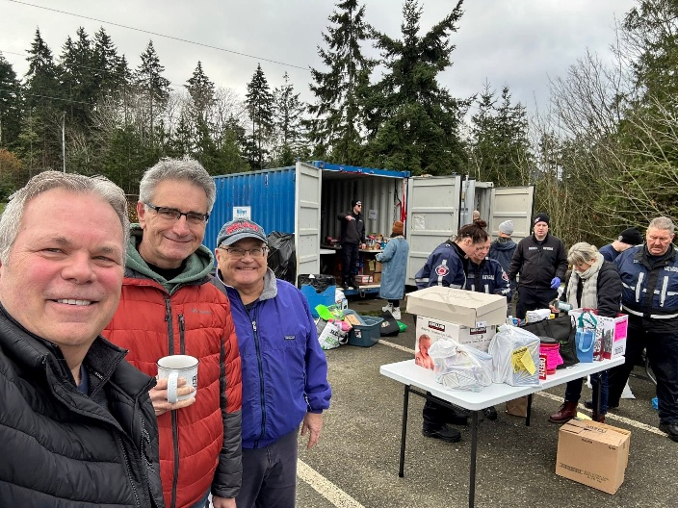

December 6, Santa Clause Parade


Lantzville Rotary Crew busy at work at the parade

December 6, Salvation Army Kettle Campaign
Good to see you back on the mend James after your hospital stay.
Thank you, Dale, for organising the kettle campaign.


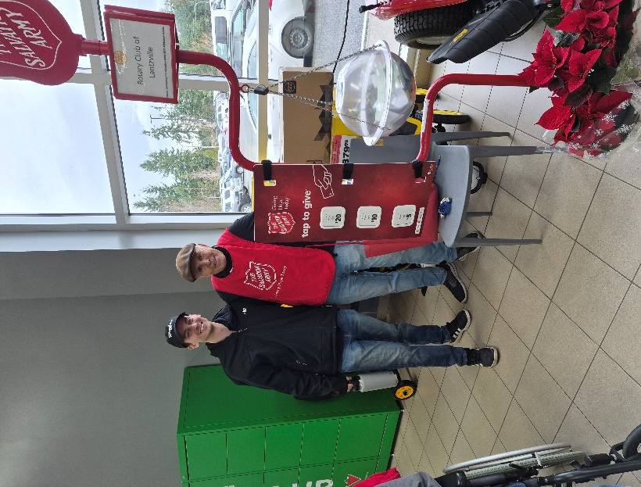

December 9th, RCL Annual Christmas Party
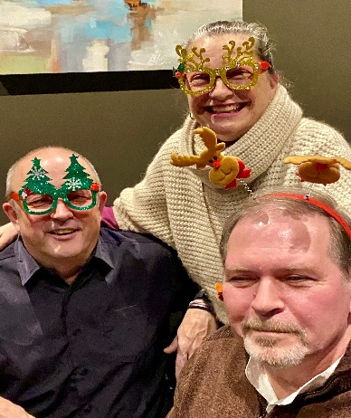
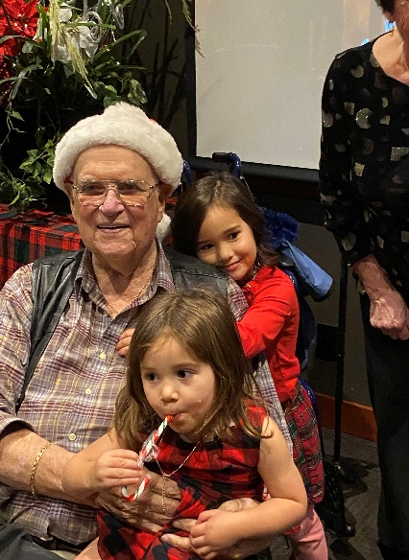
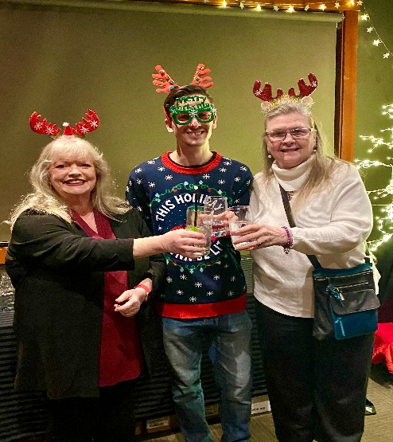

December 13, Breakfast with Santa.
A big Thank you to all the Rotary members who donated their time to cook up a fantastic breakfast for the community of Lantzville. You put big smiles on kids faces. A big thank you to the trio of Dover Bay Jazz musicians who doated their time.
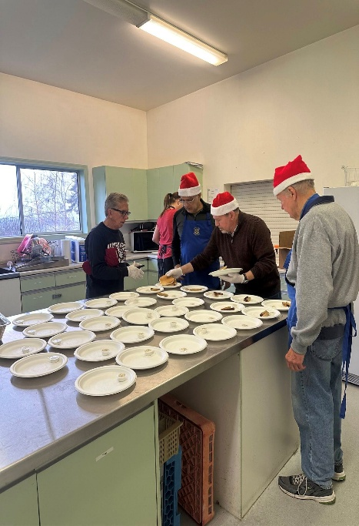

Upcoming Events for January

January 1, Happy New Year, No Meeting. Sleep in!!
January 8th, No Board Meeting
Jan 22nd will be a hybrid club meeting
January 31 Rugby (Double Header) Spaghetti & Meatballs c/w Garlic Bread. Serving 1PM and 4 PM

Birthdays and Anniversaries

Jan 3 Dale Werezak
Jan 14 Greg Devenish
Happy Birthday Guys

Upcoming Speakers

January 9th Marylyn Sullivan Autism
January 15th Shawn Kliner Travel Industry
January 22nd Cassie Stevenson Paramedic Service
January 29th Kimberly Plumley Chamber of Commerce

2026 ROTARY CLUB OF LANTZVILLE DUTY ROSTER
January – March 2026
If the date you are assigned does not work for you, please ask someone to take your task
 | Greeter | Cash | Sgt. Arms | INTROS | INSPIRATION | ROTARY  MINUTE
JAN 8 | Stephen | Jo-Anne | Brian | Jodie | Lance | Leanne
JAN 15 | Ralph | Joy | David | Lee | Stephen | Rachel
JAN 22 | Leanne | Mark | Greg | Alexis | Janice | Douglas
JAN 29 | Don T. | Trevor | Douglas | James | Doug S. | Mark
FEB 5 | James | Jo-Anne | Lance | Stephen | Norm | Lee
FEB 12 | Michael | Mark | Doug S. | Leanne | David | Janice
FEB 19 | Trevor | Joy | Brian | Rachel | Michael | Alexis
FEB 26 | Greg | Trevor | David | Greg | Leanne | Lance
MAR 5 | Brian | Jo-Anne | Greg | Trevor | Jodie | Joy
MAR 12 | Dale | Mark | Douglas | Michael | Lee | Norm
MAR 19 | Jo-Anne | Joy | Lance | James | Rachel | Dale
MAR 26 | Norm | Trevor | Doug S. | Joy | Alexis | Doug

For any additional news about The Rotary Club of Lantzville, please visit our Facebook Page:
https://www.facebook.com/RotaryClubofLantzville/

New Years Quote: “There Are Far Better Things Ahead Then Any We Leave Behind.”


Happy Reading. Cheers!

