Theme for November  Rotary Foundation Month  Birthdays    Nov 29: James Williams  Anniversaries  Lee and Caroline  Nov 4, 1995  Greg and Susan  Nov 13, 1976    November 11 Remembrance Day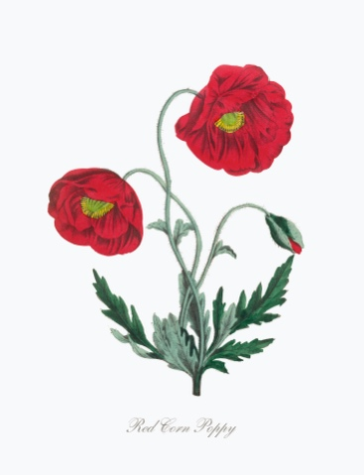  Lest we forget.  November Lantzville Club Events  Christmas Shoe Boxes Due Early November  Nov. 12 Loaves and Fishes  Nov 14: Bring your Bottles for the Scouts  Nov 15: Nanaimo Hornets/RCL  Social Beer & Burger  $ 20 per person |   "We are not going to end polio or bring peace to the world by waving a wand. It's up to you. You create the magic with every project completed, every dollar donated, and every new member." President Stephanie Urchick  October in Review  Of course, the captivating element of the month from the perspective of this writer is Rotary in Italy, where oh where is it??? Although there are many clubs listed as existing, evidence was difficult to find. My eye was peeled for indications of Rotary in Napoles, Rome, Tuscany, Puglia…but was only discovered in Marzamemi, Sicily! (One of the landing sights of the allies (and Canadians) in July of 1943)  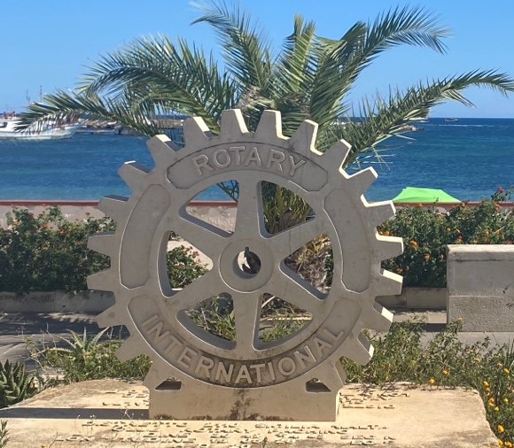 Evidence of Rotary  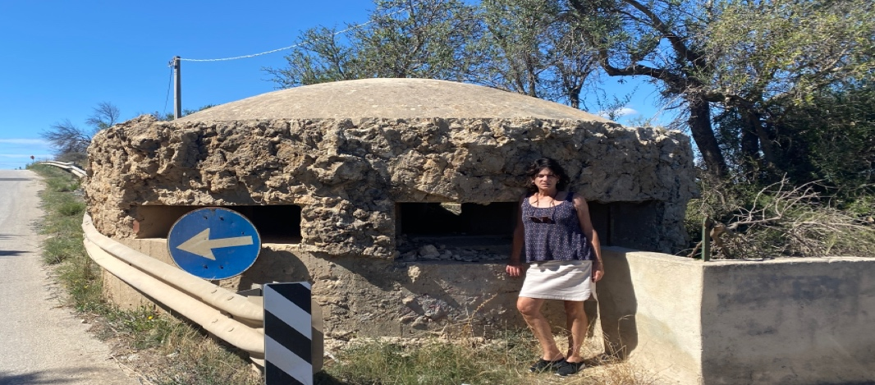 A German Pillbox up the street. Canadians landed there.  Back to our club: A Big shout out to Joy for keeping me abreast of what the club has been up to for the month of October. Here is a brief synopsis:  - Ralph Lemmon spoke briefly to the club about the Christmas shoe box initiative. Members were invited to take a box to fill or possibly contribute $35 to a Santa Helper. RCL pays the shipping cost  - Getting to know you – Lieutenant Colonel (Ret.) D.E. Slowski, CD  Doug was the featured member and gave the club a fascinating look into his life. He was born in Blairmore Alberta and following Dad’s coal mining injury, his family moved to Saskatchewan. He embarked on a 40-year banking career which began in Saskatchewan and branched into Northern Alberta and Vancouver Island.  Doug joined the Air Cadets of Canada in 1962 and today has ongoing roles with the Air Cadet League of BC, the Air Cadet League of Canada and the International Air Cadet Association. Doug is also a life member of both the Vancouver Island Military Museum and the Parksville Chamber of Commerce, a 30 – year veteran of the 808 Air Force Association and a charter member/past president of the United Services Institute, Nanaimo North Island.  35 years ago, Doug joined Rotary in Campbell River. He is a founding/charter member of Parksville AM Rotary Club and in 2000 Doug joined the RCL.  He has been an active participant in numerous community organizations and events and has received numerous significant local, provincial and national awards in recognition of his input and service.  In his so-called spare time, Doug is passionate about woodworking and is an active member of the Nanaimo Amateur Radio Association. Doug & Heather have a daughter in Nanaimo and son in the lower mainland.  Thanks, Doug, for sharing your story!  - Members were acknowledged by President Ribicic for their participation in sorting food at Loaves and Fishes.  - Jason Yochim, Vancouver Island Real Estate Board (VIREB) CEO spoke to the club about the structure of organized real estate, VIREB responsibilities to their 1200 members, VI real estate statistics, the economic spin-off for home sales and the impact of the ever changing mortgage and taxation policies on housing prices.  - Lance Bereck, chair 205 Collishaw Squadron Sponsoring Committee was joined by his wife Maria (squadron civilian instructor) & daughter Erica (cadet Flight Sergeant). They shared that the 205 Collishaw is about 100 cadets strong with solid base of volunteer members. Lance noted that, “Air Cadets receive training in subjects such as flying and gliding, survival skills, physical fitness, public speaking, citizenship, and precision drill. Select cadets may participate in summer courses at training centres across Canada.” He outlined several opportunities for civilian volunteers to engage with the cadet and gave us a standing invitation to come to any of their public events.  - Visit to the Nanaimo Art Gallery (NAG) Hosted by Carolyn Holmes, Executive Director  Club members enjoyed an early morning outing to the NAG to see the current exhibit: the other side. This is an exhibition of photo -based and sculptural artworks by artists Michelle Sound & Eliot White-Hill.  Member found it interesting to see the exhibit itself, the working premises for the Nanaimo Art Gallery and their ongoing challenges. The Nanaimo Art Gallery offers several ‘artistic’ related programs for kids, teens and adults throughout the year. In 2023-2024, their programs had a total audience of 25,600. Family membership is a very reasonable $ 30.00.  The month ended in Spooktacular fashion.  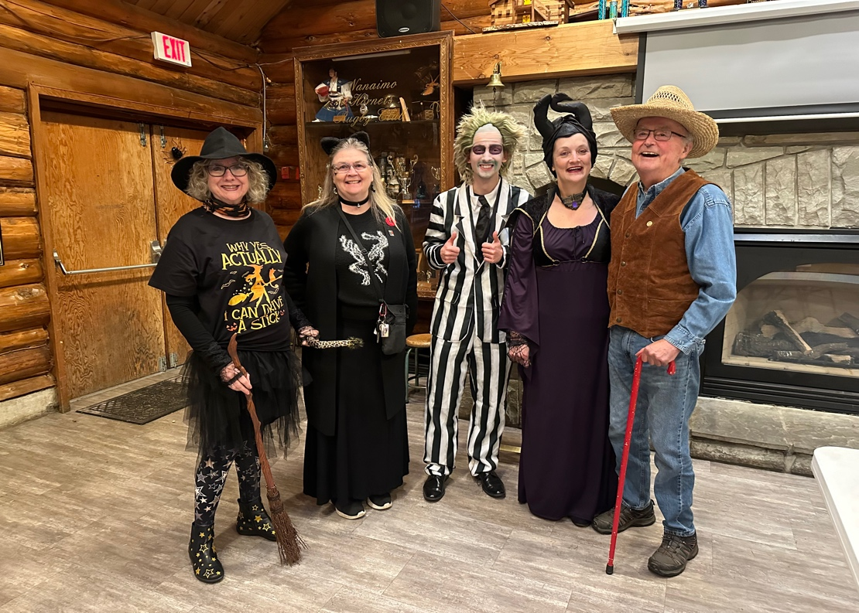 Thanks for dressing up!!!  ON TO NOVEMBER:  See what Rotary International has to say about this month’s theme…..  https://my.rotary.org/en/Node/180961  Mark your November calendar  World Interact Week is celebrated every year during the week of November 5th to commemorate the founding of the first Interact club in 1962. “Interact clubs are sponsored by Rotary clubs as a program of Rotary International. Rotary clubs provide guidance and inspiration, but the Interact clubs are self-governing and self-supporting. Clubs vary greatly, with single-gender and co-ed clubs, as well as those with large and small membership.” There are currently 14,900 clubs in 145 countries around the world!!!! Anyone know about the Interact club in Nanaimo??  NOVEMBER EVENTS AROUND TOWN (click on the link to read about the event)  Bastion Lighting Colour Red: Veterans' Week and Remembrance Day from November 5 – 11  Bastion Lighting Colour Purple: Shine the Light on Woman Abuse on November 25 - 2  Did you Know? Bastion Lighting Colors can be requested to honor different occasions. What would be our Rotary Colors and Occasion?  More Events! Nanaimo and surrounding areas are hosting several craft fairs and Christmas socials. Beginning with this one:  Nov 1 – 3, 2024  Lots for us all to do and attend!  Check out the Vancouver Island University Speaker Series this month:  https://ah.viu.ca/colloquium-series  Basketball anyone? Come out and support our Mariners!  https://mariners.viu.ca/landing/index  Presenters for November  November 7. Remembrance Day – Brian McFadden  RYLA Students  November 14 Wellington Jazz Band – Carmella Luvisotto  November 21 2025 Seniors’ Games – Diana Johnston  November 28 Sea Wolves Men’s Cancer – Tentative  Don’t forget to get your spot at the:  Rotary International Conference: Calgary, Alberta
NOVEMBER DUTY ROSTER

Remember if you are not able to do your duty, please find someone to replace you and let Michael know!

DATE | CASH | SGT ARMS | GREETER | INTROS | INSPIRATION | ROTARY MINUTE
Nov 7 | Jo-Anne | Greg | Doug | Stephen | Lance | Jodie
Nov 14 | Joy | David L. | Janice | Lee | Shelia | MIKE W
Nov 21 | Mark | Douglas | Don | Rachel | Cor | Joy
Nov 28 | Trevor | Troy | Leanne | Doug | Stephen | Lance

Don’t forget to check out our Facebook page for photos and memories!!
https://www.facebook.com/RotaryClubofLantzville

Get ready to have some Christmas fun with our club and Lantzville community!!

December 4 Simon Holt Christmas Social
December 14 Breakfast with Santa


This Photo by Unknown Author is licensed under CC BY-NC

