Theme for October  Economic and Community Development  Birthdays    Oct. 2 David Lobay  Oct 10 Shawn Kilner  Anniversaries  None this month  October Events  Sept 30 -Oct 6: Rotary Alumni Reconnect Week  October 24  Nanaimo Senior Services Network Seniors Health and Wellness Fair  Beban Park Social Centre  October 24. World Polio Day  Upcoming Rotary Events  Sept 27 0ctober 6 Rotary Club of Nanaimo Book Sale  Oct 5.  Rotary Daybreak Garage Sale 1085 Moyse Cresent,  October 8  RCL Loaves and Fishes  Octo 19th  Rotary Daybreak October Fest @ Beban Park  Like the dude to the right of this page, WE are unique!! All other Rotary clubs meet at the Nanaimo Golf Course. Below is their schedule, feel free to visit them.  RC Nanaimo North  6:10pm 1st & 3rd Tuesdays  RC Nanaimo Daybreak  7am Wednesdays  RC Oceanside  5:15pm 1st and 3rd Wednesdays  RC Nanaimo  12pm – 2nd, 4th and 5th Fridays  1st Friday – Zoom  3rd Friday – Social Event  Rotaract  Meets at 6:00pm alternating Mondays and Wednesdays  at VIU | 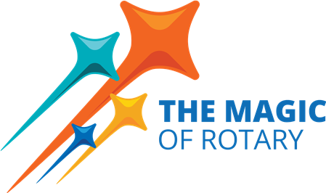  September in Review  It was a magical lead up to September, hearing the stories of the Youth Exchange Students regarding their experiences abroad. Amazing young people!! Our club members Stephen, Greg, and Alexis cooked and served for the crowd while Rachel and her kidlets welcomed guests who were there to support the Youth Exchange program. Thanks to Troy for helping to organize.  And then the school year begins!! We opened the month by taking the opportunity to rid ourselves of those “bottles in the garage” by donating them to the Scouts. Once the bottles were collected, we enjoyed an update to the activities of the Nanaimo Scouts, specifically the 2024 Scout Jamboree. Thanks William and family team, for the wonderful and engaging presentation. Looks like Scouts rock!!  An evening of sorting and hard labor took place at the Loaves and Fishes Warehouse. Shout out to the dry goods sorters: Jodi, Leanne, Jo-Ann and team captain Trevor. And the “Yuck Award” goes to Greg for accepting his position at the wet, mush food station. Thanks for being late! Honorable mention to the team for missing the US debate to volunteer in our community!  We had the privilege of a visit from Paige Quinn, from the Canucks Autism Network (CAN), a non-profit organization funded by the Canuck family. Paige gave an overview of opportunities for children and youth on the autism spectrum which included afterschool programs, pop up programs, as well as family and community events. She navigated several questions related to the admission process and funding structure of CAN and noted that all $ raised through their fundraising events stay on Vancouver Island. Thanks for the informative presentation.  Several members volunteered to be the “cooking and serving” team for the Nanaimo Hospital foundation Breakfast, held on September 21. Thanks to the early birds!  Ken Hammer gave us an overview of Rotary Friendship Exchanges and invited member to consider this wonderful Rotary opportunity to connect with others around the world. Ken also highlighted the upcoming  Leslie Sundby from Rotary Club of Nanaimo enlightened us on an international project she has been involved in India. Leslie spoke about the many projects undertaken in Sunyani, Ghana. The Rotary Club of Nanaimo  has been the lead with contributions from all five Nanaimo clubs and MIRG. Most recently, 2022,saw the completion of the Nsoatre Primary School project. Leslie shared a wealth of information on the process of working internationally, challenges and rewards of the work, as well as some stringent rules of applying for Rotary International Grant money.  Club Goodbye: Chris Widsten has chosen to end his membership with our club. We wish him and his family well and invite him to return to visit (or rejoin!) at any time. We thank him for the time he devoted to the club events and to him and his family for hosting a wonderful summer barbeque on their exquisite property. You will be missed.  And now……. October!  Theme Economic and Community Development  “We can create, partner, share ideas related to the Economic and Community development around the world. As a club of world travelers and explorers, we have opportunities to rejoice in the work of Rotary and seek out events and projects in our local communities and those abroad that Rotary is involved in.”  See what Rotary International has to say about this month’s theme…..  https://my.rotary.org/en/Node/180961  Speakers this Month  Oct. 3 Getting to know you (Doug Slowski)  Oct 10 Business meeting  Oct 17 Nanaimo Art Gallery Tour – 7:30 am, Carolyn Holmes (CEO)  Oct 24. TBA  Oct 31. Royal Canadian Air Cadets, 205 Collishaw Squadron  Lance Bereck, vice chair  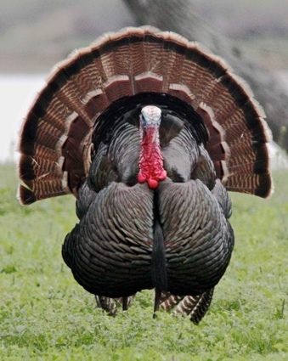 Thanksgiving October 14  https://www.farmersalmanac.com/when-canadian-thanksgiving  October spooky Halloween Fun in Nanaimo  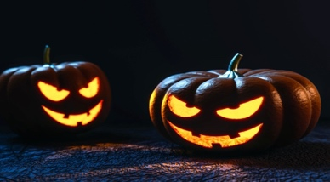  https://nanaimomuseum.ca/whats-happening/events-presentations/  Did you know? Bastion Lighting Colors can be requested to honor different occasions. What would be our Rotary Colors and Occasion? Check it out..  - Bastion Lighting Colour Orange: Halloween on October 31
OCTOBER DUTY ROSTER

Remember if you can’t do it, please find someone to replace you and please let Michael know!

DATE | CASH | Sgt. ARMS | GREETER | INTROS | INSPIRATION | ROTARY  MINUTE
Oct 3 | Trevor | Greg | Shelia | Jodie | Troy | Don
Oct 10 | Jo-Anne | David L | Cor | Janice | Dale | Alexis
Oct 17 | Joy | Douglas | Stephen | Lance | James | Mike
Oct 24 | Mark | Troy | Lee | Shelia | Jodie | Dale
Oct 31 | Trevor | Brian | Rachel | Cor | Lee | James

Don’t forget to check out our Facebook page for photos and memories!!
https://www.facebook.com/RotaryClubofLantzville

