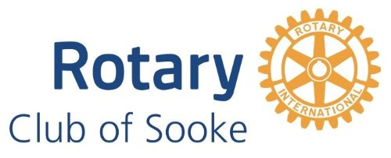

**August 7 th, 2024 – Community Hall - At 5:30 Acting President Deena called meeting #1663 to order**

The meeting began with the territorial acknowledgement.

**Guests: Olivia Hyde and her sisters, Carolina and Rosa lea, Janine, Shamus and Hunter Gullekson**

**Guest Speaker: Shannon Lysyk, Sooke’s Community Paramedic**

**Rotary Moment:**

**John shared a recipe book he borrowed from Frank Gurtsma’s libraray. It is a collection of recipes collected and put together by members of District 5020. There looked to be some yummy recipes to try.**

Our speaker, Shannon Lysyk spoke to us of her roll in and around Sooke. She is our Community Paramedic. She is a licensed Paramedic who uses her skills in non-urgent settings; in patients’ homes or community settings. She focuses on community outreach and awareness, health promotion that includes providing CPR and AEC training sessions, and the provision of primary as well as palliative care.

Her talk was enlightening and well received.

More information can be found at: [www.bcehs.ca/ourservices](http://www.bcehs.ca/ourservices)

Email: [CommunityParamedicine@bcehs.ca](mailto:CommunityParamedicine@bcehs.ca)

Grant offered a Thank you on behalf of the club.

**Whats New:**

Myrtle shared her well-deserved award received acknowleding her amazing athletic abilities.

**The meeting was adjourned at 7 19 pm**