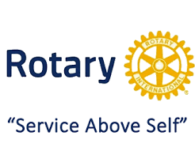
South Puget Sound Rotary Club
Community Grant Application
Your Auction Dollars at Work
Grant fund requests are due quarterly by the 15th of March, June, September, and December. The committee will review applications the following month. If received after the deadline the request will be considered the following quarter. Recipients will be invited to attend a SPS Rotary meeting during the next month to accept the check.
Priority is given to: *Organizations that directly impact our South Sound residents *Causes that will benefit large numbers of people *Causes that provide a direct tangible benefit to the community *Causes that have promise for long term operation and service to the community *Organizations with humanitarian goals
Schools are encouraged to apply. Other organizations must have a 501©(3)tax status. This application is not for single beneficiaries, or for organizations with political or religious pursuits. Organizations that have received funds previously will be assigned a lower priority for additional funds.
Name of Organization: _______________________________________
Amount Requested: _______________________________ Date Requested: ________________
501c(3): __________________
Applicant Name/Title: _____________________________
Mailing Address: _____________________________________________________________
Phone: _________________________ Email: _____________________________________
Please describe below how the funds will specifically be used. (i.e. when and where the funds will be used? who will be involved and what exactly the funds will pay for? why the project is important?)

Thank you for applying and for your cause, please mail completed form to:
Community Service Committee
South Puget Sound Rotary,
PO BOX 7456
Olympia, WA 98507

